Finance Advisory Committee
FY2026 Budget and Fiscal Recommendations to Superintendent Hines
February 25, 2025

Executive Summary | Pages 1-2
FY2026 Budget Recommendation Background | Pages 3-11
- Recommendation #1: Within revenue constraints, build an expenditure budget that maintains an unreserved fund balance of at least 8% with growth | Page 3-4
- Recommendation #2: 2.53% (current MDE estimate) increase in per pupil formula | Page 5
- Recommendation #3: 4,326 K-12th grade adjusted pupil units (APU) | Pages 6-8
- Recommendation #4: Maintain student fees and meal prices at current rates; add a technology fee and increase community education premier space rental fee | Pages 9-10
- Recommendation #5: Understand district cost drivers and focus on cost containment | Pages 11
Finance Advisory Committee Membership | Page 12

Executive Summary

The Financial Advisory Committee (FAC) is tasked with advising administration and the school board on economic and school finance issues and to build community trust in district finances. The Committee has met six times this year.
The recommendations presented to the Superintendent reflect a general consensus among the Committee members regarding the key assumptions for the 2025-2026 (FY2026) budget. These recommendations are based on three major factors that influence the school district’s financial planning:
- State Economy - The economic outlook in Minnesota has weakened recently. Although the 2023 State legislative session (the last funding session) saw a historic and significant investment in public education, it’s unlikely that additional funding will come from the 2025 legislative session. Any extra funding from that session should be used to balance the budget and strengthen or maintain reserve funds.
- Cost Structure - Around 85% of the district's General Fund (excluding capital-related expenses) is dedicated to human resources, primarily salaries and benefits. The current employment market remains highly competitive. Other cost drivers, such as transportation, substitute teacher fees, and utilities, continue to rise rapidly. As a result, expenses are growing much faster than revenues, posing a serious threat to the district's financial stability and programs. Efficiency initiatives must be a critical focus moving forward.
- Student Enrollment - Enrollment - a key indicator of fiscal health - has not yet returned to pre-pandemic levels. While enrollment stabilized in FY2022 following the pandemic, FY2025 marked the first increase in student enrollment in over a decade. This increase is encouraging, especially due to ongoing efforts to engage families and improve academic outcomes. However, historical trends suggest that enrollment may continue to decline in the future.
In light of these conditions, the Committee offers the following fiscal and budget assumptions to the Superintendent:
FY2026 Budget Recommendations:
- Fund Balance Minimum:
  - Maintain an unreserved fund balance of at least 8% within revenue constraints.
  - Develop a long-term plan to increase the fund balance to 12%-16%, which would cover approximately two months of expenditures.
  - If enrollment continues to decline or state funding lags behind inflation, this may necessitate expenditure reductions.
- General education funding formula
  - A 2.53% increase in the per-pupil formula, based on the Minnesota Department of Education's current estimate of inflation for FY2026.
- Student enrollment
  - The committee recommends 4,326 adjusted pupil units (APU) for K-12 students.
  - Continue efforts to improve student capture rates to stabilize and grow enrollment.

- Local revenue
  - Introduce a technology fee to cover damage or loss, to be implemented by district staff.
  - Increase the community education premier space rental fee to align with neighboring districts. Recommendations for class fees and rental rates will come from the Community Education Advisory Council.
  - Encourage sports boosters or a district-wide booster club to increase funding.
  - Keep current student fees in the General Fund and meal prices in the School Nutrition Fund unchanged.
- Expenditure recommendation
  - Continue analyzing cost drivers specific to St. Louis Park Public Schools, comparing them to historical and statewide data.
  - Focus on cost containment strategies to avoid future budget cuts.
  - Prioritize retaining classroom teachers and student-facing roles.
  - Communicate clear expectations for results and success metrics, especially when adding non-classroom positions.

FY2026 Budget Recommendation Background

FY2026 Budget Recommendation #1: Fund balance minimum
In line with revenue constraints, the district should develop an expenditure budget that ensures an unreserved fund balance of at least 8%. A long-term strategy should also be created to gradually increase the fund balance to 12%-16%, which would equate to approximately two months' worth of expenditures.
Should student enrollment continue to decline or if local, state, and federal funding fails to keep pace with rising expenditures, reductions in expenditures may be necessary. Additionally, the potential loss of federal funds, as recently reported, could further jeopardize the district’s financial stability. These unexpected changes highlight the importance of maintaining a healthy fund balance. A solid reserve will provide the district with the flexibility to maintain stable operations in response to shifts in funding.
The FAC emphasizes that the General Fund Balance is critical to the district's overall financial health. While the district should aim to use its resources to fully support its strategic plan and meet the needs of today’s students, it is equally important to safeguard a fund balance that ensures healthy cash flow. This balance will also help the district manage any unforeseen financial challenges or capitalize on unexpected opportunities that may arise during the fiscal year.
Audit results for FY2024 reveal that St. Louis Park’s General Fund Unreserved Fund Balance, combined with amounts Assigned for future year deficits, totaled $5.3 million, representing approximately 8.27% of FY2024's unassigned operating expenditures. The FY2025 budget, as approved by the school board, is balanced; however, due to rising expenditures, the projected fund balance for FY2025 is slightly reduced to 8.25%. The chart below illustrates the recent history of the fund balance and the current budgeted fund balance for FY2025.

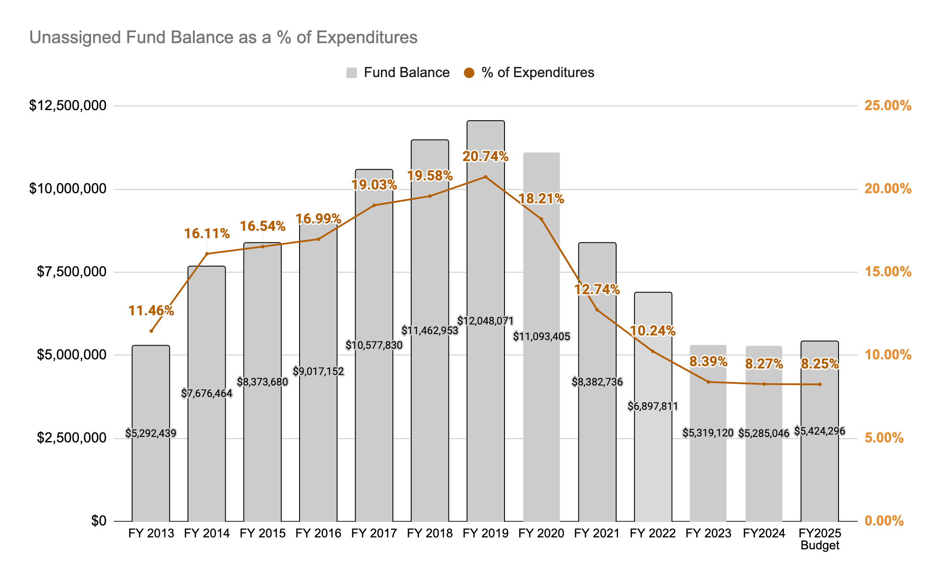
The chart below presents data from the FY2024 audit report, illustrating historical statewide trends in fund balances. The chart uses a comparable fund balance calculation, which differs slightly from the district's internal calculation. While St. Louis Park has seen a reduction in its fund balance over the past few years, the trend statewide has been an increase in fund balances. This contrast highlights the need for the district to focus on rebuilding its reserves in line with broader statewide practices to ensure long-term financial stability.
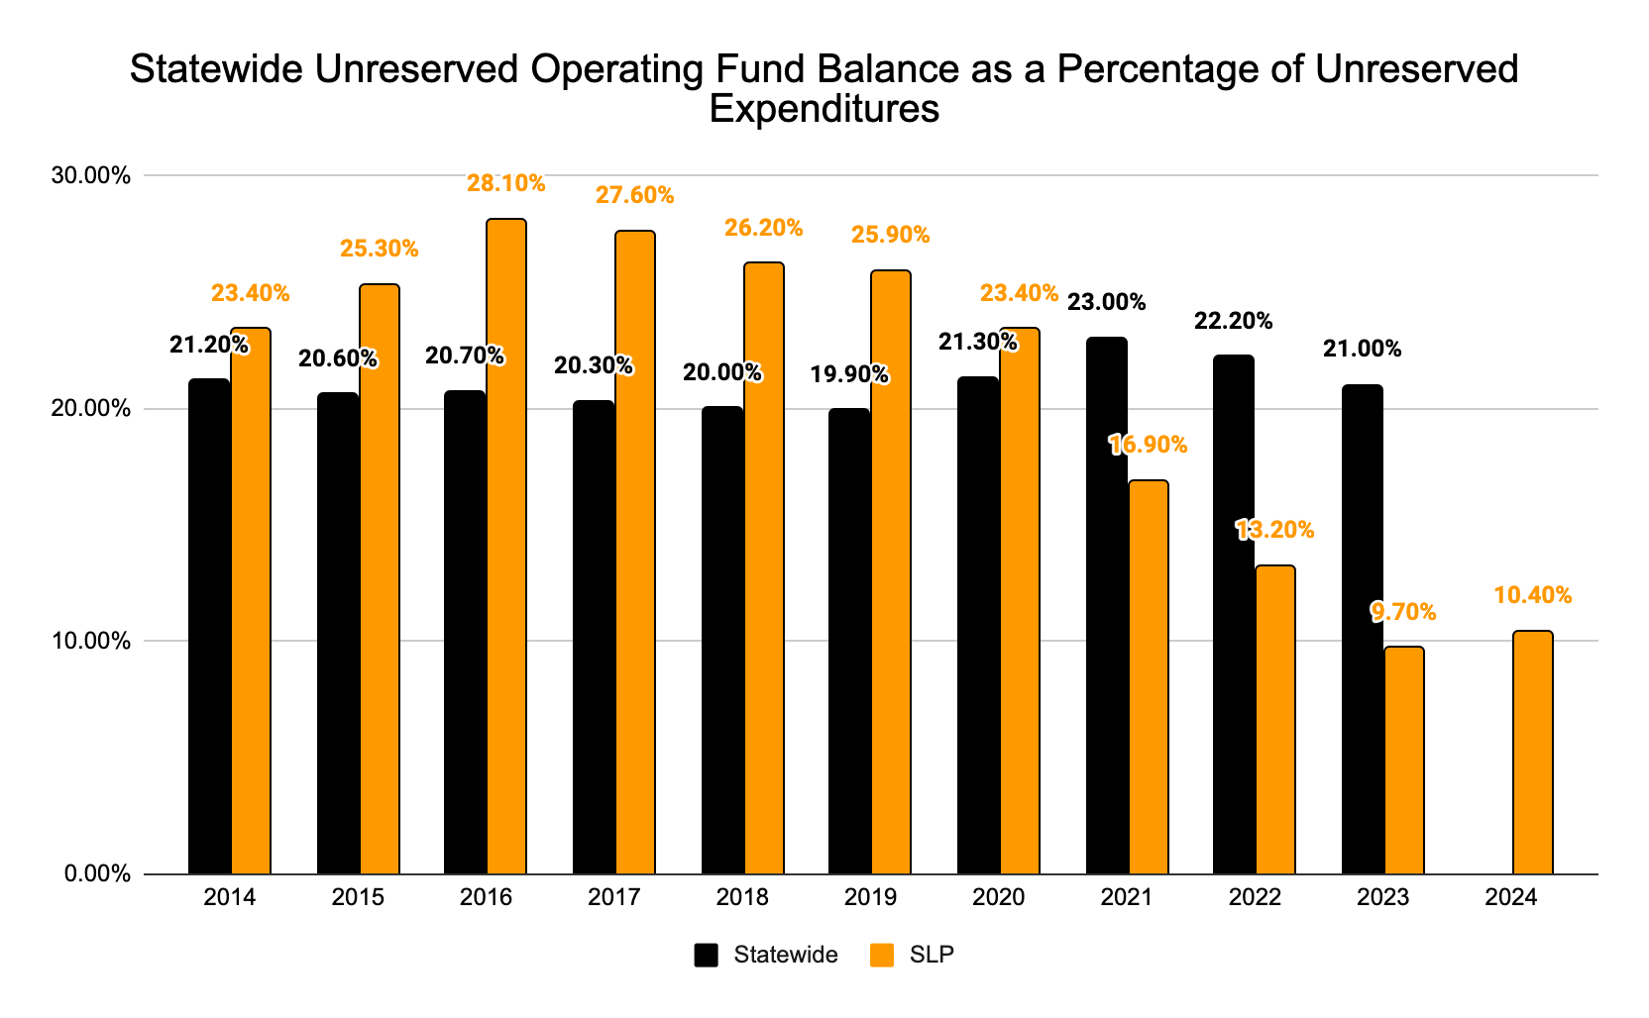

FY2026 Budget Recommendation #2: Per pupil funding formula
The recommendation is to factor in a 2.53% increase in the per pupil funding formula for FY2026, based on the current Minnesota Department of Education (MDE) estimate of the inflationary impact.
The chart below illustrates the State’s basic formula allowance increases over the past several years, providing context for the proposed adjustment. This increase is critical to support the district’s ability to address rising costs, ensuring that funding keeps pace with inflation and the growing financial demands of the district.
Year | Amount | Explanation
2013-14 | $5,302 | 1.5% increase
2014-15 | $5,831 | 1.5% increase + $25
2015-16 | $5,948 | 2.0% increase
2016-17 | $6,067 | 2.0% increase
2017-18 | $6,188 | 2.0% increase
2018-19 | $6,312 | 2.0% increase
2019-20 | $6,438 | 2.0% increase
2020-21 | $6,567 | 2.0% increase
2021-22 | $6,728 | 2.45% increase
2022-23 | $6,863 | 2.0% increase
2023-24 | $7,138 | 4.0% increase
2024-25 | $7,281 | 2.0% increase
2025-26 | $7,465 | 2.53% increase (current MDE est)

Due to stagnant economic indicators in the State of Minnesota, despite relatively low unemployment and a historic budget surplus, it is unlikely that the state will continue to provide substantial funding increases. Current state law mandates that general education aid increases in alignment with inflation, with a minimum of 2% and a maximum of 3%. However, the state will face competing funding priorities and potential future economic downturns, making additional funding less predictable. This underscores the importance of reducing current expenditures and limiting expenditure growth to maintain financial stability.
In addition, voter approval of the operating referendum in November 2017 set the operating levy at the maximum level, with increases tied to an inflationary factor as defined by state law. As a result, the district now receives the maximum operating levy dollars and has no capacity to raise the operating levy further. Consequently, the district must rely on increases in the General Education Formula Allowance to help meet funding needs.

FY2026 Budget Recommendation #3: student enrollment projection
The district should plan for 4,326 K-12 adjusted pupil units (APU) in FY2026. A continued focus on improving student capture rates will be essential to both maintain current enrollment levels and encourage growth. Efforts to engage families and enhance the educational experience will play a key role in ensuring that the district's enrollment numbers remain strong, helping to secure the necessary funding to support educational programs and services.
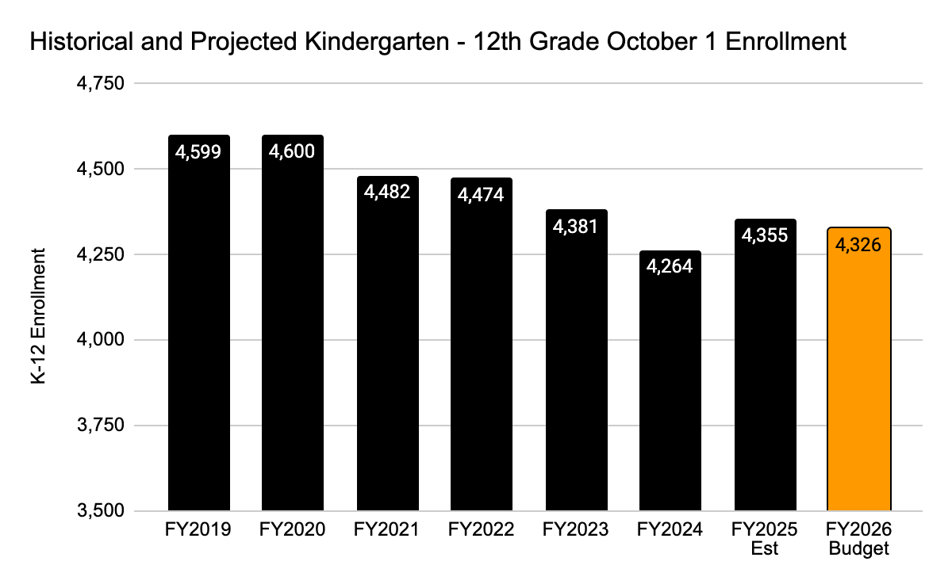
 | Historical Fall Actual |  |  |  |  |  | Est | Budget
 | FY2019 | FY2020 | FY2021 | FY2022 | FY2023 | FY2024 | FY2025 | FY2026
Kindergarten | 332 | 391 | 302 | 351 | 298 | 323 | 334 | 302
Grade 1 | 351 | 329 | 384 | 309 | 345 | 282 | 331 | 331
Grade 2 | 333 | 338 | 319 | 365 | 294 | 345 | 300 | 339
Grade 3 | 355 | 334 | 325 | 319 | 364 | 283 | 339 | 294
Grade 4 | 357 | 346 | 322 | 315 | 316 | 339 | 300 | 341
Grade 5 | 360 | 347 | 345 | 312 | 303 | 317 | 351 | 304
Total Elementary | 2,088 | 2,085 | 1,997 | 1,971 | 1,920 | 1,889 | 1,955 | 1,911
Grade 6 | 356 | 358 | 323 | 330 | 320 | 310 | 321 | 357
Grade 7 | 322 | 357 | 340 | 331 | 322 | 315 | 329 | 328
Grade 8 | 340 | 333 | 338 | 331 | 316 | 313 | 324 | 328
Total Middle School | 1,018 | 1,048 | 1,001 | 992 | 958 | 938 | 974 | 1,013
Grade 9 | 392 | 370 | 374 | 399 | 361 | 326 | 339 | 346
Grade 10 | 390 | 380 | 366 | 383 | 393 | 354 | 338 | 342
Grade 11 | 337 | 378 | 356 | 352 | 364 | 375 | 363 | 334
Grade 12 | 374 | 339 | 388 | 377 | 385 | 382 | 386 | 380
Total High School | 1,493 | 1,467 | 1,484 | 1,511 | 1,503 | 1,437 | 1,426 | 1,402
Total K-12 | 4,599 | 4,600 | 4,482 | 4,474 | 4,381 | 4,264 | 4,355 | 4,326
Change |  | 1 | -118 | -8 | -93 | -117 | 91 | -29
 |  | 0.02% | -2.57% | -0.18% | -2.08% | -2.67% | 2.13% | -0.67%*
Historically, the Committee has used a seven-year survival rate model to project future enrollment. This method smooths out one-time fluctuations caused by factors such as demographic shifts and population changes, providing a more stable estimate of enrollment. However, this year, following a period of enrollment growth, the Committee decided that excluding the anomalous COVID-19 year and using only the past three years of survival rates would yield a more reasonable projection.
Moving forward, the plan is to gradually return to the seven-year model by incorporating one additional year of data in each successive forecast.
For FY2025, the District is expected to graduate a senior class of 386 students and anticipate a smaller kindergarten class in FY2026, with only 302 students enrolled. This alone is projected to decrease overall enrollment by 84 students in FY2026.
The chart below illustrates the history of resident student enrollment for families who choose public school education. It also highlights the trend in the percentage of resident students attending public school, whether within St. Louis Park Public Schools, opting for charter schools, or attending a different public school district. The students attending their district of residence are included in the calculated capture rate. The orange line represents the decline in this capture rate, dropping from 84.76% in FY2018 to 81.41% in FY2024.
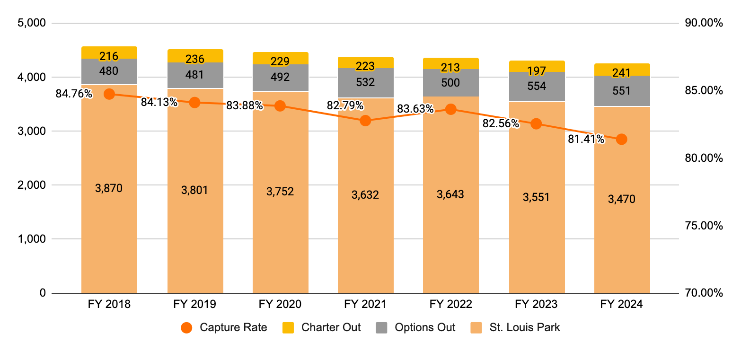
To maintain and increase enrollment, the district must focus on attracting St. Louis Park residents who might otherwise choose other public school districts, charter schools, or private schools. The following actions are recommended to help achieve this goal:
- Persist in Improving Academic Outcomes: Continuously improve academic performance for each student and continue to invest in teacher development to demonstrate the district's commitment to quality education and student success.
- Promote Unique Strengths: Understand and highlight what makes St. Louis Park Public Schools stand out, emphasizing the qualities that attract and retain families within the district, such as
  - Preschool programs,which serve as a positive and inviting entry point for families into the district’s educational system.
  - Small town in the city highlighting proximity to the city with the benefits of a smaller school setting
  - Low elementary class sizes
  - Engaged and connected teachers - teachers care about their students
  - Modernized schools and cafeterias as a result of community support and investment
  - Offerings of International Baccalaureate (IB), Advanced Placement (AP), and concurrent college enrollment at the high school
- Increase Outreach to Families with Incoming Kindergarteners: Target outreach efforts specifically to families with incoming kindergarteners to ensure they are aware of the opportunities available in the district.
- Create High Expectations for Initial Family Experiences: Ensure that the first interactions families have with the district are positive, including the appearance of school facilities, the quality of staff interactions at the enrollment center and front offices, and overall customer service.
- Ensure Transparency in Student Access: Guarantee clear communication regarding student access to curricular, co-curricular, and extracurricular activities that foster student growth and development.
- Enhance Non-Academic Experiences: Pay attention to the non-academic aspects of student and family life, such as transportation and school nutrition, and implement changes to improve these experiences, further supporting families in choosing the district.
By focusing on these key areas, the district can better meet the needs of its current and prospective families, which will help boost enrollment and foster long-term growth.

FY 2025 Budget Recommendation #4: local fees
- Add a Technology Fee: Implement a technology fee to cover damage or loss of district-issued devices. Costs have averaged between $150,000 - $200,000 annually. The fee would be imposed in the case of repairs due to negligence or loss, something like:
  - Lost chargers - $35
  - Chromebook screen replacement would - $35
  - Total replacement - $280
The district will evaluate exceptions to the fees, such as permitting one lost item before applying the charge. District staff will oversee and manage the collection of this fee.
- Increase Community Education Space Rental Fees: Adjust the premier space rental fees for Community Education to align with neighboring districts. The Community Education Advisory Council will provide recommendations on class fees and rental rates.
- Maintain Existing Student Fees and Meal Prices: Keep other student fees in the General Fund and meal prices in the School Nutrition Fund at their current levels. Even a significant increase in these fees would not generate enough revenue to justify raising them.
- Encourage Sports Boosters to Increase Funding: Urge existing sports booster organizations to increase their financial support to help alleviate the pressure on the general fund.
- Form a District-Wide Booster Club: Seek volunteers to establish a district-wide booster club focused on enhancing community support for the district. This club would also work to provide additional funding to support a wider range of opportunities for students that might not otherwise be possible due to budget constraints.
- Focus Booster Support on Transportation: Given the significant impact of transportation costs on athletic and activity budgets, encourage booster support in this area. Transportation is vital for student participation, especially for events and after-school activities, and additional funding here could help ensure broader access for students.
By implementing these recommendations, the district can enhance revenue streams while promoting community engagement and maintaining access to essential services for students.
- High School Activity Fees will be maintained as outlined below:
Cross Country | $210
Swimming | $210
Synchronized Swimming | $210
Tennis | $210
Baseball | $220
Golf | $220
Nordic Ski | $220
Soccer | $220
Softball | $220
Track & Field | $220
Volleyball | $220
Basketball | $230
Gymnastics | $230
Lacrosse | $230
Football | $250
Hockey | $270
- Middle School Activity Fees: The per-activity fee for all sports will remain $110.
  - Note: High School and Middle School fees are reduced by half for students who apply and qualify for reduced educational benefits. Fees are waived entirely for students who qualify for free educational benefits.
- Parking Fees: No changes are recommended to the current parking fee of $100 per year. These fees will continue to accrue to the General Fund.
- Meal Prices (School Nutrition Fund):
  - Breakfast & Lunch Prices: Meal prices will remain as outlined in the chart below.
  - The 2023 Minnesota Legislative Session fully funded breakfast and lunch for all students, regardless of economic status. As a result, these meal prices will only apply to second meals for students.
  - Adult Meal Prices: Adult meal prices will remain unchanged and are not impacted by state or federal funding. These prices will apply to all adult meals.
These recommendations aim to maintain consistency in fees while ensuring that students and families who qualify for assistance are supported, and adult meal pricing remains stable.
Breakfast
 | Current Fee
Elementary | $1.75
Middle School | $1.75
High School | $1.75
Adults/Guests | $3.00

Lunch
 | Current Fee
Elementary | $2.95
Middle School | $3.15
High School | $3.30
Adults/Guests | $5.25
FY2026 Budget Recommendation #5: District cost drivers
The district must continue to focus on understanding and addressing the key cost drivers for St. Louis Park Public Schools, ensuring that these costs are in line with historical and statewide trends. By identifying areas for cost containment, the district can mitigate future budget reductions. The Committee has identified the following areas as either significant cost drivers or as somewhat discretionary in nature:
- Substitute Teachers and Substitute Paraprofessionals: ($1,600,000 in FY2024)
- Printing: $151,000 (in FY2024)
- Transportation: $6,800,000 (in FY2024)
- Additional Pay Beyond Contracted Pay: $334,000 (in FY2024)
The district must prioritize retaining classroom teachers and direct student-facing positions, ensuring that investments in non-classroom positions, such as administrative roles, deliver a clear return on investment. Specifically, investments in administrative positions, such as directors and supervisors at the district and school levels, must be closely monitored to ensure that they are directly contributing to improved student achievement.
The ongoing work of the Finance Advisory Committee should continue to focus on understanding cost drivers and how they compare to broader historical and statewide data. This will allow the district to identify opportunities for cost containment, ensuring that expenses remain within the constraints of available revenue.
Financial Advisory Committee Membership

 | First Name | Last Name | Connection to district
Students
1 | Charlotte | Cox | high school senior
2 | Jaiden | Leary | high school senior
3 | Evan | Scott | high school junior
Community Members
1 | Matthew | Ernst | High School
2 | Barry | Fitzpatrick | Middle/High School
3 | Tim | Goldencrown | Park Spanish Immersion Elementary School
4 | Iman | Hatibu | Peter Hobart Elementary School
5 | Mitch | Meyer | Aquila
6 | Anna | Younger | Park Spanish Immersion Elementary School
7 | Lisa | Wahlstrom | Susan Lindgren; PK
District Staff
1 | Michelle | Bryant | School Social Worker at Susan Lindgren
2 | Sue | Cantor | SPARK
3 | Cody | Christensen | Senior Accountant
4 | Patrice | Howard | Director of Community Education
5 | Patricia | Magnuson | Director of Business Services
6 | Josiah | Nebo | Assistant Director Business Services
7 | LaNisha | Paddock | High school Principal
8 | Scott | Peterson | Accountant
School Board
1 | Celia | Anderson | School Board (served during 2024)
2 | Anne | Casey | School Board (served during 2024)
3 | Abdihakim | Ibrahim | School Board (served during 2025)
4 | Taylor | Williams | School Board (served during 2025)

