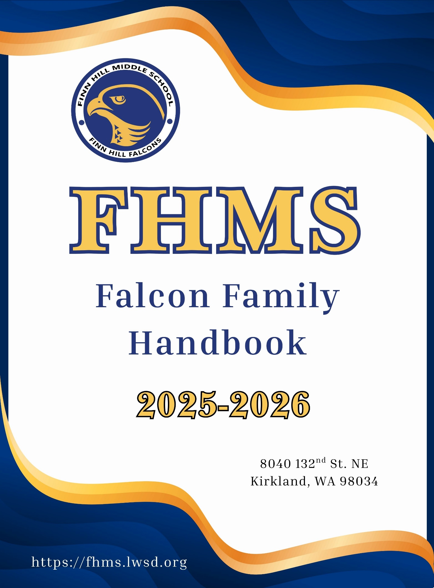



Dear Families,

Welcome to Finn Hill Middle School! At Finn Hill we are extremely proud of our school, with its caring family atmosphere and strong academic program. We feel certain that you will share in that pride. We are excited to work alongside you and your students as they learn, grow, and succeed academically, socially, and personally. Our expectations are high: we expect the very best for and from our students.

This guidebook is designed to familiarize students and parents with some of our programs, policies, and procedures at Finn Hill. Please read through this guidebook and keep it handy. It can answer questions that you might have regarding the daily operation of our school. If you don’t find the answer to your question inside, please give our office a call and we will do our best to help you.

Again, we welcome you to FHMS. We are looking forward to an outstanding year!

Sincerely,

The Staff of Finn Hill Middle School
TABLE OF CONTENTS

ACADEMIC HONESTY 5
ACCEPTBABLE USE POLICY/LAPTOP USE 5
ACCIDENTS OR ILLNESS AT SCHOOL 5
ACADEMICS 5
ACTIVITIES & CLUBS 6
AFTER SCHOOL EVENTS 6
ANIMALS 7
ARRIVAL & DISMISSAL 7
ASB 8
ASSEMBLIES 8
ATTENDANCE 8
BACKPACKS 8
BEHAVIOR EXPECTATIONS 9
BUS INFORMATION 9
CARE OF PROPERTY 9
CELL PHONES/OTHER ELECTRONIC DEVICES 9
CHANGE OF ADDRESS 9
CLOSED CAMPUS 10
CLUBS 10
COMMUNICATION 10
CONFIDENTIALITY IN COUNSELING 11
COUNSELING 11
DANCES 12
DRESS CODE 12
ELECTIVE CLASS FEES 13
EMERGENCY INFORMATION 13
EVENING ACTIVITIES 13
FALCON TIME/FLEX TIME 13
FIELD TRIPS 13
FINANCIAL ASSISTANCE 13
FOOD/DRINKS/GUM 13
FUNDRAISING 13
GRADES 14
HALL PASSES 14
HARASSMENT, INTIMIDATION, & BULLYING 14
HOMEWORK POLICY 14
ID/ASB CARDS 15
LEGAL CUSTODY & VISITATION 15
LOCKERS 15
LOST & FOUND 16
LUNCH 16
MEDICATIONS/HEALTH CONCERNS 16
MULTI-TIERED SYSTEMS OF SUPPORT (MTSS) 16
NONDISCRIMINATION POLICY 17
PANTRY PACKS 17
PARENT ORGANIZATION 17
PASSING PERIODS 17
PERSONAL DELIVERIES 17
PERSONAL PROPERTY 17
REPORTING CONCERNS 17
SAFETY AT SCHOOL 18
SCHEDULE CHANGES 18
SCHOOL CLOSURE 19
SCHOOL PAYMENT 19
SCHOOL SUPPLIES 19
SOCIAL EVENTS 19
SPORTS 19
TRANSFER/WITHDRAWAL 21
VOLUNTEERING 21
VISITORS 21
WHEELS 21
YEARBOOK 21

ACADEMIC HONESTY—Students are taught expectations regarding academic honesty by teachers and during our review of Acceptable Use Policy. Plagiarism, cheating, and stealing others’ intellectual property will result in consequences and an expectation that students demonstrate their knowledge independently.

ACCEPTABLE USE POLICY/LAPTOP USE—LWSD provides a laptop for educational use for all middle and high school students. The laptop and its charger belong to the school district. Laptops are checked out to students and may go home with students during the school year. Students are responsible for taking care of these items and using them appropriately. Students agree to follow the AUP and the Student and Staff AUP Procedure when they sign the “Laptop Agreement Form.” Students are expected to use their laptops only for academic and school related purposes. All computer use history is saved and can be reviewed by LWSD. This includes and is not limited to emails, Teams chats, and browsing history. Students with off-task laptop behavior will receive a classroom consequence and may be referred to administration.

ACCIDENTS OR ILLNESS AT SCHOOL—The school will make every effort to inform parents/guardians/families of any accident or illness occurring at school that may need care or observation at home. No student will be sent home unless a parent, guardian or emergency contact has been notified. No students will be allowed to walk home if they are leaving ill.

ACADEMICS—Academic progress is an important part of the Finn Hill experience. Here are
some reminders about how to meet and exceed expectations academically as we strive to make academic progress this year.

- Students are expected each day to bring binders, writing instruments, completed assignments, fully charged laptop, and other required materials specific to the class.
- Skyward is a great tool for students and families to stay informed about the students’ grades in each class.
- The school year is divided into four quarters. Report cards are issued after each quarter. The end of each semester is the final grade for student transcripts and for credit. We have four middle school courses that are represented on high school transcripts for credit: Spanish, WA State History, Algebra, and Geometry.
- Grades are meant to communicate what a child knows and is able to do in relation to content standards. At the middle school level, letter grades are assigned that represent students’ overall proficiency in relation to standards for the subject. These letter grades are based on a body of evidence, based on student work. Since the electronic grade book uses a numerical measuring system, a district-wide scale has been agreed upon for middle school to convert a final numerical percentage to a letter grade. This grading scale is already in Skyward.
- Grading Scale for Finn Hill Middle School
  - A grades typically mean that students are performing above standard level.
  - B+/B/B- grades typically mean that the student is at standard.
  - C+/C/C- grades typically mean that the student is approaching standard.
  - D+/D grades typically mean that a student is at risk in this subject area.
  - N=Not Passing. This means that there is not enough evidence for a grade to be assigned. The N grade replaced the F grade. N grades do not meet credit requirements.
- Additional/Modified Grading Scales
  - In addition to this grading scale, there are some other grading scales that may be used for individual students. These are S/N (Satisfactory/No Credit) grading scales and a P/N (Pass/No Credit) grading scale.
  - An Individualized Education Plan, 504, or other team meeting with parents and teachers will determine that one of these grading scales is appropriate for individual students.
  - Definitions of S, P, and N are defined in LWSD policy as:
    - S: Satisfactory- student has not met course requirements but has met objectives commensurate with ability. Parents, students, teacher, counselor, and principal should all be consulted in determining whether an "S" grade should be given.
    - P: Passing- meets minimum requirements for credit.

*Please check the class syllabus to determine what percentage grade aligns with letter grades in each class.

ACTIVITIES & CLUBS—All students are encouraged to get involved in school activities such as sports or activities. There are a variety of clubs and activities that meet before, during, and after school. Listen to the announcements for days and times of upcoming meetings.

AFTER SCHOOL EVENTS—Spectators are welcome. However, students are expected to sit in the stands in the gym/commons. Spectators and participants are to demonstrate sportsmanship; this includes refraining from making inappropriate comments to officials, opponents, and fans. Failure to do so will result in person/persons being asked to leave and not allowed to return to after school activities without approval from administration.

Once students leave the event, they are expected to leave the school grounds. Spectators waiting for the game may not wait inside the school, unless they are under the direct supervision of an adult.

Parents/guardians/families are required to pick students up within 15 minutes of any school event ending.

High School Athletic Events—For high school athletic events, middle school students must be accompanied by an adult. Students must show picture identification for events. All school behavior expectations apply at school and district events and when students visit other schools. Students are accountable for violations that occur at other district schools or at school sponsored events. All school conduct regulations remain in effect at school and at district events and apply to students when they are visitors at other schools. Students will be accountable at their home school for violations that occur at other district schools or at school-sponsored events.

ARRIVAL AND DISMISSAL—Students who arrive by car are dropped off in the front of the school. Students arriving by bus will be dropped off in an area designated for buses only. When students arrive, they should head through the gates into the courtyard and into the building. Students who are eating breakfast may go directly to the commons. The courtyard gates close at 7:50 when classes begin. After 7:50, all students are tardy, and they must be accompanied into the office by their parents and signed in. Students will receive a late pass and be sent to class.
At dismissal time, bus riders line up on the sidewalk in the bus loop by bus route. Students should refer to the bus conduct section of the LWSD Students Rights and Responsibilities for more information about expected behavior at bus stops and while riding a school bus.

Students not involved in an after-school activity (supporting or participating) will be asked to leave school grounds.

Standard School Day (M/T/Th/F)
7:30 AM Gates open to allow students into the courtyard, breakfast may be purchased
7:45 AM First bell rings-students head to class
7:50 AM Start of Period 1-late arrivals must check in at the main office for late pass
2:25 PM Dismissal (On Wednesdays dismissal is at 12:40 PM)

Pick Up/Drop Off­—If you are using the car line for drop off or pick up, please review this traffic flow diagram:

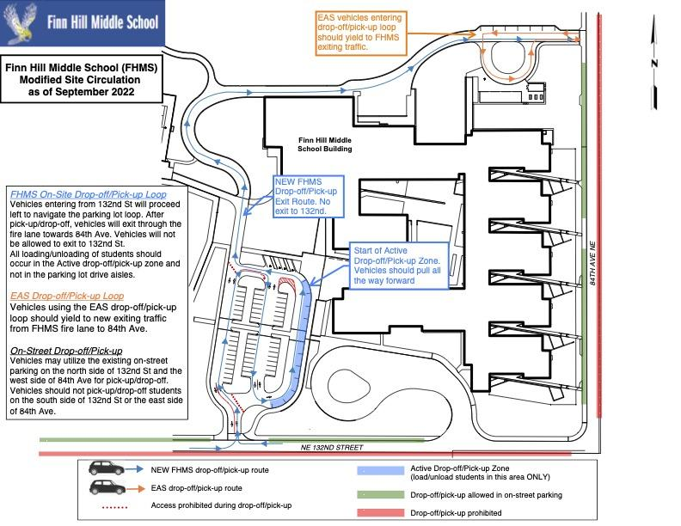
ANIMALS—Family pets may be gentle at home but unpredictable at school when confronted by many unfamiliar people and surroundings. Many students have allergies and having pets in or around the outside of building during school hours causes concern for student safety. Due to these health and safety concerns, pets may not come to school to visit. We ask that parents do not bring pets into the “busyness” of the school grounds at the beginning and end of the school day for the same reasons.

ASB—ASB stands for Associated Student Body and is the governing body of Finn Hill Middle School. Its purpose is to support cultural, athletic, recreational, and social activities at Finn Hill. All students joining after school sports, clubs, choir, orchestra, and band must be members of the ASB. The ASB membership fee is $35.00.

ASSEMBLIES—We have different types of assemblies at FHMS: spirit, informational, entertainment, and recognition assemblies. Assemblies provide opportunities to practice formal audience behavior. For all assemblies, students are expected to act in a polite and respectful manner. Students should leave notebooks, books, backpacks, coats, etc. in their classroom or locker. As always, phones should remain turned off and out of sight for the entire assembly.

ATTENDANCE

Attendance Voicemail: 425.936.2341 (leave a message in any language)

Email: FinnHillMSAttend@lwsd.org (leave a message in any language)

- Early Dismissal or appointments during school hours: Please notify the attendance office a minimum of an hour before you need your student picked up early. This allows us enough time to get the hall pass to your student, for them to collect their things and leave class, go to their locker and come to the office to meet you. You can either call the main office, the attendance voicemail, or the attendance email. Parents will need to come into the office to sign them out. Only approved emergency contacts listed in Skyward can pick students up early.

- Late Arrival: If the student is arriving to school late (the courtyard gates will be closed) parents must accompany students into the office to sign them in - this is part of our Safe Arrival Program. Please do not just drop your student off and leave.

- Absent from School All Day: Notify the school attendance office no later than the morning your child is absent. Please leave full name, date, & reason for the absence. If no reason is provided with the absence notification it will be considered unexcused. If the parent/guardian would like the absence to be considered excused, they must submit an excuse via phone or email within forty-eight hours of the student’s return to school. Per LWSD guidelines, failure to provide a valid excuse within forty-eight hours will result in the absence being marked as unexcused. [See LWSD Administrative Policies ‘Excused & Unexcused absences - 3122P’.]

- Pre-Arranged Absences: If your child will be absent three or more consecutive days, please complete a FHMS Pre-Arranged Absence Form and submit the completed form to the Attendance Office two days prior to the absence. Note that this form must be complete with all teachers’ initials/signatures and parent signature before being turned in. This form is available in the office or on the school web site.

BACKPACKS—Students may carry backpacks to classes during the school day and are the responsibility of each student. They should be stored in a safe spot when in classrooms and under tables in the lunchroom. Backpacks should be secured in a locked or monitored room when a student is not able to stay with his or her pack. Students should only carry items essential for the school day. Backpacks need to be small enough to fit under a classroom chair or under a lunch table.

BEHAVIOR EXPECTATIONS—At Finn Hill, we demonstrate Falcon PRIDE. Please see our Schoolwide Behavior Expectations Matrix for more information.

BUS INFORMATION—Buses are provided by the district to ensure students have safe transportation to and from school and school-sponsored activities if they live outside our “walk zone”. If a student lives within the “walk zone”, they will not be provided a bus by our transportation department. Bus transportation is a privilege, and students are expected to follow the rules of the bus as well as Falcon PRIDE. The driver of the bus is the adult in charge. Behavior issues on the bus may result in losing the privilege to ride the bus. Lake Washington School District transportation prohibits students riding home with other students. All students must ride the bus they are assigned to at the beginning of the year. Due to the high number of students traveling on buses, we are unable to give out any buss passes.

Bus Route information is available via Skyward. This information will include the pick up/drop off location and times.

CARE OF PROPERTY—Students are held responsible for the loss of, or damage to LWSD and/or FHMS property, including property issued to students. The decision will be the responsibility of the school or district and will be communicated to the student and family. Student discipline that involves restitution will not be the responsibility of the school or the district and will be handled directly by the families involved.

Students are also expected to care for our school grounds by staying on sidewalks, treating plants properly, and playing only in designated areas.

CELL PHONES/OTHER ELECTRONIC DEVICES—To ensure privacy and focus on learning in classrooms, students must place all cell phones, tablets, headphones, and other non-school provided electronic devices in their backpacks between 7:50 AM and 2:25 PM: as we say, “Bell to Bell, No Cell.” All devices must be powered “OFF” and out of sight during the school day (which includes lunch and passing periods). This includes phones being visible in pockets, headphones visible around the neck, AirPods in ears, etc. Phones and electronic devices may be confiscated at any time on the school campus. Students who need to call home can use the phone located in the counseling office as needed. Parents/guardians needing to contact their student, including during lunch, should call the school office at 425-936-2320. We will deliver urgent messages to students right away.
School-issued laptops are the only electronic devices that are allowed to be used at Finn Hill Middle School.

Students are not allowed to photograph or record others without their permission (including TikTok, Instagram live, and other social media platforms), and will receive consequences if they choose to do so. Publishing, sharing with others, or uploading to a media or social networking site any photograph or video taken at school or a school event without permission is prohibited.

It is strongly recommended that students leave electronic devices at home to prevent loss or distraction. Lost, misplaced or stolen electronic devices are rarely recovered. FHMS is not responsible for any electronic devices that are lost or stolen at school.

CHANGE OF ADDRESS—If your family moves, you will need to provide proof of residence to the registrar and keep your mailing address up to date.

CLOSED CAMPUS—Finn Hill Middle School is a closed campus. Once students have arrived, they may not leave school grounds without office permission. This includes in the morning and during lunch or entering campus grounds when absent without checking in at the attendance office. Leaving school grounds after arrival requires parent/guardian permission. A closed campus also means that student guests/visitors from other schools or communities are not permitted during the school day. Dances and other ASB-sponsored events are closed to non-FHMS students.

Communication—We believe that communication between school and home is vital. To support this belief, we use numerous methods to keep the flow of communication going both ways:

Email/ParentSquare
- Email and ParentSquare are great ways to communicate with teachers. All teacher e-mails can be found on our school website. In most cases, the email address for staff is firstinitiallastname@lwsd.org. This is the preferred method of contact. (example: kdahl@lwsd.org ).
- If students or parents have a question, concern, or commentary, they should reach out directly to the teacher. Most teachers are available to respond to email from 7:20 AM-3:20 PM. Please allows 48 hours for your child’s teacher to respond.
- ParentSquare is a communication platform that allows Lake Washington School District to unify all family communication from the district, schools, classrooms, and school activity groups under one umbrella.

Falcon News Update
- As a school, we send a weekly email update with important information. We call this the Falcon News Update. Please ensure that your email address is up-to-date, and you are signed up for ParentSquare so you will get this communication. The Falcon News Update is also posted on the website as soon as it is published each week.

Skyward
- Lake Washington School District has a system which allows students and parents/guardians to access student records including grades and attendance via the Internet. By registering for Parent Access, families will have access to general student information, attendance, grades, lunch account balances and volunteer applications. One log-in links parents to all students in their family.

Falcon Fest
- This night is planned early in the year to give parents an opportunity to meet their student’s teachers and see their classrooms.

Classroom Communication
- At the classroom level, teachers may send home newsletters and/or e-mails on a regular basis.

Websites
- The Finn Hill website is your first place for information. All communication and happenings are posted regularly on this site.

https://fhms.lwsd.org/

- The LWSD website is your go-to for district information.

https://www.lwsd.org/students-families/for-students-and-families

Phone
- The school phone number is 425-936-2340. It is not generally possible to contact a teacher immediately, except in an emergency. During the school day, phone calls to teachers, other than emergencies, will be transferred to voice mail.

Parent Conferences
- Parents may meet with a teacher at any time during the year upon request.

Social Media
- We’re on social media! Check us out on our public Facebook page!

Guidelines for Successful Communication
Communication between home and school means a better education for your child. Some guidelines for successful communication are:

- If you have a concern about your child and/or school, please let us know. If we are unaware of a problem, we will not be able to help remedy it. Often miscommunication is cleared up through the teacher and parent talking.
- Deal with the person most directly involved first. If your child is having a learning or social problem, talk to his/her teacher first. This is the person most familiar with your child.
- Make an appointment to see the person involved whenever possible. When making the appointment, state the nature of your concerns. This will allow the person to have any necessary materials on hand and save you unnecessary delays.
- See an administrator when you have general school concerns or if you need further resolution.

CONFIDENTIALITY IN COUNSELING— When a student indicates that he/she is thinking about hurting himself/herself or other students, school personnel are required to take action to ensure the safety of the student or other students. This action may include sharing of information with the school principal, parents, and other outside agencies.

COUNSELING—Our school counselors are here to support students with a variety of needs, resources, and guidance! Stop by the counseling center or e-mail to make an appointment to see your counselors.

Counselors:
- Provide support on academic concerns
- Support on issues relating to the health of students
- Support on bullying/harassment issues
- Support on friendship issues
- Conflict resolution
- Small group guidance
- Scheduling assistance
- Accessing resources to support student attendance including clothing, food, school supplies, and future scholarships

- Students whose last name begins with A–K: Camila Larson at clarson@lwsd.org
- Students whose name begins with L-P: Mandy Bergan at mbergan@lwsd.org
- Students whose last name begins with Q-Z: Kirstin Doughty at kdoughty@lwsd.org

If there is an emergency safety concern, please notify a teacher or other staff member right away.

Youth Eastside Services provides behavior health services, counseling, and school-based services. Our YES counselor is Matt McGaffey at c-mmcgaffey@lwsd.org

Additional Resources: We can connect you with a variety of resources to meet your needs. If your family needs help with school supplies, finding medical or housing resources, finding mental health counseling, college prep resources or anything else, please reach out to school counselors. We are here to help you find the support you need for school success!

COMMUNICATION—The school phone number is 425-936-2340. The most up-to-date school information will be on our school website (https://fhms.lwsd.org/), the reader board in front of the school, and Ms. Cleaves’ weekly Falcon Focus. Announcements are made at school to keep students up to date on what is going on at FHMS. We use ParentSquare to communicate. Please make sure your contact information and preferences for communication (immediate or in a digest form once a day) are up-to-date.

DANCES—FHMS ASB offers several all-school dances/socials throughout the year. Dances are held at the school, typically in the gym and commons. Students must follow our PRIDE expectations at all school events. Only current FHMS students are permitted to attend any Finn Hill Middle School dance-no guests are allowed to attend. All tickets are pre-sold during lunch and before school and not sold at the door. Unless a parent is present to pick up the student at the door, students are not allowed to leave the dance until the dance is over. To attend the dance, students must be at school at least one-half of the school day (defined as four classes in a row). Appropriate student conduct is expected, and discipline policies and actions are the same as those for the regular school day. The school’s dress code applies to school dances. Students are expected to be respectful and safe.
DRESS CODE—Matters of dress remain the primary concern of students in consultation with their parents. Creating an environment where all students feel safe, comfortable, and able to focus on learning is our priority. Our dress code supports that environment and applies to all genders.
Student dress shall not be regulated except in the event that a student dresses in a manner that is not conducive to the educational environment. A student’s dress or appearance may not present a health or safety hazard or create material and substantial disruption of the educational process at the school. Student dress shall not be gang related, nor may it promote illegal activities or activities that violate school regulations.

ELECTIVE CLASS FEES—The elective classes have a class fee. Students will know the elective class when the schedules are handed out. The fee cost will be in the class syllabus handed out during the first few weeks of the new school year and payment is expected to be made immediately. Fees that are not paid the 1st month of school will turn into fines. If you need any financial support, please contact ASB secretary, Rebecca Elizondo, in the main office or your student’s school counselor or teacher.

EMERGENCY INFORMATION—All addresses, phone numbers, and emergency contact information must be current at all times. Please notify the school office immediately of any changes. In an emergency, if we are not able to reach a parent or an emergency contact, we must call 911 for emergency medical care.

EVENING ACTIVTIES—To attend any evening event that requires a ticket to gain entrance, students and families must purchase tickets prior to the event. We do not sell tickets at the door. Students who are loitering on campus or not involved in an activity (supporting or participating) will be asked to leave school grounds.

FALCON TIME/FLEX TIME—Falcon Flex is a period of time twice (Tuesdays/Thursdays) per week when students can get the help and support that they need at school. Every teacher has a Flex. Students and teachers use the FlexiSched system to request attendance. Students are expected to attend Flex with one of their current teachers that they would like more time to get academic support or enrichment in this class. In some cases, Flex with a certain teacher is open to students who are not in their current class. This is communicated by the teacher that is offering the Flex.
Falcon Time is a period of time once a week (Mondays) for students to receive social emotional learning and school support. Students can get support from each other and from their teacher during this time. Falcon Time will have specific Social Emotional lessons and or FHMS specific school announcements and activities.

The Falcon Time/Flex time on Fridays is devoted to clubs, house meetings, and all school assemblies.
This period is referred to as ‘Period 10’ in Skyward for Attendance purposes.

FIELD TRIPS—Teachers may schedule field trips that enhance classroom learning. Written permission from the parent is required for a child to be allowed to go on school-sponsored field trips. When your child brings home a request for permission to go on a field trip, please see that he/she returns it promptly to the teacher. Parents cover the cost of these trips. This is in addition to any admission cost at the venue. We expect students to demonstrate Falcon PRIDE throughout the trip.

FINANCIAL ASSISTANCE—The link for information is https://www.lwsd.org/students-families/breakfast-and-lunch-menus. Please select the Free/Reduced Meals tab for the application and the information. Before filling out an application please read the information letter to see how to receive additional benefits.

FOOD/DRINKS/GUM— Food and drinks other than water are allowed to be consumed only in designated eating areas during lunch or the morning nutrition break. Accommodations will be made for students/staff per their 504/IEP/health plans. Students may chew gum as long as they do it silently and dispose of it properly. If students do not follow the no noise/no mess policy, teachers may prohibit gum chewing in their classrooms.

FUNDRAISING—Students or clubs must seek prior approval from administration before selling any items at school. The sale of any item must be approved through the ASB fundraising process. All other sales of items at school are prohibited.

GRADES—Students and families can access academic progress tracked on Skyward at any time. This can be accessed via the Lake Washington School District website at “For Student and Families.” Most teachers update grades on Skyward approximately every two weeks. Parents or students who have questions should contact the teacher. Both Quarter Progress Reports and Semester Grade Reports are available to students and families through Skyward approximately one week after the end of the quarter or semester.

HALL PASSES—Students must have an authorized pass when leaving the classroom. Students must sign out and back into class when leaving to use the restroom or get a drink of water. Written passes are required for other movement around the building during class times. Students who are in the hall during class time need to sign out, carry a hall pass, and sign back in upon return. Students without a hall pass will be asked to return to class.
HARASSMENT, INTIMIDATION, AND BULLYING—Finn Hill Middle School has an established culture of kindness, safety, and respect for every member of its community. Everyone in our school has the responsibility to make sure Finn Hill is safe and positive for all.
Our expectations include:
- Everyone is treated with respect, and no one is physically or emotionally harmed.
- Members of our school community will not be harassed because of their race, color, religion, ancestry, national origin, sex, gender, sexual orientation, including gender expression or identity, mental or physical disability, or other distinguishing characteristics.
- Anyone who observes, overhears, or otherwise witnesses harassment, intimidation, or bullying, or to whom such actions have been reported, must take prompt and appropriate action to stop the harassment and to prevent its reoccurrence by reporting it to an adult.
- Damaging another student’s property or using other student’s property without permission is not allowed. This includes accessing another student’s PE locker, backpack, laptop, or other property without permission.
- Students are asked to report any physical aggression (intentional pushing, tripping, hitting, or spitting which could be expected to cause physical injury to another person) to adults at school. Progressive discipline will ensue.

Lake Washington School District Harassment, Intimidation and Bullying (HIB) Policy defines HIB violations as severe, persistent, or pervasive behaviors that create an intimidating or threatening educational environment; or that have the effect that substantially disrupts the school learning environment. These behaviors can include but are not limited to acts intended to harm the student physically or emotionally or damage their property.
If students encounter difficulties such as bullying, harassment, or any behaviors that create discomfort for them, they should see a teacher, a counselor, or an administrator as soon as possible. Please see Harassment, Intimidation, and Bullying section of the LWSD Student Rights and Responsibilities handbook for more information https://www.lwsd.org/programs-and-services/student-services/student-rights-and-responsibilities
All incidents will be reported to an administrator for investigation. Depending on the situation and the severity of the incident, these investigations can vary from building level to formal investigations that include district-level cooperation. Students involved can be placed on an emergency removal for up to 10 days while the investigation is open.
HOMEWORK POLICY—Recognizing that our students participate in many family, faith-based, school and community activities outside of school, we strive for balance in our approach to homework. Please check the Classroom Teams Site or OneNote, or email specific teachers for their homework policies.
The following are recommended guidelines to teachers, students, and parents:

- The student is responsible for taking accurate notes, paying close attention to the explanation, and putting forth consistent effort to learn the material being presented in class.
- The student is responsible for keeping an up-to-date calendar in their Student Planner. This means tracking due dates as well as assignment completion.
- The student is responsible for seeking additional help with the presented material if he/she doesn’t thoroughly understand the task after the class explanation. Help should be sought by the following day.
- Parents who are concerned about their child’s progress or the amount of homework assigned are asked to contact the teacher.
ID/ASB CARDS—All students receive an ID card when their pictures are taken during Prep Day or Retake Day. Students who have paid the ASB fee will have the ASB sticker automatically put on the card. The first ASB/ID card is provided at no cost. Replacement cards cost $5.00 each. If your student pays the ASB fee after cards have been printed, please have your student come to the office and Mr. Morales will apply the ASB sticker to the card.

LEGAL CUSTODY AND VISITATION—Either legal parent will be allowed to visit at school unless legal documents stating otherwise are provided to the principal. Any questions regarding legal custody of students between parents should also be settled with appropriate legal documents.

LOCKERS—All students are assigned a locker. Students should keep their combinations private. Students should use only the locker that has been assigned to them (no sharing or exchanging lockers). Report difficulties with lockers to Ms. Elizondo in the main office. Lockers are school district property and can be searched at any time, without warning. Students, not the school, are responsible for all personal belongings. Leave valuable items at home. Students scheduled in PE classes will also be assigned a locker in the locker room. (This PE lock remains the property of FHMS, and if lost, a fine will be assessed).

Students may decorate the INSIDE of their lockers under the following guidelines:
Do’s:  Magnets  - Magnetic mirrors  - Sticky Tack | Don’ts  - No tape of any kind  - No contact paper  - No stickers or writing  - Nothing glued or stuck to lockers, such as mirrors or notepads

LOST AND FOUND—We generally accumulate a very large selection of lost and found items. Students are reminded to check the “Lost & Found” when an article is missing. Lost and found items are kept in the library and photos of the lost items are posted in the hallway outside of the main office. If items are labeled, every effort is made to return items to the student. To help identify personal property, we urge families to write students’ names or initials on everything they might bring to school.

Valuable items such as glasses, keys, money, wallets, jewelry, etc., are kept in a safe place in the main office. We discourage students from wearing valuable jewelry or bringing items of value and large quantities of cash to school.

Several times a year, the lost and found items are donated to a local charitable organization and notices of these occurrences are announced in the Falcon News Update.

LUNCH—Students can purchase lunch at school using an electronic cash register system. This account is accessed with the student’s Finn Hill Middle School identification card. Students are required to have their cards or cash to receive school lunch. All payments must go directly through Nutrition Services. Families can either pay at the commons (cafeteria) or online through LWSD web site>Student & Families>For Student & Families>MySchoolBucks. The cost for breakfast is $2.50 and lunches are $4.00 for middle school students.

Students may not utilize food delivery service for lunch such as Uber Eats, pizza, etc. We request that parents do not bring fast food from Taco Bell, McDonald’s, etc. to school to eat with their children or share with students in the commons. This is difficult for the other children who do not have this opportunity. Sandwiches from Jimmy Johns or Subway don’t seem to have the same effect on other kids, so they are fine for parents to bring. If you would like to bring a special lunch for your student, please let us know in advance, and we are happy to reserve the conference room for you to enjoy eating with your child.

MEDICATIONS/HEALTH CONCERNS—If your child will be taking medications (to include nutritional supplements or homeopathic/herbal remedies) during the school day or has any significant health concerns we need to be aware of, please email our school nurse, Karen Walker (karwalker@lwsd.org) or call the office at 425-936-2340.

There are specific guidelines for medication at school. The LWSD medication policy can be found on page A14 in the Student Rights and Responsibilities. The Health Forms on Skyward should be updated regularly by parents/guardians.

If a student has sustained a minor injury at school, basic first aid, such as a band-aid, is available in the health room. Other equipment, such as an ice pack, can be checked out to a student. The health room is intended to help students return to class quickly or serve as a care facility until they are picked up to go home. Students are only permitted to stay in the health room for approximately ten minutes unless there is a serious injury or illness that requires parent/guardian assistance.

MULTI-TIERED SYSTEMS OF SUPPORT (MTSS)—MTSS is an intervention framework that promotes a well-integrated system connecting general, gifted, and special education in providing high quality, standards-based instruction and intervention that is matched to students’ academic, social-emotional, and behavioral needs. To intervene, we use screening, problem solving, progress monitoring, evaluation, and targeted and intensive individualized supports that are based on data and incorporate evidence-based instructional and behavioral support strategies. The ultimate purpose of MTSS is to enhance the success of students with a variety of academic and/or behavioral needs.

NONDISCRIMINATION POLICY—The Lake Washington School District #414 complies with all federal rules and regulations and doesn’t discriminate on the basis of race, color, national origin, sex, or handicap. This holds true for all students who are interested in participating in educational programs and/or extracurricular school activities. Inquiries regarding compliance procedures may be directed to Personnel Office, Title IX Officers P.O. 97039, Redmond, WA 9807349739, telephone number (425) 702-3200.

PANTRY PACKS—Hopelink is an organization that provides free snacks and meal options for the weekends. Students can pick up pantry-packs from the counseling office on Friday afternoons. Talk to a counselor for more information.

PARENT ORGANIZATION—The Finn Hill Parent-Teacher-Student Association (PTSA) is a chapter of the Lake Washington PTA, Washington state PTA, and National PTA. Its purpose is to promote positive relationships between our parents, students, and staff, sponsor school events, and raise funds for school projects. An elected board governs PTSA.

PTSA general membership meetings will be listed on our website as well as the FHMS PTSA’s website. All are invited and encouraged to attend!

PASSING PERIODS—Passing periods are five minutes long. Students are expected to use this time to get a drink from the drinking fountain and use the restroom.

PERSONAL DELIVERIES—Please do not have balloons, flowers, or gifts of any kind sent to the school for your children on their birthday or for other occasions, including Valentine’s Day. We will not be able to deliver them to the students. If these items are at school or delivered during the school day, they will be held in the main office during school hours until they can be picked up at the end of the school day.

PERSONAL PROPERTY—Finn Hill Middle School strongly advises that students bring to school only those items which are necessary and essential for learning. Any item that can create disruption or detract from an orderly school environment should be left at home. Nuisance items that are brought to school and interfere with the educational process will be confiscated and may be searched. Personal property brought to school is the responsibility of each student; FHMS cannot be held responsible for damage to or loss of items brought to school which are unnecessary to the learning process
REPORTING CONCERNS—At FHMS, safety is very important. We expect that all FHMS community members be upstanders by reporting any unsafe behavior to an adult at school that they trust such as a teacher, administrator, counselor, or other staff member. Students can come to the main office and ask to speak to anyone available about safety concerns.
Parents/guardians should email or call the principal or other administrators with concerns. Jeremy Barrie is Finn Hill’s School Safety and Prevention Specialist. He is another great resource to talk to if you have any concerns about the safety on campus or any other security related concerns.

Anyone who is a bystander and does not report, could be considered a contributor to unsafe behavior. Videoing of unsafe/unkind behavior without reporting is considered contributing to the likelihood that this behavior continues and could disrupt the learning environment.

Safe Schools Alert is our district’s tip reporting system allows students, staff, and parents to submit safety concerns to our school administrators in different ways: Phone: (425) 529-5763
Email: 1342@alert1.us Web: http://1342.alert1.us Text: Text your tip to (425) 529-5763

SAFETY AT SCHOOL—We welcome visitors to Finn Hill, and we want our students and staff to be safe. All doors are kept locked during the school day. The front door has a video camera on it with a buzzer that rings into the office. An office staff member will speak to everyone through the intercom and ask them to identify themselves and their purpose for the visit. Then they will be buzzed in and will report to the office to check in.

To ensure that we know who is always in the building, we require everyone entering the building during the day to use the front door, check in at the office, and wear a visitor badge during their visit.
Please do not seek access at any other door. When staff members are unsure of the identity of a visitor, we will ask for identification.

Finn Hill has emergency plans for fire, natural disasters, and unwanted intruders. Drills are conducted regularly so that students will know what to do in an emergency. Quiet, orderly behavior is expected during all drills.

To prepare for emergency situations, students should memorize their parent/guardian contact information. Families should create detailed family emergency/communication plans. Parents and guardians should make sure all contact information, emergency contacts, names of who is allowed to pick up your child, health information, etc. is up to date at school in Skyward.

SCHEDULE CHANGES—Classes at Finn Hill Middle School last either a semester or are full-year courses. To provide the optimal learning environment for students, schedule changes for the current semester are not permitted unless the following process is used:

- The student will arrange a meeting with the teacher, discuss his/her concerns, and attempt a mutual resolution over a reasonable period of time. Conferences are best scheduled in advance and held before or after school.
- The student or their parent/guardian may make arrangements for a conference with the teacher. The student’s counselor may attend the conference. The objective is to clarify and resolve the problem while the student remains in class.
- If, after the parent/teacher conference, it is in the student’s best interest to change teachers, the student or his/her parent will contact the counselor to process a schedule change.
- If, after the parent/teacher conference, the parent still supports a schedule change, but the teacher does not support the change, the issue will be deferred to the assistant principal. The assistant principal may schedule a meeting to include the assistant principal, parent, student, teacher, and counselor.
- Following the meeting, the assistant principal will grant, postpone, or deny the request.
The entire schedule change process is dependent upon availability of courses.

SCHOOL CLOSURE—In case of special circumstances such as inclement weather or emergencies, school may be closed by the district. If this occurs it will be announced starting at 5:30 am on local AM radio stations such as KOMO 1000, or KIRO 710, and TV stations such as KOMO Ch. 4, KING Ch. 5, and KIRO Ch. 7. You should receive communication from ParentSquare, and you can check on the district web site at www.lwsd.org.

SCHOOL PAYMENTS—Payments made at school will be at the cash register window located immediately inside the main hallway as you enter the school. The payment window will open at 7:30 AM until the bell rings for class at 7:45 AM. The payment window will also be open during your student’s lunch.

PLEASE NOTE:
1-The payment window will close after all lunches and students cannot pay for anything after school.
2-Breakfast/lunch accounts are processed only through Nutrition Services.

You may also pay for items online by going to lwsd.org>Students & Families>For Student & Families. You will be taken to the next page where you will select the ONLINE PAYMENTS button and follow the instructions.

SCHOOL SUPPLIES—Click this link for the supply list. Note that some classes may require additional supplies. Check your student’s syllabi for more information. While it will be helpful for students to have a bag to carry around personal items and some very basic supplies like a folder and writing utensil, students do not need to bring all their supplies from the supply list until Monday, September 9.

SOCIAL EVENTS—Social events including after school dances and movie nights are sponsored by the ASB for the student body of FHMS; only FHMS students are permitted to attend school social events. Students must attend four periods of the day to be eligible for dances. Students must purchase tickets prior to the event as announced. No tickets are sold at the door for any reason. Students may not leave the event until it is over unless parent/guardian is present to pick up the student. Appropriate student conduct is expected, and discipline policies/actions are the same as those for the regular school day.

SPORTS—We have three sports seasons. If your student wants to play a sport, they must be a member of ASB, have an updated sport physical and pay the sports fee, and they cannot have any failing grades (Ns). Registration will open for each sport approximately two weeks before the start of the season. Completed physicals can be submitted at any time to Ms. Elizondo; however, we recommend getting them done as soon as possible.

All sports registration and fees must be done online through the LWSD website>Student & Families>For Student & Families>Athletics & Final Forms. To pay the sports fees payments you select the Online School Payments Button that is on the same page as Final Forms. The cost for ASB is $35.00 and the sports fee is $125.00. There is a way to qualify for the sports fees to be waived if you qualify for free and reduced lunch. There is also an option to play intramural sports in between some of the seasons that allow students to compete against other students at Finn Hill. This will be a great opportunity for students to meet new people and play sports in a more relaxed environment.
According to district policy, sports practices are closed to observers; however, spectators are welcome to attend games.

For more information, contact our Athletic Director Luke Weaver at lweaver@lwsd.org or our ASB & Athletic Secretary Rebecca Elizondo at relizondo@lwsd.org. You can also call the main office at 425-936-2340.
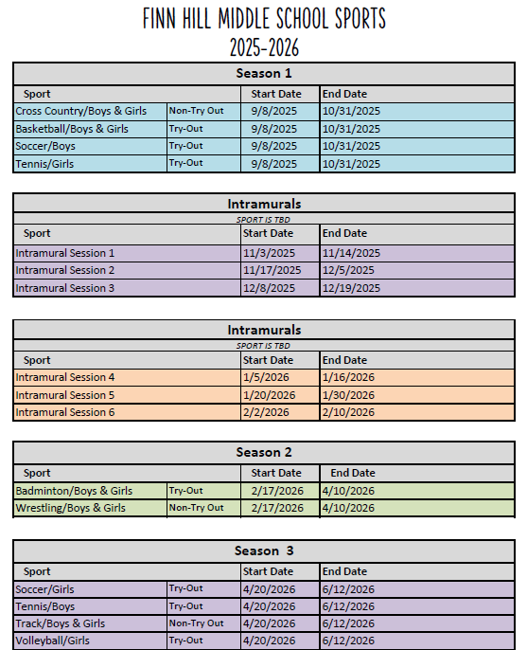
TRANSFER/WITHDRAWAL—Please let us know if you move out of our boundaries, as your child will need to transfer to his/her new school. There is a withdrawal form that requires a parent’s signature. It is important that your child returns all school-owned books and materials and closes out any lunch account. We will release records to your child's new school once all materials have been returned or paid for.

VOLUNTEERING— Please consider volunteering at Finn Hill Middle School! You can volunteer by going to the LWSD website and clicking on “Get Involved” at the top of the main page and selecting “Volunteer Programs.” All volunteers should complete a volunteer application and be approved before they can begin volunteering. (https://www.lwsd.org/get-involved/volunteering-in-lwsd)

VISITORS—Parents and other visitors to FHMS are very welcome at school. All visitors to Finn Hill are required to report to the main office upon arrival. All adults within the building must visually display an employee or guest badge. Students not attending Finn Hill are not permitted as guests during the school day.

Parents wishing to visit their student’s classroom should make arrangements with the teacher in advance. Usually 24 hours notice is required.

Juanita High School students can visit teachers by appointment and after school.

WHEELS—If students ride a bike or scooter to school, they must obey all safety/traffic rules, wear a helmet, dismount once they reach school property, walk their wheels on the sidewalk to the bike rack, and provide their own lock. Please park and lock bikes/scooters immediately upon arriving at school. FHMS is not responsible for damage or loss to student property, including bikes or scooters. No skateboards, roller skates, roller blades, “Heelys,” or other wheeled items are to be on campus at any time; we have no secure area to store these items, and they can be a safety risk for students.

YEARBOOK—Finn Hill produces a yearbook, which includes student pictures as well as pictures of school events. The yearbook may be ordered in advance and will be available at the end of the year. The cost is $35. You can purchase online as early as Prep Day by going to lwsd.org>Students and Families>For Students and Families which will take you to another page. Select the online payments button and follow the instructions. Students can also purchase yearbooks at the cash register window before school or during their lunches.

