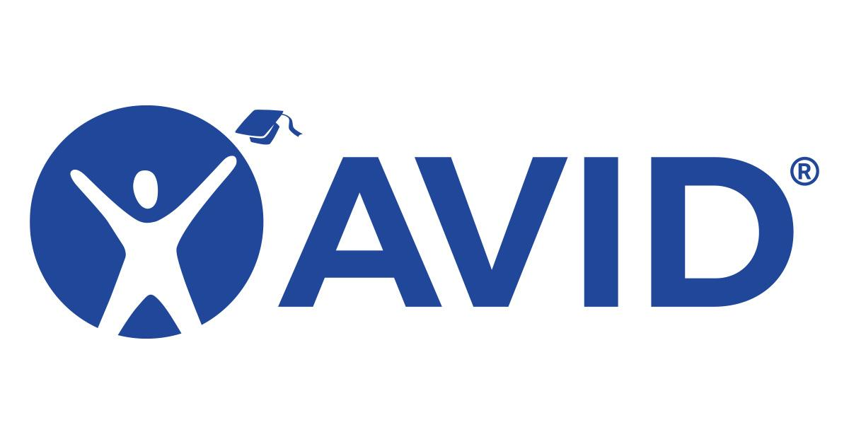
Isbell AVID Site Team Meeting Minutes
Thursday, September 4, 2025

Attendees: Mark Lopez, Angela Hicks, Sydney Gomez, Mark Robertson, Maria Ortiz, Shauna Catalano, Zecariah Murray, Darren Hicks

Funding
- No information on Tutors yet or funding for field trips.

Collaboration with SPHS
- Shooting for a date in November. (18 or 19)

AVID Weekly
- Lopez contacted AVID Center. No Contract Yet. District is working on It.

AVID Trainings
- San Diego Summer Institute was discussed & AVID strategies will be shared with all staff during professional development.
- AVID information for staff will be posted on Isbell AVID website.

Professional Development Presentation
- Site Team discussed that Lopez, Murray, & Robertson will present to staff a recap of AVID Summer Institute, Isbell’s AVID Goals, & the next steps for AVID schoolwide.

Survey Creations
- Lopez will remind Judith Thiellemann to create a parent survey on student organization improvement.
- Angela Hicks will add a teacher sign off line on the next grade check form.

AVID Goals One Pager
- Was loaded up to Isbell Website under AVID tab.

Parent Academy
- There will be a focus on AVID students for the Parent Academy. Hopefully AVID students will be able to increase the attendance number of parents.

