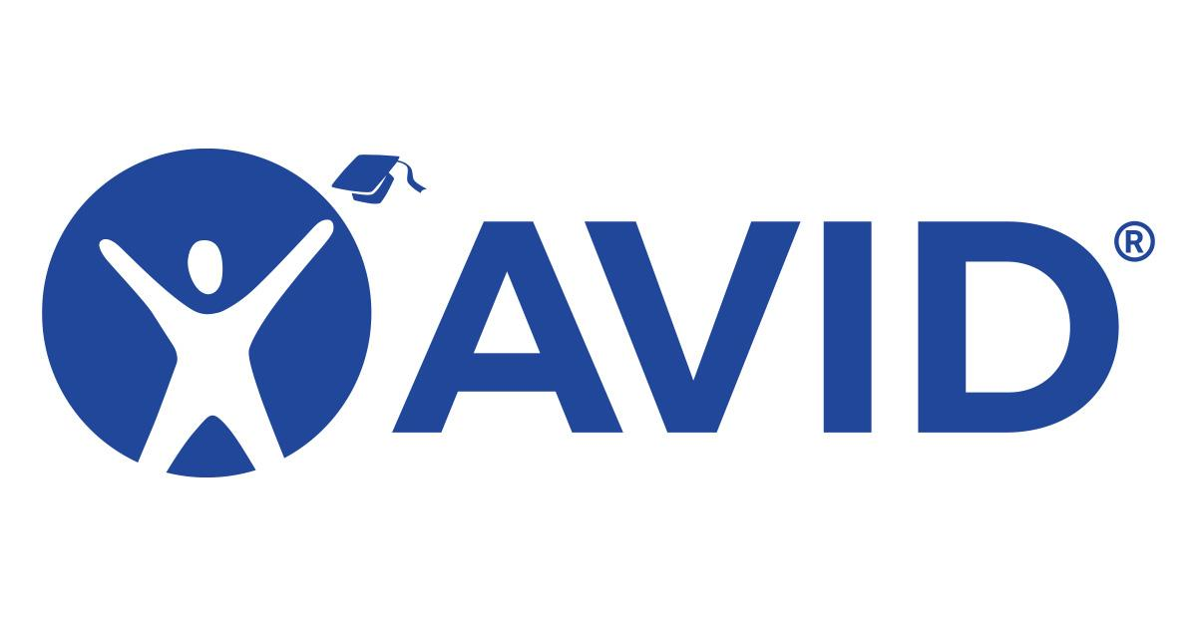
Isbell AVID Site Team Meeting
Thursday, September 4, 2025

Attendees: Mark Lopez, Angela Hicks, Sydney Gomez, Mark Robertson, Maria Ortiz,Shauna Catalano, Zecariah Murray, Darren Hicks

1.) Funding (Will need to talk to Melissa once she takes her new role)
- Tutors - do we have any? Is there funding? Timeline when we will receive them?
- Field Trips-? Do we have buses? Will we take vans? Will we need drivers?

2.) Collaboration with SPHS (They are meeting to discuss this week)
- Shooting for a date in November. (18 or 19) (Last year wind event forced date move)
- 9:42 am to 11:48 am (8th Grade - Period 2 to Period 4) (7th Grade - Period 2 to Period 5)
- 7th Graders will eat lunch with 8th graders

3.) AVID Weekly (No Contract Yet-District Working on It)
- Anyone at Isbell who wants access can have access
- Lopez will send out an email informing staff that they can have access to it.
- We can start with the AVID Site Team.

4.) AVID Trainings
- San Diego Summer Institute
  - We had 10 attendees who learned AVID strategies & how to implement them in their everyday curriculum.
- Isbell Website will post when other AVID Trainings occur & e-mail will be sent to all staff.

5.) Professional Development Presentation
- Murray/Robertson - Philosophical Chairs / Lenses with student examples
- Lopez/Gomez - WICOR / Organizational Strategies (Binder & Planner)
  - WICOR Survey for Staff (Lopez)

6.) Survey Creations
- Parent Survey if student organization improves (Thiellemann)
- Grade Check Form (Angie)
    - Did it have a Teacher sign off area?

7.) AVID Goals One Pager

8.) Parent Academy
- AVID students will be the focus of Parent Academy in hopes of bringing numbers up!

Next meeting: Tuesday, October 21, 2025 @ 7:15 AM

-Send out Rosters today to everyone!

