The Ashland City School District Board of Education met for the Regular Meeting on Monday, December 16, 2024 at Ashland City School District Central Office, 1407 Claremont Ave., Ashland, Ohio. John Teevan, Board President called the meeting to order at 5:30 p.m.

I. ROLL CALL., Mrs. Pam Mowry, Mr. Tom Hart, , and Mr. John Teevan were present. Mrs. Gina Deppert and Mr. Greg Summers were absent.

*At this time , we would like to observe a moment of silence for longtime Ashland High School freshman basketball coach, Tom Carver, who passed away on Sunday, December 8th.

II. PLEDGE OF ALLEGIANCE – The Pledge of Allegiance was led by Ashland Middle School Students, Eric Boone and Milo McDonald.

III. APPROVAL OF AGENDA 2024-12-119 Mrs. Mowry motioned; second by Mr. Hart to approve the agenda as presented. Motion carried 3-0.

IV. COMMENTS/QUESTIONS – (On agenda items only)

A. Public

**Mr. Summers joined the meeting**

V. SUPERINTENDENT’S REPORT

- Recognition of:
- Students of the Month
AHS – Wendy Robinson 9th Grade
Cole May 10th Grade
Shaswatt Iswarya (Ishu) Sakthivel 11th Grade
Adria Brock 12th Grade

AMS – Eric Boone 6th Grade
Milo McDonald 8th Grade

Taft – Jonathan Russell 5th Grade – Mrs. Burgett
- Mrs. Baughman
- Mr. Beck
- Ms. Harley

Edison – Rosie Watson 2nd Grade – Mrs. Harlan

Reagan – Hudson Young Kindergarten – Mrs. Ediger

- Support Staff Member of the Month – Rhonda Carey

- Certified Staff Member of the Month – Flory Mauriocourt

- Two-hour Early Release for Students–Friday, December 20, 2024
      - AHS 12:35 p.m.
      - AMS 12:35 p.m.
      - Edison 1:20 p.m.
      - Reagan 1:20 p.m.
      - Taft 1:25 p.m.

- Senior Citizen’s Christmas Luncheon Debrief
D. Tri-County ESC Business Advisory Council Consortium Update

E. Lincoln Property

F. Out-of-State Field Trips
- World Culture Trip – June 9-19, 2025 – Ireland, Scotland, Whales and England

- Spanish and/or Life Science – March 28 -April 7, 2026 – Ecuador and the Galapagos Islands

G. Organizational Meeting – Monday, January 6, 2025 at 5:30 p.m. in the Little Theater at Ashland High School

H. Reconfiguration and State of the Schools Address – Wednesday, January 22, 2025 at 7:00 p.m. at Archer Auditorium

- Arrow Dynamics – AHS Choir and Abby Helbling
VI. FINANCIAL/BUSINESS REPORT

A. Treasurer’s Consent Calendar 2024-12-120 Mrs. Mowry motioned; second by Mr. Summers to approve the Treasurer’s Consent Calendar. Motion carried 4-0.

Note: Items under the Treasurer’s Consent Calendar are considered routine and will be enacted under one motion. There will be no separate discussion of these items prior to the time the Board votes unless a Board member requests an item be clarified or removed from the calendar for separate action.

The Treasurer recommends the following actions:

1. Financial Report

Approval of the Financial Reports (November 2024) as presented.

2. Minutes

Approval of the minutes of the following Board meeting(s) as presented by the Treasurer:

Regular Meeting November 25, 2024

3. Approve the transfer of funds from the General Fund (001) to the Severance Reserve Fund (035) in the amount of $73,880.39

4. Approve the transfer of funds from the General Fund (001) to the Ohio K12 School Safety Grant fund (599-9023)in the amount of $11,324.39

5. The Treasurer recommends approval of the following contracts (EXHIBIT A):

Mid-Ohio ESC Mental Health and Wellness Consulting FY25 $18,000.00
Swank K-12 Streaming and Licensing FY25-FY26 $7,574.00

VII. NEW BUSINESS

A. Superintendent’s Consent Calendar 2024-12-121 Mr. Hart motioned; second by Mr. Summers to approve the Consent Calendar. Motion carried 4-0.

Note: Items under the consent calendar are considered routine and will be enacted under one motion. There will be no separate discussion of these items prior to the time the Board votes unless a Board member requests an item be clarified or removed from the calendar for separate action.

The Superintendent recommends the following actions:

- Certificated/Licensed Personnel

Approve the personnel and/or contract recommendations detailed in the exhibit items listed below as per the dates, terms and other applicable conditions specified and pending completion of all state, local and district requirements.

a. Supplemental Duty Contract for the 2024-2025 School Year (EXHIBIT B)

b. Substitute Teachers/Home Instructors for the 2024-2025 School Year (EXHIBIT B)

c. Live Streaming/Event Technician (EXHIBIT B)

2. Support Staff

Approve the personnel and/or contract recommendations detailed in the exhibit items listed below as per the dates, terms and other applicable conditions specified and pending completion of all state, local and district requirements.

a. Classified New Hire (EXHIBIT C)

b. Classified Transfers (EXHIBIT C)

c. Classified Resignation (EXHIBIT C)

d. Classified Substitutes for the 2024-2025 School Year (EXHIBIT C)

3. Program/Other

B. State Testing Resolution 2024-12-122 Mrs. Mowry motioned; second by Mr. Hart to approve the Superintendent’s recommendation of a Resolution to administer paper and pencil test forms for the Grade 3 ELA and Mathematics State Testing. (EXHIBIT D) Motion carried 4-0.

- 2025-2026 School Calendar 2024-12-123 Mrs. Mowry motioned; second by Mr. Hart to approve the Superintendent’s recommendation of the 2025-2026 school calendar. (EXHIBI E) Motion carried 4-0.
D. ACTA Memorandum of Understanding 2024-12-124 Mr. Hart motioned; second by Mr. Summers to approve the Superintendent’s recommendation of a Memorandum of Understanding with ACTA. Motion carried 4-0

- Operating Standards for the Education of Children with Disabilities 2024-12-125 Mrs. Mowry motioned; second by Mr. Summers to approve the Superintendent’s recommendation of the Operating Standards for the Education of Children with Disabilities per the updates from the Department of Education and Workforce to be compliant (policy updates will be reflected on the Ashland City School District website). Motion carried 4-0.
F. Seve- Semester Graduate 2024-12-126 Mr. Summers motioned; second by Mrs. Mowry to approve the Superintendent’s recommendation of the following seven-semester graduate of Ashland High School, having met all credit requirements:
Beck Hixon Zoe Mullet Kale Robinson

G. President Pro-Tempore for Organizational Meeting 2024-12-127 Mrs. Mowry motioned; second by Mr. Hart to approve Mr. John Teevan to act as President Pro-Tempore at the Ashland City School District Board of Education Organizational Meeting. Motion carried 4-0.

H. Policy 2024-12-128 Mr. Summers motioned; second by Mr. Hart to approve the Superintendent’s recommendation of the following policies for the Ashland City School Board of Education:

- 0100 Definitions (Revised)
- 0142.1 Oath (Revised)
- 0151 Organizational Meeting (Revised)
- 0152 Officers (Revised)
- 0155 Committees (Technical Correction)
- 0163 Presiding Officer (Technical Correction)
- 0164 Notice of Meetings (Revised)
- 0165 Board Meetings (New)
- 0165.1 Regular Meetings (Rescind)
- 0165.2 Special Meetings (Rescind)
- 0166 Agendas (New)
- 0167.2 Executive Session (Renumbered)
- 0167.7 Use of Personal Communication Devices (Renumbered/Revised)
- 0173 Board Officers (Rescind)
- 4120.08 Employment of Personnel for Co-Curricular/Extra Curricular Activities (Revised)
- 4121 Criminal History Record Check (Revised)
- 5131 Student Transfers (Revised)
- 5136 Personal Communication Devices (Revised)
- 5200 Attendance (Revised)
- 5500 Student Conduct (Revised)
- 5780 Student/Parent Rights (Revised)
- 6320 Purchasing and Bidding (Revised)
- 6460 Vendor Relations (Revised)
- 7530.01v1 Cellular Telephone Allowance (Revised)
- 7530.01v2 Board Owned Technology Resources Used for Communication (Revised)
- 7530.02 Staff Use of Personal Communication Devices (Revised)
- 7540.03 Student Technology Acceptable Use and Safety (Revised)
- 7540.04 Staff Technology Acceptable Use and Safety (Revised)
- 7540.09 Artificial Intelligence (“AI”) (New)
- 8310 Public Records (Revised)
- 9160 Public Attendance at School Events (Revised)
- 1130 Conflict of Interest (Revised)
- 3113 Conflict of Interest (Revised)
- 4113 Conflict of Interest (Revised)
- 6110 Grant Funds (Revised)
- 6111 Internal Controls (Revised)
- 6112 Cash Management of Grants (Revised)
- 6114 Cost Principles – Spending Federal Funds (Revised)
- 6325 Procurement – Federal Grants/Funds (Revised)
- 6550 Travel Payment and Reimbursement/Relocation Costs (Revised)
- 7310 Disposition of Surplus Property (Revised)
- 7450 Property Inventory (Revised)

VIII. COMMENTS/QUESTIONS – (On agenda and non-agenda items)

A. Public

B. Board Members

IX. EXECUTIVE SESSION 2024-12-129 Mr. Hart motioned; second by Mr. Summers to enter Executive Session. Motion carried 4-0

Whereas, as a public board of education may hold an executive session only after a majority of a quorum of this board determines by a roll call vote to hold such a session and only at a regular or special meeting for the sole purpose of the consideration of any of the following matters:

A. To consider one or more, as applicable, of the check marked items with respect to a public employee or official:
1. _ _ _ Appointment.
2. _ Employment
3. ____ Dismissal
4. ____ Discipline
5. ____ Promotion
6. ____ Demotion
7. _ _ Compensation
8. ____ Investigation of charges/complaints (unless public hearing requested).

B. To consider the purchase of property for the public purposes or for the sale of property at competitive bidding.

C. Conferences with an attorney for the public body concerning disputes involving the public body that are the subject of pending or imminent court action.

D. Preparing for, conducting, or reviewing negotiations or bargaining sessions with public employees concerning their compensation or other terms and conditions of their employment.

- Matters required to be kept confidential by federal law or rules or state statutes.

F. Specialized details of security arrangements where disclosure of the matters discussed might reveal information that could be used for the purpose of committing or avoid prosecution for a violation of the law.

Now, therefore, be it resolved, that the Ashland City School Board of Education, by a majority of the quorum present at this meeting, does hereby declare its intention to hold an executive session on item(s) B, D as listed above.

Entered Executive Session at 6:22 p.m.
Executive Session Ended at 7:53 p.m.

X. ADJOURNMENT 2024-12-130 Mr. Teevan motioned; second by Mrs. Mowry to adjourn the December 16, 2024 regular meeting. Motion carried 5-0.

Meeting adjourned 7:53 p.m.

Certificate Section 5705.412, Revised Code

It is hereby certified that the Ashland City School District Board of Education, Ashland County, Ohio, has sufficient funds to meet the contract agreement, obligation, payment or expenditure for the above, and has in effect for the remainder of the fiscal year and succeeding fiscal year the authorization to levy taxes which, when combined with the estimated revenue from all other sources available to the district at the time of certification, are sufficient to provide operating revenues necessary to enable the district to operate an adequate educational program on all days set forth in its adopted school calendar for the current fiscal year and for a number of days in the succeeding fiscal year equal to the number of days instruction was or is scheduled for the current fiscal year.

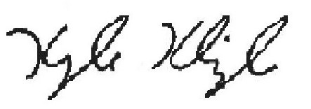
12/16/24 ___________________________________________
Treasurer

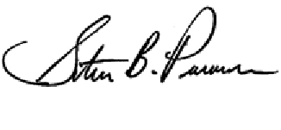
Superintendent of Schools
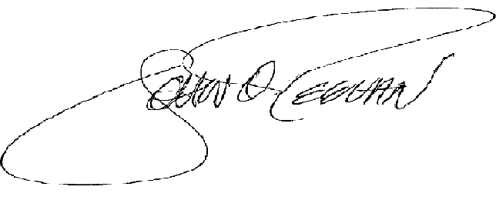

President Board of Education

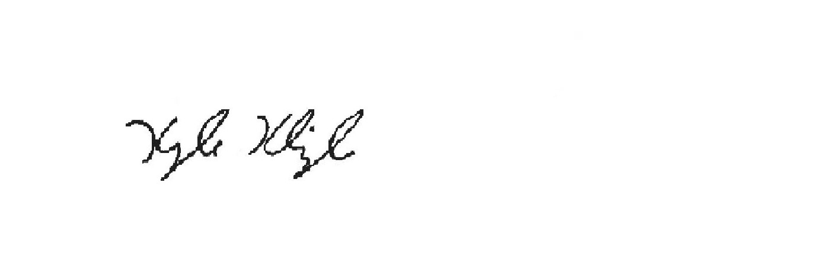
_______________________________ _____________________________
John Teevan, Board President Kyle Klingler, Treasurer

IMPORTANT DATES
NO DECEMBER WORK SESSION
January 6, 2025 Organizational Meeting AHS Little Theater 5:30 p.m.
January 22, 2025 Reconfiguration and State Archer Auditorium 7:00 p.m.
of the School Address
January 27, 2025 Regular Board Meeting Adm Offices 5:30 p.m.
February 10, 2025 Work Session Adm Offices 5:30 p.m.
February 24, 2025 Regular Board Meeting Adm Offices 5:30 p.m.

