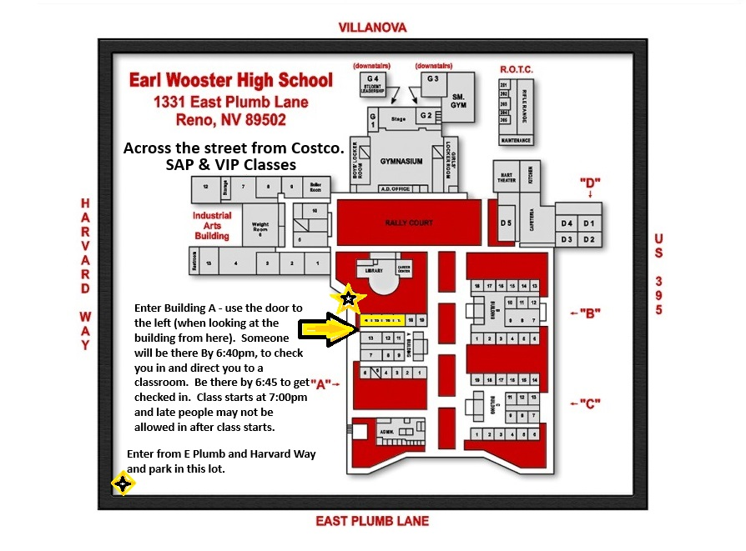
Substance Abuse Prevention (SAP) & Violence Intervention Program (VIP) Classes
SAP – Tuesdays, check in at 6:45 pm
VIP – Thursdays, check in at 6:45 pm
Wooster High School, Building A – Please see the map above for details.

*No classes when there was no school that day (holidays, school breaks, weather closures). See schedule on the Counseling Department website.

