General Fund Resolution
Resolution for Adoption by the Board of Education
Public Schools of the City of Ann Arbor
General Fund 2024-2025 Proposed Amended Budget, Adopted June 25, 2025

RESOLVED, that this resolution shall be the General Appropriations of the General Fund for the Public Schools of the City of Ann Arbor for the fiscal year 2024-2025.

A RESOLUTION to make appropriations; to provide for the expenditure of the appropriations; and to provide for the disposition of all income received by the Public Schools of the City of Ann Arbor.

BE IT FURTHER RESOLVED, that the total revenues and unappropriated fund balance estimated to be available for appropriations in the GENERAL FUND of the Public Schools of the City of Ann Arbor for the fiscal year 2024-2025 is as follows:

REVENUE

Local Sources | $ 111,746,079
State Sources | 150,201,472
Federal Sources | 10,954,833
Interdistrict Sources | 44,290,521
TOTAL REVENUE AND INCOMING TRANSFERS | $ 317,192,905
FUND BALANCE AS OF JULY 1, 2024 | 7,142,192
TOTAL AMOUNT AVAILABLE TO APPROPRIATE | $ 324,335,097
BE IT FURTHER RESOLVED, that $306,359,914 of the total available to appropriate in the
GENERAL FUND is hereby appropriated in the amounts and for the purposes set forth below:

EXPENDITURES and TRANSFERS

Basic Programs | $ 142,391,870
Added Needs | 40,456,520
Adult & Continuing Education | 348,918
Pupil Support Services | 35,760,932
Instructional Staff Services Support | 15,432,689
General Administration | 3,435,906
School Administration | 16,756,263
Business Services | 3,137,771
Operations & Maintenance | 23,847,038
Transportation | 10,632,864
Central Support Services | 8,269,028
Athletics | 4,487,694
Community Services  Other Financing Uses | 1,034,571  367,850
EXPENDITURES TOTAL | $ 306,359,914
FUND BALANCE | 17,975,183
FUND BALANCE AT JUNE 30, 2025 (Projected) | 17,975,183
TOTAL APPROPRIATED | $ 324,335,097

BE IT FURTHER RESOLVED, that no Board of Education member or employee of the school district shall expend any funds or obligate the expenditure of any funds except pursuant to appropriations made by the Board of Education and in keeping with the budgetary policy statement hitherto adopted by the Board. Changes in the amount appropriated by the Board shall require approval by the Board.

BE IT FURTHER RESOLVED, that, for purposes of meeting the needs of the school district, the Superintendent or his/her designee is permitted to implement adjustments and/or transfers within line items of the budget adopted by the Board subject to later authorization of the Board of Education. When the Superintendent and Assistant Superintendent make a transfer of appropriations as permitted by this resolution, all such adjustments and/or transfers which alter the budget at the function level shall be reported on a regular basis to the Board at a scheduled meeting. Authorization for such adjustments and/or transfers shall be included in the Budget Amendments of the General Appropriations Act, as needed.

BE IT FURTHER RESOLVED, that the Superintendent and Assistant Superintendent for Finance and Operations are hereby charged with general supervision of the execution of the Budget adopted by the Board and shall hold the department heads responsible for performance of their responsibilities within the amounts appropriated by the Board of Education and in keeping with the budgetary policy statement hitherto adopted by the Board.

This appropriation resolution is to take immediate effect.

On the motion of Trustee Schmidt and seconded by Trustee Wilks, the above Resolution was presented to the Board of Education.

AYES: 7 NAYS: 0 ABSENT: 0

RESOLUTION DECLARED: ADOPTED

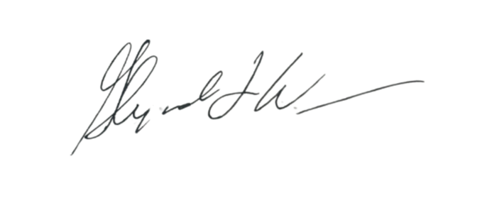
I, the undersigned, Secretary of the Board of Education of the Public Schools of the City of Ann Arbor, do certify that the foregoing is a conforming copy of the Resolution adopted by the said Board of Education at a regular meeting on June 25, 2025, Ann Arbor, Michigan.

Board of Education Secretary
DATE: June 26, 2025 CITY OF ANN ARBOR
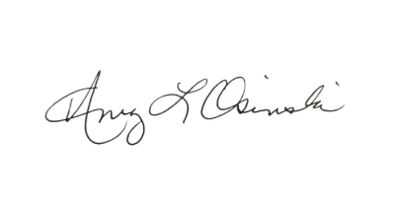
COUNTY OF WASHTENAW STATE OF MICHIGAN

NOTARY

