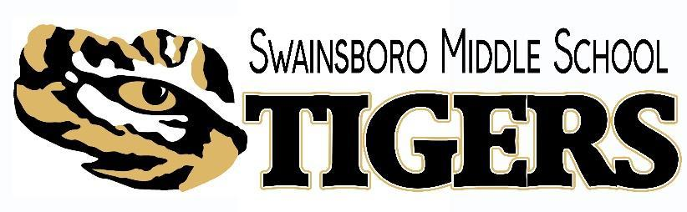
2025-2026
School-Parent Compact

Please review this School-Parent Compact with your child. This School-Parent Compact will be discussed with you throughout the year at different school-family events as we work together to help your child succeed in school.

Please sign and date below to acknowledge that you have read, received, and agree to this School-Parent Compact. Once signed, please return the form to your child’s teacher. We look forward to our school-parent partnership.

Teacher Signature: ___________________________________________ Date: ___________

Parent/Guardian Signature: ____________________________________ Date: ___________

Student Signature: ____________________________________________ Date: ___________

We, the administrative staff of Swainsboro Middle School, pledge our support in the implementation of this compact.

Principal: ____________________________________________________

Assistant Principal: ____________________________________________

Assistant Principal: ____________________________________________
Counselor____________________________

School-Parent Compact
Swainsboro Middle School

Dear Parent/Guardian,

Swainsboro Middle School, students participating in the Title I, Part A program, and their families, agree that this compact outlines how the parents, the entire school staff, and the students will share the responsibility for improved student academic achievement as well as describes how the school and parents will build and develop a partnership that will help children achieve the state’s high standards.

To understand how working together can benefit your child, it is first important to understand our district’s and school’s goals for student academic achievement.

Emanuel County School’s Goals:

1. All students will reach high standards, at a minimum attaining proficiency or better in Reading/Language Arts and Mathematics.
2. All limited English proficient students will become proficient in English and reach high academic standards, at a minimum attaining proficiency or better in Reading/Language Arts and Mathematics.
3. All students will be taught by highly qualified teachers.
4. All students will be educated in learning environments that are safe, drug-free, and conducive to learning.
5. All students will graduate from high school.

School Responsibilities:
Swainsboro Middle School, will:
1. Provide high-quality curriculum and instruction in a supportive and effective learning environment that enables the participating children to meet the state’s student academic achievement standards by:
- Providing high-quality curriculum and instruction using the Georgia Standards of Excellence in Reading, English/Language Arts, and Mathematics.
- Providing high-quality curriculum and instruction using the Georgia Standards of Excellence in Science, Social Studies, Music, Health, and Physical Education.
- Providing effective Response to Instruction (RTI) supportive interventions to students who struggle with the rigorous curriculum.

2. Hold parent-teacher conferences during which this compact will be discussed as it relates to the individual child’s achievement by:
- Providing annual parent-teacher visitation opportunities during PTO (Parent-Teacher Organization) meetings to discuss their child’s achievement.
- Providing individual meeting opportunities for parents to discuss their child’s progress; during the teacher’s planning period or after school. Meetings may be requested by the teacher or the parent.
- Using the School-Parent Compact to guide conferences to align strategies to be used at school and at home to maximize the child’s academic achievement.

3. Provide parents with frequent reports on their children’s progress by:
- Providing parents with communication opportunities through Kinvo to report on their child’s progress in an understandable and uniform format.
- Providing parents with a formal report (Progress Report and Report Card) every four and a half (4 ½ ) weeks of instruction and every nine weeks of instruction.
- Providing the parent portal for parents to view the progress of students.
.

4. Provide parents reasonable access to staff by:
- Providing parents reasonable access to staff before school, during school (prearranged), and after
school (prearranged).
- Parents and teachers may respond through one-on-one conferences, email, telephone, text, or written notes.

5. Provide parents opportunities to volunteer and participate in their child’s class and to observe classroom activities as follows:
- Parents, guardians, and community members may volunteer frequently as their schedule permits.
- Volunteers may assist with classroom instruction and mentoring
- Volunteers assist teachers with daily classroom tasks and field trips.
- Volunteers may help with book Fairs, media needs, fundraisers, and other activities as allowed.

Parent Responsibilities:
I/We, as (a) parent(s), will:
- Make sure that my child is at school every day on time.
- Support my child’s teacher in bringing about needed changes in academic performance, classroom behavior, or participation.
- Participate in school activities, field trips, etc. as my schedule permits.
- Participate, as appropriate, in decisions relating to my children’s education.
- Stay informed about my child’s education and communicate with the school by promptly reading all notices from the school or the school district either received by my child or by mail and responding, as appropriate.

Student Responsibilities:
I will:
- Do my homework every day.
- Ask for help or assistance when I need it.
- Participate in class assignments and activities.
- Behave appropriately at all times in the classroom, at recess, and on the bus.
- Treat my teacher and other adults in authority with respect.
- Give to my parents or the guardian all notices and information received by me from my school every day.

