
The College Application Process

Lower Dauphin High School – Counseling Department
Application Types
- CommonApp – CommonApp is an undergraduate college admission application, which provides the opportunity to streamline applications.
- Once an account is created, you can add multiple schools to your application list.
- All demographic information will be the same for each application but some features (such as essays) may vary among schools.
- Not all schools accept CommonApp so check the website for details: www.commonapp.org
- Direct to Institution – Many colleges have their own “in-house” application. You should visit the ADMISSIONS tab on each college website to understand the application options that are available.
Admissions Decision Types
- Rolling Admissions – Colleges will review applications as soon as they are complete. You will learn of the admissions decision as soon as the college makes one.
- Early Decision – This a BINDING application where you apply early and learn of an admissions decision early. You should ONLY apply for Early Decision if you are CERTAIN that the college is your first choice. If you are accepted through an Early Decision process, you must attend that school and withdraw all other applications at the time that you receive the admissions result.
- Early Action – This is a non-binding application process where you can apply early and learn of the admissions decision early. Many Early Action deadlines are in the fall (October 15, November 1, etc.).
- Regular Decision – Colleges typically have a deadline for the application. They will review shortly after that deadline and notify you of the admissions decision by a date that has been determined by the school.

The first step in the process is to do your college research in Naviance and save your searches by adding colleges to your “Colleges I’m Thinking About” list.
After completing your research and visiting schools, get ready to apply. You can apply either directly through the college using their application or through an application service such as Common Application (CommonApp). If using CommonApp, there are additional directions on matching Naviance with your CommonApp account so that the two platforms can communicate and share information. If you need an unofficial copy of your transcript to use for reference (some schools require that you provide a list of the classes, grades and credits you have earned), the Counseling Office can provide that to you. Note: You are not responsible for downloading transcripts.

Accessing the List
- From Naviance Student, go to Colleges and select Colleges I’m Applying To.
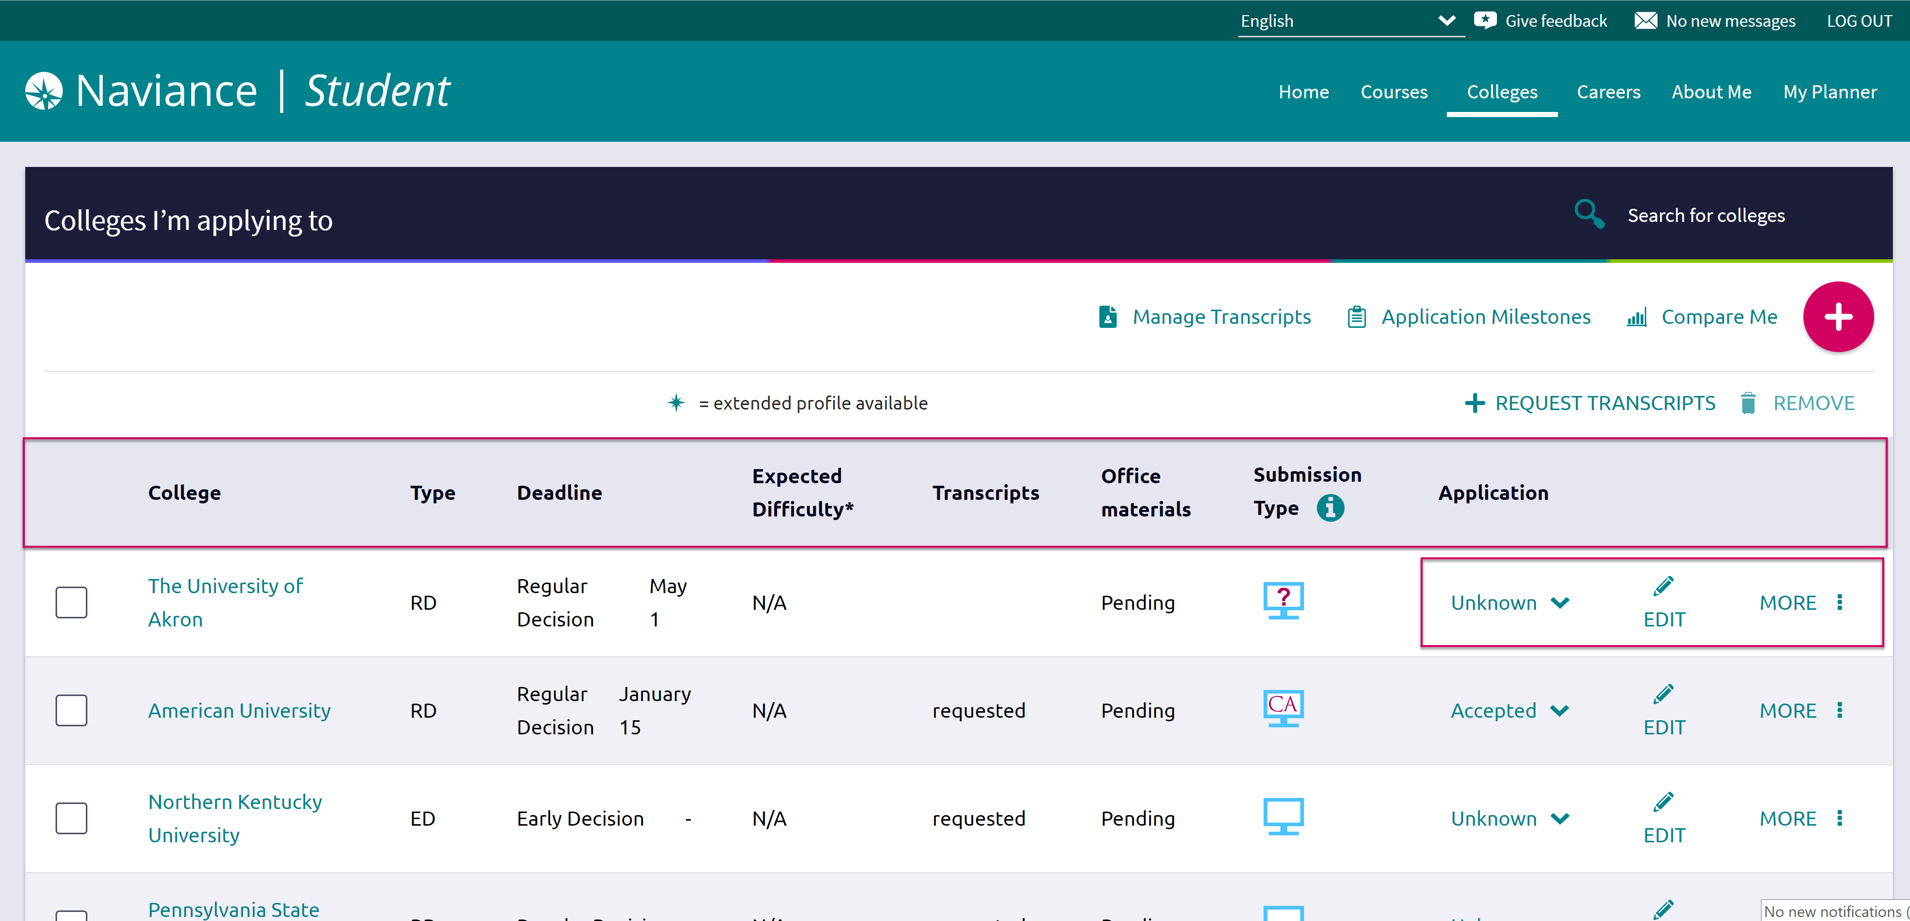

Adding a College to the List and Requesting Transcripts
Colleges can be added to the Colleges I’m Applying To list in two different ways:
- From the Colleges I’m Applying To list
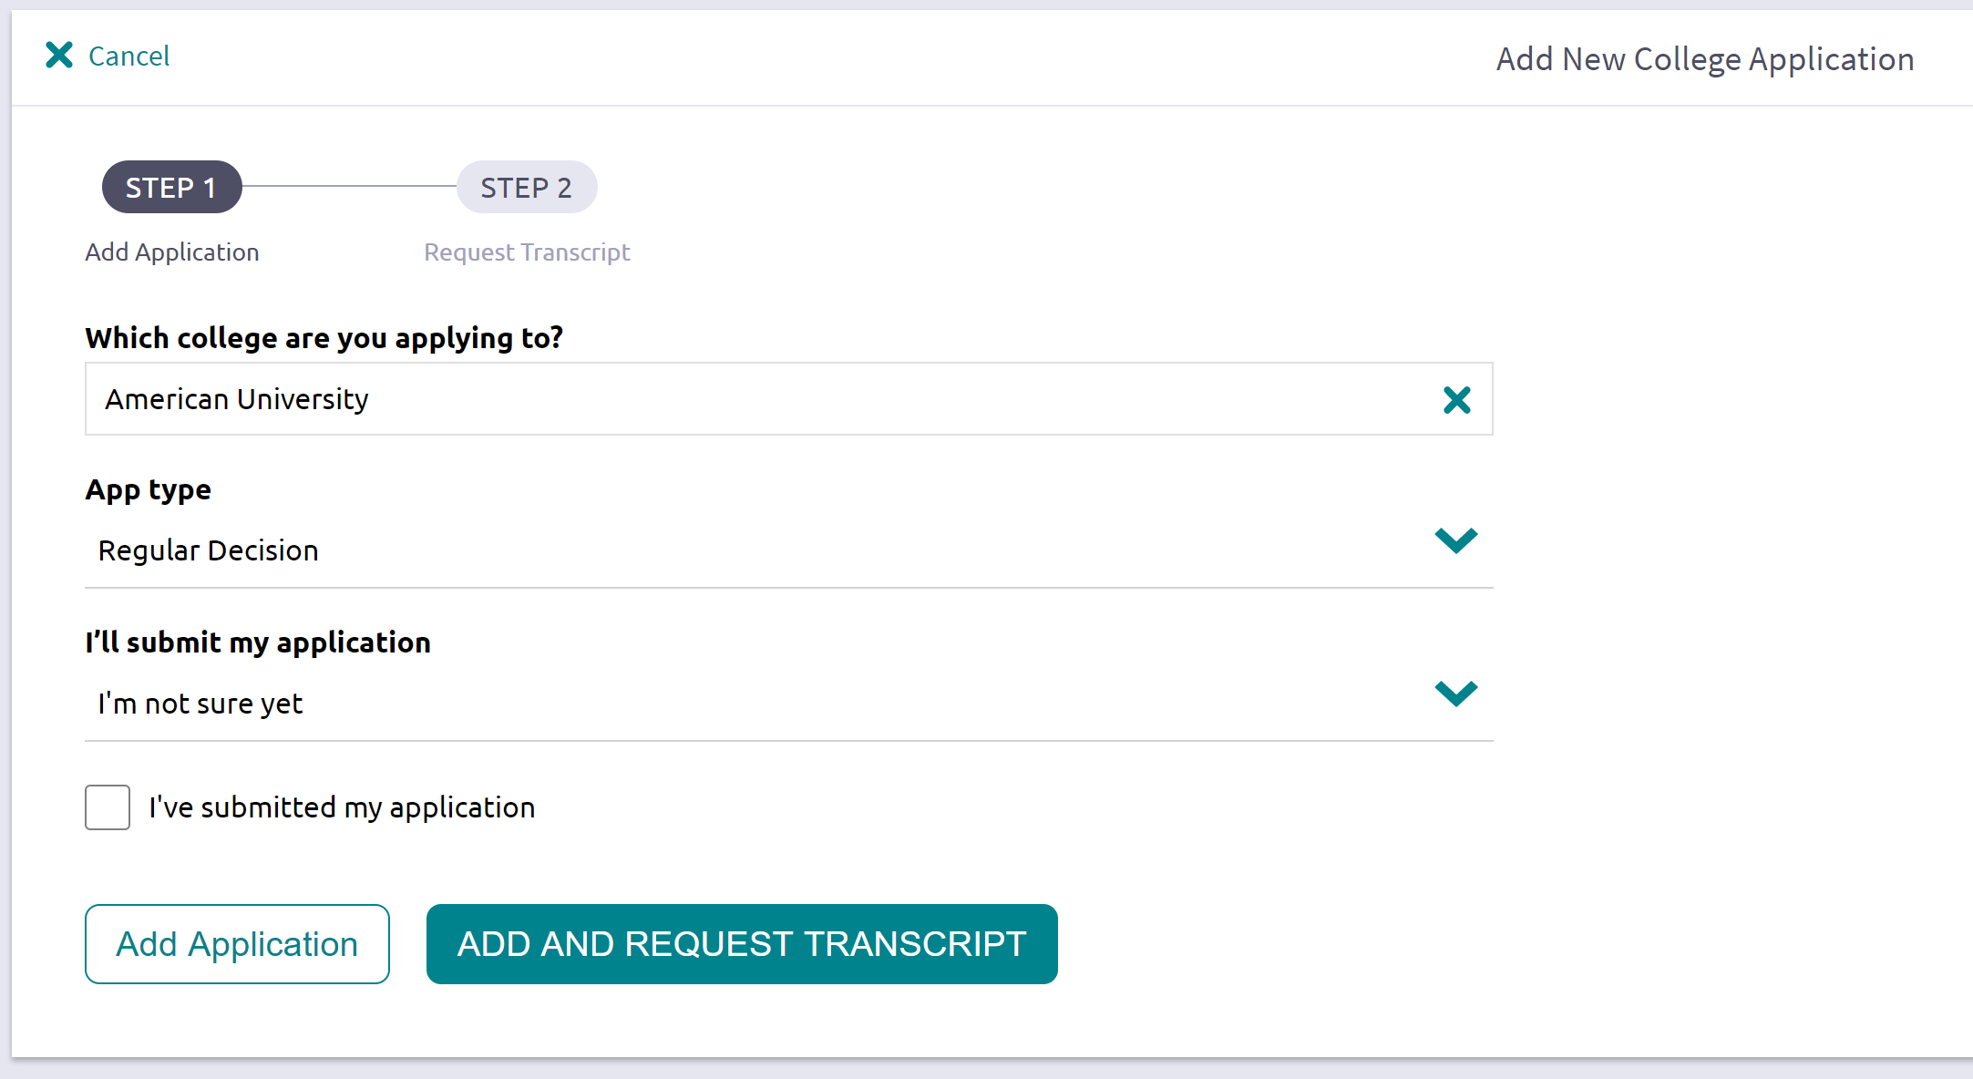
- From the Colleges I’m Thinking About list

From Colleges I’m Applying To
- Click Add.
- From Which college are you applying to? use the drop-down or type the name of the desired college and select from the matches.
- From App Type click the drop-down to identify your answer (Rolling, Regular Decision, Early Action, Early Decision, etc.)
- From I’ll submit my application? click the drop-down to identify your answer (direct to institution or CommonApp).
** you must MATCH your CommonApp account and Naviance so that the two systems can communicate**
- If you have already sent in your application, select the checkbox labeled I’ve submitted my application. If not, leave it unchecked.

If you currently do not need to request transcripts, select Add Application.
- Click Add and Request Transcript.
- From What type of transcript/s are you requesting? First time requests are for the INITIAL Transcript
- From What additional materials, if any, do you want included? We DO NOT have or send test scores. You must do that through the test company (College Board or ACT).
- Review Where are you sending this transcript? to ensure the proper college name is displayed.
- Click Request and Finish.

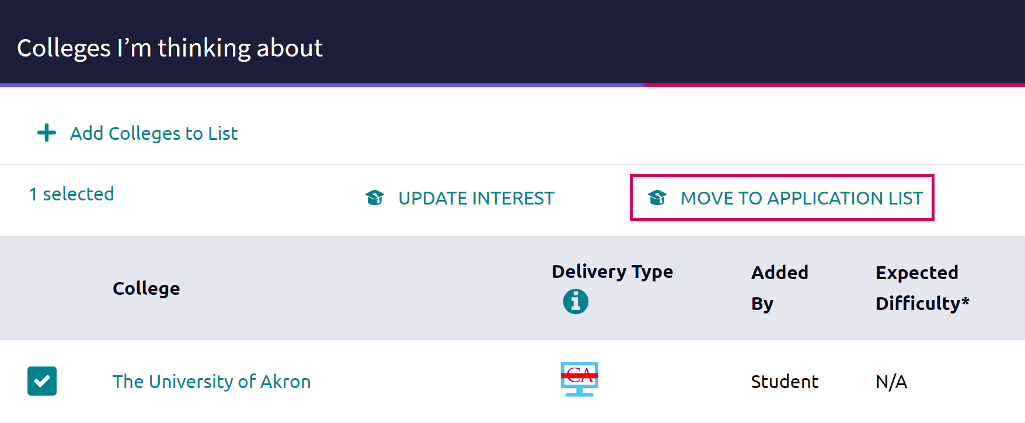
From Colleges I’m Thinking About
- From Naviance Student, navigate to Colleges and select Colleges I’m Thinking About.
- Place checkmarks in the checkboxes next to the schools to which you are applying.
- Click Move to Application List.
- Use the drop-down menus to select the accurate responses.
- If you have already sent in your application, select the checkbox labeled I’ve already sent my application. If not, leave it unchecked.

If you do not currently need to request transcripts, select Add Applications.
- Click Add and Request Transcripts.
- From What type of transcript/s are you requesting? First time requests are for the INITIAL Transcript
- From What additional materials, if any, do you want included? We DO NOT have or send test scores. You must do that through the test company (College Board or ACT).
- Review Where are you sending this transcript? to ensure the proper college name and deadline type is displayed.
- Click Request and Finish.

Request Transcript
A transcript can be requested for schools that were previously saved to your Colleges I’m Applying To list if you have submitted your application. It is important to let the Counseling Office know (through Naviance) that you have submitted and paid for your application.
**If you are under 18, you must have parent permission to release transcripts. Parents/Guardians grant permission through the InfoSnap Returning Student Registration process. If InfoSnap was not completed or permission was not granted, a Transcript Release Form must be completed for your transcript to be shared. Forms are available online and in the Counseling Office.
- From Colleges I’m Applying To, click Request Transcripts.
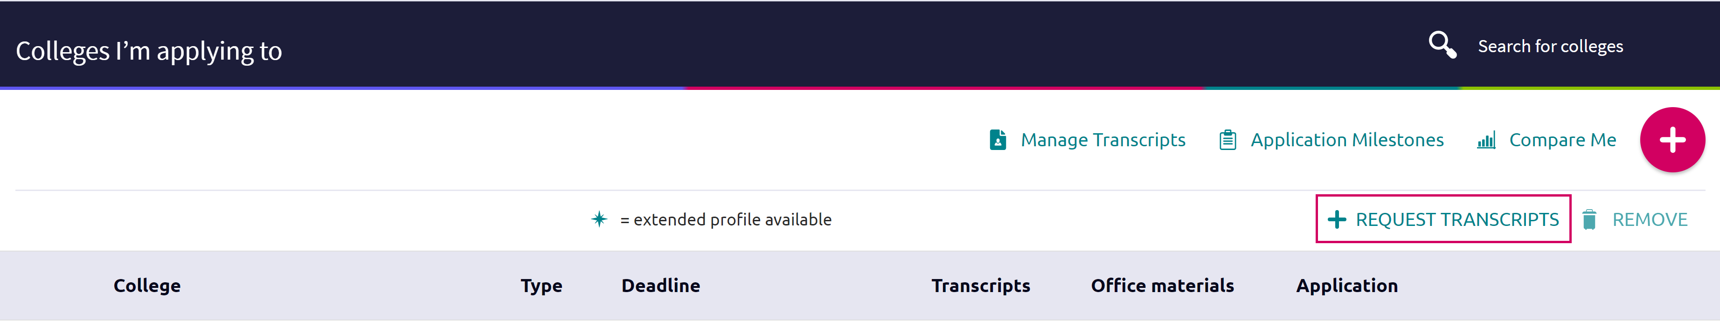
- Use the checkboxes and drop-downs to answer the transcript-related questions.
- Click Request and Finish.
*SAT and ACT scores are NOT on your transcript. You must request that the testing service send scores to schools directly. See www.collegeboard.org or www.act.org for details

Student Bio Sheet – Important for Recommendations!
When requesting letters of recommendation, teachers will often refer to the Student Bio Sheet to give them more insight and information about the activities you have been involved in throughout high school. To access this survey:
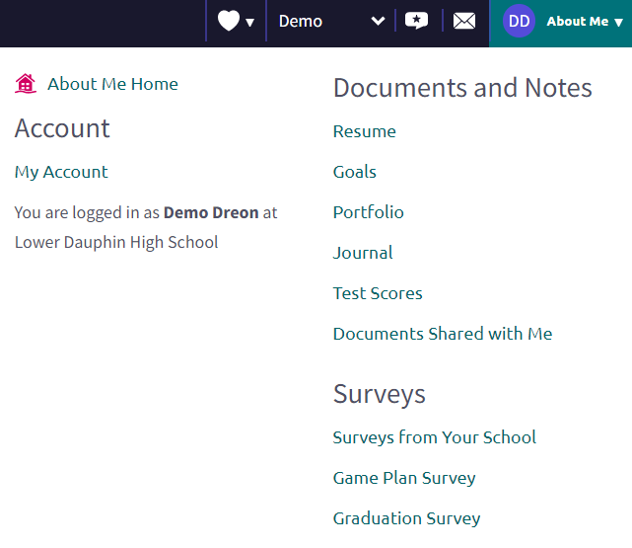
- Click on your Icon, in the upper right corner, click on Surveys from Your School
- From Surveys, click on Student Bio Sheet
- Update the Bio Sheet throughout the year as needed.
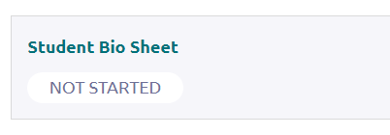

Letters of Recommendation
Request and keep track of letter of recommendation requests from Colleges > Apply to College > Letters of Recommendation.
We recommend that you speak with your teacher to ask them if they are able and willing to write a letter of recommendation for you. We also suggest that you ask teachers to write a letter that you can use for both admissions AND scholarships so their letter should be generic enough for you to be able to use it for either purpose.
After you have asked, then you can add a Naviance request.
When adding a request, select a teacher to write the recommendation and write a note to share with your teacher. It would especially be nice to thank them for agreeing to write a letter for you in this space. Typically, you only need 1-3 letters of recommendations and most often, you should only send what the school is asking for unless you have additional information to share. You will have the option of selecting certain schools to receive their letter but we recommend that you indicate it is a GENERAL REQUEST so that you can use the letter for multiple purposes (admissions and scholarships).
**You MUST give teachers AT LEAST TWO WEEKS NOTICE to write a letter.
If you have asked an outside recommender (employer, supervisor, pastor, scout leader, volunteer supervisor, etc.) or a retired teacher to write a letter for you, they must submit their letter directly to the school or if you are using CommonApp, you must add them as a recommender within that system. They cannot upload letters into Naviance. Speak with your Counselor or Mrs. Kain if you are seeking outside references.

Scholarships
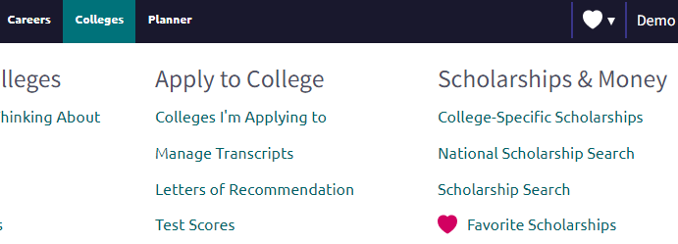
When looking for scholarships:
- From the Colleges Tab, click on Scholarship Search or National Scholarship Search
- From our Scholarship list, click on the scholarship for more details.
- When requesting transcripts for Scholarships, see “manage transcripts” section for direction.
**It’s important for you to check this list often and to pay attention to deadlines.

Other Questions or Need Help with Naviance, Common App, Transcripts or Scholarships?

Make an appointment with your counselor and/or stop in to see Mrs. Kain (who can help with Common App, Naviance and general application questions) or Mrs. Schwartz (who can answer questions about scholarships).

