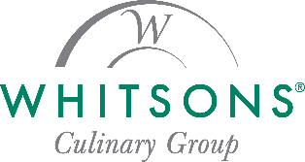
Dear Killingly Community

Welcome back to a new school year! Whitsons Culinary Group is excited to partner with Killingly Public Schools to provide healthy, tasty meals for all students. Our goal is to serve nutritious, well-balanced meals that kids enjoy while meeting all National School Lunch and Breakfast Program requirements.
At Whitsons, our mission—Enhancing Life One Meal at a Time™—means offering fresh, wholesome meals made with care, just like we’d serve our own families.
School Menus
Find daily menus, nutrition, and allergen details at www.fdmealplanner.com or by downloading the FD Meal Planner app.
Payment Methods
Meals may be paid for with cash, or check (Killingly School Lunch Fund Program) or by utilizing MySchoolBucks.com where you can add funds, monitor transactions and receive reminders when your students balance is getting low.
Dining Stations
Students will enjoy a wide variety of choices, including:
🍕 Pizza & Italian favorites (La Cucina)
🥗 Made-to-order salads (Fresh From the Garden)
🌮 Mexican favorites (Coyote Grill)
🥪 Deli sandwiches (Great American Sandwich Co.)
…plus many more!
We Value Your Feedback
We look forward to serving your family this year. If you have suggestions or questions, please contact me directly:
Amanda Newcomb- General Manager/Food Service Director
newcomba@whitsons.com
Here’s to a great year of nutritious and delicious meals!

