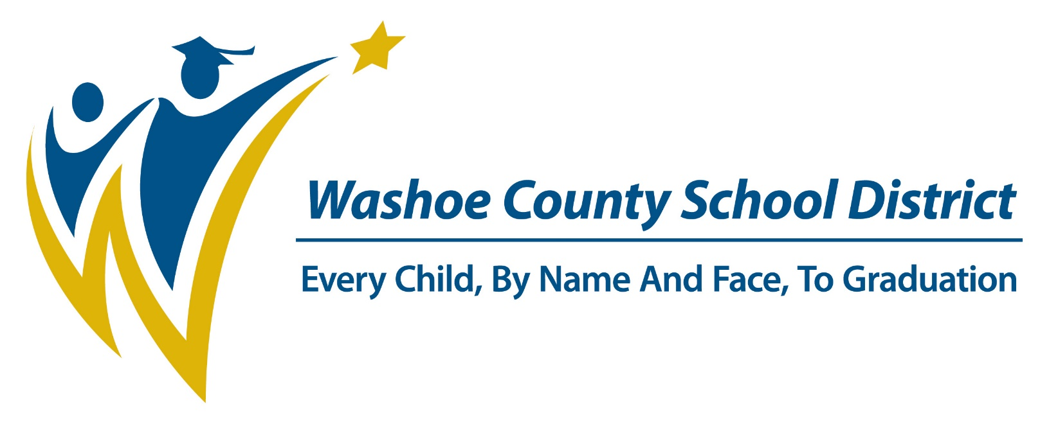

POLICIES, REGULATIONS, AND PROCEDURES

FOR

PROCESSING FROM WCSD TO OUT-OF-DISTRICT
(Students Residing in WCSD Who Want to
Attend a School in an Adjoining District or State)

STUDENT VARIANCES

CONTENTS

DEFINITIONS Page 3

CONDITIONS Page 3

PROCESSING VARIANCE Pages 4-6
REQUESTS BY STUDENTS RESIDING IN WCSD
WHO WANT TO ATTEND SCHOOL IN
ANOTHER DISTRICT OR STATE

- WCSD Application to Attend School Outside District of Residence Page 4
- After Receiving the Application to Attend School Outside Page 4
- Documentation of Decision Page 4
- Distribution of Copies of Completed and Signed-Off Form Page 4
- IC Documentation Page 5
- Reapplication Page 5
- Student Enrollment and Records Responsibilities Page 5

DEFINITIONS

- Variance to Attend Outside WCSD – A request by a student living in WCSD to attend a school in an adjoining county in Nevada or an adjoining county in another state.
- Official Residence – The official residence of a child is the residence of the child’s parent(s) or legal guardian. A child may not claim residency by living with any relative other than a parent or with any other person, unless such relative or other person has obtained guardianship as provided for by the provisions of Nevada Revised Statutes.

- Adjoining County – Is defined as a county that physically adjoins Washoe County:
  - In Nevada: Carson City County, Storey County, Lyon County, Pershing County, Humbolt County, and Churchill County.
  - Out of state counties: i.e. Lassen, Modoc, Nevada, Placer & Sierra counties in California and in Oregon the counties of Harney and Lake.

CONDITIONS

When a parent/guardian applies for a variance, the parent/guardian must understand the following conditions:

- When Washoe County students do qualify for enrollment at a school in an adjoining county or state, a written agreement between the Washoe County School District and the other school district is required. The written agreement shall contain the necessary stipulations pertinent to the length of time, services, and tuition costs.
- Variances granted to students who reside in WCSD to attend school in an adjoining county or state are for one school year only.

- The parent/guardian must reapply each school year.

- The student is not permitted to enroll in the outside district until that district approves the application.

PROCESSING VARIANCE REQUESTS FOR STUDENTS RESIDING IN WCSD WHO WANT TO ATTEND SCHOOL IN AN ADJOINING DISTRICT OR STATE

- WCSD Application to Attend School Outside District of Residence

Students whose official residence is in Washoe County and who want to attend a school in an adjoining county in Nevada or an adjoining county in another state must complete either the Out-of-District Variance Application form or the form from the district to which the student is applying.

- After Receiving the Application

  - Once the form has been received by Student Enrollment and Records, the parent/guardian should be informed regarding the procedure for processing such applications:

    - If the student is currently receiving special educational or instructional services, the administrator of the department providing the services should be notified by Student Enrollment and Records of the variance request. The administrator must approve the variance for it to go further. If the administrator of the department providing services denies the variance, the variance is denied.

    - The supervising administrator approves or denies the application before the application is submitted to the adjoining county or state.
- Documentation of Decision
Once a recommendation has been reached by the supervising administrator and the central office department administrator (if applicable), the supervising administrator will indicate their recommendation in the “Permission From District of Residence” portion of the Out-of-District form or in the appropriate section of the district of residence’s comparable form.
- Distribution of Copies of the Out-of-District form or the appropriate section of the district of residence’s comparable form
Once the supervising administrator has indicated the recommendation on the Out-of-District form or in the appropriate section of the district of residence’s comparable form, the form is sent back to Student Enrollment and Records.

Student Enrollment and Records will send the Out-of-District form to the requested district.

5. IC Documentation

Once the supervising administrator has approved the application for a variance by a student whose residence is in WCSD to attend a school in an adjoining county or state, the school must do the following if the student is enrolled in school:

- The school must withdraw the student from IC using code “W2a” – Public School in NV/Outside WCSD if the student was granted a variance to attend school in an adjoining Nevada county, or

- The school must withdraw the student from IC using code “W2d” – Out-of- State if the student was granted a variance to attend school in an adjoining state.

- Student Enrollment and Records enrolls all students living within the boundaries of Washoe County who are attending a school out of state in the Out of State calendar in IC.

6. Reapplication
Any student whose official residence is in Washoe County and who is attending a school in an adjoining district or state must reapply each school year for the variance.

7. Student Enrollment and Records Responsibilities

The Student Enrollment and Records Department will be responsible for the following:
- Providing the receiving school district with a copy of the completed variance application indicating the decision of the WCSD to either approve or deny the request to attend school in an adjoining district or state; and
- Creating an annual database of students whose official residence is in WCSD and who have been granted a variance to attend school in an adjoining district or state; and
- Notifying each WCSD student granted a variance to attend school in an adjoining district or state that the student must reapply each school year if the student plans to attend the out-of- WCSD school the approaching school year; and
- Ensuring that all students who reside within Washoe County but attend a school out of state are enrolled in the Out of State calendar in IC for ADE;

- Student Enrollment and Records will be responsible for developing the written agreement between the Washoe County School District and the other school district.
- Providing information as needed to the Business and Financial Services Department for billing purposes.

