
Ethel W. Kight PBIS Team Members
Nigel Walker Principal
Our school-wide behavioral expectations center around three basic principles:

BE RESPECTFUL BE RESPONSIBLE BE SAFE

Scholars will receive PBIS points when displaying positive behaviors in these areas through Classdojo. Appropriately acknowledging and rewarding the positive behavior of scholars is among the most effective ways to decrease problematic behavior and essential to strengthening the repeated display of positive behavior in the school setting.
Specific procedures for teaching and celebrating these expectations will occur throughout the year. This will be achieved through the use of:

PBIS Store– Scholars will have an opportunity to attend the school school and buy items with the points they have earned though Classdojo. Prior to the school store, scholars will be given a “check” with the amount of points earned, that they can then spend at the PBIS store.

Kim Whaley Assistant Principal

LaTonya Young Assistant Principal

Misty Rhein
PBIS Coach

Asia Davis
Team Lead

Keyanna Staples
School Social Worker

Stacye Smith
SWIS Data Analyst

Grade Level Representatives
Tiffany Allen
Ciara Battle
Leanne Moore
Erica Perry
Kelly Calhoun
Tasia Zachery
Sara Proctor
Catherine Proctor
Jonny Warren
Officer Lawson
Dijmon Edge

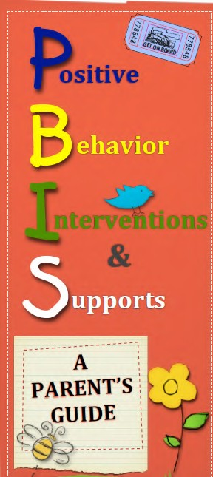
Ethel W. Kight Elementary 75 Gordon Road
LaGrange, GA 30240
706.812.7943
www.troup.org

Ethel W. Kight Elementary School P.B.I.S. Goal

Our goal at Ethel W. Kight Elementary School is to create a positive social culture that will encourage positive behaviors and interactions that lead to optimal student achievement (academic and behavior) while enhancing student learning through teaching and recognizing positive behavior.

How PBIS works to accomplish the goal
- School-wide expectations for all scholars, staff and settings -
at Ethel W. Kight, we are calling this
"The Knoble Knights Rules for Royalty".
BE RESPECTFUL BE RESPONSIBLE BE SAFE
- Direct instruction of expected behaviors
- Organizing routines and transitions for scholars and staff (arrival, dismissal, hallway, etc.)
- Acknowledging expected behaviors
- Responding to problem behavior with consistent consequences that are focused on re-teaching the expectations.



P.B.I.S. (Positive Behavior Intervention & Supports) is a
school-wide approach to discipline, establishing expectations, and developing a process to create a

DEFINE: clear and concise definition of behavior expectations
TEACH: direct teaching of behavior expectations
PRACTICE: scholars practice expected behaviors in their settings
REINFORCE: positive recognition of expected behaviors being performed
REDIRECTION: for negative behaviors
CELEBRATE: consistent acknowledgements of the expected behaviors being performed consistently school wide
P.B.I.S

at home

I am Respectful:
- I speak nicely to others
- I am truthful
- I listen to my family

I am Responsible:
- I finish all of my homework
- I pick up my toys/clothes when I am finished with them
- I go to bed when I am told
- I am prepared for the next school day

I am Safe:
- I play with my toys the correct way
- I always let my mom know where I am
- I watch out for my friends

