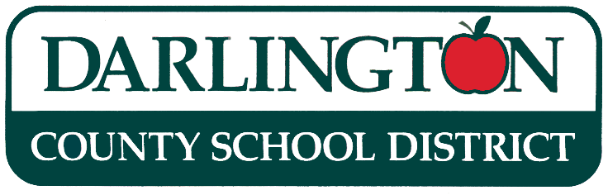

DARLINGTON COUNTY SCHOOL DISTRICT
AUTHORIZATION FORM FOR USING PROCUREMENT CARD

Authorization is given to for use of DCSD VISA Procurement Card number on this date, ; not to exceed $

By signing this form, I am agreeing to:
- Adhere to purchase limits/restrictions of this Procurement Card, not to exceed $2,500 per transaction;
- Provide all sales slips and/or register receipts for all purchases for each transaction while using this Procurement Card;
- Provide a detailed itemization of receipt if receipt is not clear as to what has been purchased;
- Provide attendance information (number of people attending, place, date, food provided, etc.) for all transactions involving food.

Cardholder’s signature: __________________________________________________
MUST HAVE SIGNATURE PRIOR TO PURCHASE

Authorized User’s Signature: ______________________________________________
MUST HAVE SIGNATURE PRIOR TO PURCHASE

Approved by: ___________________________________________________________
MUST HAVE SIGNATURE PRIOR TO PURCHASE Special Revenue Fund Manager

Account Number(s): Amount:
$
$
$
$ TOTAL (IF MORE THAN ONE AMOUNT)

Check Number: Vendor:___________________________

Post Date (from statement) : ___________________________

Purpose: (DETAILED): ________________________________________________________________________________________________________________________________________________________________________________________________________________________________________________________________________________________________

