Transportation

Handbook



2025-2026

Table of Contents
Table of Contents 2
Introduction 3
Bus Transportation To and From School 4
Registering for Bus Transportation 4
Bus Stops and Bus Routes 4
Behavior 5
Responding to Problem Behavior 5
Bus Rules and Procedures 5
The School District is responsible for: 5
Drivers are responsible for: 6
Parent / Guardians are responsible for: 6
Students are responsible for: 7
Bus Rules 7
Discipline 8
Response to Student Misbehavior 8
Conduct Detrimental to the Normal Function of Transportation: 8
Due Process 8
Suspension and Expulsion 9
Expulsion 9
Suspension, Bus 9
Suspension, Long-Term 9
Suspension, Out-of-School 9
Electronic Devices 9
Field Trips, Athletics, and Other Activities 9
Food and Drinks 10
Personal Belongings 10
Pets / Animals Policy 10
Safety Information 10
Crossing Procedures 10
When Crossing the Street to Board the Bus 10
When Crossing the Street After Leaving the Bus 11
Evacuations 11
School closings 11
Severe Weather Procedures 11
Video Monitoring Systems 12
Appendix A:
Behavior Documentation Form 13

Introduction
The purpose of these guidelines is to provide students and parents/ guardians with general information about the Old Redford Academy (ORA) pupil transportation system. State of Michigan Public Act 187 of 1990, the Public Transportation Act, outlines the laws that all school districts must follow.
Michigan law defines a “school bus” as a motor vehicle with a manufacturer’s rated seating capacity of 11 or more passengers, including the driver, used for the transportation of pre-primary, primary, or secondary school students to or from school or school-related event. A school bus does not include a vehicle operated by a public transit authority.
Vehicles with a seating capacity of ten or fewer occupants, including the driver, are not defined as school buses. Thus, they are not regulated by the Pupil Transportation Act.

Law does not require transportation of students to and from school (except in some cases as required by the Individuals with Disabilities Education Act). Please take time to read the following pages and review them with your children in order to protect your transportation privileges. It is the mutual responsibility of the parent/ guardian and school district personnel to make an effort to understand and cooperate with each other regarding safe and orderly pupil transportation.

School bus transportation is provided only for eligible students and shall be considered a PRIVILEGE to be enjoyed only as long as the students accept responsibility for their own personal conduct and carefully follow all rules and regulations.

This handbook is condensed from the student handbook to reflect the needs of transportation and is not a comprehensive student handbook covering all areas. Please see the Old Redford Academy Student Handbook for all other policies.

Bus Transportation To and From School

Registering for Bus Transportation
Registration for busing is done during the district enrollment process. For more information about enrollment, please visit https://www.oradistrict.org/enrollment.

Bus Stops and Bus Routes
Safety is the most important factor in transporting Old Redford Academy students. The following information is offered to help make pupil transportation safe and successful.

- Bus stops and bus routes are established on the basis of safety, efficiency, the age of students, as well as the State of Michigan guidelines. Bus stop locations must avoid as much traffic as possible. Buses shall be visible in both directions when stopped.

- Students should arrive at the bus stop five minutes prior to the scheduled arrival of the bus. This should allow time to catch the bus but not enough time for problems among students to arise. PARENTS/GUARDIANS ARE RESPONSIBLE FOR THEIR STUDENTS UNTIL THE BUS ARRIVES.

- By state law, students must cross in front of the school bus. They will receive instruction on proper crossing procedures from bus drivers. PARENTS/GUARDIANS WHO MEET STUDENTS AT THE STOP SHOULD SET THE EXAMPLE AND ALSO FOLLOW THIS IMPORTANT SAFETY RULE.

The district reserves the right to change stops and routes when necessary. Parent cooperation is required to make sure students ride the buses to which they are assigned. This ensures that the school will know who is actually on a bus, that a student can be located in an emergency, that overcrowding is controlled, and that other possible problems can be prevented.

Students may only ride assigned school buses and must board and depart from the bus at assigned bus stops. Students will not be permitted to ride unassigned buses for any reason other than an emergency, except as approved by the Principal.

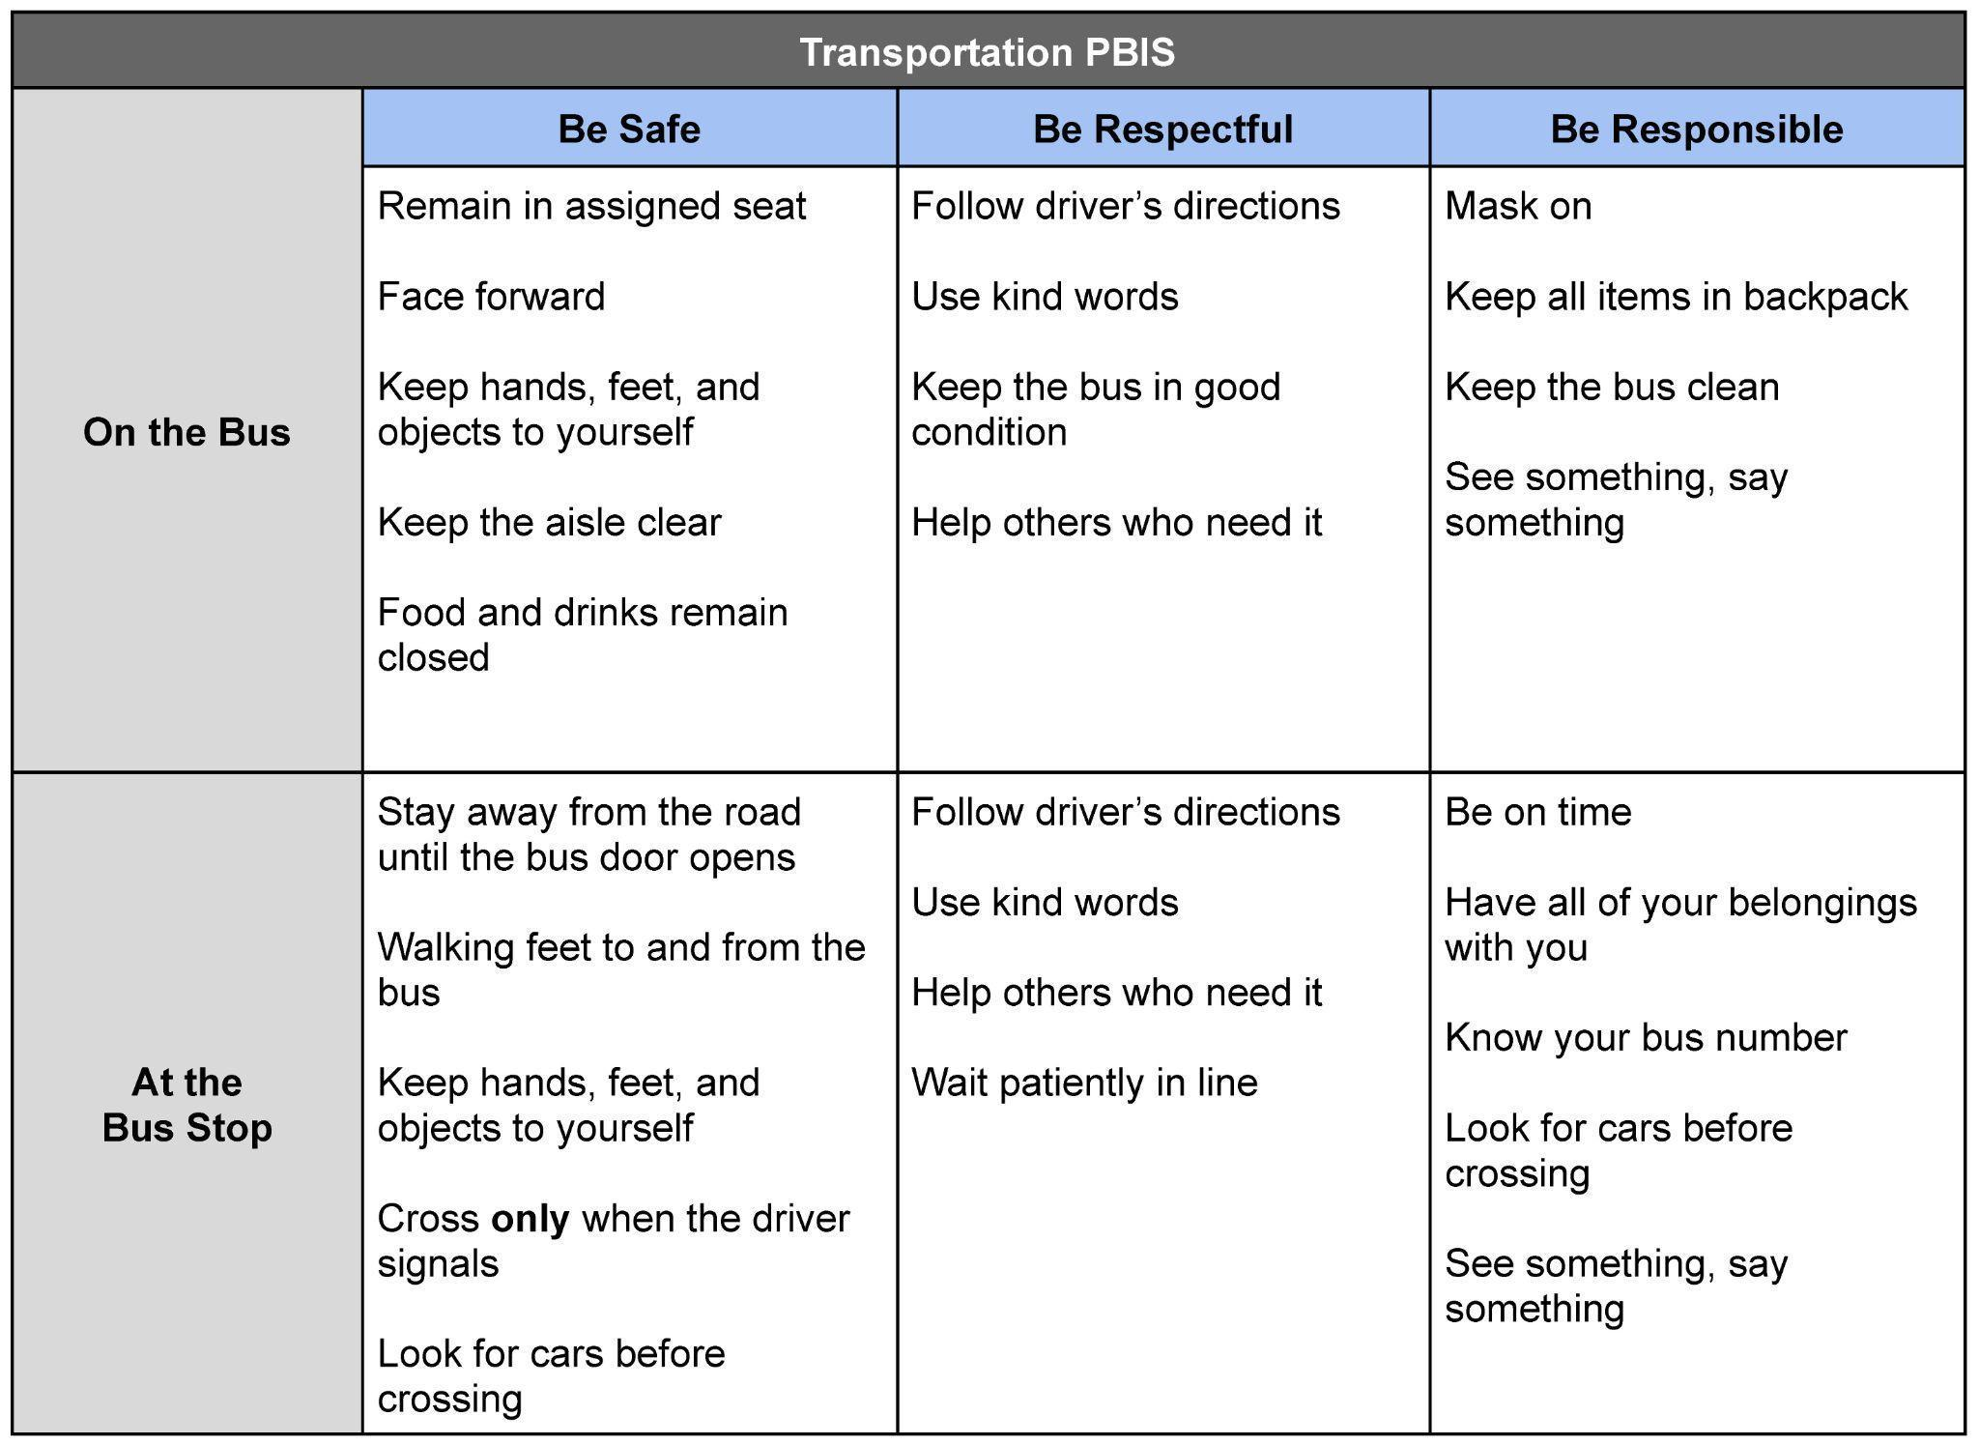
Behavior

Responding to Problem Behavior
While we work hard to focus on teaching positive behavior and reinforcing students when they meet expectations, there are times when staff must respond to more repeated and/or more serious behaviors in a different way. Even in these situations, the focus stays on helping our students reflect on what occurred and think of better ways to handle the situation.

Bus Rules and Procedures

The School District is responsible for:
- Establishing the policies and procedures by which the pupil transportation program functions.
- Establishing pupil regulations governing the behavior and safety of students while on the bus.
- Instituting and administering an instructional program that teaches students proper conduct and safety procedures.
- Conducting a training program for school bus drivers to ensure that all policies, procedures, regulations, and their enforcement are understood.
- Ensuring that parents receive transportation safety rules and regulations and clearly establishing their roles and obligations with respect to student promptness, attitude, and behavior.
- Initiating procedures to open lines of communication and cooperation between school administrators, transportation staff, and state agencies.

Drivers are responsible for:
- Providing safe and orderly transportation for students.
- Ensuring proper conduct and communications with students, parents/guardians, and building administrators.
- Establishing and enforcing bus expectations and rules in accordance with district policies and procedures. This includes teaching students the expectations and rules for safe bus riding and street crossing and enforcing these rules.
- Following the scheduled route and time each day, providing conditions allow.
- Picking up and discharging students only at their designated stops, except with permission from the transportation supervisor to do otherwise.
- Assigning seats.
- Notifying the School office if the bus will be late arriving in the morning.
- Checking the bus by walking from front to back to make certain it is empty at an appropriate location after the last child exits the bus, between all runs, and before parking the bus.
- Contacting the building Principal about student behavior issues.
- Providing for school bus emergency evacuation drills as required.
- Drivers are responsible for calling in medical emergencies to dispatch and, as needed, calling 911.

Parent / Guardians are responsible for:
- Supporting safe riding and discipline practices.
- Making certain that their student arrives at the bus stop on time (5 minutes prior to scheduled bus arrival)
- Monitoring their student's behavior until the bus arrives.
- Providing alternative transportation for their student if oversized objects or live animals must be transported to or from school, or when a student's bus riding privileges are suspended for cause.
- Ensuring that payment is made for damages resulting from vandalism to the bus.
- Having a family emergency plan if the student arrives home early or if parents/ guardians are not present at the time of their arrival.
- Does your child have a house key or know where to find one?
- Does your child have a neighbor to go to in case no one is home?
- Have you discussed several possibilities so your child knows what to do?
- Do a drill or at least a periodic verbal check to be sure your child knows what steps to take.
- Keep the procedure updated as personal circumstances change.
- Supporting emergency evacuations drills and other emergency procedures as set by the school district.
- Kindergarten, and certain special education students may require a family member or guardian to receive them at the end of their ride home at the scheduled drop off time. If in the judgment of the driver the student's safety is in question, the student will remain on the bus while the driver initiates the following procedure:
  - The driver contacts dispatch and dispatch telephones the parent, guardian or emergency contact.
  - If there is no emergency contact made, the student is taken back to the school.
  - If no family member is present to receive the student, the principal and/or transportation supervisor will contact the parent or guardian for a conference to discuss future safety arrangements.

Students are responsible for:
- Following the ORA Student Handbook, including the Code of Conduct.
- Observing appropriate behavior in order to protect their riding privileges.
- Being courteous to others. Demonstrate responsible citizenship through positive social interactions while on the bus. Use no profanity or verbally abusive language.
- Remembering that eating, drinking, smoking, and possessing illegal substances, weapons or obscene materials are not allowed on the bus.
- Cooperating with the bus driver and following the bus driver's instructions the first time they are given.
- Remaining seated while the bus is in motion.
- Extending nothing, including head, hands, and feet out of the bus windows. Open windows only with permission.
- Maintaining the condition of the bus.
- Displaying proper respect for the rights and comfort of others on the bus.
- Being on time at bus stops and staying off roadways while waiting. Buses cannot wait for tardy students.
- Crossing in front of the bus at all times.
- Limiting objects that are brought on the bus to those items that can be safely held by the student. Do not bring or use any items on the bus that could affect the health, safety, and security of any passengers. Examples: Scooters, skateboards, sleds, large band instruments, and live animals may not be transported on the bus.
- Realizing that ANY driver distraction is potentially hazardous to the safety of all passengers.

Bus Rules
- Students must obey the instruction and directions of the school bus driver. Driver is authorized to assign seats.
- Students must be on time to ride the school bus, board and depart at their scheduled stop location, stay off the roadway, and maintain proper conduct while waiting to board or upon leaving a school bus. They must cross the street in front of, not behind, the bus and must not hit the sides or windows.
- Students may lift the emergency exit handle or use the emergency exits only during an emergency or with the permission of the bus driver.
- Students must keep hands and head inside the bus and may not throw any object, including snowballs, on, at, or out of the bus windows.
- Students must not move about or change seats on the bus without the permission of the driver, nor may they speak loudly, shout, or create any other disturbing noise. Students must not tease, scuffle with, or fight with fellow passengers.
- Students must not litter the bus. No eating or drinking on the bus.
- Students must not use profane, vulgar, or abusive language, or make obscene gestures.
- Students must not damage or vandalize the school bus. Students will be required to pay for repair of damage.
- Possession or use of laser lights, firecrackers, smoke bombs, or other incendiary devices is strictly forbidden. Use of various substances (alcohol, tobacco, marijuana, or illegal drugs) as well as possession and/or being under the influence of these substances is forbidden.
- This Handbook incorporates by reference all ORA Board policies, procedures, administrative guidelines, and the current ORA Student Handbook, including the Code of Conduct.

Discipline

Response to Student Misbehavior
While Old Redford Academy is focused on positive expectations for behavior and restorative, instructional approaches to discipline, there are some behaviors that cannot be tolerated in a school setting and for which specific consequences result. Restorative and reteaching will occur in addition to the consequences assigned. Below are some (but not an exhaustive list) of specific behaviors and administrative responses. Administration reserves the right to alter consequences based on information obtained after investigation. Progressive discipline may apply to students who repeatedly violate school and/or bus policies.

Undesired behavior falls within one of three levels of behavior. Level 1 is usually corrected after reminders from the driver. If the behavior persists or is more significant, it may fall under Level 2, which requires more response from the driver and may be documented for data collection as part of ongoing problem solving for transportation behaviors. Level 3 behaviors are more significant and require the building administrator to become involved, contact the student’s parent or guardian, and assign consequences for the behavior. Under this system, the Student Code of Conduct language for Tier 1, 2, and 3 responses apply.

Conduct Detrimental to the Normal Function of Transportation:

Any violation of the Student Code of Conduct or the Transportation Handbook, may result in disciplinary measures which may include bus suspensions, loss of bus privilege, school suspension or expulsion, and detention.
Transportation is the responsibility of the parents/guardians when a student is assigned to detention at school.

Due Process
All students suspended and/or expelled will be provided notice and an opportunity to be heard in accordance with a student’s due process rights under the law. Nothing in this Policy shall diminish or be in derogation of the due process rights accorded to students who have been determined to be eligible for special education services under federal and State laws.

Suspension and Expulsion

Expulsion
Expulsion is the removal of a student from school by the Old Redford Academy. Expulsion is noted on the student’s permanent record. Removal may be permanent, for the remainder of the school year, or a designated number of days. Students who are expelled do not have access to Old Redford Academy-provided transportation for the duration of the expulsion

Suspension, Bus
Bus riding is a privilege afforded to students. Bus riding privileges may be temporarily suspended or permanently revoked if the school administrators deem it is warranted based upon persistent or severe student misbehavior.

Suspension, Long-Term
Transportation privileges are unavailable while a student is suspended.

Suspension, Out-of-School
Transportation privileges are unavailable while a student is suspended.

Electronic Devices
All personal electronic devices are prohibited for use while on the bus unless explicitly approved by the driver for a specific activity. If a student possesses such a device, these items are to be turned on silent and out of sight while on the bus. The school is in no way liable for the loss or theft of any electronic devices.

Cell phones and other electronic devices (i.e. smart watches, tablets, etc.) can be disruptive to the driver and must be turned off while students are on the bus. If such items are seen while riding the bus, they may be confiscated by the driver or administration.
This handbook incorporates by reference the Electronic and Wireless Communications Devices policy in the Student Handbook. Violations of this policy may result in an out-of-school suspension, long-term suspension, or expulsion depending on the severity of the offense and the requirements of the law.

Field Trips, Athletics, and Other Activities
All transportation policies and rules apply for student activities that require use of Old Redford Academy vehicles. No student may participate in any school-sponsored trip without parental consent. The Student Handbook and Transportation Handbook apply to all field trips, athletics and other activities off of Old Redford Academy campuses.

Food and Drinks
Food or drinks of any kind are NOT allowed on the bus. This includes, but is not limited to, breakfast foods, lunch items, candy, suckers, fruit snacks, and gum.

Personal Belongings
Students should not bring items of value on the bus or to the Academy. The Academy cannot be responsible for their safekeeping and will not be liable for loss or damage to personal valuables. Examples of valuable items include, but are not limited to, cash, wireless communication devices (phones, MP3 players, iPads, handheld games, etc.), trading cards, jewelry, expensive clothing etc.

Pets / Animals Policy
Pets and animals of any kind are prohibited on Old Redford Academy buses. This applies to all pets and animals, whether alive or dead. Building policies determine if pets are allowed at school, but in cases where they are allowed it will be the responsibility of the parent/guardian to transport the pet to/from school. All pet visits should be coordinated with your child’s teacher.

Service animals are allowed with prior authorization. Please coordinate with the transportation supervisor and your building administrator to arrange for appropriate accommodations for service animals.

Safety Information

Crossing Procedures
Please review these important safety procedures with all of your children. Parents, who escort their children to and from the bus when crossing, must set an example for their children and also adhere to these important safety procedures. Everyone needs to know that not all cars stop as required by state law, even when the red lights are flashing on school buses.

When Crossing the Street to Board the Bus
- Students wait in a group at the designated bus stop at least 10 feet away from the edge of the roadway.
- The bus driver gives one instruction to cross. Drivers will hold a paddle, red side out to indicate "STOP" and will turn the paddle to the smile face when it is safe to cross the street.
- Students proceed directly across the road, always staying well in front of the bus and board the bus. Stay out of the DANGER ZONE!
- Do not stop in the middle of the street or cross behind the bus.

When Crossing the Street After Leaving the Bus
- Students exit the bus and take 10 giant steps in front of the bus staying on the side of the street. Stay out of the DANGER ZONE!
- Students stand in a group and look to the driver for instruction to cross.
- Drivers will hold the paddle, red side out to indicate "STOP" and will turn the paddle to the smile face when it is safe to cross the street.
- Students proceed to a point even with the left side of the bus and STOP.
- Students look left and right for passing cars.
- Students look to the driver for instruction to complete the crossing.
- Do not cross behind the bus.
- If a paper goes under the bus, always ask the driver for help.
- Do not get mail from roadside mailboxes until after the bus leaves the stop.

Evacuations
Three state-mandated evacuation drills are performed each year.

School closings
On occasion, it may be necessary to cancel school because of inclement weather or mechanical failure. Snow and ice may make it impossible for transportation. At such times, a message will be sent to parent emails and our messenger service will call every parent. For this reason, please make sure the office has the most accurate information possible. Please watch Channels 2, 4, and 7 for school closings. Please note: Old Redford Academy is not part of the Detroit Public School District and is listed separately.

Transportation will not be provided for students when schools are closed due to inclement weather or other conditions. If students are already on the bus when a closure is determined, the students will be dropped back off at their homes.

Severe Weather Procedures
When the U.S. Weather Bureau issues tornado watches or warnings, Old Redford Academy students will be retained in school until dismissal time or until such time that, in the judgment of the Superintendent or designee, they may be safely dismissed.

- If a tornado watch is announced during the day, students will be dismissed at the regular time.
- If a tornado warning is in effect, students will not be dismissed and will be moved to designated areas within each school

Information about severe weather events will be communicated using automated phone calls, text messages, and emails as well as posted on the district website.

Video Monitoring Systems
Academy buses may be equipped with electronic surveillance, which may include video and audio recording, for the safety of students, staff, and visitors. Your actions may be recorded and preserved. If a discipline problem is captured on audio or video recording, these recordings may be used as the basis for imposing student discipline. If criminal actions are recorded, a copy of the recording may be provided to law enforcement.

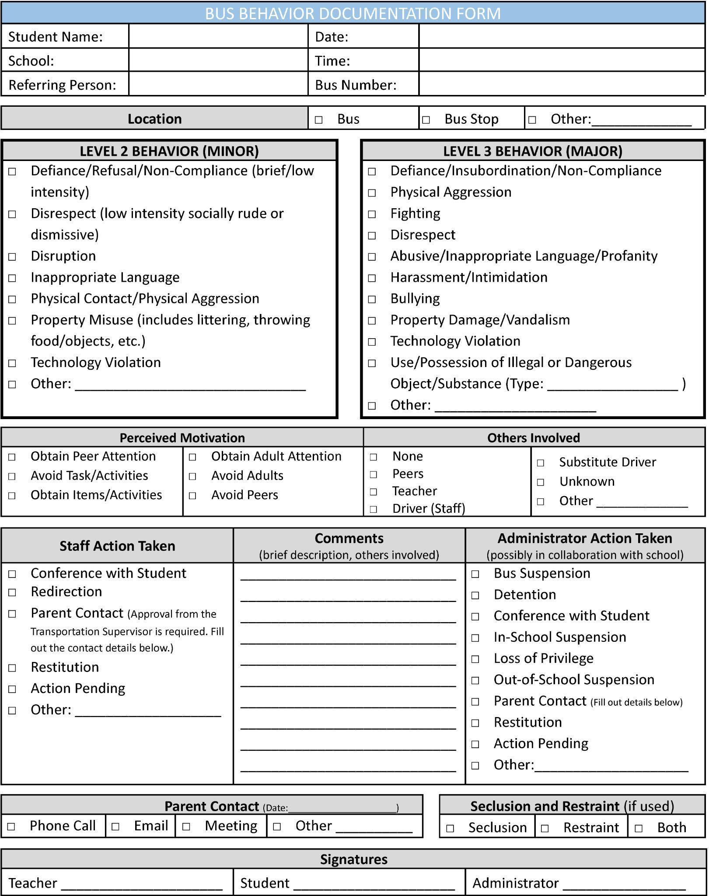
Appendix A:
Behavior Documentation Form

PLEASE SIGN AND RETURN THIS PAGE TO THE SCHOOL OFFICE

Please sign below to indicate that you have read the 2025-2026 Transportation Handbook and you and your child agree to abide by the regulations and policies set forth herein.

Thank you.

Date __________________________

Student Name (Printed) _________________________________________________

Student Signature _____________________________________________________

Parent Name (Printed) __________________________________________________

Parent Signature ______________________________________________________

