J. O. DAVIS ELEMENTARY
PARENT GUIDE


310 Davis Drive
Irving, TX 75061
972-600-4900

Home of the Bruins. Home of the Best!

MISSION
It is the mission of J. O. Davis Elementary School to
ensure high levels of learning in a positive school environment.

VISION
J. O. Davis Bruins will be responsible, respectful, and unified
for the betterment of their communities.

BRUIN OATH
I am a J. O. Davis Bruin.
Today, I will give my absolute best.
I will give my Bruin’s B.E.S.T. by
- Being respectful,
- Encouraging kindness,
- Staying safe, and
- Taking pride in my actions.
I vow to be responsible, respectful, and unified
for the betterment of my school.

TABLE OF CONTENTS

ABSENCES/ATTENDANCE 4
ARRIVAL 4
BIRTHDAY PARTIES 4
BREAKFAST 5
CELLPHONES 5
CLASSROOM OBSERVATIONS 5
COUNSELORS 5
DELIVERIES 5
DISMISSAL 5
DRESS CODE 6
EMERGENCIES 7
IMMUNIZATIONS 7
LEAVE EARLY 7
LOST AND FOUND 7
LUNCH 7
MEDICATION 8
MEETINGS 8
RECESS 8
SAFETY PLAN 8
SCHOOL SUPPLIES 9
SCHOOL TRANSFERS 9
STUDENT CODE OF CONDUCT 10
STUDENT ID BADGES 10
VOLUNTEERS 10

ABSENCES/ATTENDANCE
- Regular school attendance is essential. Absences from class may result in serious disruption of a student’s education. The student and parent should avoid unnecessary absences.
- State law requires that a student who is at least 6 years of age shall attend school, unless the student is otherwise exempt from attendance or legally exempt.
- When your child misses a day of school, you should write an excuse note. Please include
  - Child’s full name, school ID number (6 digits), & homeroom teacher
  - Date and reason for absence
  - Parent’s name and signature
- Here is an example of a complete excuse note.
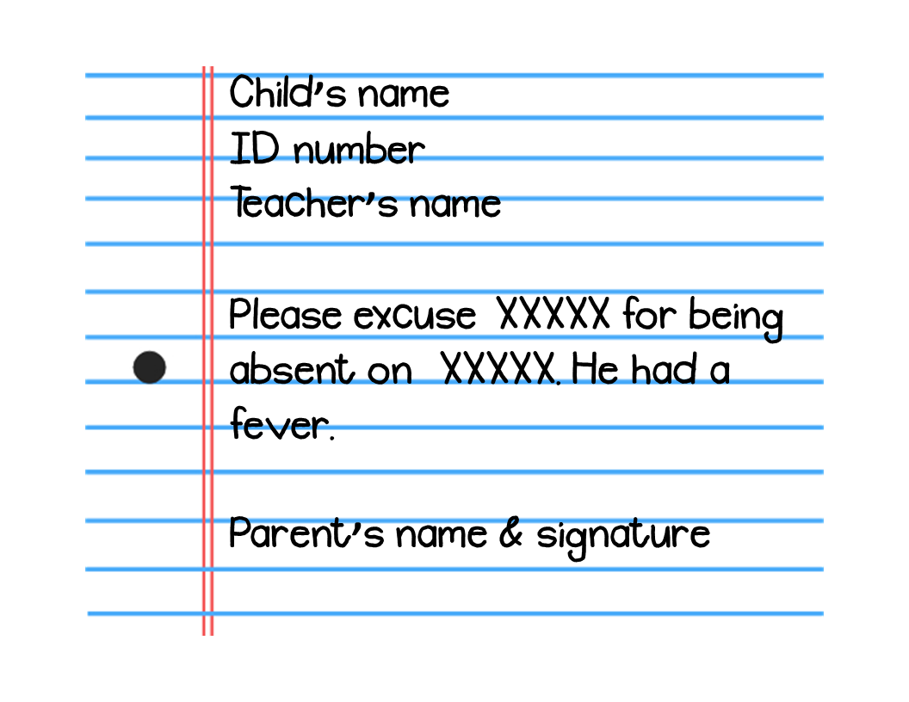
- You can also send the same information in an email from the parent’s account to our attendance clerk, Monica Villalobos movillalobos@irvingisd.net.

ARRIVAL
- Our school opens at 7:30.
- Students should not be dropped off before 7:20 since there is no adult supervision.
- PK-2 students should be dropped off at the Jackson St. door
- 3-5th grade students should be dropped off at the main entrance on Davis Dr.
- Students must be in class before 7:45 or they will be marked tardy.

BIRTHDAY PARTIES
- Each student will be recognized on the announcements on their birthday.
- We do not allow cakes or other edible items to be passed out to students.
- Parents who want to drop off gift bags for the class, should contact the teacher first. The gift bags will be passed out at the end of the school day.

BREAKFAST
- All students receive a free breakfast each morning.
- Breakfast is served from 7:30 - 7:45.
- Breakfast must be eaten in the classroom before classroom instruction begins.

CELLPHONES
- Students may bring their phones to school, but the phone must be turned off and put away during the school day.
- Please do not expect your child to call or text you during the school day.
- If you need to get an emergency message to your child before the end of the school day, you may leave a message with the front office before 2:00 pm.
- Drivers are not permitted to use a cell phone while driving in the school zone or in our parking lot.

CLASSROOM OBSERVATIONS
- We understand that you may have concerns about your child’s performance in the classroom.
- In order to protect the privacy of other students, we do not allow adult classroom visitors.
- We encourage you to schedule a meeting with your child’s teacher to share your specific concerns.

COUNSELORS
- Haley Kornely is the school counselor for grades 1st, 3rd, and 5th.
- Sonja Shine is the school counselor for grades Kinder, 2nd, and 4th.
- School counselors provide whole group guidance lessons and a few small group sessions. School counselors do not provide individual counseling services.

DELIVERIES
- We do not accept student deliveries or drop-offs such as lunch, flowers, cookie cakes, etc.
- Students who forget their lunch will receive a free, hot meal from the cafeteria.

DISMISSAL
- We are trying very hard to protect your child and our staff members. We realize that many of these protocols are inconvenient. However, they are necessary for the safety of our students and staff members.
- 3:10
  - Safety Patrol
  - Bus
  - Pick up all PK and Kinder students from the Jackson loop in the afternoon. Their siblings will join them at that door.
  - Ensure you are in the car line by 3:30. Staff members are off duty at 3:30. Please honor their time by picking up your child on time.
  - Communicate with your child’s teacher by email AND call the front office BEFORE 1:00 if there is an emergency and you need to change the way your child will go home. We need time to update our dismissal rosters.
- 3:15
  - All Walkers and Bike riders will be allowed to leave the front door & must leave campus immediately. These are students without dismissal numbers.
- 3:30
  - Parents MUST be in car line before 3:30 with the dismissal number
  - We will enter numbers for every car that is in line at 3:30.
  - Once the last number is entered at 3:30, we will not enter any more numbers.
  - Students whose parents walk up with a dismissal number will be called to the front.
- 3:35
  - Any student whose number was not entered before 3:30 is considered a late pick-up. You will need to get out of your car and sign the late pick-up log.

DRESS CODE
- Campus administrators will have complete and final judgment on all matters concerning the interpretation of the dress code.
  - Bottoms
    - Solid, khaki, navy, or black classic style
    - Skirts, jumpers, shorts, skorts, or pants
  - Shirt or blouse
    - Button-up or polo-style
    - Short or long-sleeves
    - Solid color, any
  - Sweater
    - Solid color
    - Cardigan, pullover, or vest
    - May be worn at any time during the instructional day
  - General Rules
    - All clothing parts must be a solid color.
    - The toe and heel of the shoe should be closed.
    - Clothing should be clean and free from holes and frays.
    - Clothing should fit appropriately, not excessively loose, tight, short, or long.
- Coats and jackets are not allowed to be worn in the classrooms or cafeteria. Sweaters that fit the above description are permissible.
- Student ID badges are part of the school dress code and must be worn at all times.

EMERGENCIES
- It is imperative that you keep your contact information up-to-date so that we can contact you in case of an emergency.
- If you need to get an urgent message to your child, call the front office before 2:00. Teachers do NOT check their emails throughout the day and may not see your message.
- You may correct your child’s official record, by contacting our Records Facilitator, Mrs. Vargas at crvargas@irvingisd.net

IMMUNIZATIONS
- Students are not allowed to enroll in school without current immunization records. Irving ISD will offer a free immunization clinic on Saturday, August 13 at the Irving ISD Administration Building.

LEAVE EARLY
- It is important that your child attend school each day, all day.
- Preparing for dismissal at the end of the school day can be hectic.
- We ask that you not pick your child up from school after 2:15 pm unless there is a medical necessity. We will then ask you to bring a doctor’s note the following day.
- When you pick your child up from school early they miss important daily class messages, class instruction, disrupt the learning of other learners, and divert the teacher’s attention away from the class to the learner leaving early. We understand that emergencies arise and we will certainly make exceptions in those instances

LOST AND FOUND
- Our lost and found collection is kept outside of the cafeteria.
- Students are allowed to look through the lost and found during lunchtime.
- You can help by writing your child’s name on their coat, jacket, and lunch box.

LUNCH
- All students receive a free lunch each day. Students who choose to get a lunch tray must take an entree and at least one vegetable/fruit.
- Students may not come through the line just to get a free milk. They must take an entree and at least one vegetable/fruit.
- Beginning September 27, lunch visitors are welcome to visit according to established guidelines. Guidelines are available for the CAMPUS and DISTRICT
- You may set up a lunch account so that your child may purchase additional items at schoolcafe.com.

MEDICATION
- If a student must take medication during school hours, the student’s parent must provide the medication. All medication, whether prescription or nonprescription, must be kept in the nurse’s office and be administered by the nurse or another authorized district employee.
- A student with asthma or severe allergic reaction (anaphylaxis) may possess and use prescribed asthma or anaphylaxis medication at school or school-related events only if he or she has written authorization from his or her parent and a physician or other licensed healthcare provider. The student must also demonstrate to his or her healthcare provider and the school nurse the ability to use the prescribed medication, including any device required to administer the medication. If the student has been prescribed asthma or anaphylaxis medication for use during the school day, the student and parents should discuss this with the school nurse.

MEETINGS
- Our administrators want to provide excellent service to our parents. If you need to meet with the principal, assistant principal, or counselor, please make an appointment at 972-600-4900. Should you drop in expecting to meet with an administrator, it is quite possible that due to instructional demands, one may not be available to meet with you. However, a future appointment will be made for you.
- Our teachers are available to meet with you during their conference period. Your child’s teacher will be happy to meet with you. However, you must schedule a day and time that is mutually convenient.

RECESS
- Recess is a regularly scheduled time in the school day for unstructured, free play.
- Physical activity is vital to a child’s physical and mental development.
- All learners should have the opportunity for outside recess, weather permitting.
- Should you want your child not to participate in recess, you are free to direct them to engage in an alternate activity.

SAFETY PLAN
- Student safety is always our top priority at Davis Elementary. Because of that, we do a number of emergency drills throughout the year to practice our response to a variety of scenarios. Schools in Irving ISD utilize a system known as the Standard Response Protocol, which includes five actions:
  - Hold - Students and staff must clear the halls and stay in their room or area. Example: medical emergency inside the school
  - Secure - Threat or hazard outside of the school building. Example: police activity in the neighborhood
  - Lockdown - Threat or hazard inside the school building. Example: dangerous person in the school
  - Evacuate - Move students and staff from one location to another. Example: fire, gas leak, etc.
  - Shelter - Personal protection is necessary. Example: tornado or earthquake
- Many of our parents and community members are familiar with fire drills where students evacuate the school at a safe distance and wait for the “all clear” to return to class. However, our students and school staff must also be prepared for violent school situations that have played out across our country. Because we take the safety of our students and staff very seriously, we take all of our practice situations very seriously.
- As we conduct more secure and lockdown drills at our schools, parents and community members may notice additional law enforcement personnel on campus and patrol cars around the school. In Irving ISD, we partner with the Irving Police Department and other agencies to ensure our drills are conducted in a safe and realistic manner. When we are in a Secure or Lockdown (whether a drill or a real situation), visitors are not allowed inside the school and those already inside are not allowed to exit the building.
- We share this information with you about our safety drills to keep you informed and to help you understand that you may see a drill in progress from time to time. Your child may come home and talk with you about the drill and an increased police presence at the school. We want to assure you that in the event of an actual emergency at our school, we will use the School Messenger calling system to communicate with you as quickly as possible. You will not be allowed on school property while we are in the middle of a crisis. Your presence may only impede the efforts of law enforcement. We want to maintain open, timely communication with you while partnering with you for your child’s safety and well-being.

SCHOOL SUPPLIES
- All students should have a backpack without wheels and headphones with an AUX port.
- You can find the rest of the supply list HERE.

SCHOOL TRANSFERS
- Irving ISD provides families with options through a board-approved transfer application process. Here are the two ways a parent can request a student transfer:
  - An in-district transfer may be granted to current Irving ISD students wishing to attend a district school outside of their attendance zone for approved reasons.
  - An out-of-district transfer may be granted by application to non-resident students in grades K-12 currently living outside of Irving ISD boundaries.
- Here's the good news! Whether you are an in-district or out-of-district transfer, you will complete the same application. Click HERE to start the process.

STUDENT CODE OF CONDUCT
- The Irving ISD Student Code of Conduct is adopted annually by the Irving Board of Trustees. You may access the Student Code of Conduct here.

STUDENT ID BADGES
- All students are required to wear his/her/their ID badge at all times as a dress code requirement.
- Student ID badges are school property and must be kept at school.
- The first badge will be provided free of charge.
- If a student loses or misplaces their ID badge, they will need a replacement. The ID badge replacement cost is $2.
- Replacement badges can be purchased in the school library.

VOLUNTEERS
- Irving ISD welcomes and encourages parents, grandparents, guardians, as well as other patrons of this district to become involved in neighboring schools by volunteering their spare time. Contact your Parent Liaison, Ms. Romero, and ask how you can volunteer.
- If you are interested in volunteering, you must reapply each year. You will need to complete the IISD Volunteer application. The application takes approximately five minutes to complete.
- English Application
- Spanish Application

