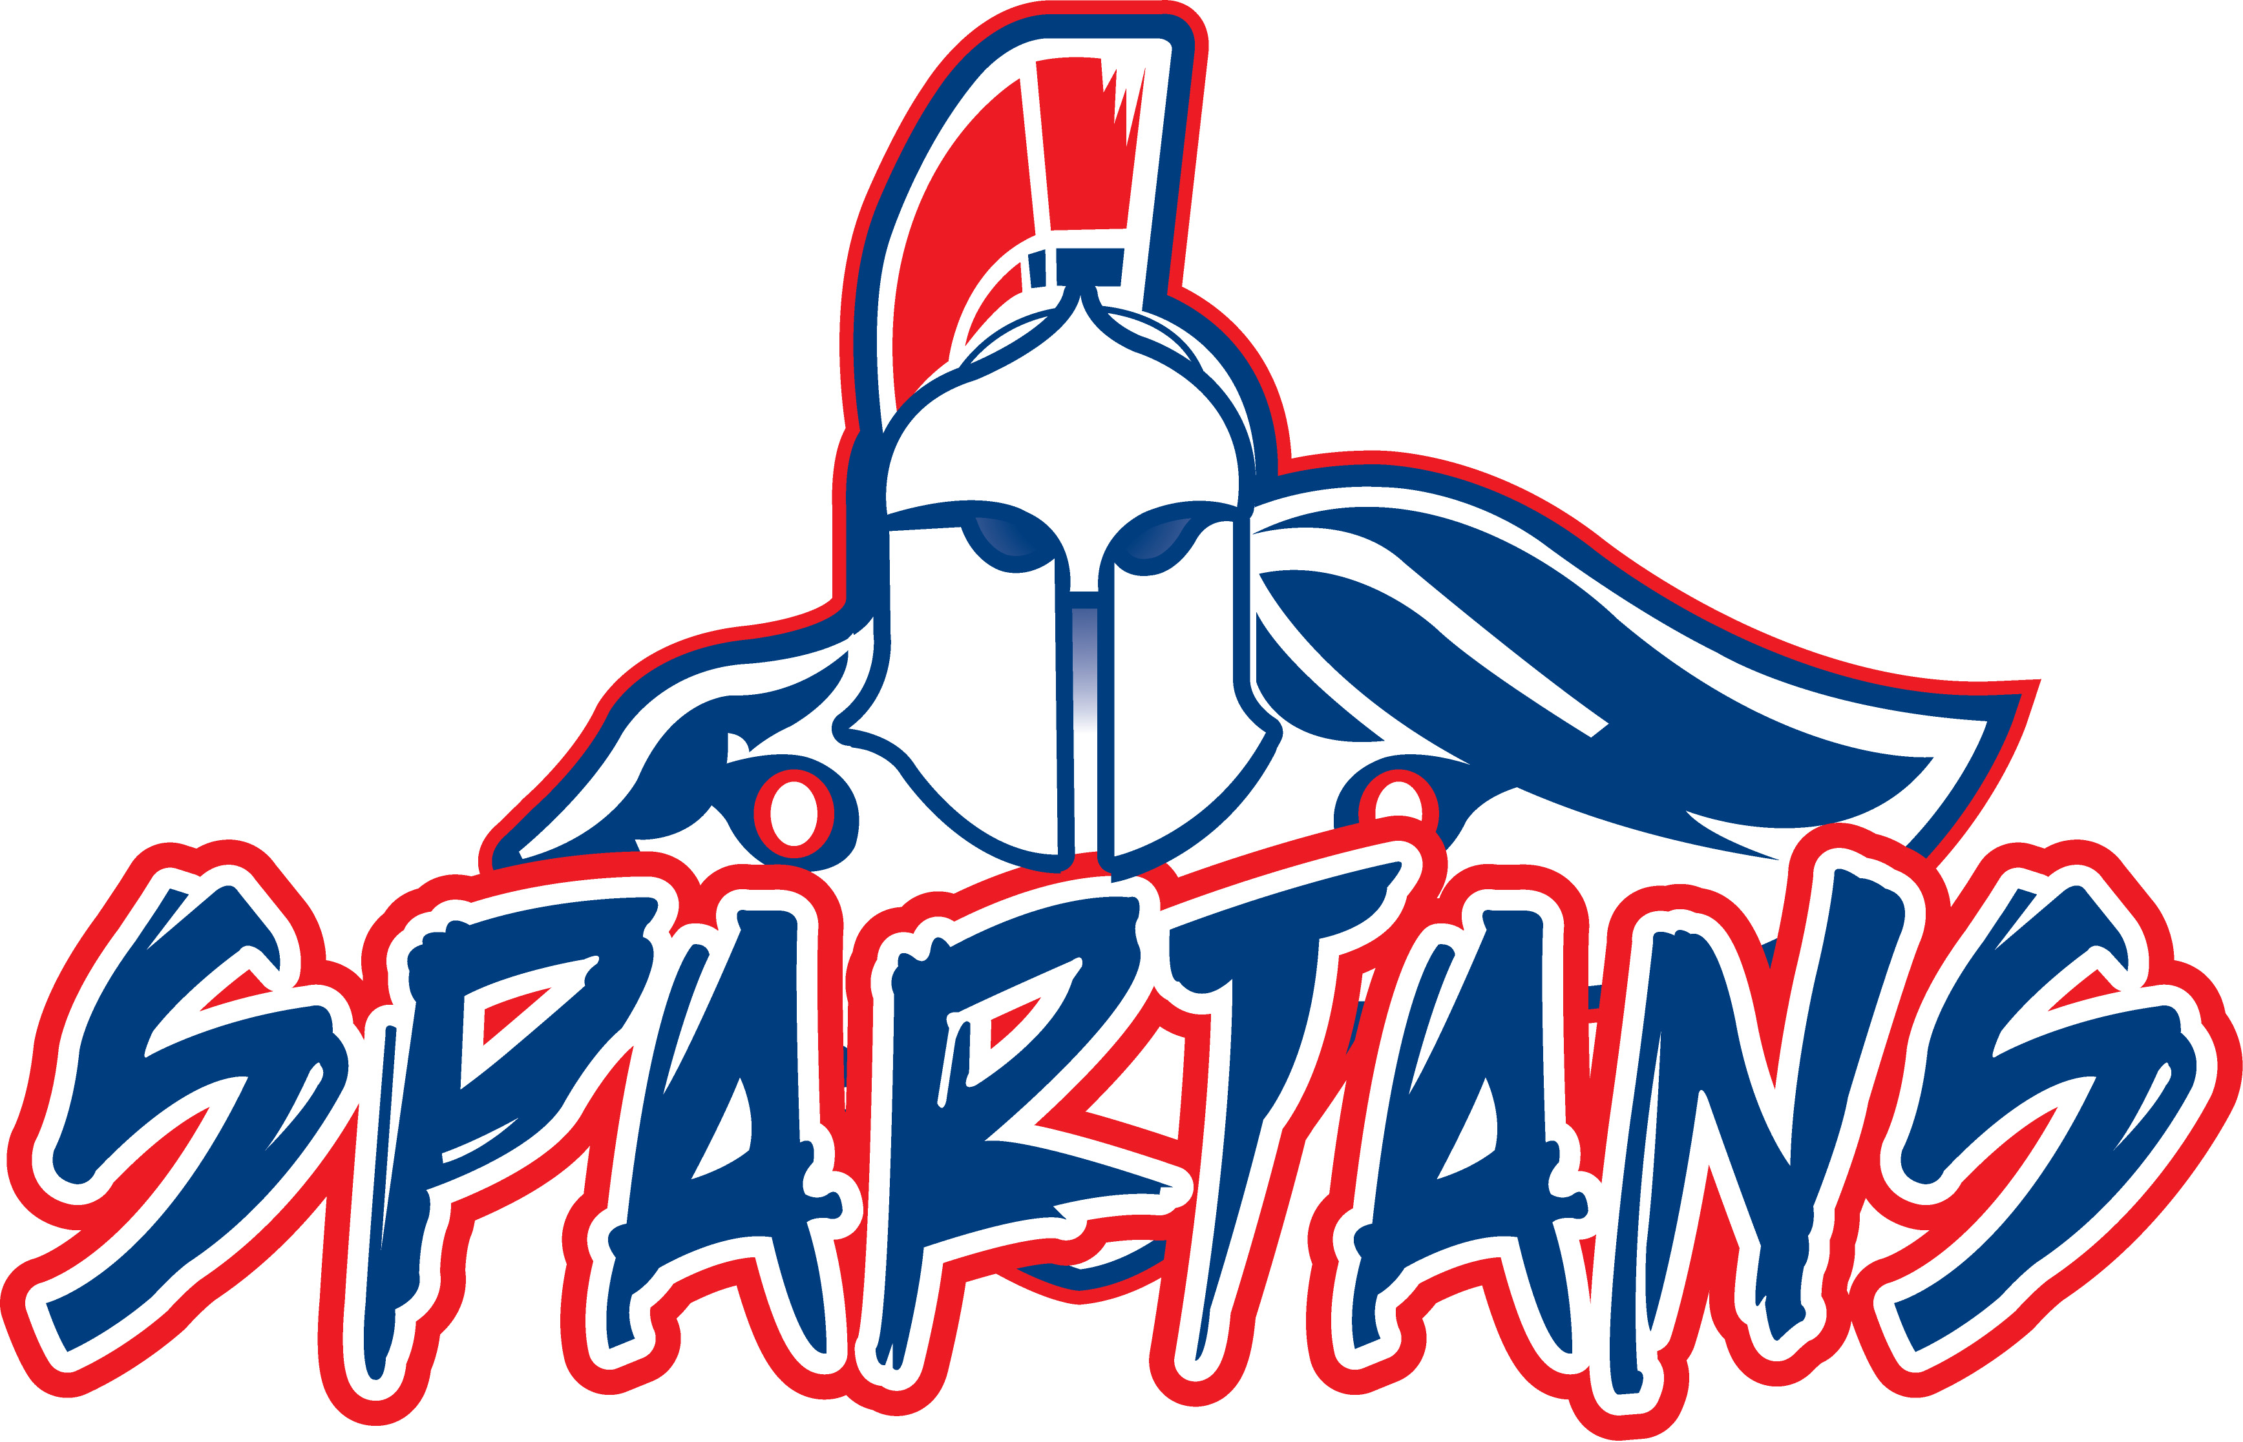
Swallows Charter Academy

WHEREAS, Colorado is a local control state, where local school boards, particularly and specifically those governing charter schools are constitutionally granted broad discretion in setting curriculum and standards for their students; and,
WHEREAS, Swallows Charter Academy has successfully pursued the most rigorous academic standards in a program that encourages students to recognize and value scholarship and character through a sound curriculum based on the great ideas and values of our Western Heritage; and,
WHEREAS, the Common Core State Standards (CCSS), while potentially reasonable and appropriate for many schools to emulate, are not reasonable or appropriate at Swallows Charter Academy because our standards are more rigorous, more thorough, and more directly tailored to the unique needs of our students, as they prepare to become active and responsible members of the community; and,
WHEREAS, the CCSS inhibit innovation, run contrary to our mission and vision, eviscerate content, weaken rigor, and require assessments and date processes that compromise student privacy while incurring unnecessary financial burdens; and,
WHEREAS, the Board of Swallows Charter Academy has reviewed the CCSS, and determined that they do not meet the expectations our school has for all of our students.
NOW THEREFORE BE IT RESOLVED that the Swallows Charter Academy School Board hereby expresses its general opposition to the imposition of the Common Core State Standards as more fully detailed in the attached Statement of Concern, because charter schools should retain broad latitude in establishing customized, rigorous and high standards and guidelines for the maximum character development and educational attainment of all students.
More particularly, the School Board expresses its opposition to the uniform imposition of Common Core State Standards in the specific case of Swallows Charter Academy, because our model of pursuing honesty, integrity, respect, responsibility and excellence as guidelines for success is better measured by less intrusive, less costly, more rigorous and more traditional means than the one-size-fits-all effort that comprises CCSS. Swallows Charter School is resolved and committed to meet or exceed its vision and mission, at every turn, for every student, in every circumstance
278 S. McCulloch * Pueblo West, CO 81007 * 719-547-1627

