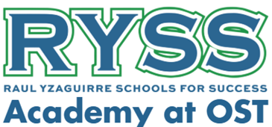
RYSS Academy at OST Dress Code Policy
Our student dress code guidelines are designed to promote a safe and distraction-free learning environment. Students need to always adhere to this policy. We consider families to be our partners in ensuring that students come to school dressed appropriately, following these expectations.
Following the dress code involves not only wearing the correct items of apparel but also respecting the proper way to wear the school uniform. Students are expected to comply with the uniform policy and maintain a neat appearance. Wearing the uniform with pride is important, as it reflects both the students themselves and the school community.
Students must always wear the proper school uniform in the specified manner, both to and from school.
Uniform Rules
- Shirts and blouses must be tucked in and remain tucked during all school hours.
- All girls must wear modesty shorts under their skirts.
Girls Daily Uniform
- Jumper: navy blue or khaki with white peter pan collar blouse
- Pull-on Polo Dress: navy blue with modesty shorts (See Below)
- Shorts or Pants: navy blue or khaki pull on
- Skort: navy or khaki pull on
- Shirt: white, navy blue, or red short or long-sleeved polo shirt
Tights, leggings, modesty shorts, and undershirts
- Tights and leggings: solid navy blue, black, red, and white tights
- Modesty shorts: solid navy blue, black, and red
- Undershirts are permitted
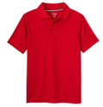
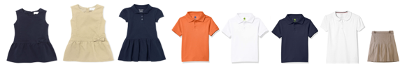
Boys Daily Uniforms
- Shorts or Pants: navy or khaki pull-on
- Shirt: white, navy blue, or red short or long-sleeved polo shirt
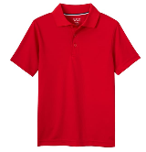
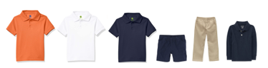
All School Boys’ and Girls’ Outerwear Options
Students may wear personal jackets and coats during the cold weather season. Raincoats and Rainboots are also permitted when the weather is rainy. Lightweight jackets may be worn in the classroom.
Socks
Solid navy blue, black, red, or white socks must be worn at all times.
Shoes
Students may wear athletic shoes (Velcro is recommended due to pre-K students' fine motor development). Sandals, boots, open-back, flip-flops, or house slippers are not allowed.
Hair
Hair is to be clean and neatly combed at all times. Hair should not cover the student's eyes. No inappropriate or extreme haircuts or styles with designs are allowed.
Hair Accessories (bows, headbands, etc.)
Hair accessories should be one of the following solid colors: navy blue, black, brown, red, or white. Unicorn, animal ears, pom poms, or any hair accessory that becomes a distraction will be collected by the Teacher.
Jewelry
OPTIONAL pairs of small earrings that fit entirely on the earlobe, one ring, a watch, and one modest necklace are permitted. Hoop and dangle earrings present safety issues and are not permitted. The school will not be responsible for the loss, breakage, or theft of jewelry and/or personal items.
Cosmetics and Nails
Cosmetics are not allowed. Nails should be in their natural state, or girls may wear clear nail polish.

Body Art
No tattoos or body art are allowed.

Spirit Day Dress
Every Friday is spirit day. On this day, students can wear a spirit or college shirt. Tops should be worn with school-approved uniform bottoms, shoes, and daily hair accessories. Spirit shirts will be on sale the first few weeks of school.

Free Dress
During the school year, special days may be designated as non-uniform dress days. This will be communicated to parents.

Free Dress Guidelines:
- Halters, tank tops, strapless tops, spaghetti straps, and bare midriffs are not permitted.
- Pants with holes are not allowed.
- Inappropriate printing, logos, or decorations are not permitted on clothing.
- Clothing and accessories must not display vulgarity, firearms, weapons, sexual innuendos, or cultural or racial insensitivity, including statements that demean or promote religious or political beliefs, or promote the use of tobacco, drugs, or alcohol.
- Pajamas and slippers are not appropriate school attire and must not be worn.
- Sandals, flip-flops, high heels, or house slippers are not permitted at any time.

If you have any questions, please contact us at 713-581-9695.

