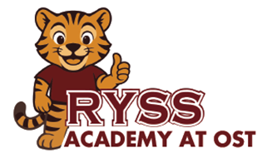
RYSS Academy at OST Kindergarten School Supply List
Below is a list of supplies that your child will use in their classroom this school year.

1 | Clear View ½ inch  White Binder | 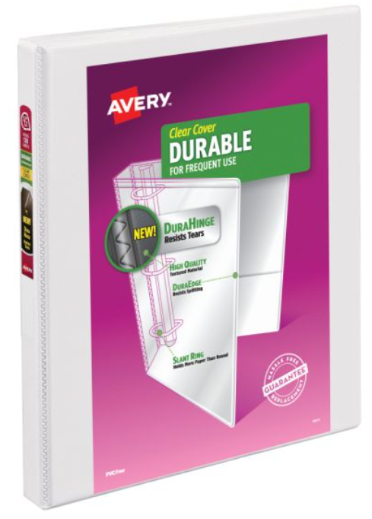
1 | 3 Ring Binder Pencil Pouch  (3 Metal Holes) | 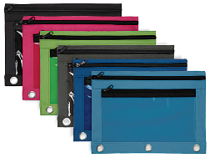
5 | Plastic Folders with Pockets and Brads  (1 Blue, 1 Green, 1 Yellow, 1 Red, and 1 Purple) | 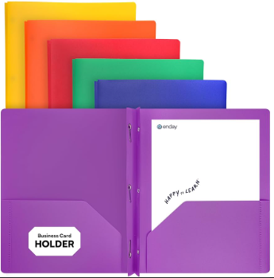
2 | 24 Count #2 Pencils | 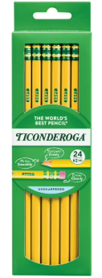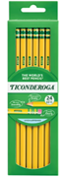
2 | Box of 8-Count Washable Crayola Markers | 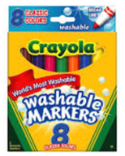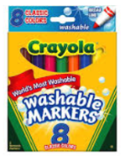
2 | 24 Count Crayola Crayons  (Pre-K 4 Students) | 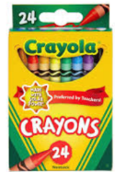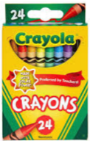
1 | Crayola Color Pencils | 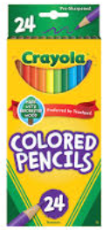
2 | Watercolor Pallets | 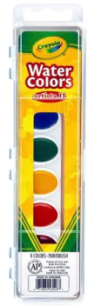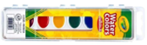
1 | 4-count Play-Dough Packs (Primary Colors) | 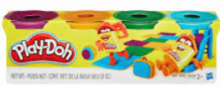
1 | Pair of Fiskars Scissors | 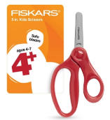
2 | Bottles of Emler’s Glue | 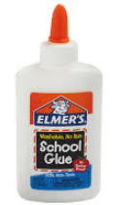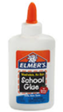
4 | Glue Sticks | 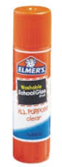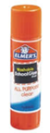
4 | Primary Composition Notebooks | 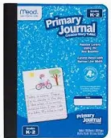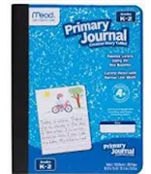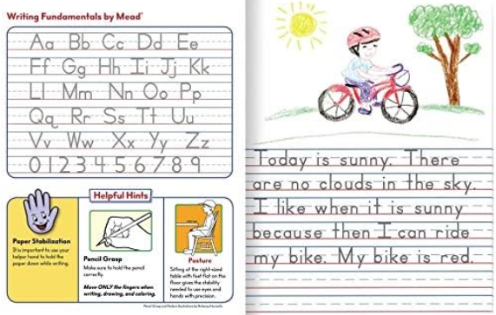
2 | Manilla Paper  (1-9x12 and 1-12x18) | 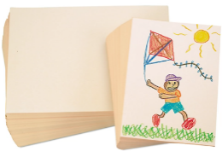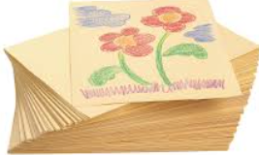
2 | Multicolor Construction Paper  (1-9x12 and 1-12x18) | 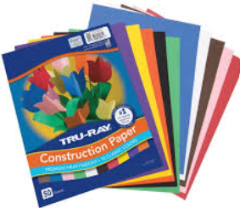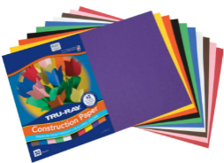
1 | Wipes | 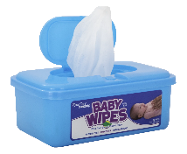
2 | Box of Kleenex | 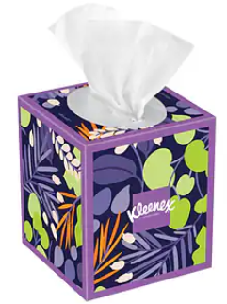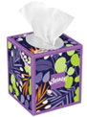
1 | Spillproof Water Bottle | 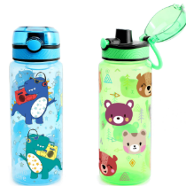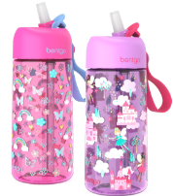
1 | Backpack  (Large enough to fit a ½ binder and their small blanket) | 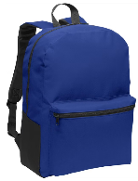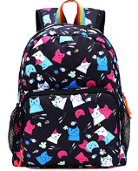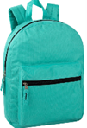  No roller wheel backpacks or toddler backpacks
1 | Change of clothes in a Ziplock Bag (top, bottom, socks, and undergarments)  Weather Appropriate

