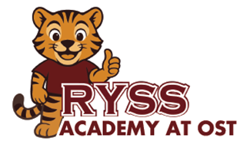
RYSS Academy at OST Pre-K School Supply List
Below is a list of supplies that your child will use in their classroom this school year.

1 | Clear View ½ inch White Binder | 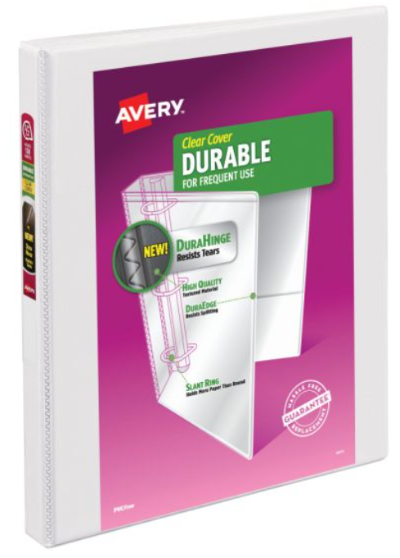
1 | Pencil Pouch  (3 Metal holes) | 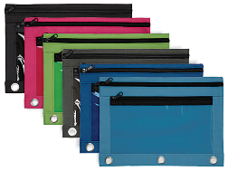
2 | Box of 8-Count Washable Crayola Markers | 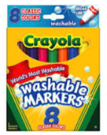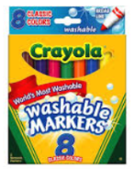
2 | 24 Count Crayola Crayons  (Pre-K 4 Students) | 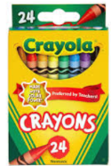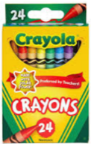
2 | 16 Count Jumbo Crayola Crayons  (Pre-K 3 Students) | 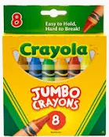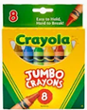
1 | Crayola Color Pencils | 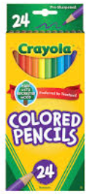
2 | Watercolor Pallets | 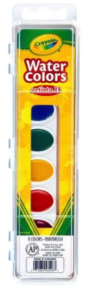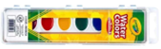
2 | 4-count Play-Dough Packs (Primary Colors) | 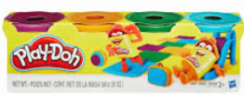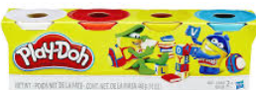
1 | Pair of Fiskars Scissors | 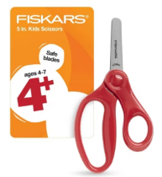
2 | Bottles of Emler’s Glue | 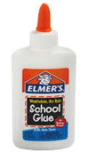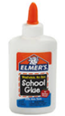
4 | Glue Sticks | 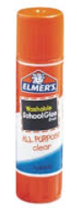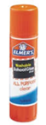
4 | Primary Composition Notebooks | 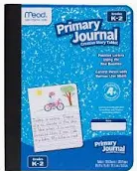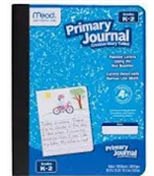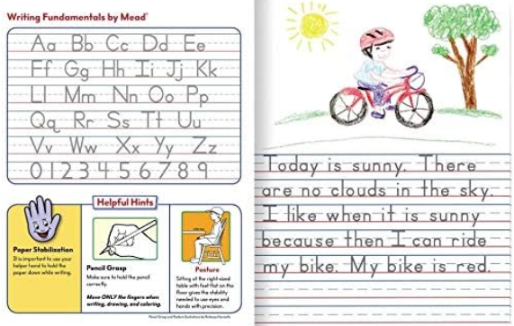
2 | Manilla Paper  (1-9x12 and 1-12x18) | 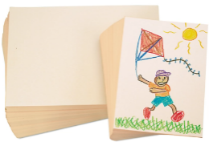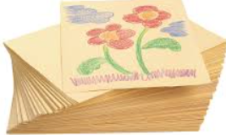
2 | Multicolor Construction Paper  (1-9x12 and 1-12x18) | 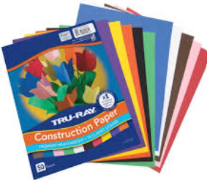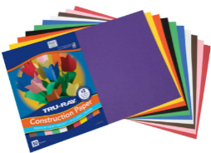
1 | Wipes | 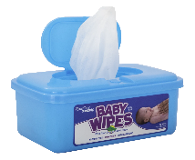
2 | Box of Kleenex | 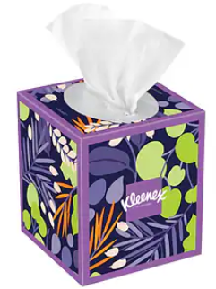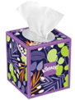
1 | Red and Blue Sleeping Mat (Kinder Mat 1”x19”x45”) | 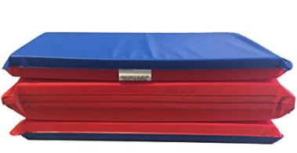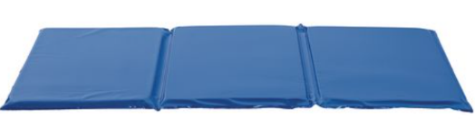
1 | Small Blanket (30x40) | 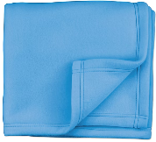
1 | Spillproof Water Bottle | 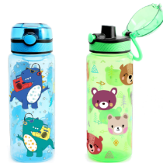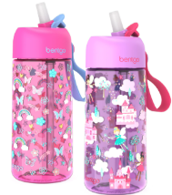
1 | Backpack  (Large enough to fit a ½ binder and their small blanket) | 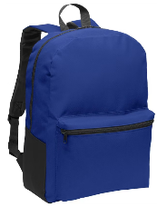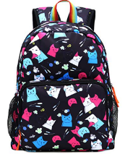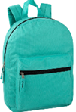  No roller wheel backpacks or toddler backpacks
1 | Change of clothes in a Ziplock Bag (top, bottom, socks, and undergarments)  Weather Appropriate

