ABOUT WHITSONS

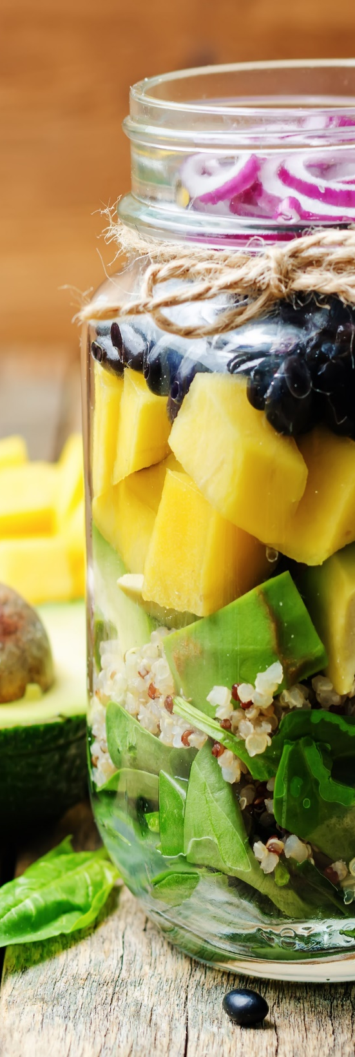
At Whitsons, we believe that every meal should be a celebration of real ingredients and authentic flavors. That’s why our meals are crafted with care and precision, using traditional scratch-cooking methods that respect the essence of real, fresh, wholesome food packed with nutrition and natural goodness.

INTRODUCING REAL MEALS™ BY WHITSONS
Real Meals™ by Whitsons are made fresh with wholesome ingredients the way nature intended, and they are fueling the minds of students across the country. We are dedicated to nourishing students within the communities that we serve with delicious meals made from scratch using local ingredients whenever possible, truly supporting our mission of Enhancing Life One Meal at a Time™.
This approach reflects our commitment to personalizing high-quality, innovative, and culturally appropriate meals for each of our communities. We believe it is important to serve the same kinds of meals to our customers that we would serve to our own families, and they would serve to theirs.

UNDERSTANDING SCHOOL MEALS
School meals are a healthy option, a great value, and convenient for busy families!
- The National School Lunch & Breakfast Program (NSLP and SBP) are federally funded programs providing nutritionally balanced meals to children each school day.
- The Healthy, Hunger-Free Kids Act (HHFKA) ensures that meals are healthy and well balanced and provide students with all the nutrition they need to succeed at school. Some things you can expect to see from Whitsons includes: whole grain offerings, variety of fresh fruits and vegetables, focus on lean protein choices, smart snack options, fat-free and low-fat milk, and reduced sodium content.
- All student meals include: Protein Choice, Fresh Vegetable Choice, Grain Choice, Fruit Choice, and Milk Choice.
LIFELONG WELLNESS STARTS NOW

Our interactive Real Meals™ healthy eating program motivates and inspires students to consider the many benefits healthy eating and exercise have on their growing bodies and minds. We are on a journey to help students develop positive self-esteem and healthy eating habits by presenting healthy living as a lifelong mindset. It’s all about making the connection between food and healthy habits at a young age.
At the elementary level, our award-winning Nutrition Safari® program introduces younger students to lovable characters to teach them about selecting healthy choices from each different food group for a well-balanced diet. The program’s mission is to encourage students to develop lifelong healthy eating habits.
At the secondary level, monthly Flaves and special event Pop-up Shops will feature trendy menus items and activities to engage older students. Whitsons also invests in professional signage and merchandising that creates a food court-style environment. It’s like going out to lunch without ever leaving the building. Our goal is to entice students to make nutritious and delicious meal choices.

OUR MENUS
Healthy school meals are a critical component to the overall educational experience, nourishing the body, and setting the stage for a day of learning and knowledge retention. We offer age-appropriate lunch menu options at each grade level, with increasingly more options at the older grade levels as students mature and learn how to make healthier choices.
At the elementary school level, we strive to help educate and guide younger students to make balanced meal choices by offering familiar “kid-friendly” foods made with healthier ingredients. Whereas, at the secondary level, we offer a food-court style environment with a wider variety of wholesome menu options.
Whitsons offers a variety of meal choices and Smart Snack options that meet NSLBP, HHFKA, and state nutrition guidelines, and are analyzed and approved by Registered Dietitians. We also collaborate with parents, students, and school nurses to accommodate the dietary requirements of students with food allergies and other special diets.
Our interactive menus may be found online at www.fdmealplanner.com, and they will provide you with all the nutritional and allergen information you will need to plan your child(ren)s’ school meals. You can also download the FD Meal Planner app on your smartphone for convenient access.

CONTACT US
If you have any suggestions for the school nutrition program, please contact Stacey Toney, General Manager at stoney@millburn24.net. .We are here to serve you and your child(ren)’s needs and look forward to being a part of your community for many years to come!

