MT. DIABLO HIGH SCHOOL STUDENT PHONE POLICY

Phones, earbuds,tablets or iWatches are not to be used during school. Every student is assigned a personal Yondr Pouch. While the Yondr Pouch is considered school property, it is each student’s responsibility to bring their Pouch with them to school every day and keep it in good working condition. Bluetooth Headphones and iPads are not allowed to be used during the school day and must remain out of sight.

DAILY PROCESS
When students Arrive at School, they will:
- Place their phone, iWatch and earbuds inside their Pouch and secure and lock it.
- Store their Pouch in their backpack for the day.
- Before entering their First Period Class, teachers will check that the student’s phone is in their Pouch and that the Pouch is locked and not damaged.

At the end of the day, students will open their Pouch, remove their phone, and put their Pouch in their backpack. Students must bring their Pouch to school with them each day.

*Students arriving late or leaving early will pouch/unpouch their phones at the attendance window in the Main Office.

Students who do not have a phone:
- Will need to go to the office and receive a “No Phone” day pass. They will need to keep this pass with their Yondr Pouch and show it when there is a Yondr Check.
  - A call will be made home to confirm the student does not have a phone.
  - If the student does not own a phone, they will get a special pass stating that they will not have a phone on campus. A new pass will be issued each semester.

Students who do not have their Yondr Pouch:
- Must go to the office and leave their phone. They will receive a pass that says their phone is being held in the office.
- If they have lost their Pouch, they will be given a new Pouch and $50 will be charged to their account.

INFRACTIONS

Using Phone and/or Earbuds During School and/or Pouch Damage
1) Initial Violation– phone and/or earbuds will be confiscated and secured in the main office. Student’s parents/guardians will be required to come to school to pick up the phone/earbuds.
2) Subsequent Violations – phone and/or earbuds will be confiscated and secured in the main office. Student’s parents/guardians will be required to come to school to pick up the phone/earbuds. Student’s will receive after-school detention.
3) Continuous Violations – will result in additional consequences such as a principal’s conference, behavior contract or other disciplinary measures.

Damaged or Lost Pouch - $50 Replacement Fee
Bolsa dañada o perdida: tarifa de reemplazo de $50
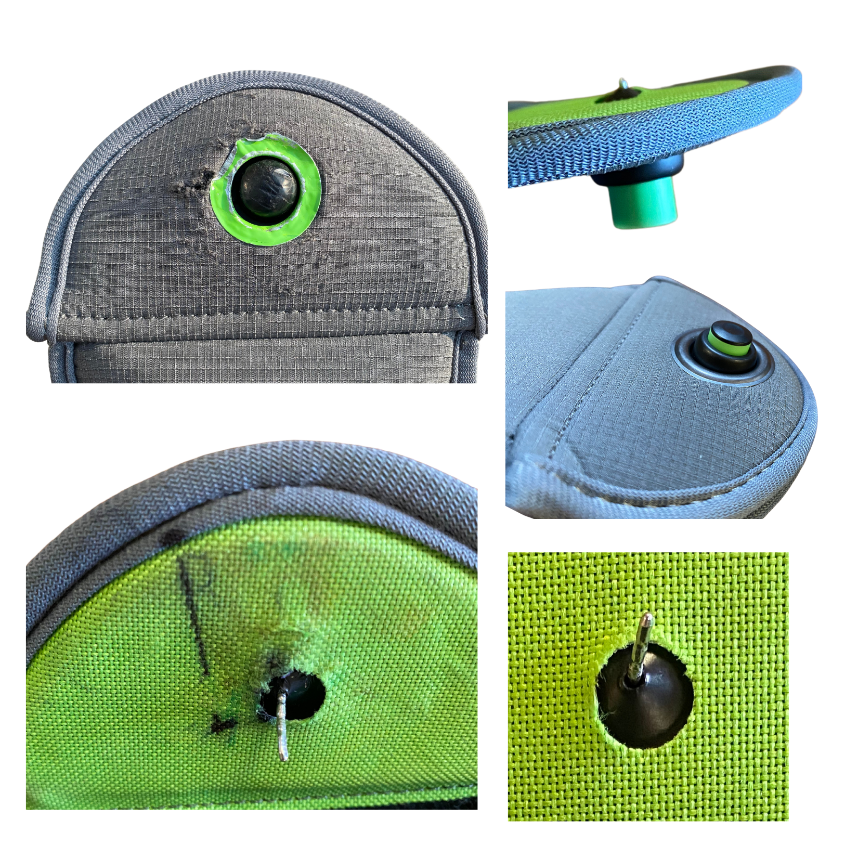

Examples of Damage / Ejemplos de daño

- Deep scratches on the globe and on the green ring around it.  - Intentional pen marks on the inside of the Pouch.  - Bent pins.  - Pin and button not fully recessing, due to pin damage.  - Damage to the locking mechanism. | - Arañazos profundos en el globo y en el anillo verde que lo rodea.  - Marcas intencionales de lapicero en el interior de la bolsa.  - Pasadores doblados.  - El pasador y el botón no encajan completamente debido a daños en el pasador.  - Daño al mecanismo de bloqueo.

