Athlete’s Name: ______________________
Northeast Academy 
DreamBox Summer Olympics

You do not need to turn this in. Progress will be noted in Dreambox. Complete as many
lessons as you can over the summer! Medals will be awarded in September based on how
many levels you do.
K-2 | Levels Needed | 3-5 | Levels Needed
Gold | More than 61 | Gold | More than 71
Silver | 41-60 | Silver | 51-70
Bronze | 21-40 | Bronze | 31-50

Lessons Tracker
If you wish, you can keep track of your completed lessons on the attached 100 chart by coloring in a box for each lesson you complete. *However, you don’t need to turn it in, it’s just for you to keep track and reach your goal!

Total Lessons: _______

Aim high! Work hard! REACH FOR THE GOLD!!!!!

DreamBox FAQ

Is it okay to help my student with their lessons?
- It is very important for students to work independently to play DreamBox. The program is adaptive, so help from an adult, sibling, etc. will alter the students’ performance and what the program is giving the students for their “just right” level. DreamBox has help tools and hints embedded in the program, so if your student is struggling, encourage them to look for those tools. Wrong answers will also help them learn and allow the program to adapt to their needs.
Which devices can I use to play DreamBox?
- Students can play DreamBox on all computers, laptops, and Chromebooks through an internet browser and on all iPad tablets since iPad 2 (2011) through our DreamBox Math apps. At this time, DreamBox is not available on smartphones and is not supported on Android tablets.
How do I log in?
- All students have the ability to log in using their Groton email address. However, younger students may also have been given a QR code from their teachers for ease in logging in. Students are familiar with the login process from school, but see attached for directions.

Log In Directions

- Go to www.clever.com

- Click Log in as a student

- If you are using your school issued Google email account to log in…
  - Search for your school (Groton Public Schools)
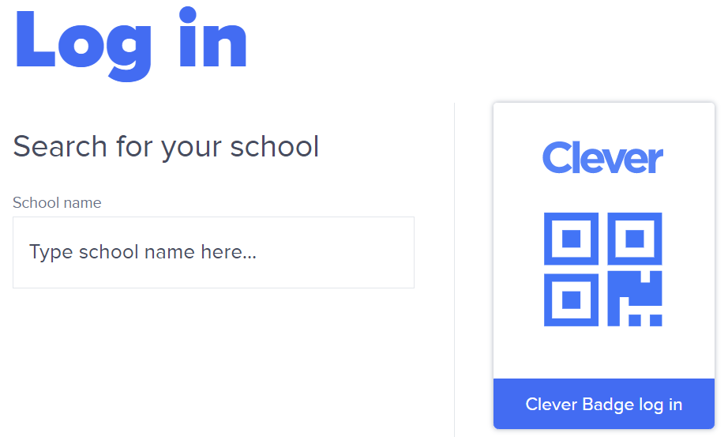
  - Click Log in with Google
  - Older students will be able to do this without help, while younger students may need help.
  - The username is their first name, middle initial, and the first four letters from their last name. (So Lucky W. Eastwood would be luckyweast@grotonk12.org.)
  - Make sure the address is @grotonk12.org.
  - Click “Next”
  - Have your child enter the password - “groton.” Click “Next.”
  - Click on the “DreamBox” icon. Now your child is logged in and can play DreamBox!

- If you are using a QR code issued by the school (younger students only)...
  - Click Clever Badge log in
  - Your computer may ask permission to access the camera. Click on “Allow.”
  - Your camera will turn on. Hold up the QR Code until a green check appears on the screen.
  - Click on the “DreamBox” icon. Now your child is logged in and can play DreamBox!

