Daleville High School

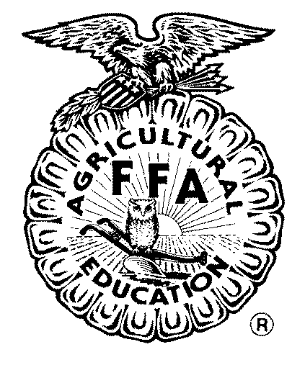

Officer Application Packet

Advisor:

Franky Jackson

UPDATED MAY 2025

2

Daleville FFA Officer Team Requirements

- You must be enrolled in an agriscience course to be an FFA member. This will allow you to become an officer.
- You must memorize your part in the Opening and Closing Ceremonies.
- You must attend chapter and committee meetings through the year as they arise.
- You must be at Officer Interviews.
- You also must:
  - Purchase an FFA Jacket as part of the Official Dress.
  - Purchase, if you do not already have, black pants, white shirts, and black shoes for the males, or black skirt or pants, white blouse, and black closed toe and heel shoes for the females to complete the requirement for Official Dress.
  - You will be given the official tie for men and official scarf for the women.
- You must attend FFA activities and events whether chapter or higher levels; County, District or State.
- You must be at FFA functions unless an emergency occurs.
- If you have a job, it must not interfere with your duties and participation.

9. Abide by Code of Conduct on the following pages.
10. Abide by the Daleville High School Student Handbook rules and regulations.
By signing the signature page, you agree to meet the above requirements

3

Code of Conduct

Being a Chapter FFA Officer is an incredible opportunity and a privilege that can change your life. With this privilege comes great responsibility. You will be a leader at your school, and have other students looking to you for advice, help, and wisdom. For that reason, we will maintain a very strict code of conduct and attendance requirement. The traditions of the FFA are that of excellence and we must work to maintain it. Not abiding by any of the rules below would greatly damage that image. In order to protect that image, and those that look to officers as models, your resignation will be expected or possibly required if you break a rule.

If selected to Chapter office, I will:

- Be dedicated and committed to Daleville FFA and consider FFA activities to be my primary extra-curricular responsibility.
- Maintain a “C” average.
- Attend school regularly, No excessive absences.
- Fulfill the specific duties for your office, as listed in the official FFA Manual.
- Serve as the chairperson of your office’s designated committee.
- Respectfully represent the Daleville FFA Chapter at all times.
- Further my knowledge of agriculture education and the FFA.
- Write thank you letters, notes, news releases and other correspondence as necessary.
- Maintain and protect my health through refusing alcohol, tobacco, and illegal substances during my year of tenure.
- Treat all FFA members equally by not favoring one over another and conduct myself in a manner that commands respect without any disrespect.
- Avoid places or activities that in any way raise questions as to my moral character or conduct.
- Participate in a career development event.
- Serve as a member of the officer team, always maintaining a cooperative attitude, working in harmony with fellow FFA officers, and not knowingly engage in conversations that hurt other FFA members, officers, students, or adults.
- To attend meetings regularly officer or chapter.
- To attend after school activities as they arise.
- You Must follow school Code of Conduct at all times including the DHS Dress Code by not wearing articles of clothing that are revealing, advertising alcohol, tobacco, drug use or sexual connotations
- Suspension from school will result in dismissal from the officer team.
- Avoid social media posts that would violate any of the above rules.
- Follow the FFA Code of Ethics:
  - Dress neatly and appropriately at FFA Functions.
  - Show respect for the rights of others.
  - Be honest and not take unfair advantage of others.
  - Respect property of others.
  - Refrain from loud, boisterous talk, swearing, and other unbecoming conduct.
  - Demonstrate sportsmanship in the show ring, judging events, and meetings. Modest in winning and generous in defeat.
  - Attend meetings promptly and respect the opinion of others in discussion.
  - Take pride in our Chapter, activities, our exhibits, and for the occupation of agriculture.
  - Share with others experiences and knowledge gained by attending leadership conferences, state, and national meetings.

4
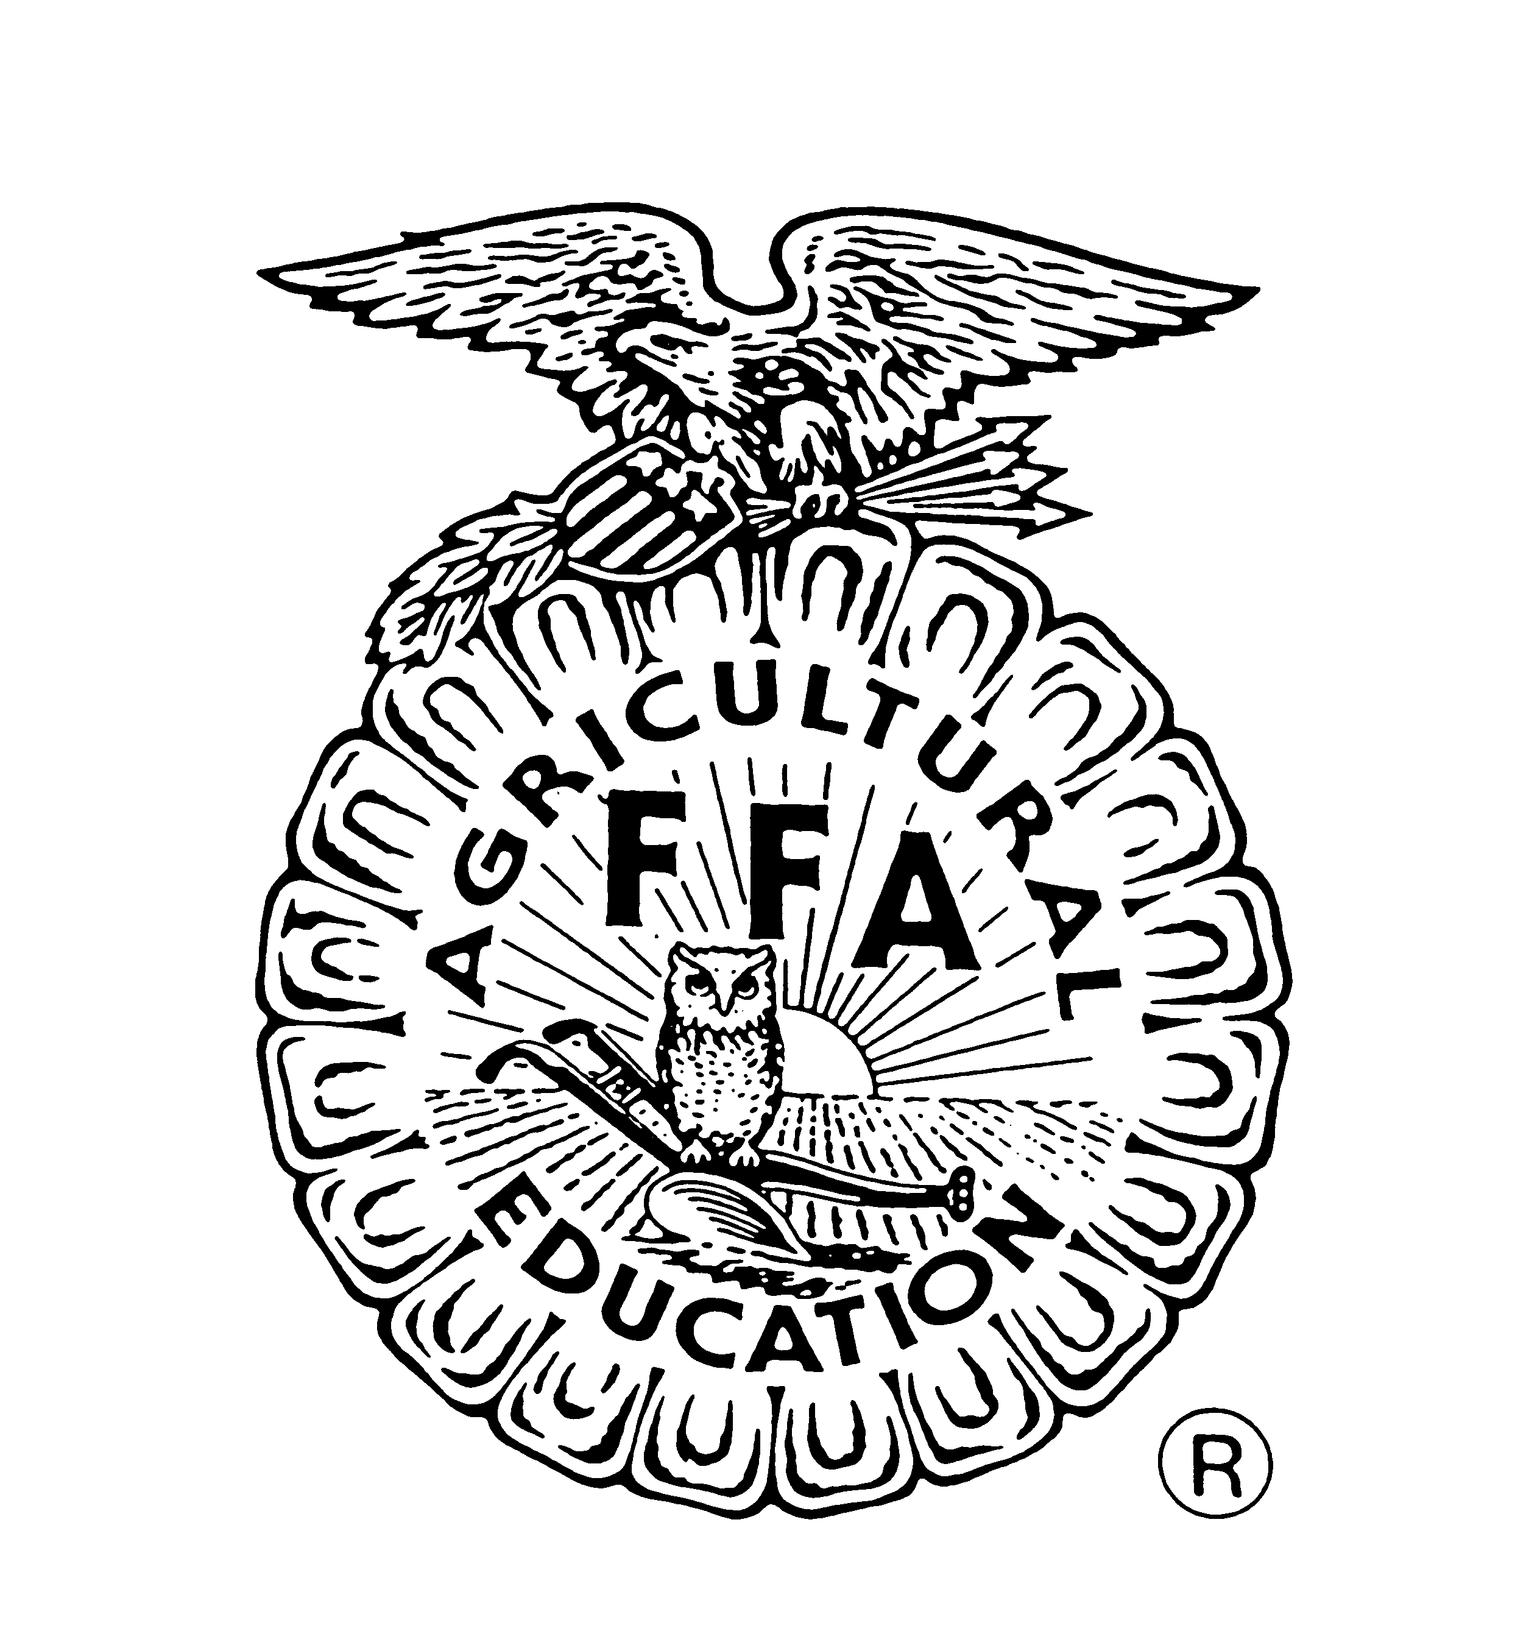
Daleville FFA Chapter

To the parents:

We are very excited that your child has decided to take the next step in their leadership involvement with our FFA chapter by running for a chapter officer position. FFA is not just another club at our school. It is the nation’s largest student leadership organization. As an officer, your child will be an intricate part of the work to coordinate and conduct the events of the chapter. They will be official representatives of our chapter and we expect them to represent our chapter in a positive light at all times.

For these reasons we ask for your help. We want to ensure that we have your full support for your child’s participation in our team. We ask that you please help us in the following ways when possible:

- Try to refrain from using FFA as a punishment for your child. We understand that each situation is different and we respect your right to discipline your child how you see fit, but it puts a strain on our team and chapter’s ability to achieve our goals. Please communicate with us if there is a time when it is necessary to keep your child from our activities.
- Please help us monitor your child on social media. Please stress the importance of them not posting any pictures or words that would be derogatory to themselves, others, or our organization.
- Please understand we try to set the majority of our date’s far in advance and communicate with your child about what their responsibilities are for the year. It is very stressful to our team when students do not communicate effectively with their parents and have to miss events because of other plans.

Once again, we appreciate your child’s willingness to serve our great organization. We have no doubt FFA has the potential to change lives as we are both products of going through great FFA programs. We encourage you to be involved in your child’s life and in our FFA activities. Thank you for allowing them this opportunity and we look forward to working with each of you throughout the coming year.

Sincerely,

Franky Jackson,
Advisor

5

Daleville High School

FFA Officer Application Signature Page



By signing this signature page, I promise to abide by all of these rules, requirements, and code of conduct and represent the Daleville High School FFA with respect, honesty, integrity, dignity, and pride. My failure to fulfill any of these requirements can result in my dismissal from the DHS FFA Officer Team.

Officer Applicant Signature: ____________________________
Parent Signature: _____________________________________
Parent Signature: _____________________________________

6

Daleville FFA

Application
Name:
Cell Number:
Overall GPA:
What grade are you in school?
Are you involved in any other teams or organizations that would interfere with you fulfilling your FFA Officer Duties? If yes, explain.
What office positions have you held in FFA? How well do you feel you did?

Why do you want to be an FFA officer?
What office do you want to hold and why?
Do you have any special skills that will help you as an officer?
What would you like for the FFA chapter to accomplish this year?
What FFA activities have you participated in or assisted with before?
We would prefer that you type your applications. You may borrow our computers if you do not have one at home. *boxes will expand, so feel to free type as much as you want for each answer.

7
What Career Development Events were you on this past year?

How important will FFA events and functions be to you?

How do your parents feel about your wanting to be an FFA Officer?
What community service activities have you participated in?
Parent contact information; phone, email, etc.

Applicant Signature:

8
Applicant’s written statement. Use more pages as needed.

1. Why would you be a great FFA Officer? What are your qualifications or skills?

2. If you have been an officer before, what do you feel your accomplishments were this past year? If not, what would you like to see accomplished this year?

