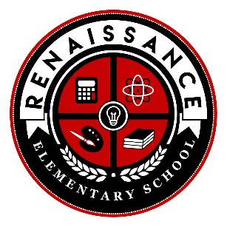
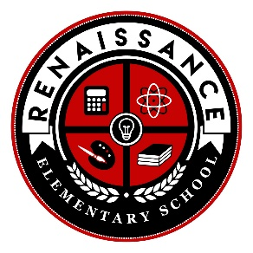
Renaissance Elementary
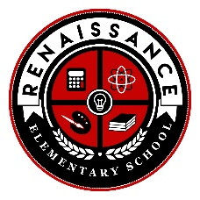
Kindergarten
2025-2026 Supply List
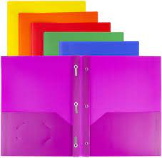  (4) Plastic Folders | 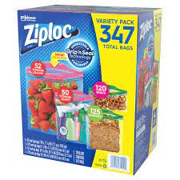 (1) Box of Ziploc Bags (gallon, quart, sandwich or snack-size) | 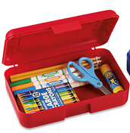  Pencil Box | 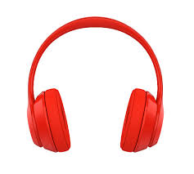  Headphones | 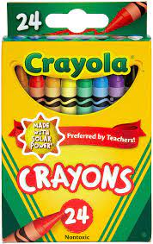 (1) 24 Count Crayon Box
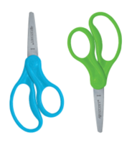  School Scissors | 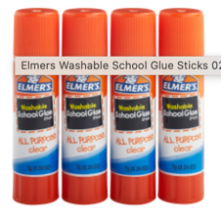  Glue Stick | 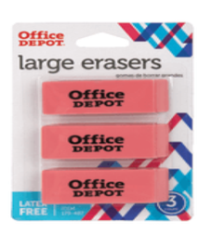  Erasers | 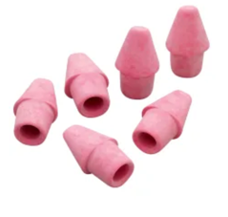  Pencil Cap Erasers | 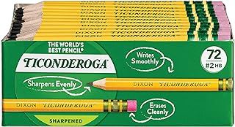  Golf Size #2 Pencils
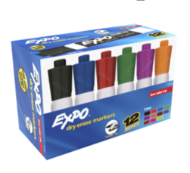 Expo Markers | 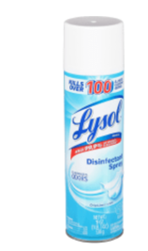 Lysol Spray | 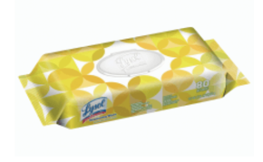  Lysol Wipes | 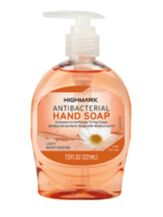  Hand Soap | 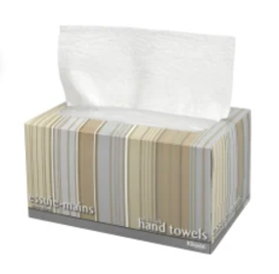  Kleenex
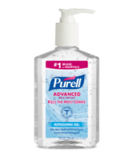 Hand Sanitizer | 😃  A Smile!
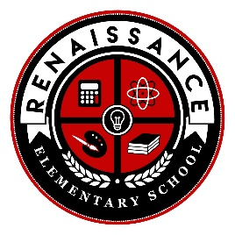
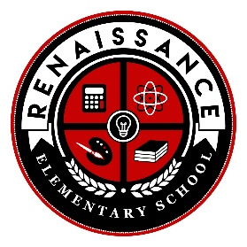
Renaissance Elementary
Third Grade
2025-2026 Supply List
(4) Plastic Folders | 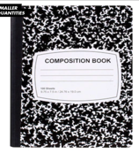  (4) Composition Notebooks | 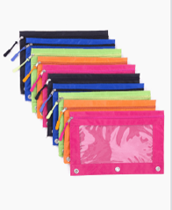  Pencil Pouch | 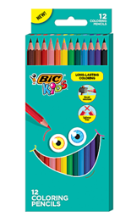  Colored Pencils | 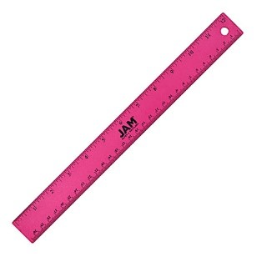  Ruler
School Scissors | Glue Stick | Erasers | Pencil Cap Erasers | 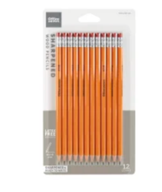  #2 Pencils
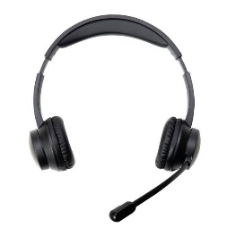Headphones with Microphone | Expo Markers | 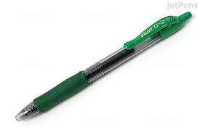  Pens (Green) | Lysol Wipes | Hand Sanitizer
Hand Soap | Kleenex | Lysol Spray | 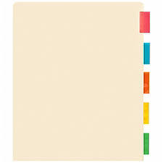Binder Dividers | 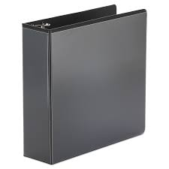 (1) 1 Inch Binder
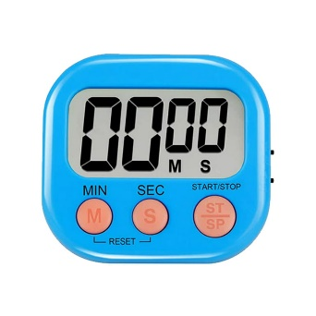  Digital Timer | 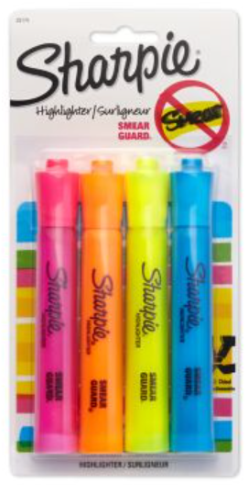Highlighters | 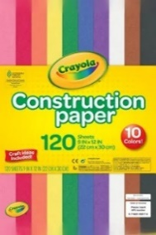  Construction Paper | 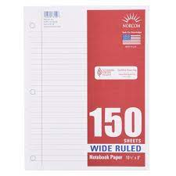 (2) Wide Ruled Paper | 😃  A Smile!

Renaissance Elementary
Second Grade
2025-2026 Supply List
(4) Plastic Folders | (4) Composition Notebooks |  | (1) Box of Ziploc Bags (gallon, quart, sandwich or snack-size) |  | Colored Pencils |  | 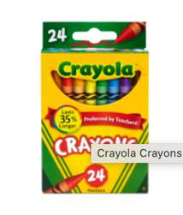Crayons
Pencil Pouch | 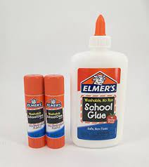  (2) Glue Sticks and Bottles |  | Erasers |  | Pencil Cap Erasers |  | School Scissors
#2 Pencils | Expo Markers |  | Pens (Green) |  | Lysol Wipes |  | Hand Sanitizer
Highlighters | Kleenex |  | Lysol Spray |  | Hand Soap |  | Headphones with Microphone
Renaissance Elementary
Fourth Grade
2025-2026 Supply List
(4) Plastic Folders |  | (4) Composition Notebooks |  | Pencil Pouch |  | Colored Pencils |  | Crayons
School Scissors |  | Glue Stick |  | Erasers |  | Pencil Cap Erasers |  | #2 Pencils
Highlighters |  | Expo Markers |  | Pens (Green) |  | Lysol Wipes |  | Hand Sanitizer
Headphones with Microphone |  | Kleenex |  | Lysol Spray |  | Hand Soap |  | (1) 3 Inch Binder
 |  | Binder Dividers |  | (2) Wide Ruled Paper |  | 😃  A Smile!

Renaissance Elementary
Fifth Grade
2025-2026 Supply List
(1) Pronged Plastic Folders | (4) Composition Notebooks | Pencil Pouch | Colored Pencils | 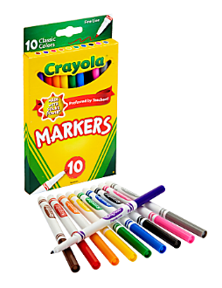Skinny Markers
School Scissors | Glue Stick | Erasers | Pencil Cap Erasers | #2 Pencils
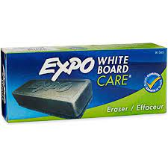EXPO Eraser | Expo Markers | Pens (Multi-Color Pack) | Lysol Wipes | Hand Sanitizer
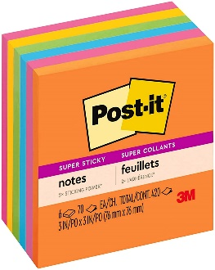Sticky Notes | Kleenex | Lysol Spray | Hand Soap | Highlighters
(1) 2 Inch Binder | Binder Dividers | Headphones with Microphone | 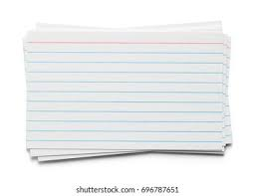 Index Cards | 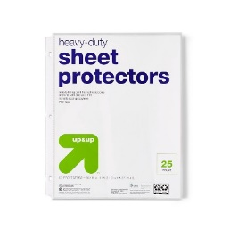 (25 pack) Sheet Protectors
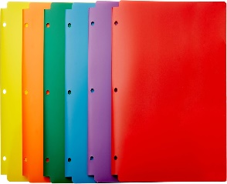
(5) Hole Punched Plastic Folders

Renaissance Elementary
Pre-Kindergarten
2025-2026 Supply List
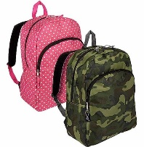  (1) Full-sized backpack (no wheels) | 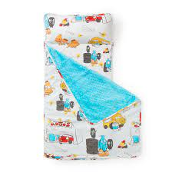  (1) Folding Cloth Mat | 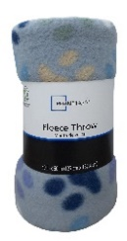  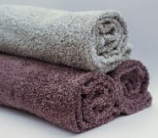  (1) Towel or Blanket | 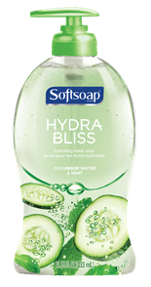  (2) Hand Soap Bottles | 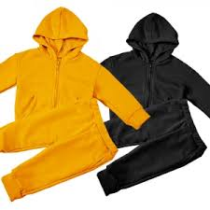  (2) Sets of Clothes (for emergencies)
(2) Hand Sanitizer | (2) Glue Sticks or Bottles | Golf Size #2 Pencils | 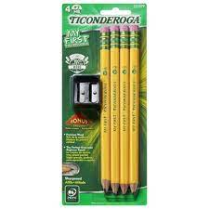  2 Packs of  “My First Ticonderoga” #2 Pencils | 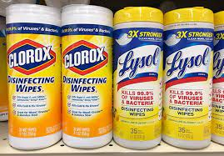  Lysol Wipes
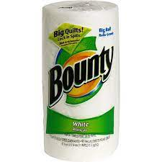 (1) Roll of Paper Towels | (1) Box of Ziploc Bags (gallon, quart, sandwich or snack-size) | 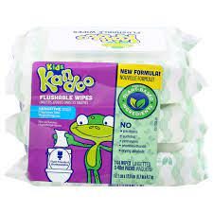  (1) Container of Flushable Wipes | (2) Boxes of Kleenex | 😃  A Smile!

Renaissance Elementary
Pre-Kindergarten (PSE)
2025-2026 Supply List
(1) Full-sized backpack (no wheels) | (1) Folding Cloth Mat | (1) Towel or Blanket | (2) Hand Soap Bottles | (2) Sets of Clothes (for emergencies)
(2) Hand Sanitizer | (2) Glue Sticks or Bottles | Golf Size #2 Pencils | 2 Packs of  “My First Ticonderoga” #2 Pencils | Lysol Wipes
(1) Roll of Paper Towels | (1) Box of Ziploc Bags (gallon, quart, sandwich or snack-size) | (1) Container of Flushable Wipes | (2) Boxes of Kleenex | 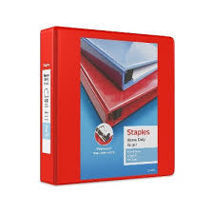  (1) 2 Inch Binder
 | 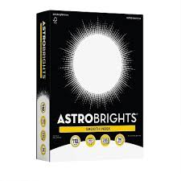 (1) Pack of White Cardstock Paper | 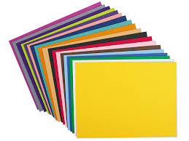  (1) Pack of Construction Paper | 😃  A Smile!

Renaissance Elementary
First Grade
2025-2026 Supply List
(4) Plastic Folders | (1) Box of Ziploc Bags (gallon, quart, sandwich or snack-size) | Pencil Box | 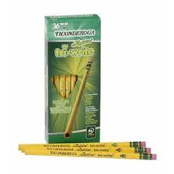  Pencils | (1) 24 Count Crayon Box
School Scissors | Glue Stick | Erasers | Pencil Cap Erasers | Golf Size #2 Pencils
Expo Markers | Pens (Green) | Lysol Wipes | Hand Soap | Kleenex
Headphones | Hand Sanitizer | Lysol Spray | (1) Box of Ziploc Bags (gallon, quart, sandwich or snack-size) | 😃 A Smile!

