In a schoolwide effort to continually improve student engagement and student performance, we have revised our attendance policy for this school year. These new procedures focus on decreasing tardies and missed days of school as referenced in the data below.

Please review this new policy carefully with your students, while keeping these key points in mind:

Supporting your students and our teachers in this effort will help set expectations for the year and create a path for students to be most successful.

Instruction is best when students are on time, partially because it minimizes interruptions and distractions.

As much as we want your student to be school, we ask that you keep sick students at home. Upon return, please bring documentation to make the day an excused absence. Also an option, students can email teachers to let them know they are absent and check Teams or Canvas for any assignments.

2025-2026 Attendance Expectations
Overall Goal: Reduce Chronic and Severely Chronic Absenteeism

SY 24-25 | # of days absent | Percent
Severe Chronic | 35+ | 7.9%
Chronic | 18-34 | 14.7%
At Risk | 9-17 | 27.4%
Satisfactory | 1-8 | 49.8%

Parents, if scheduling appointments for your student, plan pick up your child after 11:55am (after end of second block) whenever possible. It is Fulton County Schools’ policy that students picked up before 11:55am will be marked absent.

Tardies:

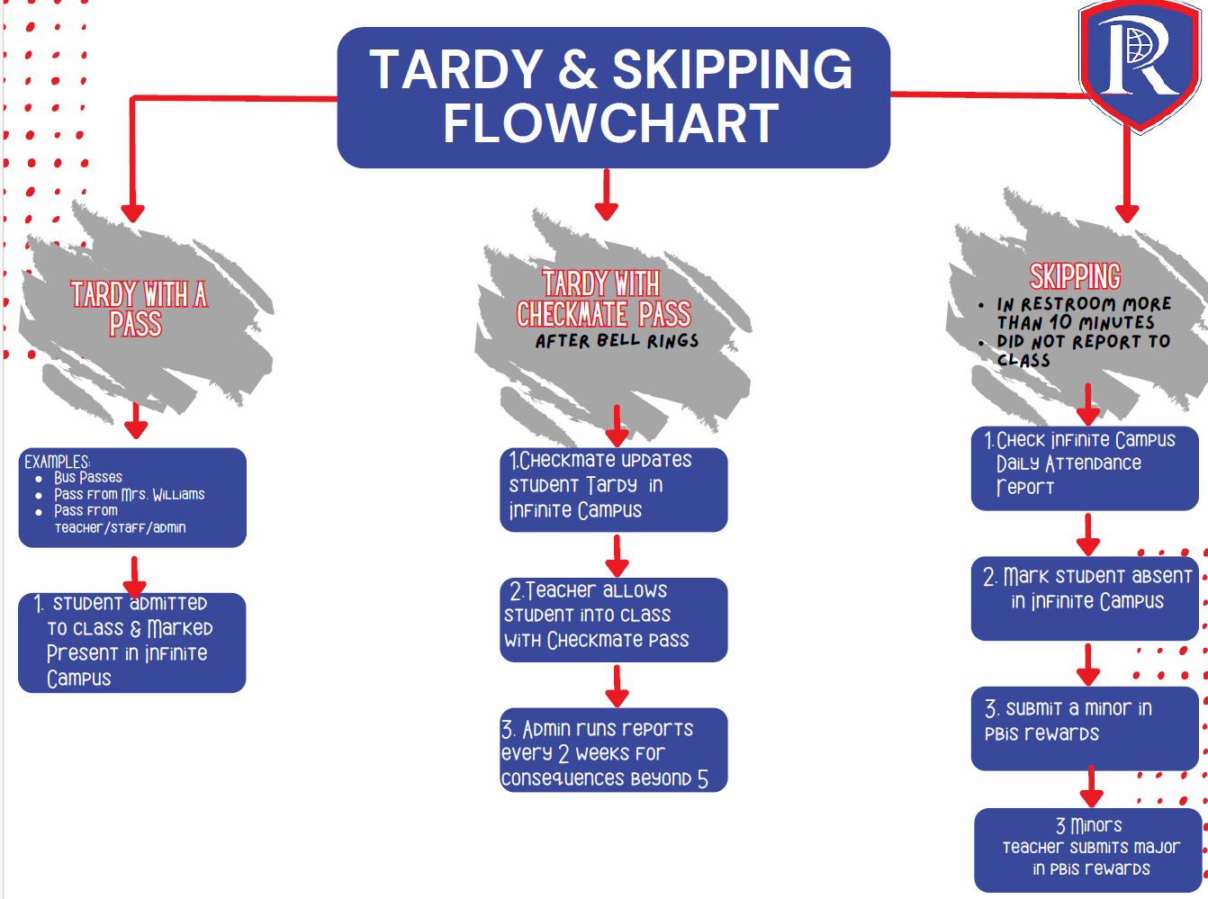
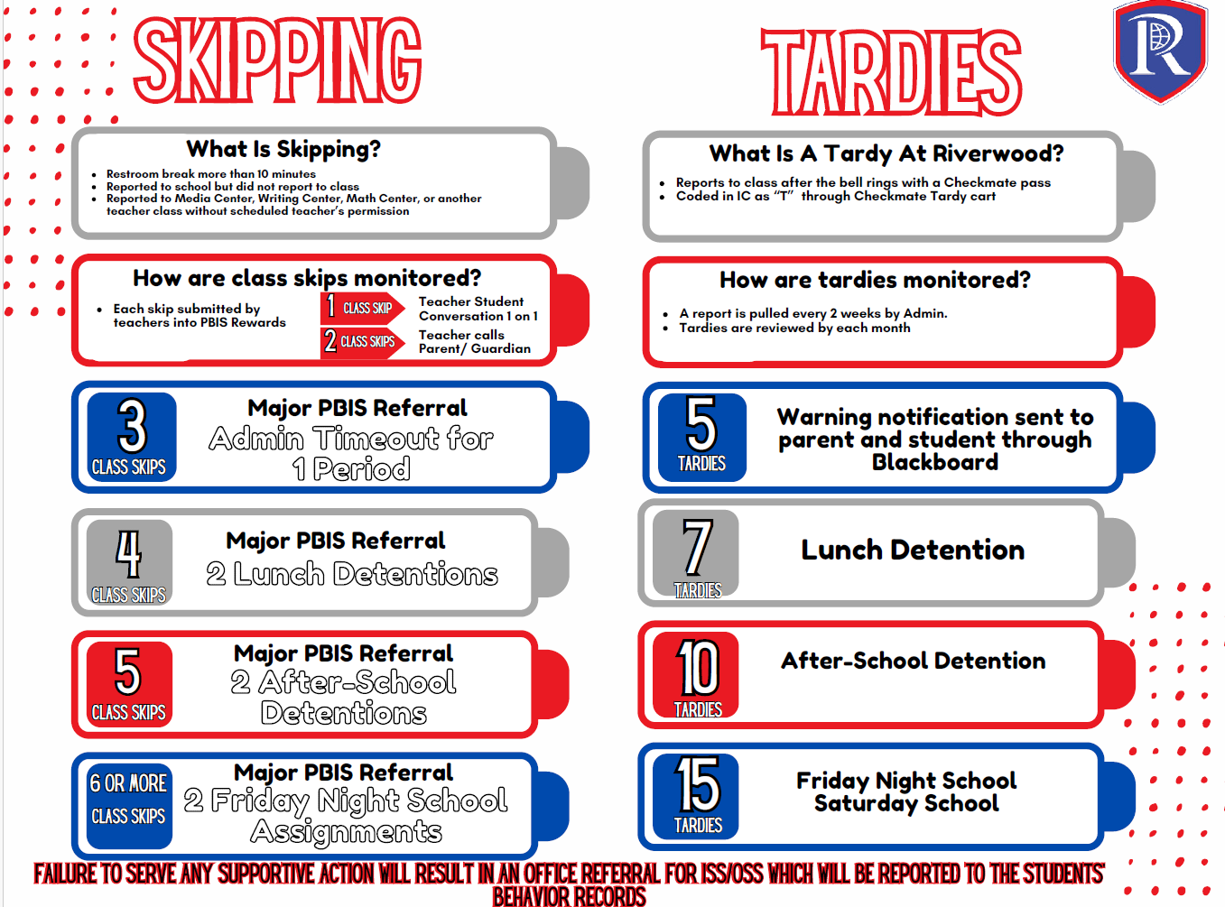

Pre-Approved Absence/Remote Day

If you know at least three days in advance that your student will be absent, please consider making it a pre-approved absence/ remote day.

Students can substitute up to 5 absences per semester (a max of 10 per year) with a remote learning day by meeting the remote learning participation benchmarks listed in Board Policy JBD. This would result in the student being counted as present for the day(s) they participate remotely.
- For security reasons, students who are out of the country may not participate in remote learning.

Remote Learning Attendance Benchmarks for High School:
- Must participate in at least half of the school day to be given credit for attendance.
- Participation may be synchronous instruction remotely,
- Or, participates asynchronously as defined by the teacher. To be considered absent but present, work that is assigned must be submitted within 2 days of the absence. Student may not use a remote learning day on a summative (major) assessment day.

Request Process:
- Student will pick up a paper copy of the Pre-approved Absence form by the Front Office or download a copy form our school website.
- It is the student’s responsibility to take the form and parent note to all of the classes for the day(s) requested to be signed off by each of the student’s teachers to get approved for a Pre-approved absence/Participated remote day.
- Note: Pre-approved absences/Participated Remote Days cannot be taken if a student has a major assessment.
- No Pre-Approved absences/Participated Remoted Days will be approved the last 2 weeks of each semester.
- Once it is filled out, it is the responsibility of the student to turn it in to Ms. Williams in the Attendance Office. She will code the attendance in Infinite Campus.

The form must be turned in 3 days prior to the requested Pre-approved absence/Participated Remote day(s). If turned in less than 3 days, it will not be approved.

There is a direct correlation between attendance and engagement and between engagement and performance. Having our students in school and on time helps us create the best learning environment possible.

Riverwood Administration
SY 25-26

