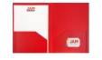  (4) Plastic, 2- pocket  folders (any color) | 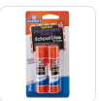  (4) Jumbo Glue Sticks | 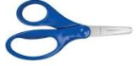  (1) Blunt 5” Fiskar Scissors Unbox and write name on it | 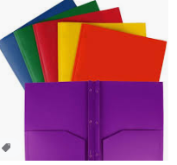  (4) PLASTIC, 2-pocket folders with prongs
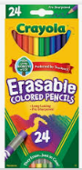  2 packs of Colored Pencils | 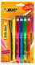  A 4-pack or 4 Highlighters | 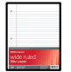  (4) Packs of 200 ct.  Wide-Rule filler paper | 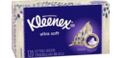  (2) Box of Kleenex Tissue
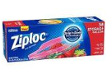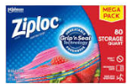  Girls – (1) Quart size Ziplocs  Boys- (1) Gallon Ziploc Bags | 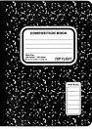  4 Marble Composition Books | 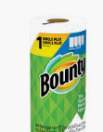  (2) Rolls of Paper Towels | 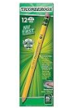  4) 24 count pencils Ticonderoga Brand # 2 yellow wood  Pre-Sharpened
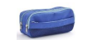  (1) Zippered pencil pouch | 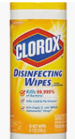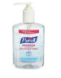  (2) Container of Clorox Wipes  (2) Hand Sanitizer | 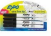  4pack Black Regular or Thin Expo Markers | 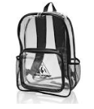  (1) Backpack – Clear or Mesh  No Wheels
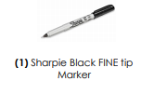 | 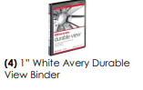 | 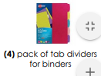
Uniforms:  Lt. Blue OXFORD button down shirt with Lincoln Logo  Navy Bottoms  Belt  Tennis Shoes | $25 Classroom Supply Fee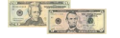  Used for:($10 Classroom Fee, $5 Art Fee, $5 Science Fee, $10 ID Fee)

