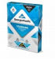  (1)Pack of WHITE copy | 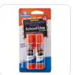  (8) Jumbo Glue Sticks | 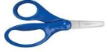  - Blunt 5” Fiskar Scissors (dual handed, NO Plastic Blades |  | 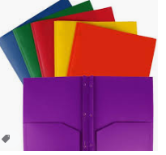  (2) PLASTIC, 2-pocket folders with prongs
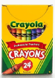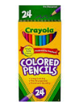  (2) Box of (24) pack Crayola Crayons OR (1) pack of Crayola Colored Pencils | 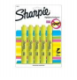  3 yellow highlighters | 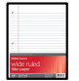  - Packs of wide-rule loose leaf paper |  | 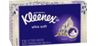  (2) Box of Kleenex Tissue
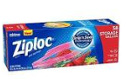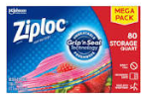  Girls – (1) Quart size Ziplocs  Boys- (1) Gallon Ziploc Bags | 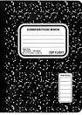  6 Black Marble Composition Book | 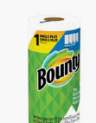  (1) Rolls of Paper Towels |  | 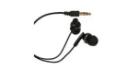  - Pair of earbuds  Students must have these
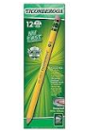  (5) Packs of 24 count pencils Ticonderoga Brand # 2 yellow wood – Pre-Sharpened  No Mechanical Pencils | 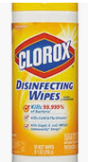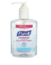  - Container of Clorox Wipes  - Hand Sanitizer | 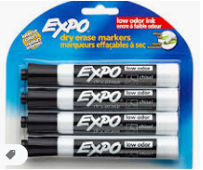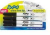  - 4pack of EXPO markers  - 4pack Black Thin Expo Markers |  | 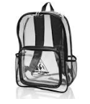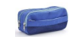  (1) Backpack – Clear or Mesh  No Wheels  (1) Zippered pencil pouch  (NO BOX
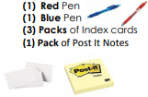 | 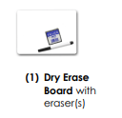 | 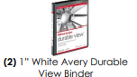 |  | 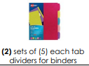
Uniforms:  Red Collared Shirt –  with Lincoln Logo  Blue Bottoms  Belt  Tennis Shoes | 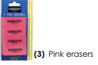 |  | $25 Classroom Supply Fee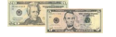  Used By:($10 Classroom Fee, $5 Art Fee, $5 Science Fee, $5 ID Fee)  Cash or Money Order

