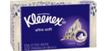  - Boxes of Kleenex Tissue | 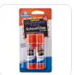  (8) Glue Sticks |  | 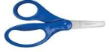  1 Blunt 5” Fiskar Scissors (dual handed, NO Plastic Blades | 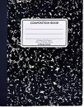  (6) 100ct. Black Marble Composition Book
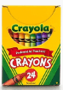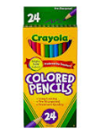  (4) 24 count Crayola crayons  (1) Pack Colored pencils  Write name on each | 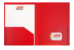  (6) PLASTIC, 2-pocket prong folders (1) Yellow, (1) Blue, (1) Green, (1) Purple (1) Green (1) Red |  | 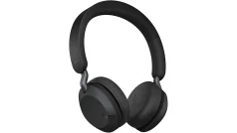  - pair over the ear headphone | 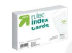  - 4X6 lined index cards
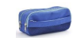  (1) Pencil Pouch | 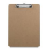  - 9 x12 clipboard  Write name on it |  | 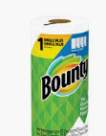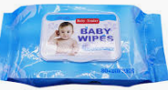  (2)Rolls of Paper Towels  (1) pack of wet wipes | 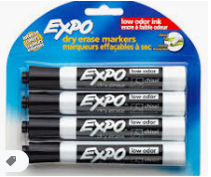  2 packs of EXPO Blaxk dry erase markers
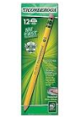  - 24 count each Ticonderoga #2 yellow wood pencils- Must be sharpened | 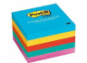  - Pack of post-it notes |  | 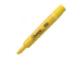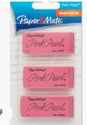  - Highlighters  Write name on it  - Pink Pearl Erasers | 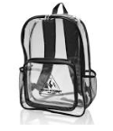  1 Clear OR Mesh Backpack  No Wheels
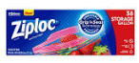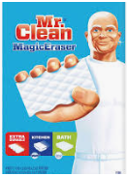  - Box of gallon size ziploc bags  (4) Mr. Clean Magic Erasers |  | 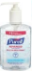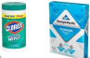  - Pack of Clorox Wipes  - Pack of COLORED copy paper  - Pump of Bottle Hand Sanitizer
Uniforms:  Red polo shirts with Lincoln Logo  Navy Bottoms  Belt  Tennis Shoes | $25 Classroom Supply Fee  Used for :($10 Classroom Fee, $5 Art Fee, $5 Science Fee, $5 ID Fee)  School Cash Online  Cash or Money Order  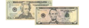  NO HOODIES or JACKETS WITH HOODS.

