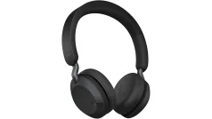  headphones | 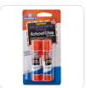  (2) Glue Sticks | 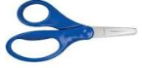  - Blunt 5” Fiskar Scissors (dual handed, NO Plastic Blades | 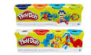  Pack of Multi-Colored PLAYDOH
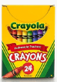  (4)Box of (8) pack Crayola Crayons | 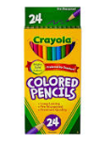  (1 )Pack Colored pencils | 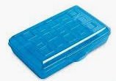  - Plastic School Box – Regular Size | 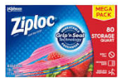  - Box Quart Size Ziploc Bags
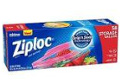  (1) Box Gallon Size/Freezer Ziploc Bags | 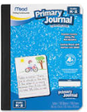  Primary Composition Book | 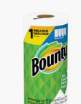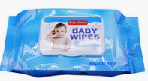  - Rolls of Paper Towels  - Pack of Baby Wipes | 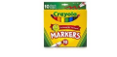  1 pack Crayola Classic Markers
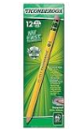  (2)Packs of pencils Ticonderoga Brand | 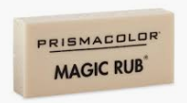  - Pack of Magic Rub (white) erasers (Walmart) | 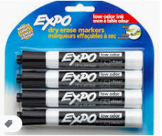  - 4 pack of EXPO markers | 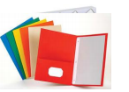  (3) Three folders
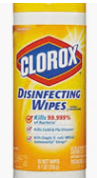  - Container of Clorox Wipes | 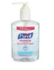  - Pump Bottle Hand Sanitizer | 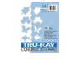  - Pack of white cardstock or colored paper | 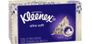  - Box of Kleenex Tissue
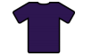  Purple collar shirt with Lincoln School of the Arts Logo | 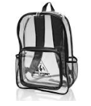  1 Backpack. No Wheels | 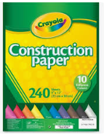  1 pack of Construction Paper | $25 Classroom Supply Fee  Used FOR :($10 Classroom Fee, $5 Art Fee, $5 Science Fee, $5 ID Fee)  School Cash Online  NO HOODIES OR JACKETS WITH HOODS.

