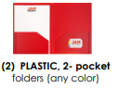 | 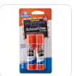  (4) Jumbo Glue Sticks | 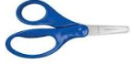  - Blunt 5” Fiskar Scissors Unbox and write name on it | 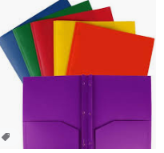  (2) PLASTIC, 2-pocket folders with prongs
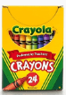  (2) Box of (24) pack Crayola Crayons | 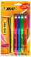  - Highlighters | 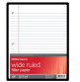  (2)Packs of 200 ct. Wide-Rule  filler paper | 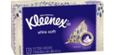  (2) Box of Kleenex Tissue
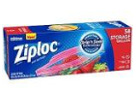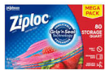  Girls – (1) Quart size Ziplocs  Boys- (1) Gallon Ziploc Bags | 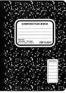  4 Marble Composition Books | 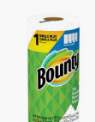  (2) Rolls of Paper Towels | 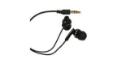  - Pair of earbuds  Students must have these
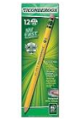  (5) Packs of 24 count pencils Ticonderoga Brand # 2 yellow wood – Pre-Sharpened  No Mechanical Pencils | 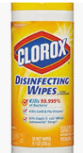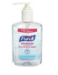  - Container of Clorox Wipes  (2) Hand Sanitizer | 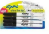  - 4pack Black Thin Expo Markers | 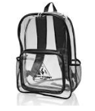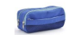  (1) Backpack – Clear or Mesh  No Wheels  (1) Zippered pencil pouch
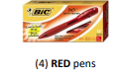 | 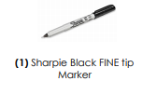 | 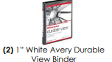 | 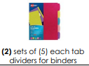
Uniforms:  Red polo shirt –  with Lincoln Logo  Navy Bottoms  Belt  Tennis Shoes | $25 Classroom Supply Fee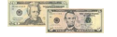  Used By:($10 Classroom Fee, $5 Art Fee, $5 Science Fee, $5 ID Fee)  Cash or Money Order

