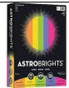  (1)Pack of COLORED COPY paper- not construction  1 pack of white copy paper | 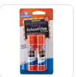  (6) Glue Sticks | 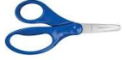  - Blunt 5” Fiskar Scissors (dual handed, NO Plastic Blades | 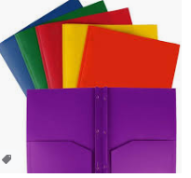  (4) Prong folder 2 pocket, 1 Blue, 1 Red, 1 Yellow, 1 Green  Plastic Folders
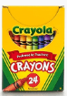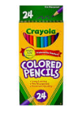  (2) Box of (24) pack Crayola Crayons(1) pack of Crayola Colored Pencils | 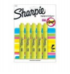  4 pack yellow highlighters | 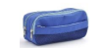  - Zippered pencil pouch (NO BOX) | 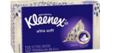  (2) Box of Kleenex Tissue
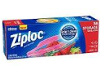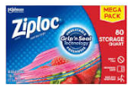  Girls – (2) Quart size Ziplocs  Boys- (2) Gallon Ziploc Bags | 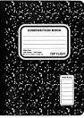  6 Black Marble Composition Book | 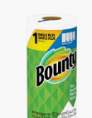  (2) Rolls of Paper Towels | 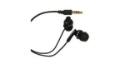  - Pair of headphones  *Students must have these
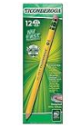  (5) Packs of 24 count pencils Ticonderoga Brand – Sharpened  No Mechanical Pencils | 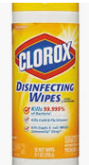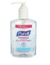  (2) Container of Clorox Wipes  (3) Hand Sanitizer | 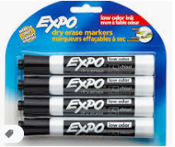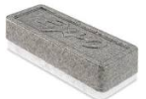  - 4 pack of EXPO markers AND 1 dry eraser | 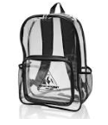  (1) Backpack – Clear or Mesh  No Wheels
Uniforms:  Red Collared Shirt – with Lincoln Logo  Blue Bottoms  Belt  Tennis Shoes | $25 Classroom Supply Fee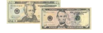  Used By:($10 Classroom Fee, $5 Art Fee, $5 Science Fee, $5 ID Fee)  School Cash Online

