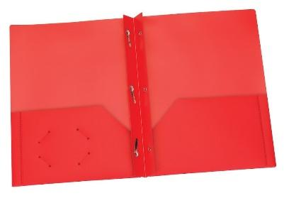  4 Plastic Folders w/ prongs  (1) Yellow, (1) Blue,  (1) Green, (1) Purple  Write name on each | 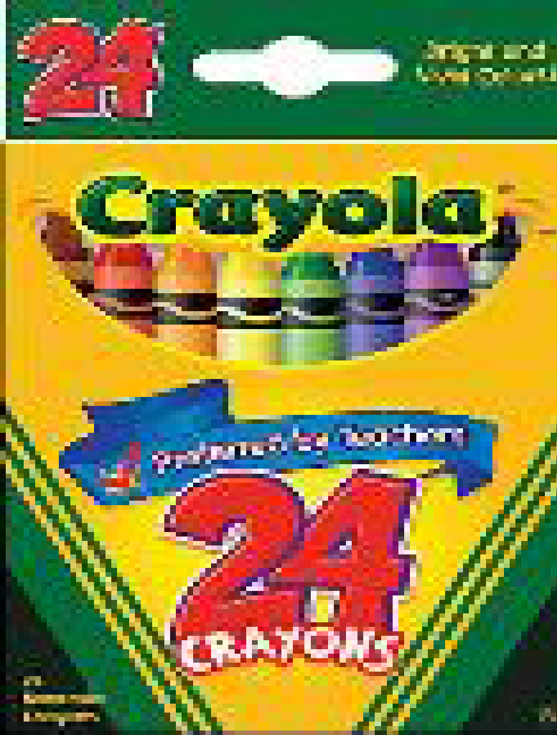  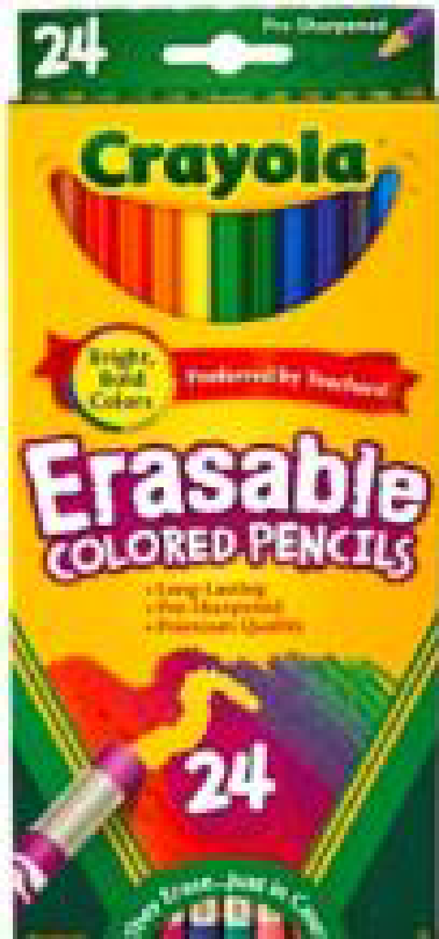  Write name on each |  | 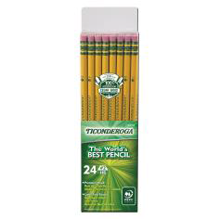 |  | 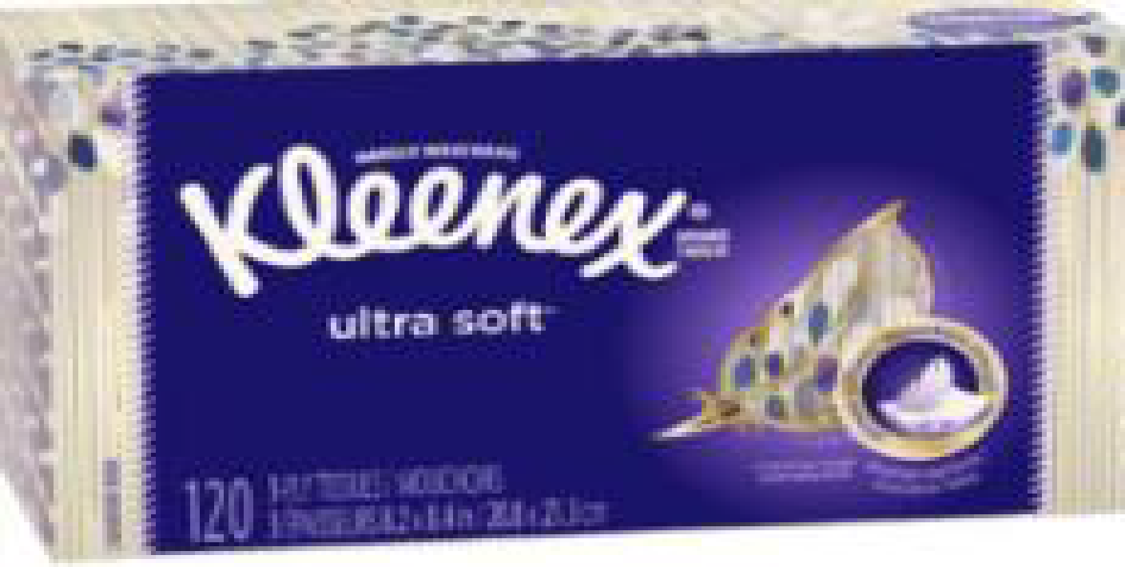  (4) Boxes of Kleenex Tissue
  (2) 24 ct. Crayola Crayons
  (1) Pack of Color Pencils
  (3) 24 count each Ticonderoga
  #2 yellow wood pencils
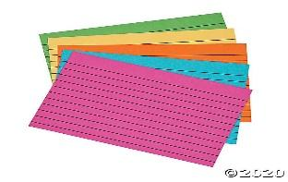  (1) Packet of index cards | 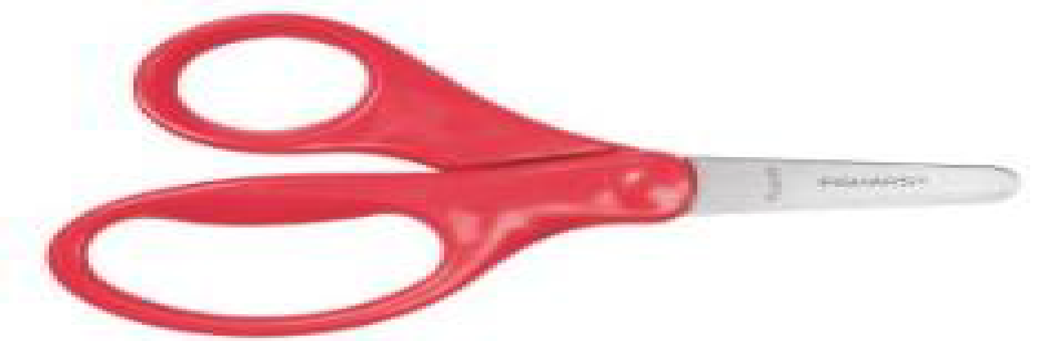 |  | 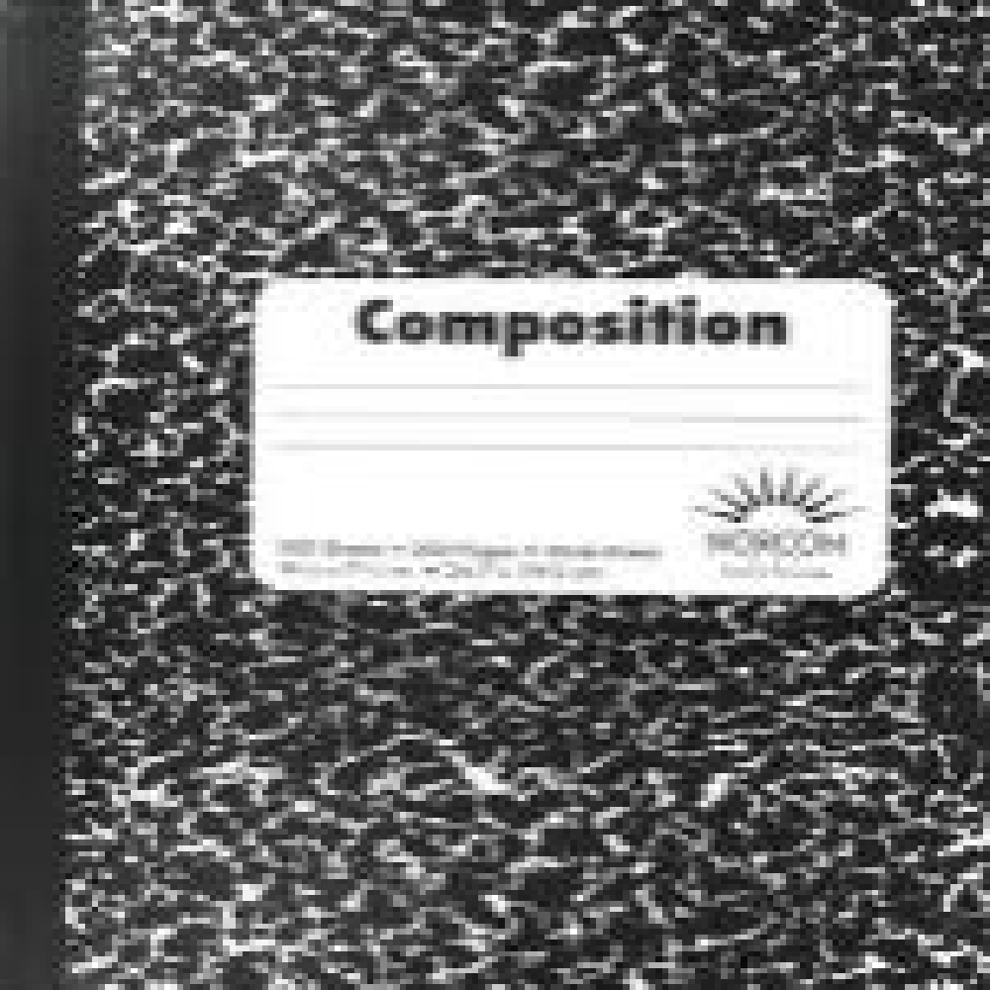 |  | 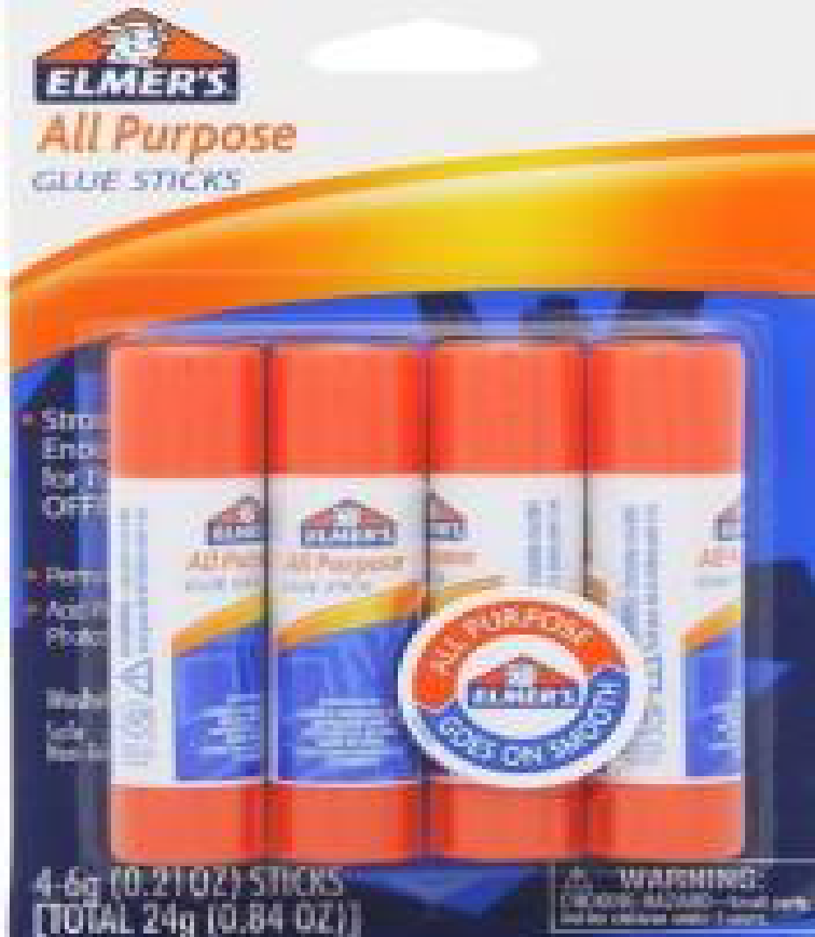  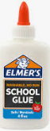  (4) Glue Sticks  1 bottle of liquid glue
  (1) Blunt 5” Fiskar Scissors
  Unbox and write name on it
  (3) 100 ct. Black Marble Composition Book
  Write name on each book
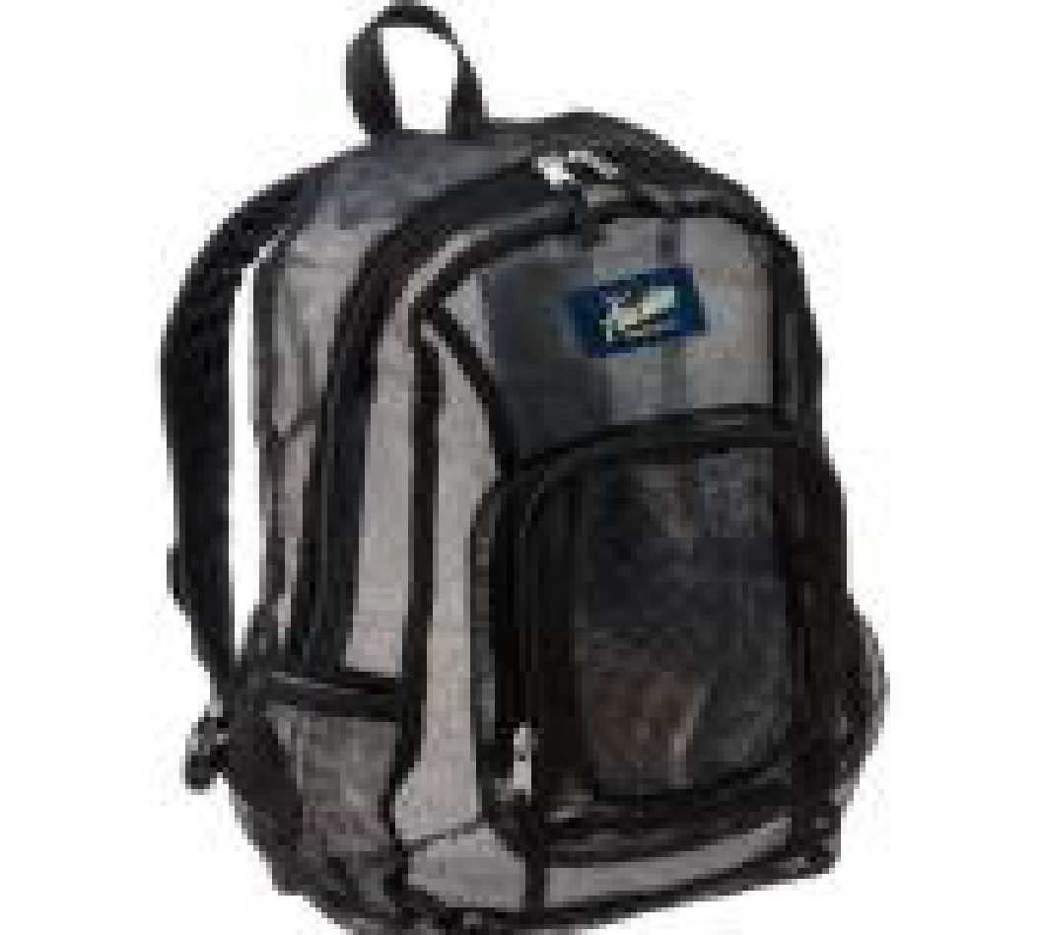  (1) School Bag no wheels!  Write name on it. | 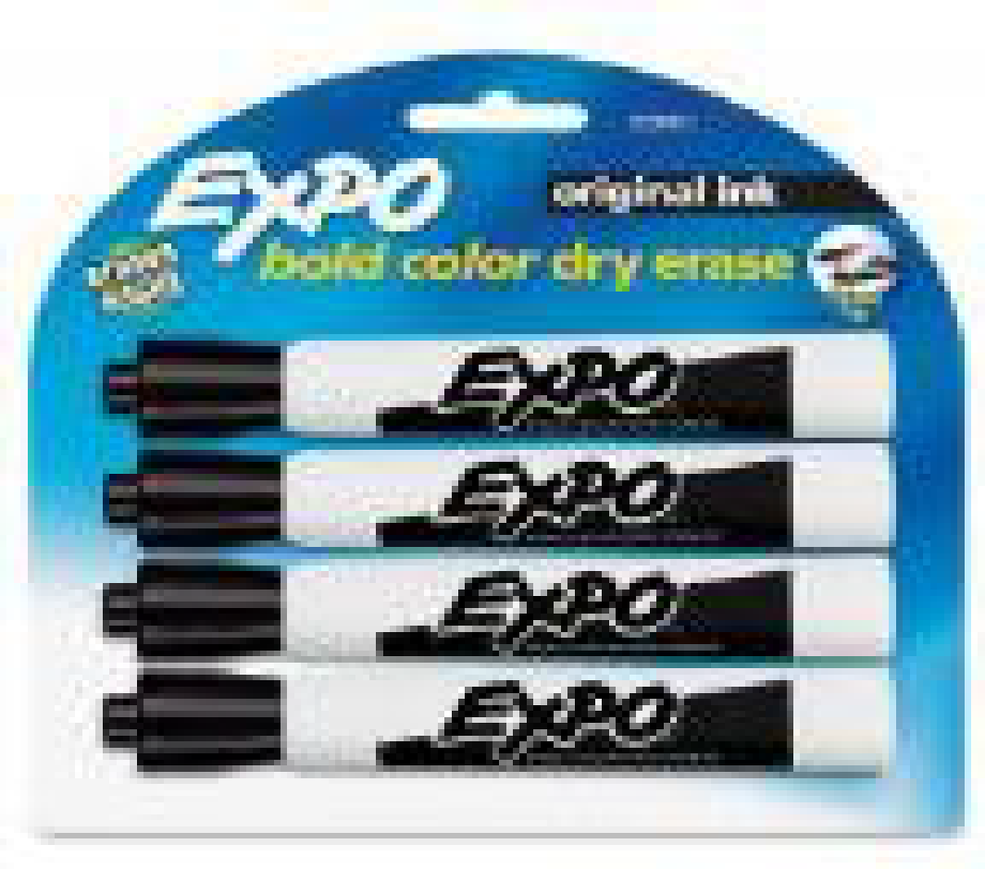 |  | 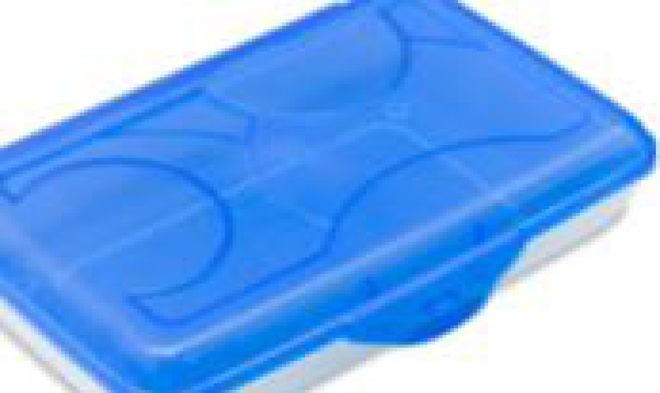 |  | 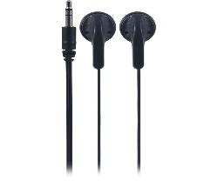  (1) packets of headphones  Write name on each
  (1) pack of 4 – EXPO Markers
  (green, black, blue and red)
  (1) Plastic School Box
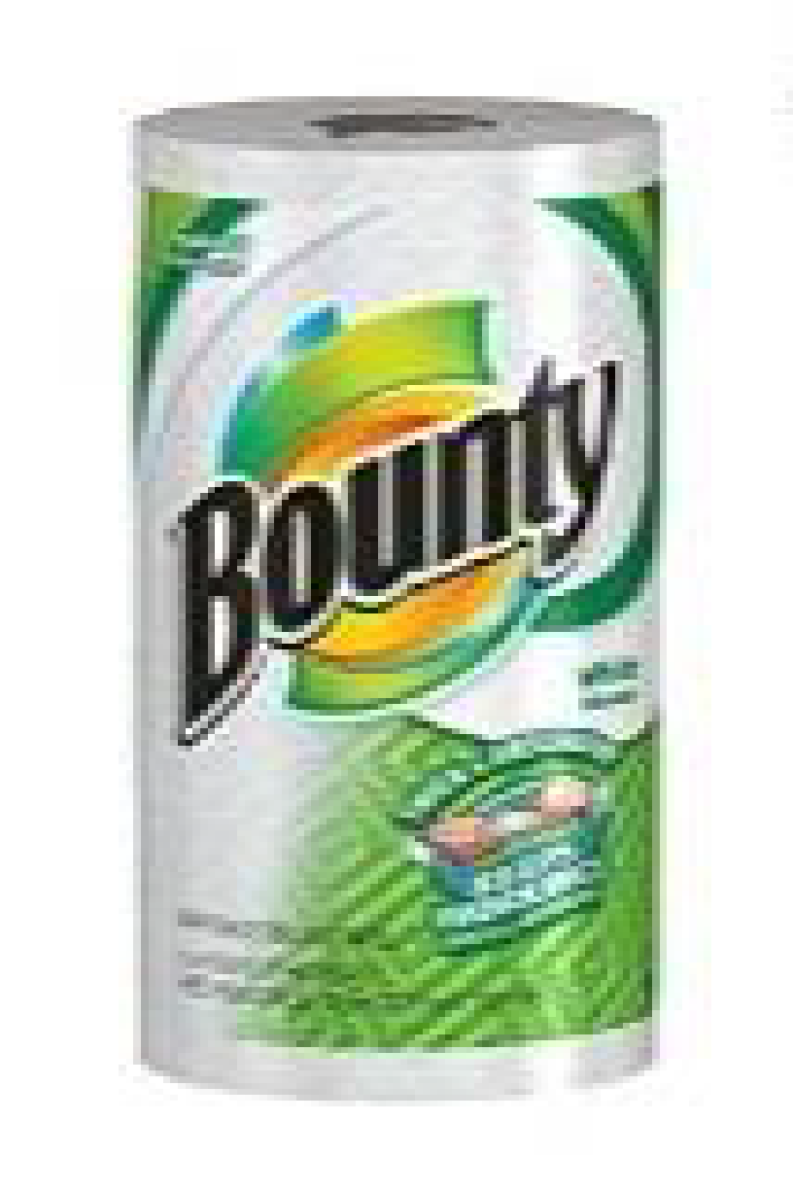  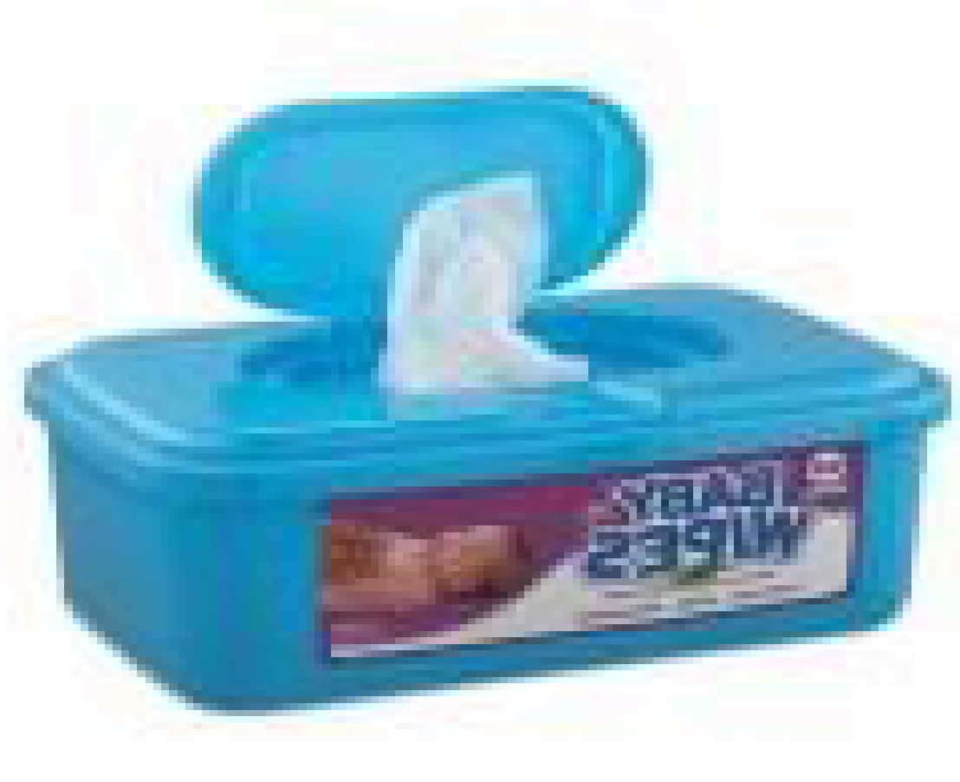  (4) Rolls of Paper Towels (2) Pack of Baby Wipes | 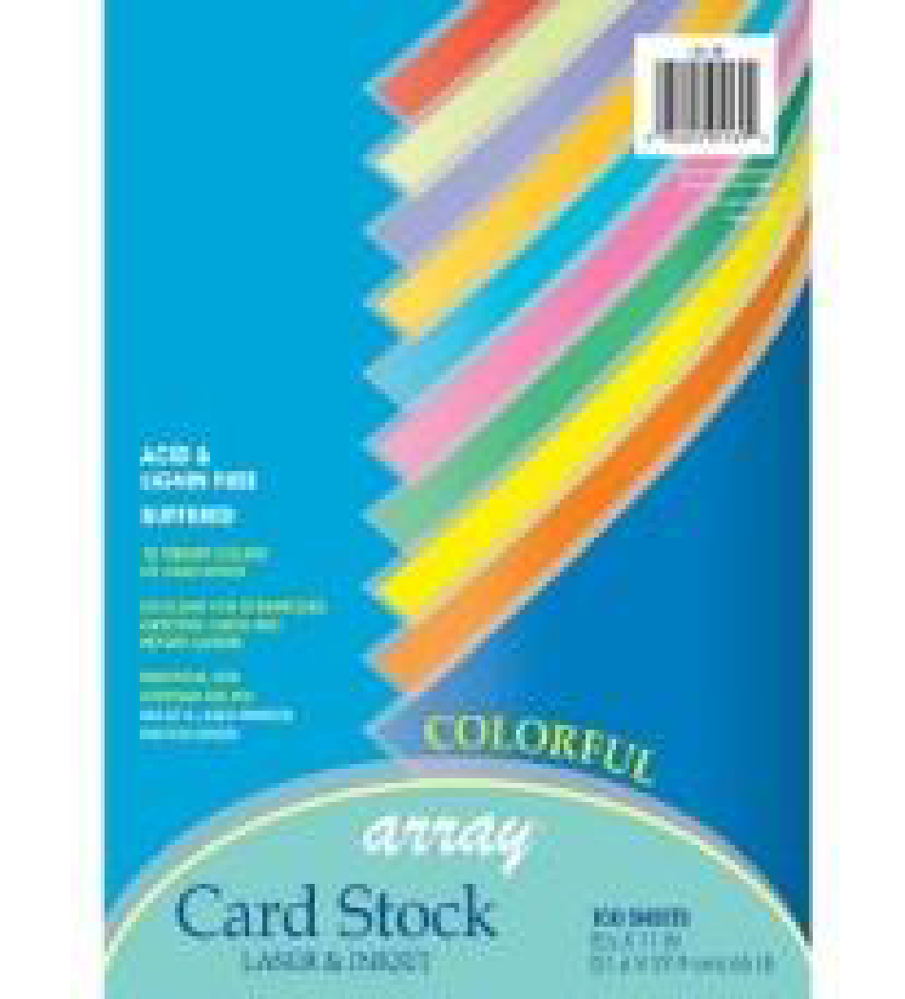   |  |  | 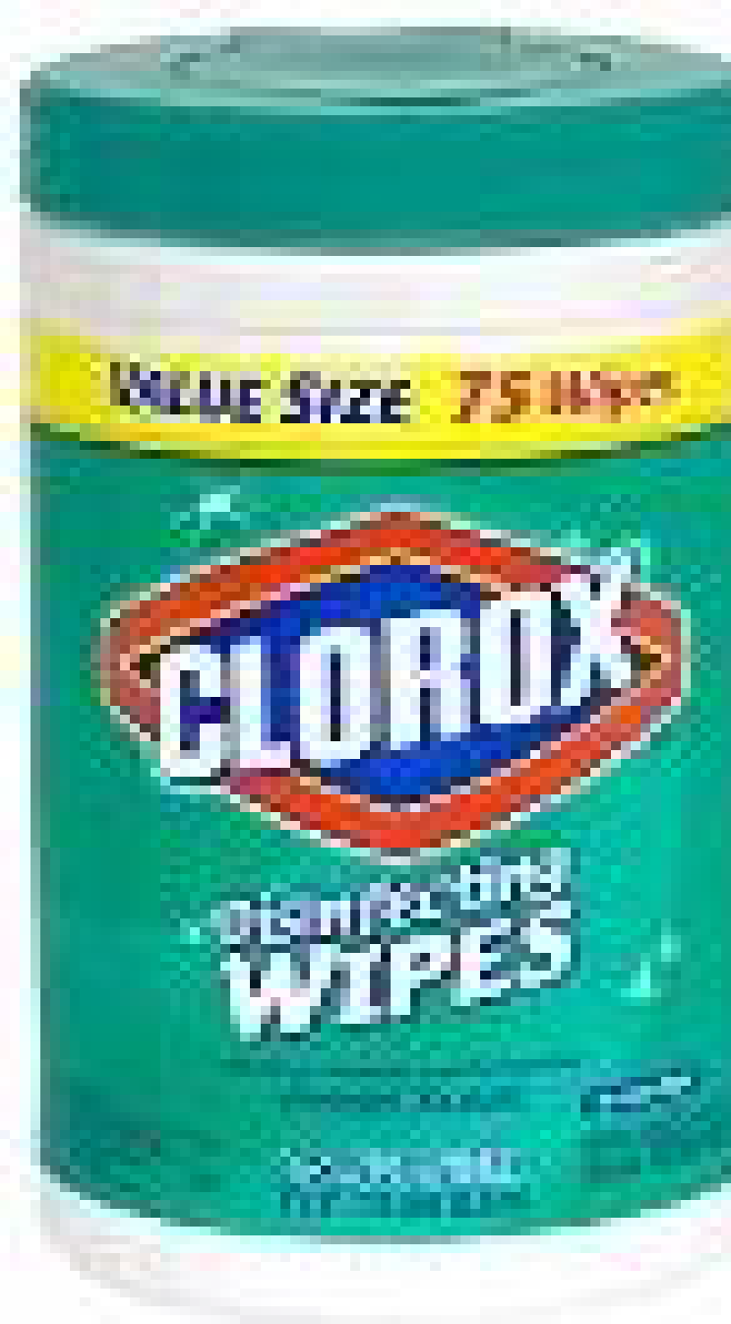  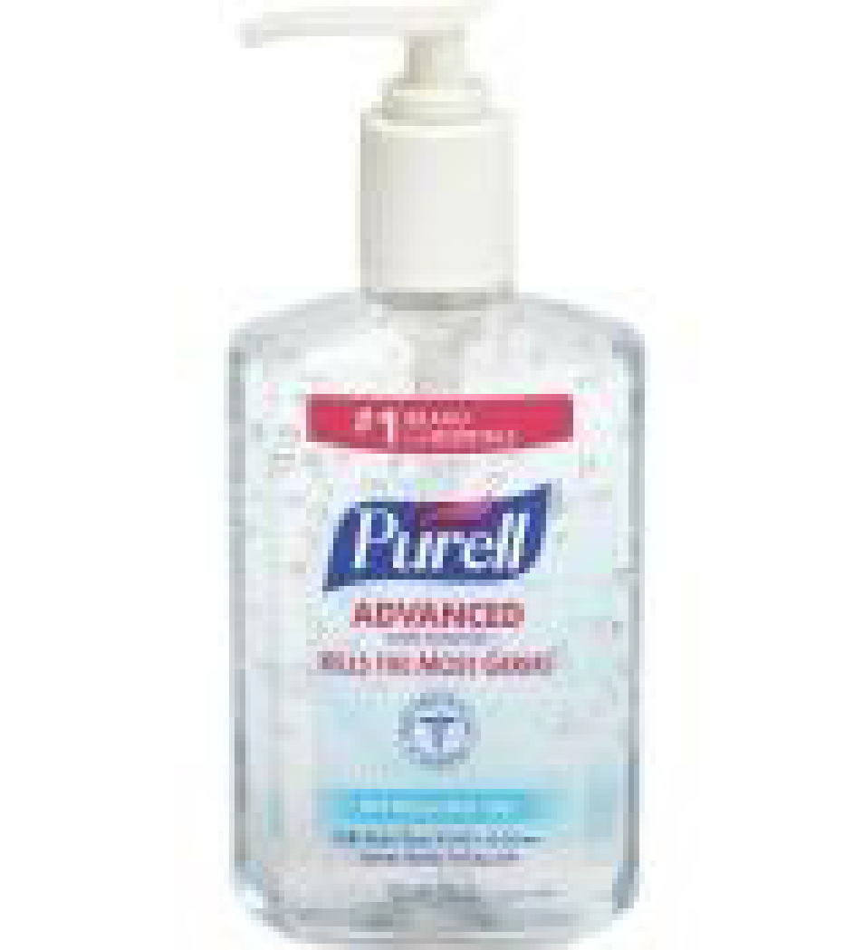  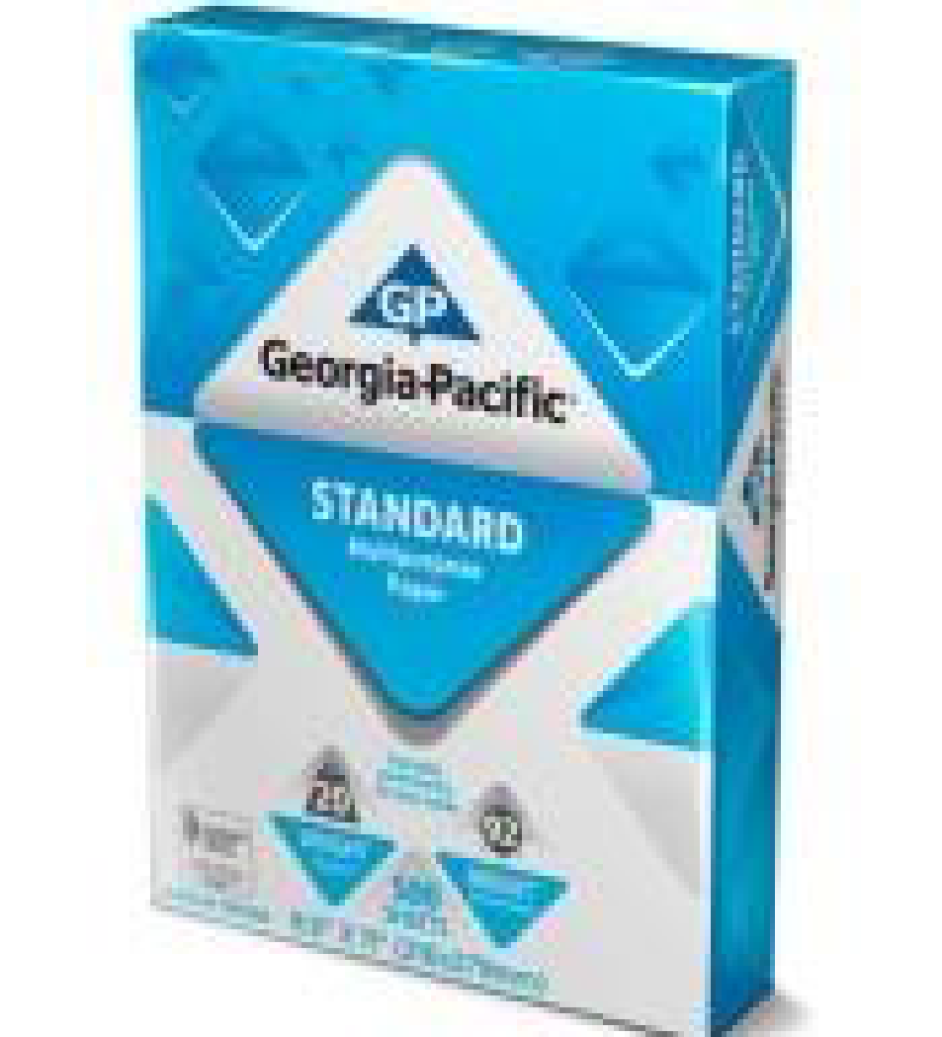
  Boys Only
  (1) Pack of cardstock
  (1) Box of Gallon Ziplocs
  (1) Pack of quart zip-lock bags
  Girls ONLY
  (1) Pack of Clorox Wipes
  (1) Pack of white, copy paper
  (1) Pump Bottle Hand Sanitizer
  $25 Classroom Supply Fee
  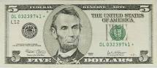
  Used By:($10 Classroom Fee, $5 Art Fee, $5 Science Fee, $5 ID Fee)
  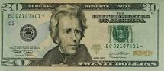
  School Cash Online
  Uniforms:
  Red polo shirts with Lincoln Logo
  Navy bottoms
  Belt
  Tennis Shoes
  NO HOODIES or JACKETS WITH HOODS.

