Pre-K
Lincoln Elementary School of the Arts
2025-2026 School Supply List
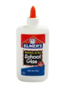  (1) Bottle of Elmer’s Glue (No Glue Sticks – please) | 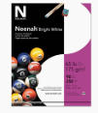  (1)Pack of white cardstock | 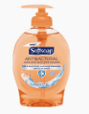  (1) PUMP hand soap | 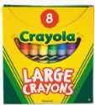  (2) Boxes of (8) pack Large Crayola Crayons (Not Jumbo)
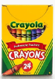  (1)Box of (24) pack Crayola Crayons | 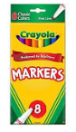  (1)Box (8) pack SKINNY Crayola Markers- Basic Colors | 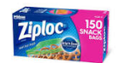  (1)Box Snack Size Ziploc Bags | 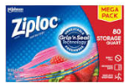  Girls ONLY  - Box Quart Size  Ziploc Bags
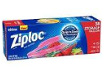  Boys ONLY  (1) Box Gallon Size/Freezer Ziploc Bags | 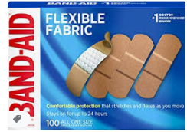  (1)Pack Band-Aids | 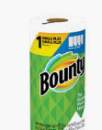  (3) Rolls of Paper Towels | 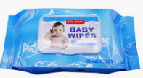  (3) packs of 80 count Baby Wipes
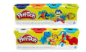  (2)Packs of Play-doh – not Rose Art | 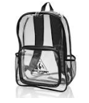  1 School Bag – No Wheels |   Purple T-shirt with Lincoln School of the Arts Logo  PURPLE SHIRTS AT ALL TIMES! | 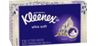  - Box of Kleenex Tissue
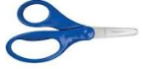  - Blunt 5” Fiskar Scissors (dual handed, NO Plastic Blades | 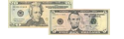  $25 Classroom Supply Fee Used for:  ($10 Classroom Fee, $5 Art Fee, $5 Science Fee, $5 ID Fee)  School Cash Online | NO HOODIES or JACKETS WITH HOODS.

