Irving ISD
Canvas Course Layout Recommendations
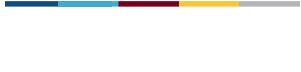..
Organizational structures are designed to ensure consistency across all content and grade-levels in student, parent, and observer navigation. The consistency allows students, or those supporting them, to spend time engaging in learning, rather than waste time trying to find what you intend for them to do.

By the Friday before school starts:

- Login to Canvas. Explore your courses and submit a help ticket if you are missing a course.
- Choose and import an IISD Approved Course Template Import from Commons
- Publish each of your courses.
- Ensure any assignments have due dates. Due Dates and Availability Dates
  - Grades 5-12, all major graded assignments are required to be added to the Canvas calendar for the first six weeks.
- All teachers have an emergency sub lesson uploaded in Canvas.
- Use the Student View to verify your course settings, navigation, and frontpage show what you expect.

By the first week of school:
- Teach students to hide any courses they will not be using.
Ongoing:
- Grades 5-12, all major graded assignments are required to be added to the Canvas calendar the Friday before the first day of the six weeks.
- Review and update Emergency Sub lesson

Best Practices to Consider:

- Use Modules to organize your course
  - All content should be organized sequentially in modules
  - Add current Assignments to the top of each module
- Remember! TAC remains the official gradebook
- For 24/7 training, check out our Training Hub
- And don’t forget to checkout the Canvas live webinars

