 | Getting Started with Secondary Templates  Need a little support getting started with the Secondary Canvas Template?  Check out the resources below to help navigate Canvas and provide consistency for ease of access for parents and students.  Note: This is a live document and view only.  Please do not send requests to share/edit documents. Thanks.

Access Template  from Canvas Commons  Search Canvas Commons for:  IISD Secondary Template  Or  IISD Secondary Template 2  How to Import one of the templates from Canvas Commons  Instructional Video  Check out the IISD Training Hub for lots of Canvas tutorials! | Curious what IISD recommends in each Canvas course?  IISD Canvas Course Layout Recommendations  Remember to design your course using MODULES! | Template Overview  How the homepage templates work  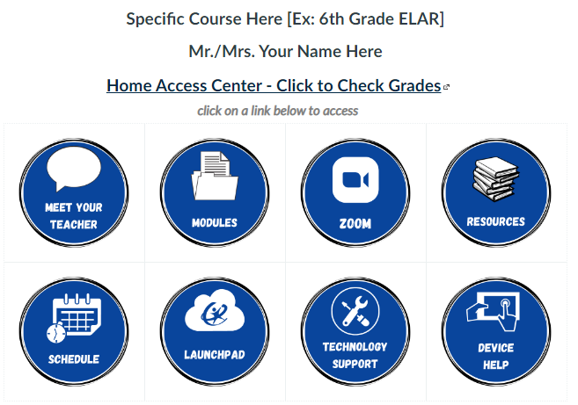  Course Template Overview:  - Import from Canvas Commons  - Use the buttons provided or edit as necessary  - Link your own assignments and class information
Understanding Pages vs. Modules vs. Assignments    - What are files?  - What are modules?  - What are pages?  - What are assignments? | Link a Text/Image Directly to a Module  When changing out template button(s) be sure to relink to page(s)  How do I insert links to course content  - Note: this homepage template uses TABLES to help keep buttons aligned. Insert/edit a table. | Already Using G Suite Apps?  Add Google Slide Decks and Google Docs as an assignment! You do NOT have to create from scratch.  How do I create a hyperlink or embed a file from Google Drive
Other Canvas Tutorials  Canvas Basics  - How to set a homepage  - Quizzes  Need answers to specific questions? Search the Canvas Guides!  - Search the Canvas Guides | Create/Edit Your Own Images to Match the Template!  Use these links to edit in Canva:  Return to Home Button  Contact Teacher Button  Middle School Home Page Buttons  High School Home Page Buttons  Spanish Round Buttons  Template 2 Header  ⭐Remember - you can get a free educator Canva account. | How to Add New Buttons  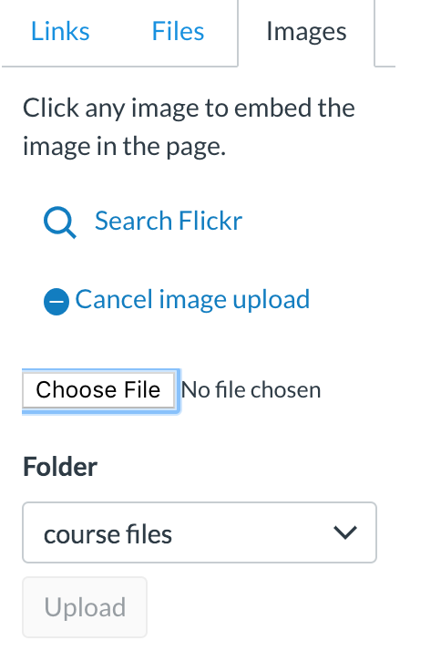  Click images.  Search the image on your device.  Choose the file>Upload.  Don’t forget to link it!

