 | Getting Started with Elementary Templates  Need a little support getting started with the Elementary Canvas Template?  Check out the resources below to help navigate Canvas and provide consistency for ease of access for parents and students.  Note: This is a live document and view only.  Please do not send requests to share/edit documents. Thanks.

Access Template  from Canvas Commons  Search Canvas Commons for:  IISD Elementary Departmentalized Template  Or  IISD Elementary Self-Contained Template  Or  IISD Elementary Specials Template  How to Import one of the templates from Canvas Commons  Instructional Video | Curious what IISD requires in each Canvas course?  IISD Canvas Course Layout Recommendations  Remember to design your course using MODULES!  Check out the IISD Training Hub for lots of Canvas tutorials! | Template Overview  How the templates work  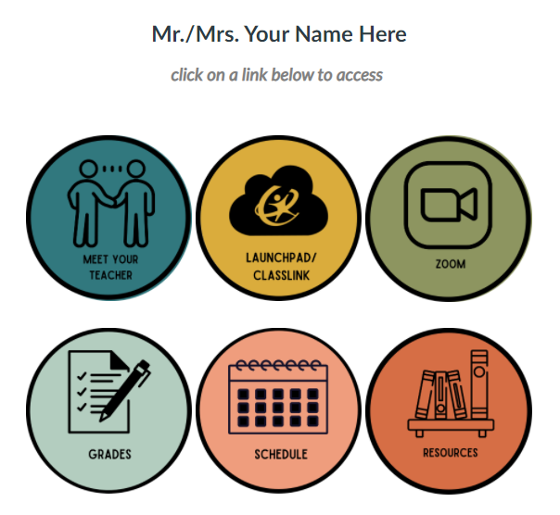  Course Template Overview:  - Import from Canvas Commons  - Use the buttons provided or edit color as desired  - Link your own assignments and class information
Understanding Pages vs. Modules vs. Assignments  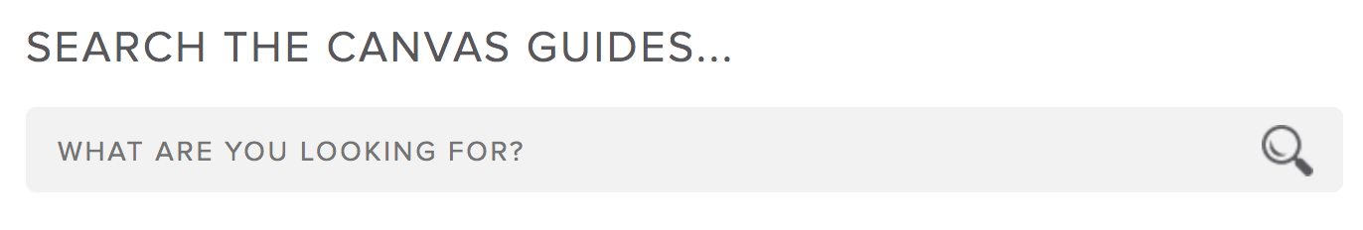  - What are files?  - What are modules?  - What are pages?  - What are assignments? | Link a Text/Image Directly to a Module  When changing out template button(s) be sure to relink to page(s)  How do I insert links to course content  - Note: this homepage template uses TABLES to help keep buttons aligned. Insert/edit a table. | Already Using G Suite Apps?  Add Google Slide Decks and Google Docs as an assignment! You do NOT have to create from scratch.  How do I create a hyperlink or embed a file from Google Drive
Other Canvas Tutorials  Canvas Basics  - How to set a homepage  - Quizzes  Need answers to specific questions? Search the Canvas Guides!  - Search the Canvas Guides | Create/Edit Your Own Images to Match the Template!  Use these links to edit in Canva. Both English and Spanish included!  Welcome Banner  Other Banners  This Week at a Glance  Return to Home Button  Round Buttons  Weekly Buttons  Square Buttons  ⭐Remember - you can get a free educator Canva account. | How to Add New Buttons  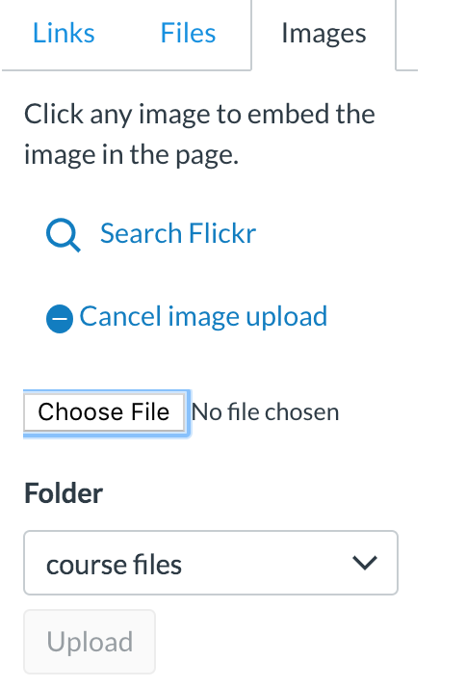  Click images.  Search the image on your device.  Choose the file>Upload.  Don’t forget to link it!

