School Supply List 2025-2026

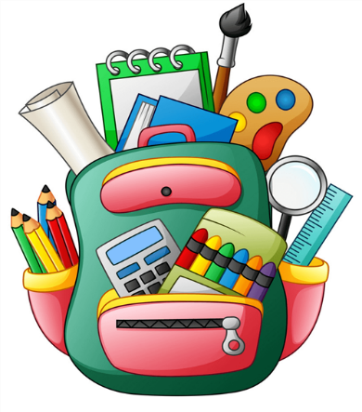

Backpack
Lunch Box with SNACK and LUNCH
Helmet (please label/to be used w/ tricycles)
Change of clothes (include SOCKS & SHOES)
Crib-sized sheet/blanket

