Returning Student Registration through
Home Access Center
To access the Returning Student Registration form through Home Access Center (HAC) go to www.irvingisd.net/HAC you click on the blue button “LOG IN” and that will take you to a login page where you enter your “User Name” and “Password” and click the “Sign In” button.
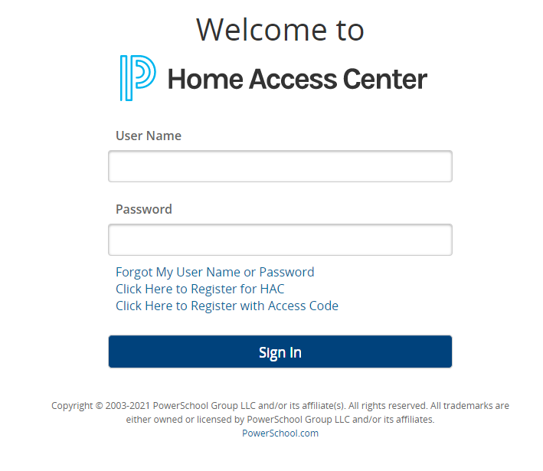
Next, click on the “Registration” tab to the right to access the registration form link.

On this page you click the tab “Update Enrollment” and you see a link to the Returning Student Registration form.
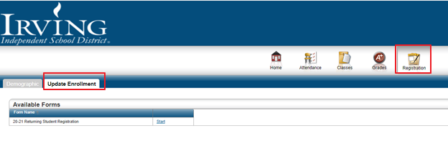
When you click on Start you will be taken to a page that asks if you want to “link your PowerSchool Enrollment Account” or “New to PowerSchool Enrollment”.
If you have used the PowerSchool Registration form before and remember your login information click “Sign In” below Link your PowerSchool Enrollment account
If you haven’t used the PowerSchool Registration form before or if you don’t remember your login information to PowerSchool click “Begin Forms” below New to PowerSchool Enrollment

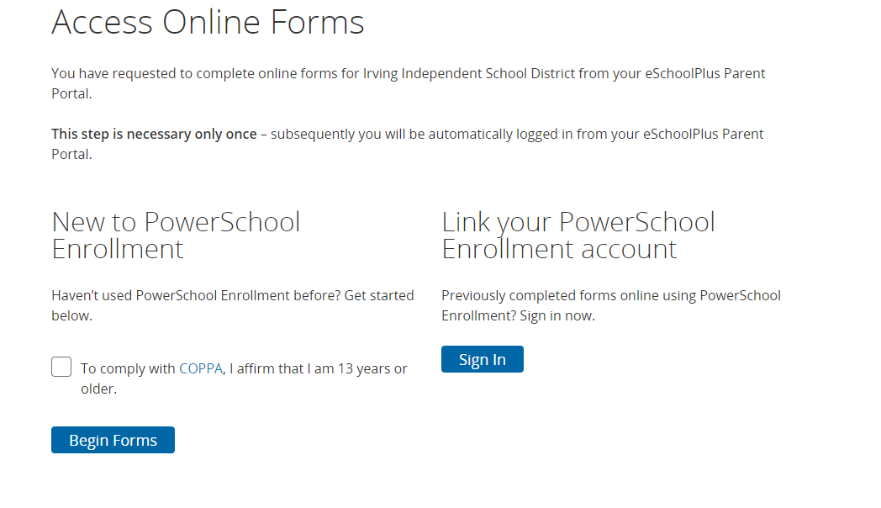
If you clicked “Sign In”
When you click on “Sign in” you will be taken to a sign in page where you enter your Email and your PowerSchool password and the account will be linked to your HAC account
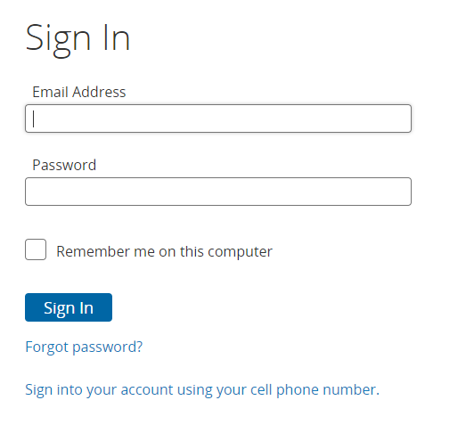
You will then be taken directly to the Returning Student Registration form. Fill out all fields with a red asterisk and click next to proceed through the form.
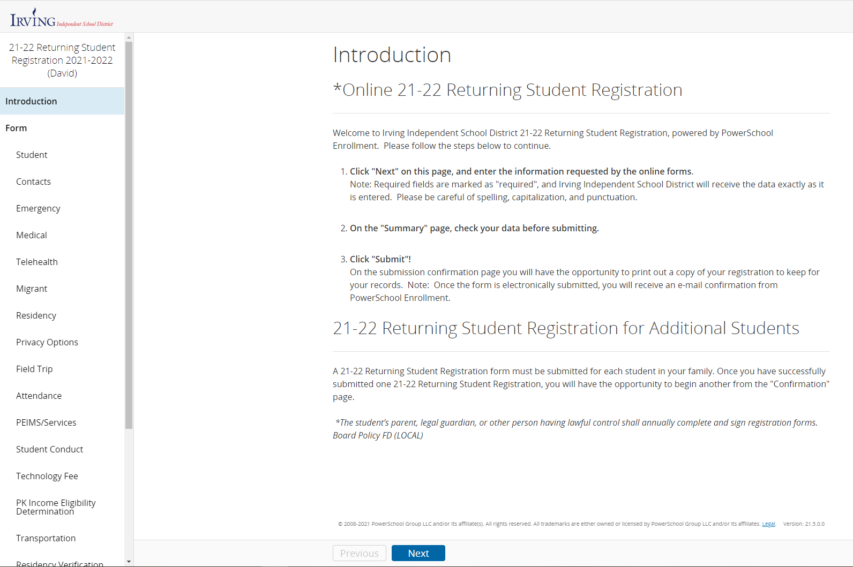
The PowerSchool registration form will remember that you have started registration, so if you get interrupted or have to stop the process log out, and next time you log in to HAC you will see that your form is there ready for you to Edit. Once you have Submitted the form you can no longer access the form
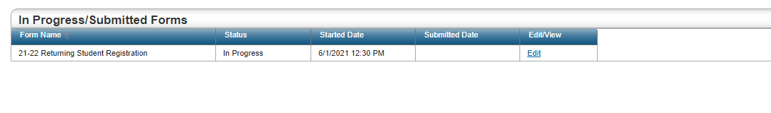
If you clicked Begin “Forms”
When you click on “Begin Forms” The system will automatically use the login information that you used to log in to your HAC account and you will be taken directly to the Returning Student Registration form. Fill out all fields with a red asterisk and click next to proceed through the form.
The PowerSchool registration form will remember that you have started registration, so if you get interrupted or have to stop the process log out, and next time you log in to HAC you will see that your form is there ready for you to Edit. Once you have Submitted the form you can no longer access the form
Registering Another Student
You must fill out a Returning Student Registration form for all children who return to Irving ISD for the fall semester. When in the Home Access Center and done filling out the registration form for the first child, look up to the right and you should see your name and the name of the student you have submitted registration for.
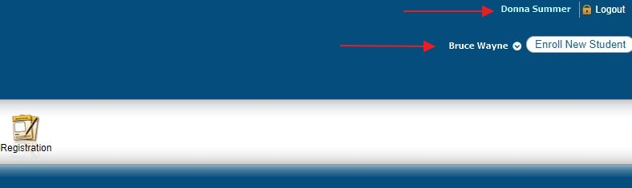

Click on the Down Arrow by the student’s name to get a screen with the names of all the children you have enrolled at Irving ISD. Click by the name of the next student you wish to register, then click Submit and repeat the steps for Returning Student Registration listed above.
