

This handbook provides important information specific to San Antonito STEM Magnet School. All students and families are also expected to follow the district-wide Student Success Handbook and Student Transportation Handbook as well

Arrival & Dismissal Procedures
- Arrival Time: 8:30–8:44 a.m.
  - Students must remain in vehicles until released by a staff member wearing a yellow vest.
  - Students may go to the cafeteria for free breakfast or wait in the outdoor learning area.
  - At 8:44 a.m. the warning bell ring will ring.
  - At 8:45 a.m., the tardy bell rings and students must be in class. Late students must be escorted to the office by their guardian for a tardy pass.
- Dismissal: Begins at 3:30 p.m.
  - Students enter vehicles using the door closest to the sidewalk.
  - Families must remain in their vehicles if using the drop off lane; staff will assist with loading.
- Pick-Up/Drop-Off Locations: Refer to Artifact #1 and #2
  - K–1st Grade: East side of the cafeteria building.
  - 2nd–5th Grade: North side of the two-story building.
  - Siblings: Older siblings join younger siblings at the K–1 area.
- Traffic Flow:
  - Each zone has 9 designated vehicle spots. Only allow students to enter/exit when in a spot.
  - Follow directions from staff directing traffic.
- Pick-Up Signage:
  - K–1 families will receive a sign with student names and teachers to display in the passenger-side window.
- Bus Riders:
  - Bus lane is at the back of the school. Be courteous and yield to buses.
  - Students must ride their assigned bus and stop. Changes require bus company permission. If a change is granted the bus company will contact Principal Gallegos.
  - Visit my bus stop to locate your child’s bus stop.
  - Bus company: 505-253-0287
- Campus Entry:
  - Students may not enter through the security gate without staff present.
  - The Administration Entrance is the only approved entry for late arrivals or visitors.
  - The playground is closed before school.
- Dismissal Routine: Students go directly to pick-up or bus when the bell rings at 3:30 p.m.
- Special Arrival Dates:
  - August 7: 1st–5th grade families may walk students to class; leave campus by 8:50 a.m.
  - August 11: Kindergarten families may walk students in or attend the New Family Breakfast (8:00–9:15 a.m.) in the cafeteria. If not attending, leave campus by 8:50 a.m.

Campus Visits & Volunteers
- All visitors must check in at the Administration Entrance and wear a visible badge.
- Only cleared volunteers (with prior teacher/admin permission) may stay on campus to volunteer.
- Volunteer info: https://www.aps.edu/community/volunteer-with-aps/volunteer-with-aps
- A photo ID is required to check out a student.
- All items must be dropped off at the front office. Office staff will deliver them to the appropriate classroom. For minimal disruption, families are not permitted to deliver items directly. If preferred, the office can call the student out of class to retrieve the item upon request.

Tardies, Early Pickups, and Sick Students
- Tardies are recorded at 8:45 a.m.; students must be walked to the office.
- For early pickup or if a student becomes ill, please bring a valid ID to the front office. This helps us verify that you are listed as an authorized contact for student release.
- Doctor's notes are required to excuse medical appointments.

Before & After School Care
- Offered at Vista Grande Community Center: Call 505-468-7500 for details

Contact Information
- Keep ParentVue contact info updated at all times.
- Call the office by 3:15 p.m. for emergency end-of-day changes. We will do our best to accommodate last minute requests.
- APS and SASM uses SchoolMessenger to send alerts via phone/email.
- Weather closures or asynchronous days will be announced via SchoolMessenger, school website, and news outlets.

Staying Connected
- SASM Website: Updated frequently with important info.
- SchoolMessenger: School-wide voice/email alerts.
- Roadrunner Newsletter: Monthly; posted on website and emailed.
- Class Email Lists: Teachers send updates regularly.
- Parent-Teacher Meetings: Scheduled as needed.

Meals on Campus
- Breakfast: 8:30–8:44 a.m. in the cafeteria (free to all)
- Lunch Times:
  - Grades K–1: 11:15 –11:45 a. m.
  - Grades 2-3 12:35-1:05 p.m.
  - Grades 4–5: 11:55–12:25 p.m.
- Milk: $0.40 if not part of a full meal.
- Shared table available in the cafeteria for unwanted food.
- Students remain in the cafeteria until dismissed by the duties.
- Snacks may be eaten during AM and PM recesses. Please send healthy options.
- Students should not share food or drinks.

Recess
- Students receive:
  - Two 10-minute and one 20-minute recess (daily)
- School provides all play equipment; personal toys are not allowed except with permission from school for special events and spirit days.
- Playground rules are taught and reviewed regularly.

Health & Safety
- Students who are not feeling well are encouraged to stay home.
- Students should be fever-free for 24 hours without medication to return
- All students sent to the health office require a pass from staff
- Parents will be called anytime a student visits the health office
- Minor issues may be managed in the classroom (e.g., paper cuts, hunger, chapped lips)
Diabetes Care: Done in the classroom except prior to lunch (handled in the Health Office).
Medication at School: Requires a signed medication authorization form from a parent and/or provider.

Classroom Protocols
- Monthly classroom newsletters emailed to parents.
- Direct communication with teachers for any classroom concerns.
- Bring a water bottle daily.
- Snacks may be eaten during AM and PM recesses. Please send healthy options.
- Bathroom sign-out systems will be used in each classroom.
- Destruction of school or bus property may result in damage fees to the student/family responsible.
- All students will be assigned a Chromebook and charger
  - Parent consent required to take devices home
  - Lost or damaged devices may result in fees to the responsible party or loss of use.
Electronic Devices:
- No phones during school hours
- Smartwatches may not be used for calling or texting during school hours
 | Consequences if phone or watch is being used:
1st | Device taken until end of day; returned to student; guardian contacted
2nd | Device held by administrator; returned to guardian during a conference

Outdoor Learning Spaces
- Teachers are encouraged to use:
  - Circle Garden, front lawn, garden area to enhance learning
- Students may wear hats/sunscreen; must apply sunscreen themselves and not shared.

School Safety
- All exterior doors remain locked; access through security gates is limited.
- Visitors/Volunteers must check in at the front office and wear a badge at all times while on campus.
- A variety of safety drills will occur throughout the year.

Dress Code
- Dress code aims to support equity and avoid stereotypes
- Prohibited items:
  - Clothing with references to drugs, violence, hate, profanity, etc.
  - Exposed midriffs, see-through clothing, short hemlines (must meet fingertip rule)
  - Shoes with wheels
- Families will be called to bring appropriate attire if needed

Special Classes: The Four Color Rainbow Schedule
- Classes rotate based on color days, not weekdays
- Asynchronous learning days are no color days
- Teachers will share the rainbow schedule in their monthly newsletter
Specials Classes-all students attend
- Art (60 mins)
- DigiLab (60 mins)
- Library (40 mins)
- Music (60 mins)
- PE (70 mins)
- Roadrunner Lab (60 mins)

Volunteering
- Volunteers must have an approved APS background check
- Contact your child’s teacher for classroom opportunities to volunteer
- All volunteers must have prior scheduled permission from teacher or administration before accessing school property.
Two Volunteer Types:
- Unsupervised (preferred): Full fingerprint clearance, initiated by Mrs. Gallegos; valid 2 years
- Supervised: Must be within sight of APS staff at all times; clearance valid 2 years
To apply for Unsupervised Clearance, email Mrs. Gallegos gallegos_pat@aps.edu
- Full Name, DOB, Last 4 SSN, Mailing Address, Phone and email address
To apply for Supervised Clearance, use APS volunteer system as a new user

If you have any questions, please contact: Principal: Mrs. Patricia Gallegos at gallegos_pat@aps.edu
School Website: https://sanantonito.aps.edu/
Phone: 505-281-3931
Office Hours: 7:45 a.m.–3:45 p.m.

Artifacts:

Artifact 1
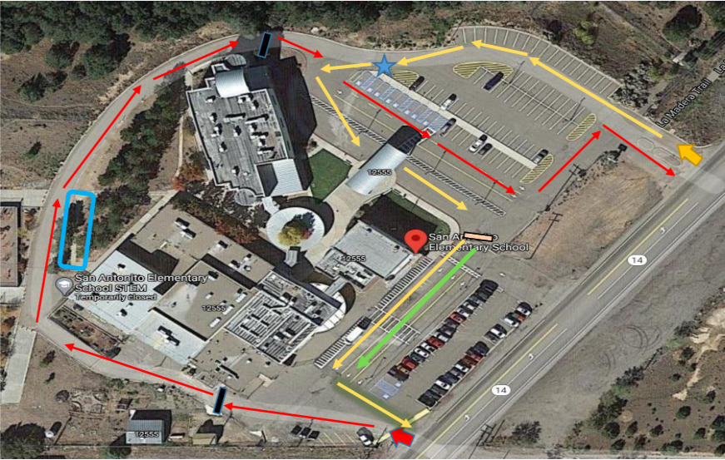

Artifact 2
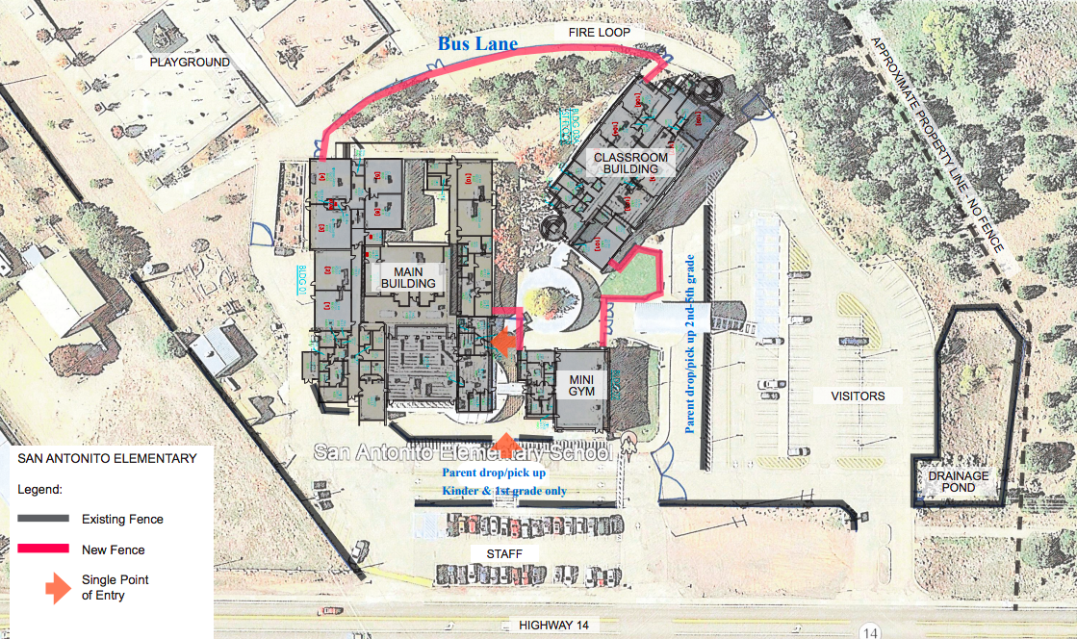

If you have any questions, please reach out to Principal Gallegos at gallegos_pat@aps.edu.

