Employee Online Instructions for Previous Employees

- Go to Employee Online at eo.nsd.org

- Click on the "Former Employees" button.
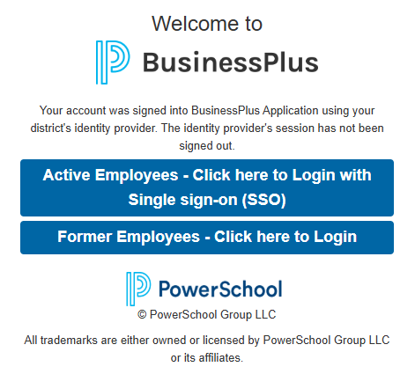

- On the next page, click the blue "Forgot Password" button and enter your personal email address in.

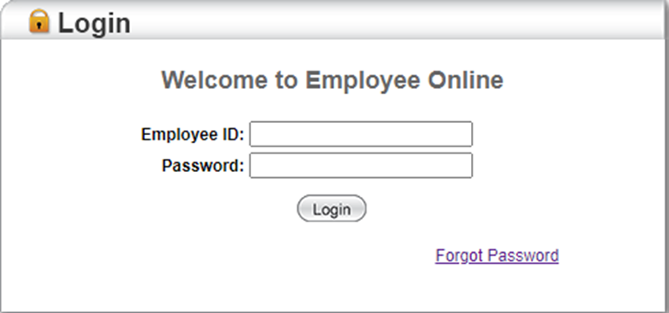

- You will then receive an email containing a blue code made up of numbers and letters.

- Return to the Employee Online home page at eo.nsd.org, and click on the Former Employee button.
- For the Username, enter your Employee ID number. For the Password, enter the blue code you received in the email.

- On the next page you will be asked to create a new password. Make sure that it is at least 8 characters long. (For "old password", it means the blue code that came to you in the email. Do NOT use the password you had used for employee online when you were an employee).

- Once in, click on Payroll and then W2.

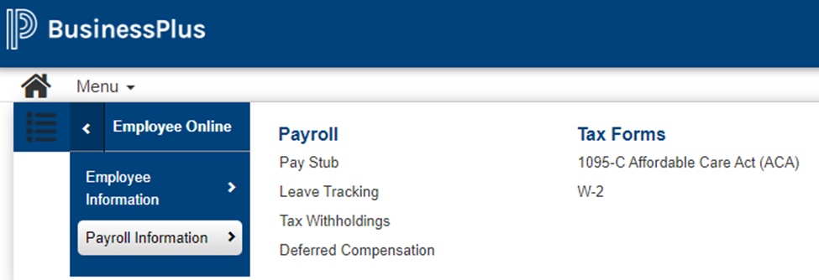

In order to change your personal information, including a new address:
Employee Information: To view and / or change your personal information (address, phone number, email)

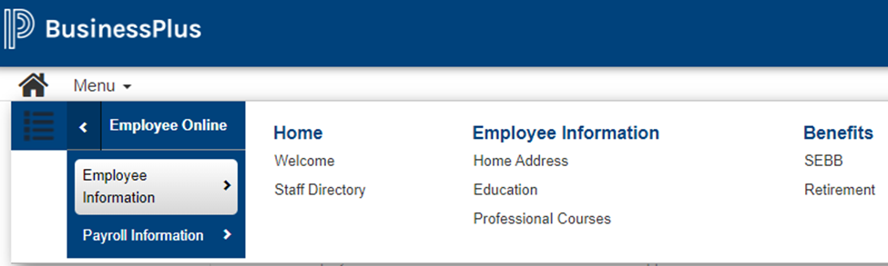

After any changes made, be sure to click the disk button in order to save.

You will have access to Employee Online for up to 2 years after your employment with the Northshore School District has ended. After that, you will no longer be able to log in to see paystubs and tax documents.

