
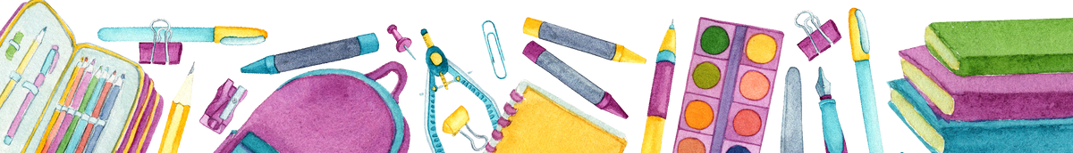

Kindergarten

1 full size book bag (no rolling bags)
2 pairs of over the ear headphones (an extreme necessity) no earbuds, no bluetooth or needs charging. 2 primary writing journals
2 boxes of 24 count crayons 1 pack of colored pencils

Large pack of glue sticks (6ct)
1 pair of scissors (Fiskar recommended) 1 large pack #2 pencils
1 pack of pencil top erasers 4 large boxes of tissues

1 pack of dry erase markers (Fine Tip)

1 pack of Expo Dry Erase Markers (Chisel Tip)

2 bottles of hand sanitizer
2 bottles of antibacterial hand soap 1 box quart size of Ziploc bags

1 box gallon size of Ziploc bags
4 containers of Disinfectant wipes 2 cans of Disinfectant spray

1-2inch binder with clear front cover 1 pack of page protectors

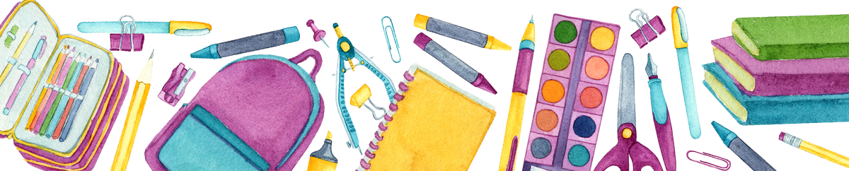

1 s t G r a d e S u p p l y L i s t

1 p a i r o f d u r a b l e h e a d p h o n e s ( n o e a r b u d s ) ( n o w i r e l e s s o n e s )
T h e s e a r e v e r y i m p o r t a n t a s t h e s t u d e n t s n e e d t h e m f o r i n s t r u c t i o n a l w o r k a n d a s s e s s m e n t s o n t h e i P a d s .
1 p a c k o f 2 4 c o u n t c r a y o n s
1 p a c k # 2 y e l l o w p e n c i l s
5 l a r g e b o x e s o f t i s s u e s
1 b o x q u a r t - s i z e p l a s t i c b a g s ( b o y s )
1 c o n t a i n e r o f b a b y w i p e s ( g i r l s )
1 h a n d s a n i t i z e r
1 p e n c i l b o x a n d / o r p o u c h
1 c o n t a i n e r o f d i s i n f e c t i n g w i p e s
1 p r i m a r y r u l e d c o m p o s i t i o n b o o k s
- p a c k o f n o t e b o o k p a p e r
- 1 - i n c h b i n d e r
- 3 - h o l e p u n c h e d b o t t o m p o c k e t f o l d e r s

S e c o n d G r a d e S u p p l y L i s t

1 f u l l s i z e c l e a r b o o k b a g ( l a b e l e d )
1 q u a l i t y p a i r o f o v e r t h e h e a d ( w i r e d ) h e a d p h o n e s f o r d a i l y c l a s s r o o m u s e ( n o e a r b u d s )
1 p a c k o f # 2 p e n c i l s
2 p a c k s o f c r a y o n s o r c o l o r e d p e n c i l s
1 p l a s t i c p e n c i l b o x ( l a b e l e d )
1 p a c k o f g l u e s t i c k s ( n o l i q u i d g l u e )
2 c o m p o s i t i o n n o t e b o o k s w i t h t h e d r a w i n g s p a c e o n t h e t o p ( n o w i r e d n o t e b o o k s )
1 p l a s t i c f o l d e r w i t h p o c k e t s f o r h o m e w o r k ( s o l i d c o l o r o n l y )
1 p a i r o f r o u n d - t i p a g e - a p p r o p r i a t e s c i s s o r s ( l e f t - h a n d e d p a i r f o r l e f t - h a n d e d w r i t e r s )
1 l a r g e b o t t l e o f h a n d s a n i t i z e r
2 + b o x e s o f K l e e n e x t i s s u e s 2 + L y s o l W i p e s
1 b o x o f q u a r t o r g a l l o n s i z e d Z i p l o c k b a g s

T h i r d G r a d e S u p p l y L i s t

1 1 p a i r o f s c i s s o r s ( c h i l d s a f e t y )
1 4 o z . b o t t l e g l u e
4 b o x e s o f t i s s u e
2 b o t t l e s o f h a n d s a n i t i z e r
1 p a c k o f c o l o r e d p e n c i l s
5 c o m p o s i t i o n n o t e b o o k s
2 p a c k s o f g l u e s t i c k s
3 p o c k e t f o l d e r s ( w i t h p r o n g s )
2 p a c k s o f w i d e - r u l e d l o o s e - l e a f p a p e r
2 p a c k s o f 4 c o u n t p a c k o f b l a c k d r y e r a s e m a r k e r s
1 b o x o f b a n d a g e s
B O Y S - 1 q u a r t s i z e & 1 b o x g a l l o n s i z e d p l a s t i c b a g s G I R L S 1 b o x q u a r t s i z e & 1 b o x s a n d w i c h p l a s t i c b a g s



F o u r t h G r a d e S u p p l y L i s t

1 | f u l l s i z e c l e a r b o o k b a g
1 | p a i r o f h e a d p h o n e s
4 | 3 - p r o n g p o c k e t f o l d e r s ( s t u r d y | o n e s )
4 | p a c k s l o o s e - l e a f n o t e b o o k p a p e r
4 | C o m p o s i t i o n N o t e b o o k s
2 | P a c k s o f D r y E r a s e M a r k e r s
1 | p a c k - 4 C o l o r H i g h l i g h t e r s
1 | p a c k o f e r a s e r s
2 | b o x # 2 p e n c i l s
2 | p a c k s o f G l u e S t i c k s
3 | b o x e s o f t i s s u e
2 p k g s o f C l o r o x w i p e s
1 b o t t l e o f h a n d s a n i t i z e r

F i f t h G r a d e S u p p l y L i s t

1 p a i r o f h e a d p h o n e s ( l a b e l e d )
4 d o z e n # 2 W o o d e n P e n c i l s
2 b o x e s o f P e n c i l T o p e r a s e r s
1 p a c k o f H i g h l i g h t e r s
1 p a c k o f C o l o r e d P e n c i l s
1 P e n c i l P o u c h
4 p a c k s o f l o o s e - l e a f n o t e b o o k p a p e r
4 f o l d e r s ( 2 – p o c k e t )
4 M a r b l e C o m p o s i t i o n n o t e b o o k s
4 b o x e s o f T i s s u e
2 b o t t l e s o f H a n d S a n i t i z e r
3 c o n t a i n e r s o f d i s i n f e c t a n t w i p e s
1 b o x o f b a n d a g e s

