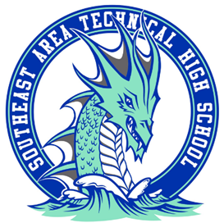

Hello Sea-Dragon Families!
We have chosen a straightforward, fun way to invite parents to help partner with us to raise funds for our Sea-Dragon students, staff and families. 100% of funds raised will be spent in our school.
Funds raised will help support student events, field trips, staff grants, staff and student appreciation events. Lunch N Learn, Awards Day, Shadow Day, outdoor classrooms and so much more. Our hope is to make fundraising straightforward and simple, this way you can use your time involved with SEA-Tech in other ways. We hope you smile a little when donating.
_______________________________________Please Return Below__________________________________________

_____Here’s the $20.00 We would have spent buying (I mean baking) something for the Bake Sale.

_____Here’s $30.00 We won’t remember to clip the box tops or bring in my soup can receipt.

_____Here's the $50.00 We would have spent on wrapping paper, ribbon, gas, and picking out a basket for a raffle.

_____Here's the $75.00 We would have spent in time, energy and imagination explaining to family and friends why they need more coupons or another magazine subscription.

______Here’s my donation as a thank you for allowing a simple and funny way to fundraise for our school. I love SEA-Tech!

Total Amount Donated_______________________ Name________________________________________________

Email___________________________________________ Phone_______________________________________________
(Please Make Checks Payable to Friends of SEA-Tech PTA.)
Thank you for being a part of the SEA-Dragon family. Any questions please e-mail seatechhighpta@gmail.com

Facebook: Friends of SEA-Tech
Date Pd___ Amount______ Cash/Check #_________

