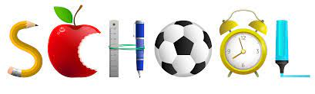
CEDAR SPRINGS ACADEMY
2025-2026
________________________________________________________________________________________________________
CONTACT INFORMATION
Principal Elizabeth Baird 864-577-7769 ebaird@scsdb.org

Lead Teacher McKaylia Waddell 864-577-7769 mwaddell@scsdb.org

Admin. Assistants Jamy Zirkle 864-577-7769 jzirkle@scsdb.org

Herbert Center Nurse Meri Revan 864-577-7781 mrevan@scsdb.org
Nurses Station 864-577-7780

Dir. of Residential Life John Reynolds 864-577-7812 jreynolds@scsdb.org

Associate Director of
Residential Life Josh Joseph jjoseph@scsdb.org

Trans. Serv. Coordinator 864-577-7701



Cedar Springs Academy Main Number 864-577-7769
SC School for the Deaf & the Blind Toll-Free Number 1-888-447-2732

