nVision Web - Functionality and Account Registration
Functionality
Finance Manager/nVision have developed a portal that allows employees to access human resource-related information. At this time they are providing access to a few important areas:
- Dashboard
  - Self-explanatory: a birds eye view of payroll information
- Attendance
  - Balances
    - Self-explanatory: a summary of attendance categories showing the starting balance, earned days, days used, and remaining days
  - Time Off Requests
    - Instructions to submit time off requests begin on the next page. This is the feature we’re most excited about. Here, employees are able to submit time off requests. The need for paper-based absence forms will be eliminated following full implementation.
- Payroll
  - Pay History
    - Self-explanatory: employees can retrieve copies of pay stubs here
  - W2 Forms
    - Self-explanatory: employees can retrieve copies of W2 forms here
Account Registration
To get started, you will need to register for an account in nVision Web. Note that this is a separate system – login credentials for those with access to nVision will not work in nVision Web.
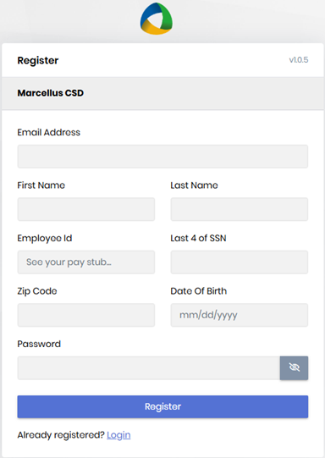
To register for a new account, use this link: Register for nVision Account
- Enter your school email address.
- Enter your first and last name.
- Enter your employee ID/number. This number can be found on your check stub. It is a 3 or 4 digit number, located in the center of the page to the right of your name.
- Enter the last four digits of your social security number.
- Enter your zip code (please use your home zip code)
- Enter your date of birth using the format shown in the field.
- Enter your preferred password, which must include:
  - 6 or more characters
  - One lower case character
  - One upper case character
  - One number
  - One special character
- After you have created your account, return to the login screen and enter your credentials. You will be asked to set up multi-factor authentication using an email address and/or cell phone.
nVision Web - Procedures to Request Paid Time Off
Sick/Family Sick/Personal
- All MFA & MSOPA members, Teacher Aides, and Teaching Assistants - please continue to submit absences in the Sub Service application to ensure coverage is secured during your absence.
- After logging into nVision Web, under Attendance, select Time Off Requests:
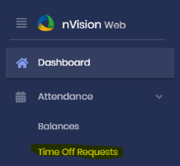
- In the upper-right corner, select “+ New Time Off Request”
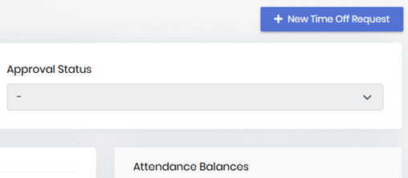
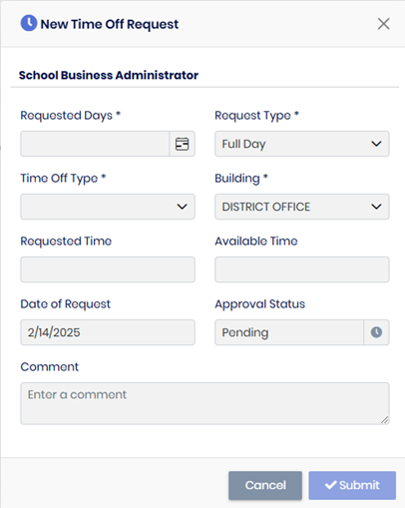
- Select the options necessary to complete the request
  - Requested Days: You must select a beginning and ending date for the request. If your request is for one day, the beginning and ending dates are the same. Weekends and holidays are greyed out.
  - Request Type: Select “Full Day” or “Half Day”. Some groups will also have the option of selecting “Quarter Day”.
  - Time Off Type: Select the type of day most appropriate for your request.
  - Building: This is only applicable if you work in multiple locations.
  - Comment: Please enter a note here if necessary.
  - Select “Submit” to submit your request for approval.
- You will receive an e-mail notification confirming your request was submitted, and another when your request was approved.
- Balances will be affected at the time of approval, even if the days used are subsequent to the date of your request.
nVision Web – Attendance Rules
Based on your employee group, you will have various options available to request full and partial use of paid time off. Please see the chart below to determine the attendance codes and full and partial day options that pertain to you.
Group | Request Options
Group | Full day | Half day | Partial day | Quarter day
Teachers | x | x
Teacher Assistants, Teacher Aides 6.5 | x | x
Teacher Aides (café) 3.5 | x | x
Food Service | x | x
Cook Manager | x | x |  | x
Building and Grounds | x | x |  | x
Administration | x | x |  | x
Transportation | x | x
Office personnel | x | x | x | x

Q & A - we will continue to provide Q&A information as more questions are presented to us
Q: What if I have already submitted a paper time off request prior to nVision web?
A: If you have already submitted a time off request (ie: for personal or vacation time) for future time off you will need to go to nVision web and submit a request for that time.
Q: Does my balance reflect the days that have been approved but not yet taken?
A: Yes, if you put in a request to take time off that is in the future, once it has been approved it is taken from your balance.
Q: How do I put in for time that I have not accrued yet?
A: The system will not let you put in for time that you have not accrued.
Q: What do I do if I put in a request for time off that has been approved and I cannot take the day?
A: Please contact your building secretary or the individual who enters paid time off in nVision. They can cancel the day for you.
Q: I requested a vacation day or other paid time off and it was approved, but I did not end up taking the day after all. Even though the time was deleted, why do I still see it listed as an approved day in time off requests?
A: If you have time that was previously approved but then deleted, you will receive the day back in your balance but the approved request will remain as receipt of the original approval. There is no way to remove this.
Q: When registering for an account, where do I find my employee ID?
A: Your employee ID can be found on the check stub emailed to you every two weeks:
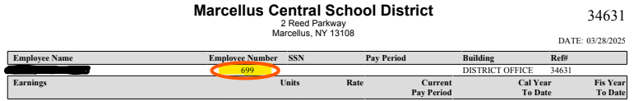
Q: If I have already put my time into the sub service, do I still need to put in a time off request in nVision Web?
A: Yes, the two systems are not connected, the sub service is used for calling substitutes and nVision Web is just for attendance purposes.

