

CAPITAL CONSTRUCTION FINANCIAL OVERVIEW

April 10, 2018

CURRENT BOND FINANCIAL STATUS
In millions
 | 2017 -18 Activity
 |  | Beginning balance from 2012 Bond |  |  | $117
 |  | Bond issue from 2012 ballot |  |  | 62
 |  | 2017 Bond Issue |  |  | 347
 |  | Premium/income |  |  | 13
 |  |  |  |  | 539
 |  | Spending projection |  |  | (63)
 |  | Ending balance 6/30/18 |  |  | 476
 | 2018-19 Activity
 |  | Income |  |  | 3
 |  | Spending projection |  |  | (185)
 |  | Ending balance 6/30/19 |  |  | 294
 |  | Remaining issuance authority |  |  | 443
 |  | Total available to finish program |  |  | $737

• Beginning of eight year plan
• Not a cash problem

2012 BOND

Nearing completion - remaining projects:
Finish Grant HS
Maker Space at Roosevelt

Schools larger than original specifications
Increased capacity
More classrooms for full time classload
Roosevelt Maker Space added to project ($5 million for space)

Currently forecast to cost $0-$10 million over funds available from 2012 authority

MIDDLE SCHOOL
IMPLEMENTATION/TRANSITION

REVISED UNFUNDED COSTS
(millions)
Tubman | $5.8
Roseway Heights | 0.2
Rose City Park | 1.9
Holladay/Youngson | 0.7
Contingency | 2.5
Design/soft costs to date | 0.8
Total construction | 11.9
Owner costs | 1.4
 | 13.3
Fundable from bond Health & Safety | -1.9
Total unfunded costs | $11.4

*Does not include any costs of transitioning ACCESS

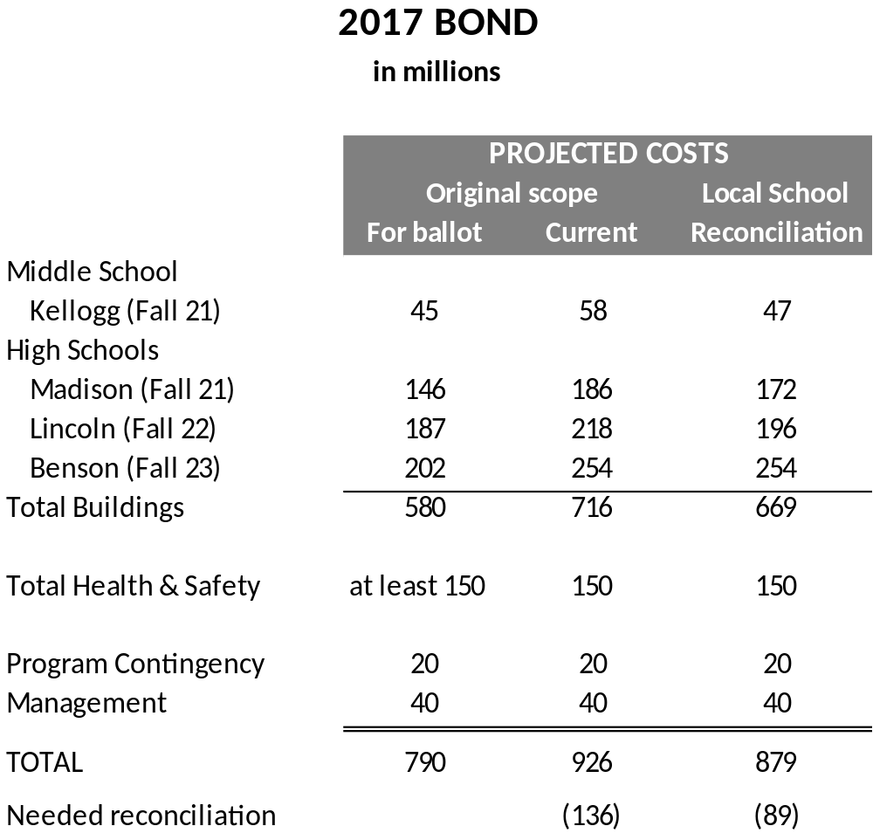

BUILDING PROCESS STATUS

KELLOGG
- Board approved master plan at original scope.
- Later analysis showed costs were much higher
- Internal group including educational leader reduced scope to get cost down Some efficiencies
Smaller classrooms, no breakout rooms
Removed small fourth floor
- Must bring revised master plan back for board approval

MADISON
- Internal group met and reduced costs to "bare minimum" $172 million Removes all field improvements
Removes 4 classrooms, 2 labs, 4 collaboration spaces
Smaller classrooms, science labs
- Waiting for direction on budget. Will then submit master plan to Board
- Can meet Fall 21 opening date if decision made by mid-May and scope changes
not too large

LINCOLN
- Internal group met and reduced costs to $196 million
- Still working on reductions.
- Decision needed by mid-May

BENSON
- No group meeting as yet
OPTIONS

MIDDLE SCHOOL IMPLEMENTATION/TRANSITION
- Include all unfunded construction costs in bond funding.
- Charge non-bond funded items to construction excise tax
  - Barely fits – can handle about $12 million
  - Allows $3 million per year for rest of schools in addition to Health and Safety bond and $1 million General Fund transfer
  - Requires postponing/repealing dedication to capital asset renewal
- Borrow money and repay from General Fund
  - Debt service about $1 million per year on 15 year loan @4%.
  - Could declare intent to refund from next voter approval

2012 BOND
- Include all unfunded construction costs in bond funding.
- Charge non-bond funded items to construction excise tax
  - Probably won’t fit if this solution used for middle school implementation
- Borrow money and repay from General Fund or CET
  - Could declare intent to refund from next voter approval

BOND OPTIONS
- Kellogg - consider revised master plan when it is ready
- High schools
  - Set timelines for high school building master plan approval
  - Continue the local process of analyzing/removing costs based on the timelines
  - Establish district reconciliation process to ensure equity across all high schools
  - Budget options
    - Go forward with reduced costs/scope
    - Do buildings in phases, fund second phase from next voter approval
    - Raise more money - some will come from structure of next bond issue and interest earnings
    - Borrow to complete projects, refund with next voter approval

