
WEST BONNER COUNTY SCHOOL DISTRICT #83
134 Main St., Priest River, ID 83856
Sd83.org • Phone: (208) 448-4439 • Fax: (208) 448-4629

Injury Report Packet
This packet outlines the process for reporting an accident that occurs to an employee/volunteer of the district. West Bonner County School District #83 is a member of the State Insurance Fund providing Worker’s Compensation (SIF). When an employee/volunteer is involved in an accident, the follow-up documentation is completed through an Injury Report by the employee/volunteer and an Incident Investigation by the immediate supervisor. Documentation will then be sent to the Human Resources Director to work with the employee/volunteer, supervisor, and SIF to assure the well-being of the employee/volunteer.
Follow these steps for reporting an injury:
1. If your accident causes an injury that immediate medical attention is needed, then call the Triage Nurse at SIFCare using the number below:
1-866-543-5216
Notify your immediate supervisor of your accident/injury!
Follow the instructions of the Triage Nurse:
1) Seek immediate medical attention at Northwest Specialty Hospital, complete the Request for Services, then, continue to Step 2 upon your return.
2) Continue to work, and move to Step 2
2. Obtain the Injury Report Packet that includes the Injury Report and Incident Investigation forms.
a. Request the Injury Report Packet from a building administrative assistant, building principal, or district department supervisor.
b. Access the form by downloading the form from the district website using the following pathway:
Home / Our District / Staff Resources / Employee Safety
3. Complete the Injury Report with all information.
4. Provide the complete report to your immediate supervisor who will complete the Incident Investigation.
5. Your immediate supervisor will contact you to complete the investigation as soon as possible.
6. Your immediate supervisor will then complete the Incident Investigation with you in person as you have firsthand knowledge of the accident.
7. Your immediate supervisor will then send the documentation to the Human Resources Director.
8. The Human Resources Director will contact you to work with you, your immediate supervisor, and SIF. regarding light duty work (if necessary).

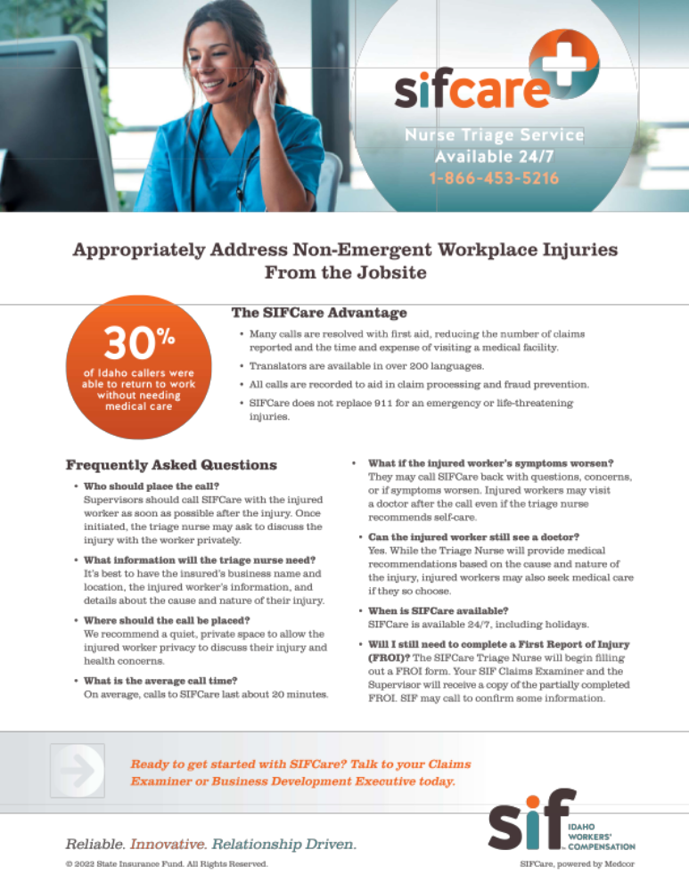

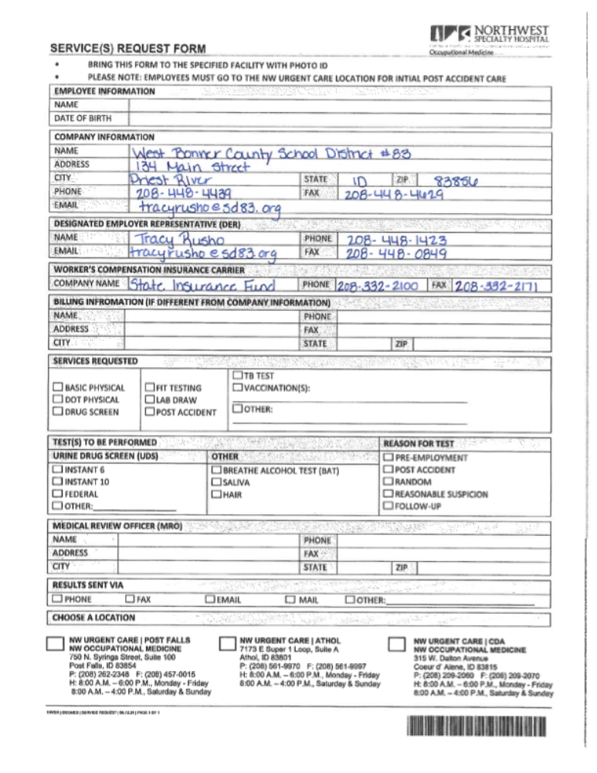

Injury Report
Instructions: Complete this form for all work-related injuries, illnesses, or near miss incidents – no matter how minor. This will assist in identifying and correcting hazards before they cause serious injuries.
This form should be completed by as soon as possible and given to your supervisor for further action.

Employee Section
Type of incident reporting: ☐ Injury ☐ Illness ☐ Near Miss
Name: Click or tap here to enter text.
Job title: Click or tap here to enter text.
Supervisor: Click or tap here to enter text.
Date of injury/near miss: Click or tap to enter a date. | Time of injury/near miss: Click or tap here to enter text.
Names of witnesses (if any): Click or tap here to enter text.
Where, exactly did it happen? Click or tap here to enter text.
What were you doing at the time? Click or tap here to enter text.
Describe step by step what led up to the injury/near miss: Click or tap here to enter text.
What could have been done to prevent this injury/near miss? Click or tap here to enter text.
List body part(s) injured? If a near miss, how could you have been hurt? Click or tap here to enter text.
Employee’s Signature
Would you like to seek medical treatment for this injury/illness at this time? ☐ Yes ☐ No
If you select No, then decide at a later time to seek medical treatment notify your supervisor and treatment will be scheduled with the Designated Medical Provider
Employee Signature: |  | Date:

Incident Investigation Report
Supervisor Section
Employee’s Name: Click or tap here to enter text. |  | Date Notified: Click or tap to enter a date.
Department: Click or tap here to enter text. |  | Job title: Click or tap here to enter text.
Location of the incident: Click or tap here to enter text. |  | Time: Click or tap here to enter text.
Nature of injury (most serious):  ☐ Abrasion, scrapes  ☐ Amputation  ☐ Broken bone  ☐ Bruise  ☐ Burn (heat)  ☐ Burn (chemical)  ☐ Concussion (to the head)  ☐ Crushing Injury  ☐ Cut, laceration, puncture  ☐ Hernia  ☐ Illness  ☐ Sprain, strain  ☐ Damage to a body system:  ☐ Other: Click or tap here to enter text. |  | Employee work status:  ☐ Regular full time  ☐ Regular part time  ☐ Seasonal  ☐ Temporary
Length of time in position
Click or tap here to enter text. year(s) Click or tap here to enter text. months
 |  | Body part(s) affected: Click or tap here to enter text.
What part of employee’s workday? ☐ Entering or leaving work ☐ Performing regular work activities
☐ During meal period ☐During break period
☐ Working overtime ☐ Other Click or tap here to enter text.
Names of witnesses (if any): Click or tap here to enter text.
Attachments  (check all included) | Written witness statements:  ☐ Yes ☐ No | Photographs:  ☐ Yes ☐ No | Maps / drawings:  ☐ Yes ☐ No
Was PPE provided ☐ Yes ☐ No  List PPE Click or tap here to enter text. |  | Was PPE worn: ☐ Yes ☐ No  Why not worn: Click or tap here to enter text.
Describe, step-by-step the events that led up to the injury. Include names of any machines, parts, objects, tools, materials and other important details: Click or tap here to enter text.

Why did the incident occur?
Unsafe workplace conditions: (Check all that apply)  ☐ Inadequate guard  ☐ Unguarded hazard  ☐ Safety device is defective  ☐ Tool or equipment defective  ☐ Workstation layout  ☐ Lighting issues  ☐ Ventilation issues  ☐ Lack of required PPE  ☐ Lack of appropriate equipment/tools  ☐ Unsafe clothing  ☐ No training or insufficient training  ☐ Other: Click or tap here to enter text. |  | Unsafe acts by employee: (Check all that apply)  ☐ Operating without permission  ☐ Operating without training  ☐ Operating at unsafe speed  ☐ Servicing equipment that is powered on (LOTO issue)  ☐ Making a safety device inoperative  ☐ Using defective equipment  ☐ Using equipment in an unapproved way  ☐ Unsafe lifting by hand  ☐ Taking an unsafe position or posture  ☐ Distraction, teasing, horseplay  ☐ Failure to wear PPE  ☐ Failure to use the available equipment/tools  ☐ Other: Click or tap here to enter text.
Why did the unsafe conditions exist? Click or tap here to enter text.
Why did the unsafe acts occur? Click or tap here to enter text.
How can future incidents be prevented?
What changes/corrective action has been taken to prevent similar incidents? (Check all that apply)
☐ Stop this activity ☐ Guard the hazard ☐ Train the employee(s) ☐ Train the supervisor(s)
☐ Redesign task steps ☐ Redesign work area ☐ Develop a procedure ☐ Enforce existing procedure
☐ Routine inspects ☐ PPE ☐ Complete JHA/JSA
☐ Other: Click or tap here to enter text.
Describe changes/corrective action checked above? Click or tap here to enter text.
Completed by: Click or tap here to enter text. Date Completed: Click or tap to enter a date.
Additional Comments: Click or tap here to enter text.
Supervisor’s Signature
Signature: |  | Date:
Reviewed by: |  | Date:

