#1
Emily Sawyer
Parent, Substitute Teacher
My name is Emily Sawyer. I am the parent of 4 PPS students and 1 graduate of Pittsburgh
Perry.
I am incredibly worried about the lack of equity directives in the current draft of policy 802.1
regarding private sponsorships.

We will not sidestep, sashay, trip, or accidentally back our way into an equitable and just school
district.

Sponsorships, which are often predicated on social capital, family and
community contacts, and the availability of resources within family, community, and social
networks, are rife for inequity if we do not purposefully design equity guardrails in. It has been made clear to me that at least some on the Board feel that including equity guardrail requirements in the policy is “micromanaging” and that this needs to be left up to the superintendent and administration. I find this a woefully lacking strategy. When will an AR be written? The policy itself allows for the fact that no AR may exist. What will become of any chance at equity then? What is the recourse of the Board or community if the AR is written and we don't find it sufficient? Why allow an insufficient AR to ever be written, when equity guardrails could be required by the policy? This is not an unreasonable ask.

At the very least, the Board should direct in policy the superintendent and administration to track and publicly report all sponsorships by campus (or for district sponsorships, broken down by amount dispersed to which campuses) is a must. We will never be able to assess whether we have equitable distribution of resources if we are not tracking and reporting resources and their distribution.

Secondarily, the Board should direct in policy the superintendent and administration to include in the AR processes and guidelines for reviewing, accepting, or requesting amendments to
sponsorships in the event that certain schools or groups are accruing or potentially accruing
disproportionate amounts of sponsorship resources.

Thirdly, the Board should direct in policy the superintendent and administration to include in the
AR processes and guidelines for distribution by the Superintendent of any districtwide
sponsorship resources so that equity is attained and needs are met before privilege is catered
to with these resources.

We won’t reach equity unless we build it in purposefully through equitable policy, processes, and practices.

Practically speaking, the first paragraph under “Purpose” and B.1. don’t match. The paragraph
under Purpose mentions “public school facilities and events” while B.1 references only “Student
Activity.” These need to have consistent language as to what can be “sponsored.” Language
needs to be kept consistent throughout the document.

#2
Sarah Schaible
Parent

#3
Shirley Ann Hill
Retired PPS Teacher
I have followed the public hearings regarding the unfair treatment of former Montessori teacher Ms. Stephanie Lapine by principal Kellie Meyer. Throughout my 41-year career with PPS, I too was subjected to toxic principals like her. In December 2023, Ms. Stephanie Lapine was removed from her classroom by Kellie Meyer. After many attempts by parents/guardians, Kellie Meyer did not offer an explanation for Ms. Stephanie Lapine’s removal. Ms. Stephanie Lapine was cleared in February 2024 but was “conveniently transferred” to another school that does not have a Montessori program. Why was Ms. Stephanie Lapine not reinstated at Montessori where she belongs? Get it right for the upcoming school year!! Why is Kellie Meyer not being held accountable for her unfair treatment of Ms. Stephanie Lapine (the only lead black teacher)? Some Montessori teachers have filed grievances and still nothing has been done. Toxic principals like Kellie Meyer put fear in teachers who speak up by sabotaging their teacher evaluations. Pretending there are no problems at Montessori definitely creates an unsettling work environment. Teachers should not have to adapt to this leadership style to keep their jobs. Some principals are good for “conveniently cutting” positions when you speak up. I question how students are first when toxic principals are not held accountable.

Carrick High School has a very small percentage of black teachers. “Having a Black teacher builds cultural bonds between educators and students and has a positive impact on students’ academic outcomes. Research has shown that Black teachers have a direct positive impact on Black and non-Black students.” (Intercultural Development Research Association, February 26, 2025) BLACK STUDENTS AT CARRICK MATTER!!

Computer Applications should be a mandatory business elective class for all incoming freshmen. During my time at Carrick, some English teachers, CTE ITL, and CTE Director have indicated the importance of this class. Freshmen are not getting the necessary skills in middle school. When it is time to do a project, some of them are lost. While at Carrick, I have helped students many times navigate through the necessary software to complete their projects. Quite often teachers require students to do projects that utilize Microsoft Word, PowerPoint, and Excel. These skills are beneficial to students beyond high school. I hope with the incoming new principal there will be changes at Carrick.

#4
Jahn Grimm
Teacher/Staff, Parent

#5
Katy Rank Lev
Parent
Hello again. I know you know that I pay a lot of attention to this plan for our district and have read/watched all the materials so far. I have questions as you face big decisions on next steps.

My big question why we can’t do the things on this proposed schedule with our current school configurations. Is there a reason that, say, Faison middle school can’t have tech ed right now?

The plan released actually has a case study for Sterrett—my children’s middle school. The plan lists enrollment there currently at 179 and there is/was a wait list for the partial magnet program there. The plan, which doesn’t reference Sterrett’s magnet program so I have no idea if it’s ending, proposes to increase enrollment to 379 students.

This proposed enrollment exceeds the capacity for Sterrett to offer all of the things laid out in the plan. My children have always had homeroom in the physical space of another subject and I’m not aware of any currently empty spaces in the building, so I don’t understand where the proposed makerspace or tech lab will go. If all schools still won’t have all specialized spaces, I’m not sure I understand how a shuffle of this magnitude increases equity.

Speaking of a shuffle, I can’t help but notice the new plan has my children and my neighbors’ children attending Minedeo for elementary school and then leaving their community and friend groups formed over the 6 years of K-5 to matriculate to a different middle school from their peers.

I wanted to look over ideas that will be in place for my high schoolers when the plan is supposed to be in place…but there is nothing in the report about standard offerings for high school. My oldest child will be moving to a different school for his senior year if you vote to proceed. His proposed high school currently has a capture rate of 23%, and only a 3% rate of completion for college or trade school.

The proposal looks to move a number of high school students from a school with advanced math and science offerings…so I am of course curious what the plan would be to improve opportunities at this and all our high schools.

Why doesn’t the plan include information about the high school level?

I wonder what will happen to make this a more attractive district for teachers since the plan hinges on significant staffing increases. We have a lot of staff vacancies currently (many in world languages, art and music…which the plan emphasizes in great measure) and I hear my children’s principals tell me how much additional adults would help with day to day challenges.

I know this has been in the works for 18 months, but it feels incomplete to me. I don’t understand the rush, I don’t understand the metrics for measuring success.


#6
Doug Johnson
Custodian

#7
Brian Brocato
Teacher/Staff

#8
Vincent Santucci
Teacher/Staff

#9
Michael Cummins
Parent

#10
April Clisura
Parent, Bus Driver

#11
Anne Farris
Parent
Courage, Clarity, and Change

Hi, I’m Anne Farris, a PPS parent living in the North Side.

The Board of Directors asked the Superintendent to deliver a feasibility report that included a financial analysis, preliminary transportation plan, and capital investment needs. Dr. Walters delivered his report and it is now your job to review it to determine whether the Facilities Utilization plan will benefit students. And I urge you not to check the box here. Yes, the superintendent included more information, details, and numbers but there is still critical information missing. I do not see at this point how an assessment can be made as to whether the plan is feasible given numerous outstanding questions:

- The demographer work is apparently being conducted in-house and is not complete. Without this to inform accurate attendance zones and feeder patterns, how do you know the proposed reduction in building footprint and grade reconfigurations will accommodate all of the students in the district? And how is it possible to have a preliminary bus plan?

- Where are the costs to implement the building closures, school closures, and reconfigurations? The previous round of school closures and reconfigurations cost tens of millions of dollars? Do the benefits to the students outweigh these costs and disruptions?

- Where are the projections for staff and faculty to support the updated grade configurations as well as the new schedule circulated to families next week? For example, how many “world language” teachers will the district employ and what is the recruiting budget and plan.

- What software licenses will be needed to implement the proposed schedule and what percentage of instruction time will students be spending on devices vs in-person instruction?

PPS has closed and reconfigured the district before and there are models of failure. Why does this plan still phase out many of the successful magnets. How is it equitable to reduce the magnet option for elementary to one? Have the courage to build more schools on the model of Dilworth, SciTech, CAPA…

Dr. Walters, please show the families whose children you are responsible for that you actually are working to support ALL students in ALL ways. The community are speaking here because they do not see it. You introduced your report last week with a call for courage, clarity, and change. Show courage by providing clarity to PPS families - do this by continuing to work on the facilities utilization plan until you get it right. You are right, this is not the 80s when traditional K-5, 6-8, 9-12 grade configurations may have been optimal. Yes, they make sense, but given the city’s demographics (which aren’t fully reported yet) does a blanket reconfiguration of all schools serve each community? Equity does not mean the same for all.

A driving force for this change is improving student outcomes, especially for all students. Does transitioning 30% of the district’s students to new schools do that? How many years will we see test scores drop and already poor performing schools perform worse when so many students experience disruption at this level.

#12
Elizabeth Cummins
Parent

#13
Trey Cummins
Student

#14
Jazlynn Worthy
Parent

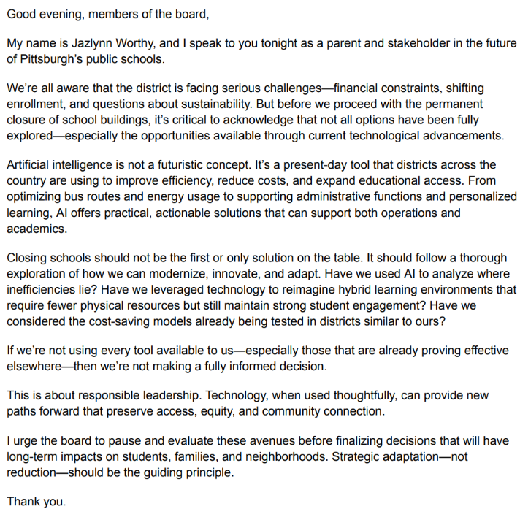

#15
Erin Breen
Parent

#16
Melinda Mix
Teacher / Staff

#17
Nina Louise Dagavarian
Student

#18
Valerie Webb-Allman
Parent

#19
Lisa Lederer
Parent
I am the parent of a first-grader at Colfax. I am concerned that the updated FU Plan does not truly demonstrate the plan’s feasibility. While I understand that it would be impossible to estimate the cost of, for example, every single piece of technology that will be purchased (because new technologies are sure to arise in the future) the “reinvestment scenarios” stated in the document on the website are unacceptably vague. Only the costs of the Teacher Centers, and to some extent specialized teachers, are called out explicitly. I question whether the stated "cost avoidances" are really enough to cover, for example:
- the "Mobile Engagement Unit" to gather community feedback
- new "furnishing and technology" to support "student-centered" learning
- in-school gifted education training and staff
The updated plan includes much more detail on the “savings” side of the ledger. However, the improvements promised by the plan authors are vast and hand-wavy. Before the Board can reasonably be expected to vote on the plan, it must also include greater detail on the “added costs” side of the ledger.

#20
Sarah Zangle
Parent

#21
Sheila May-Stein
Teacher/Staff
Nothing can substitute for the magic of the story circle in school libraries. Sitting on the carpet with our friends, criss-cross applesauce with our hands in our laps, eyes wide, with our listening ears on, hearing Amazing Grace teach her class that she can indeed play the part of Peter Pan, as No David does every bad thing but is loved and valued anyway, watching as the Caterpillar eats all the candy and cupcakes and chips and fries and gets a stomach ache—but then a fresh green leaf helps him turn into a beautiful butterfly. These stories, and all the others, teach our children at a vulnerable age that mistakes are okay to make because we can learn from them, that even when we mess up, we still deserve love, and that being different is wonderful.
The school library is different than classroom libraries. Our collections are curated to support what our teachers are doing each year, so if teachers do special projects, they will be able to find books to support them. Each school’s library collection has books that support where children are developmentally: so there may be 4 or 5 biographies of Dr. Martin Luther King on different reading levels for example, so success is guaranteed for readers. We have magazines, films, reference materials and on-line encyclopedias and databases we teach teachers and students to use for research. Most importantly, we have deep, rich collections of fiction and non-fiction for students to browse for books to read for fun. Being able to choose your own books from a large collection while in school is incredibly important. Not every family can get to a public library for book selection.
School libraries are irreplaceable. According to the Center for American Progress, Maryland and Nebraska require every school to have a certified school librarian in every school. Philadelphia and Boston are working on returning school librarians to every school in their Districts. The Lance and Schwarz’s study, “How School Libraries Pay Off” says, “…On average, Black and Latino students who had access to larger school library collections saw their percentages of advanced writing scores more than double and their likelihood of scoring below basic levels cut in half, compared with their peers in schools with smaller collections.”
If Pittsburgh Public Schools are going to create a different role for PPS Librarians than the one we currently have in the coming years, then I am calling on the Board of Directors and the Superintendent to reconsider. If we are “students first always, in all ways,” then consider how deeply influential that story circle in the school library is on little ones. Stories will build their characters, develop their hearts and minds into strong people who will build our city into the future require that kind of start—a circle in a library with a certified school librarian doing what he or she does best—reading and checking out the best books for children. Thank you.

