Positive Behavior Interventions and Supports (PBIS) the WAHOO WAY!
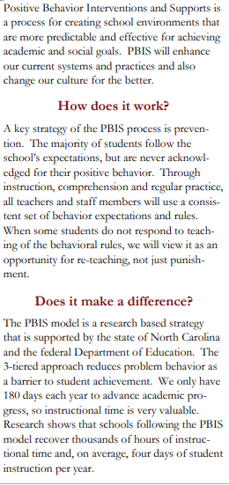

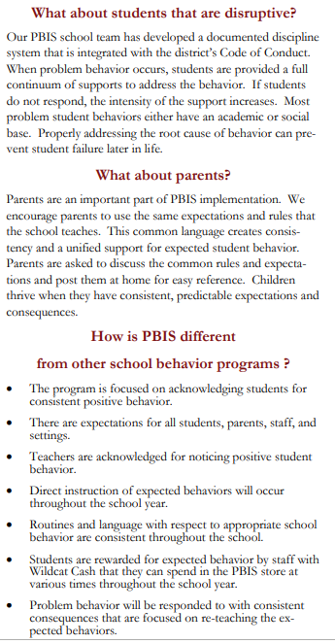

Discipline
For minor behaviors students will receive a warning and correction. Teachers will talk with your student about the choice, consequences, and alternative behaviors. If the behavior continues the student is sent to a buddy classroom to reflect on their actions. After a time of reflection if the behavior continues the parent is notified and discuss how to work together. Together we can help students change behaviors so they are ready to learn. If the behavior continue the guidance counselor and administration are consulted for further guidance or strategies. Minor behaviors usually fall into the categories of disruptive behaviors or disrespect.
Major behaviors require immediate office referral and can include repeated minor behaviors, hitting/kicking/pushing with intent to hurt, destruction of property, threats, inappropriate object at school, constantly picking on others and inappropriate touching.


To truly change behavior, appropriate behavior must be…
- Taught
- Modeled
- Practiced
- Acknowledged

Guidelines or Parents:

- Use positive wording: Instead of “Don’t run in the store,” try “You must walk in the store.” Instead of “Stop yelling” try “Use your inside voice.” Instead of “No throwing the ball in the house,” try “You can only throw the ball outside.”
- Be a teacher: When you have to say NO give a reason why.
For example, while shopping, your child asks you to buy him a toy. You know how many toys he already has, and you are short on time. You tell your child, “No, we can’t buy that toy today because you already have a toy in the car that you can play with on the way home.”
If you child accepts your answer, compliment him, saying something like, “Thank you for being respectful and understanding that we can’t buy a new toy today.

- Acknowledge appropriate behavior.
Use positive reinforcement to teach your children which actions/behaviors are expected, accepted, or desired.
Figure out what kinds of acknowledgements your child will be motivated by. Ask them what they would enjoy doing (not necessarily having)!
Parent’s Guide to PBIS
Create a special “Reward” basket or box of toys or items that you already own but that your child only gets to play with or use when they have done what was expected.
Create a sticker chart with chores and use a sticker to mark when each one is completed. At the end of the week, if all chores are completed according to expectations, give a reward.

Try PBIS at home.

- Decide Expectations

- Have a family Meeting

- Use positive reinforcement for appropriate behaviors.

- Use consequences for inappropriate behaviors.

Winstead Avenue
Elementary School
Positive
Behavior
Interventions &
Supports
Our Core Values:
Be Responsible
Be Respectful
Be a Learner
Be Prepared
Be Kind

