[Insert Project Name] Survey Questions

Survey Link for Participants to Respond:
[Insert Link]

Survey Link for Owners to Edit/View Responses:
[Insert Link]

Survey Name:
[Insert Project Name] Survey

Opening Text:
PURPOSE: The ITS division is interested in hearing your feedback about the [Insert Project Name], [Insert Purpose of Project]. How did we do? Your input will help us improve our service and future projects.
SURVEY TIMEFRAME: [Insert Date Range]
CONTACT: Please contact [Insert Name] ([Insert Email Address]) with any questions about this survey.

Questions:
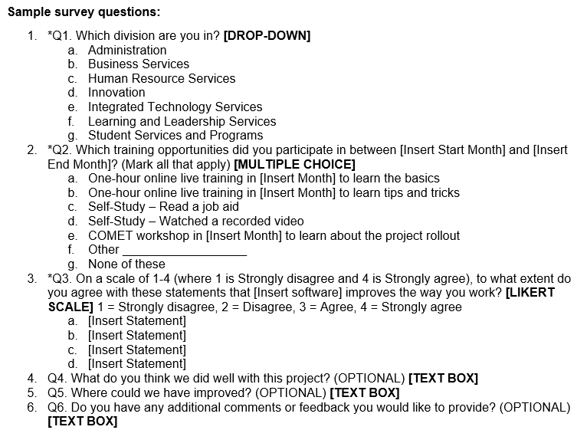
Directions: Type your questions in the outline below. If you are using multiple choice or dropdown responses, include the options. Mark required questions with an asterisk (*)

- Type question here
  - Option
  - Option
  - Option
  - Option
- Type question here
  - Option
  - Option
  - Option
  - Option
- Continue the questions here…

Thank You Message (Upon Submit):
Thank you for providing us your feedback about the [Insert Project Name]. All responses will be reviewed by our project team. Your input will help us improve our service and future projects. If you have any questions about this survey, please contact [Insert Project Manager’s Name], [Insert Project Manager’s Job Title], [Insert Department Name].

Settings (Adjust As Needed):
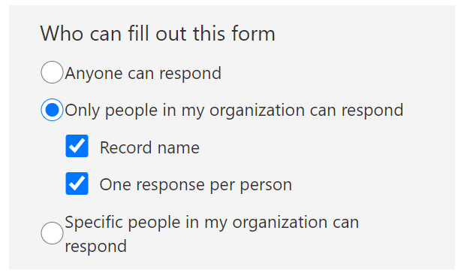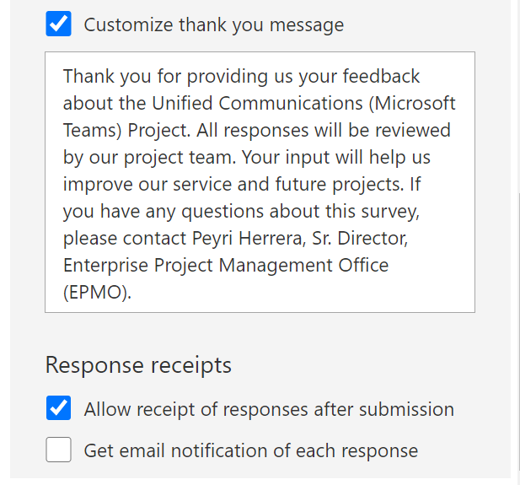

Sample survey questions:
- *Q1. Which division are you in? [DROP-DOWN]
  - Administration
  - Business Services
  - Human Resource Services
  - Innovation
  - Integrated Technology Services
  - Learning and Leadership Services
  - Student Services and Programs
- *Q2. Which training opportunities did you participate in between [Insert Start Month] and [Insert End Month]? (Mark all that apply) [MULTIPLE CHOICE]
  - One-hour online live training in [Insert Month] to learn the basics
  - One-hour online live training in [Insert Month] to learn tips and tricks
  - Self-Study – Read a job aid
  - Self-Study – Watched a recorded video
  - COMET workshop in [Insert Month] to learn about the project rollout
  - Other __________________
  - None of these
- *Q3. On a scale of 1-4 (where 1 is Strongly disagree and 4 is Strongly agree), to what extent do you agree with these statements that [Insert software] improves the way you work? [LIKERT SCALE] 1 = Strongly disagree, 2 = Disagree, 3 = Agree, 4 = Strongly agree
  - [Insert Statement]
  - [Insert Statement]
  - [Insert Statement]
  - [Insert Statement]
- Q4. What do you think we did well with this project? (OPTIONAL) [TEXT BOX]
- Q5. Where could we have improved? (OPTIONAL) [TEXT BOX]
- Q6. Do you have any additional comments or feedback you would like to provide? (OPTIONAL) [TEXT BOX]

