CALIFORNIA COMMUNITY SCHOOLS PARTNERSHIP PROGRAM:
IMPLEMENTATION PLAN SY 2025-2026

CA CS Framework Overview
A community school is any school serving pre-Kindergarten through high school students through a “whole-child” approach, with an integrated focus on academics, health and social services, youth and community development, and community engagement. It is an equity-driven and assets-building school transformation program.
Adopted in 2022, the CA CS Framework identifies 4 Pillars of Community Schools, Key Conditions for Learning, Cornerstone Commitments, and Proven Practices as follows:
Pillars of Community Schools: Integrated Student Supports; Family and Community Engagement; Collaborative Leadership and Practices for Educators and Administrators and Extended Learning Time and Opportunities
Key Conditions for Learning in a Community School: Supportive environmental conditions that foster strong relationships and community; Productive instructional strategies that support motivation, competence, and self-directed learning; Social and emotional learning (SEL) that fosters skills, habits, and mindsets that enable academic progress, efficacy, and productive behavior, and System of supports that enable healthy development, respond to student needs, and address learning barriers.
Cornerstone Commitments of Community Schools: A commitment to assets-driven and strength-based practice; A commitment to racially just and restorative school climates; A commitment to powerful, culturally proficient and relevant instruction; and a commitment to shared decision making and participatory practices.
Proven Practices of Community Schools: Community Asset Mapping and Gap Analysis; A Community School Coordinator; Site-Based and LEA-Based Advisory Committees and Integrating and Aligning with Other Relevant Programs.
The California Community Schools Framework is synthesized through the Overarching Values and operationalized through the Capacity-Building Strategies.
More information about these key concepts or community school components can be found at https://www.cde.ca.gov/be/ag/ag/yr22/documents/jan22item02a1.docx and at https://www.acoe.org/Page/2461, including the CA CS Framework.

Capacity-Building Strategies Overview
The S-TAC has launched the Capacity-Building Strategies: A Developmental Rubric to serve as a road map for both LEAs and school sites and is meant to enhance the adoption, implementation and sustainability of community schools. The Capacity-Building Strategies include a focus on:
- Shared understanding and Commitment
- Collective Priorities: Setting Goals and Taking Action
- Collaborative Leadership
- Coherence: Policy and Initiative Alignment
- Staffing and Sustainability
- Strategic Community Partnerships
- Professional Learning
- Centering Community-based Curriculum and Pedagogy
- Progress Monitoring and Possibility Thinking
The Developmental Rubric can be accessed here, and is best used as a side-by-side companion document as grantees are completing this implementation plan.
CCSPP: IMPLEMENTATION PLAN
School Site Contact Information
Yuba County Career Preparatory Charter School (YCCPCS)
1104 E. Street, Marysville, CA 95901
530-749-4000
Cynthia Soares, Director
Yuba County Office of Education

Strategies, Priorities and Goals
Describe the main process goals and action steps for the school site’s community schools initiative. Add lines as needed. Use the phase-specific activities outlined in the Developmental Rubric as a guide.

Strategy 1: Shared Understanding and Commitment
LEAs and schools raise awareness of community schools throughout the community, developing a shared understanding of the community schools approach that is centered on establishing racially just, relationship-centered schools. Schools and LEAs answer the question, “why a community school for my school/district?”

Shared Understanding and Commitment Built Around the Overarching Values
After engaging interest-holders to answer the question, “why a community school for my school?”, share your response to that question in the box below. In your response, be sure to Indicate how your site’s understanding of community schools reflects its commitment to the CA CS Framework through the Overarching Values (Overarching Values can be accessed here):
- Racially-just, relationship-centered spaces
- Shared power
- Classroom-community connections
- A focus on continuous improvement
Describe the developmental plans for ensuring these values are reflected in your community schools work:
- Racially - Just, Relationship-Centered Spaces:
  - A racially just culture creates a community founded on caring, belonging, and safety. Yuba County Career Preparatory Charter School (YCCPCS) creates a safe environment for all students, many of whom have experienced and/or are currently experiencing unpredictable and traumatic life conditions, which include absentee parent(s), homelessness, emotional, physical, and sexual abuse, neglect, and mental illness. YCCPCS has a strong vocational focus, with hands-on experiences to motivate students to complete their education.

The 2023 CA Dashboard Statewide College Career Indicator identifies many student groups as less prepared than the statewide average of 44%. The identified groups performing below the Statewide average in Yuba County include African American (21.9%), Hispanic (21.1%), special education (3%), English Learners (11.8%), and low-income students (21.1%).

In addition, YCCPS’s 2023 Dashboard data indicates the unduplicated student count was 88.21%, slightly higher than the state average of approximately 80%.
  - YCCPCS builds a trusting, positive school climate by strengthening relationships between students, families, and staff. Relationships are authentic and value diverse cultures, perspectives, and individual assets. YCCPCS proactively builds collaborative, supportive, and sustainable spaces where everyone learns and grows together. Evidence of implementing this Community Schools Forward Framework core value is collected through progress monitoring implementation and effectiveness of the following strategies:
    - Optimizing each student’s potential and opportunity to succeed by providing equitable access to productive, relevant, and meaningful learning experiences. The key attributes that comprise the Personalized Learning Program model are based upon the solid foundation of the latest educational research regarding how students best learn. These attributes include:
      - A strong emphasis on parental involvement
      - Small class sizes
      - One-on-one teacher and student interaction
      - Attention to differences in learning styles
      - Access to technology
      - Varied learning environments
      - Choice of curricular programs
      - Hands-on career technical education experiences
    - Integrating various types of age-appropriate technology in the curriculum, the instructional staff is not restricted by time, place, or availability of learning resources. This approach empowers supportive adults to be active partners in students' social development and education and allows staff to provide on-demand support to address students' specific learning needs and styles while providing opportunities for them to excel.
    - Accessing many resources and services, including but not limited to bus passes, free meals, food distribution, laundry, showers, school supplies, and clothing. Students access these items when onsite or meeting with their teacher. The school prides itself on providing services and resources that meet students’ basic needs so they can better focus on their education. Students are referred to local community agencies as needed.
    - Providing foster youth and homeless/unaccompanied youth access to the same resources described above and have access to Prevention and Support Services provided by the Yuba County Office of Education.
    - Providing English language learners with instructional support embedded into lesson plans via the Edge ELA/ELD curriculum and supplemental Nearpod lessons.
    - Understanding the profound connection between students impacted by Adverse Childhood Experiences (ACEs), behavior, and the time it takes to build positive, trusting relationships.
    - Focusing efforts on staff professional development, including implementing a tiered system of support and engaging in support and career preparation programs that address the needs of individual students with a focus on lowering suspension rates and having no expulsions.
    - Maintaining a high bar for 85% satisfaction on annual climate surveys. The school made significant strides towards this goal with a 22-23 satisfaction rate of 80%. Students indicate they feel safer and more connected to school.
    - Referring students to the school counselor or family support specialist for appropriate support as issues arise, including referral to community-based agencies for more intensive support.
    - Removing barriers for homeless and foster youth by making referrals to county services and supporting school attendance. There is an increase in the number of students with social anxiety, so having a counselor onsite throughout the week allows students to have timely social-emotional support. Staff see increased student engagement with the family support specialist and wrap-around services. The family support specialist maintains a log of services provided and works directly with the County Prevention Services and Youth Advocacy Departments.
- Shared Power
  - YCCPCS recognizes and builds shared ownership and deep engagement through shared decision-making and collaboration and recognizes these strategies are vital to building a democratic, inclusive, and empowered learning environment.

Through the following practices, YCCPCS demonstrates that it values the expertise of its educational partners. Educational partners will feel their expertise and commitment to students in the community are recognized and valued.

Evidence of implementing this Community Schools Forward Framework core value is collected through progress monitoring implementation and effectiveness of the following strategies:

    - Engaging parents, students, and community partners by inviting them to the table with YCCPCS staff as active participants in the reflection and planning process for any site plan development. All plans are reviewed and approved by the Advisory Committee. An opportunity for public comment is placed on each Advisory Committee agenda.
    - Facilitating a Western Accreditation of Schools and Colleges (WASC) “Committee of the Whole.” This supports shared perspectives, values and leadership among all educational partners.
    - Translating public documents, meetings, and communication as requested by parents/guardians.
    - Partnering with the Yuba County Office of Education.

- Classroom to Community Connections
  - YCCPCS staff understand the alignment of classroom instruction to the broader community supports college and career readiness. Rigorous, engaging, and real-world project-based learning opportunities are asset-based and provide students with connections to their community, local history, cultures, and environments in which they will be employed. Instruction is based on meaningful and relevant connections to the broader community and provides students with extensive support needs opportunities for civic engagement and real-world connection.
  - Evidence of implementing this Community Schools Forward Framework core value is collected through progress monitoring implementation and effectiveness of the following strategies:
    - Providing students with an academic advisor and family support specialist
    - Maintaining partnerships with Yuba College and Yuba County One-Stop. The CTE teachers increased collaboration with these partnering programs to better prepare students for college and career transitions. Preparation includes the following steps:
      - Students annually meet with their academic advisor through Student Success class to complete their “Grad Plan”
      - An academic advisor supports dual enrollment at the community college
      - Staff coordinates job shadow days at local businesses
      - CTE classes visit related programs at colleges and trade school programs
      - Staff provide an annual FAFSA/Dream Act Workshop
      - Staff coordinate with Yuba County One Stop for field trips and presentations
      - YCCPCS offers various internship opportunities, including but not limited to Workforce Innovation and Opportunity (WIOA)

- Focus on Continuous Improvement
  - Evaluation of implementation and effectiveness includes student and family engagement, collaborative leadership, classroom instruction, school climate, and extended learning opportunities. Needs and Assets assessments are completed in alignment with the Community Schools Forward Framework, WASC/CDE Mid-Cycle Progress Report, and the development of the annual Local Control Accountability Plan.
  - YCCPCS staff conducts personal outreach to families, students, and partner agencies, as needed, for advisory body and committee representation and to elicit input for the annual needs assessment leading to site plan development.
  - YCCPCS hosts an annual Student Voices Lunch and Parent Voices Meeting to recruit interested educational partners to participate in the various strategic planning mandates and Advisory Committee.
  - Educational partners are encouraged to complete an annual survey that elicits specific feedback directly aligned with achievement, climate, and engagement goals. This data is disaggregated, reviewed, and used to develop the annual needs assessment.
  - As a personalized learning program, YCCPCS staff also have ample opportunity to elicit feedback from educational partners during 1:1 meetings and other informal opportunities and onsite events, support classes, etc. Aeries visitation notes and weekly Professional Learning Communities and/or staff meetings are some ways staff can document conversations with partners.

Strategy 2: Collective Priorities: Setting Goals and Taking Action (The Needs and Assets Assessment)
When interest-holders come together to identify collective priorities (through a needs and assets assessment), it fosters shared focus on those areas deemed most critical by local communities, influences the impact of the strategy, and helps build momentum to sustain efforts over time.

Part A: As part of the planning process, you have gone through an initial process of understanding needs and assets. As you initiate the implementation grant process and obtain site-level resources, please reflect on how you will go deeper in this needs and asset assessment process to engage the entire community in identifying their top community school priorities and vision. Please reflect on how you will engage different groups (administrators, certificated staff, classified staff, students, family members, community members and community partners) and identify the processes (e.g., surveys, one-on-one interviews, focus groups, visioning exercises, meetings/forums, etc.) you will use to engage them. Describe how you will engage historically marginalized student and family groups.

As the foundation for establishing a community school, the YCCPCS Advisory Committee engages a wide array of educational partners in developing and planning the Community School Forward Framework rollout. YCCPCS distributed online and hard copy surveys and conducted and documented 1:1 and focus group interviews with students, families, and community partners.

Identified Needs:

- Operationalize interventions/supports to keep all students and families engaged, learning, and achieving through graduation and on to students’ college/career pathway.
  - Parent participation in daily, monthly, and school events and actively participate on school site committees.
  - Parent participation in surveys to elicit feedback
  - Getting students to access services available, e.g., tutoring, academic support classes
  - Supporting students aged 17-20 years as they navigate unique barriers to completing their high school diploma (e.g., balancing work and education, parenting, transportation, and acquiring adult living skills). There is a need for resources to support this population.
  - Increase parent buy-in for attendance and engagement.
- Increase educator efficacy in supporting all students' engagement, learning, and achievement.
  - Continue to build educator and staff capacity to maintain a multi-tiered system of support and keep parents/guardians and students engaged.
- Increase resources for students and families to support students’ social-emotional learning and mental health needs, including;
  - accessing childcare, if the student is a parent,
  - understanding the value of supports offered,
  - utilizing supports and decreasing the stigma towards mental health supports and resources,
  - increasing student presence support classes

Identified Assets:
- YCCPCS hosts an awards ceremony each semester to recognize student successes (e.g., attendance, state testing, principal's choice, etc.) and offer public feedback on why they are a recipient
- YCCPCS implemented the Bell Ringer program over the past two years. A bell is installed in front of the school where students who have met all course requirements ring the bell to celebrate their graduation. Many staff, students, and families join around and applaud the accomplishment. Students in the building hear this and are inquisitive about the process and who graduated.
- YCCPCS added an option for a cohort model where students are on site for 3 hours minimum. This increases the social time and availability for SEL instruction substance prevention services
- YCCPCS offers several CTE programs, including Aquaponics, Auto, Digital Media Arts, Vet Tech, and Welding. The school is increasing these opportunities to provide social opportunities and explore career pathways.
  - YCCPCS provides various ways to complete certifications in all CTE programs.
- YCCPCS serves students who show a lack of success in traditional educational settings.
- YCCPCS provides hands-on learning opportunities
- YCCPCS provides voice and choices in program selection, including credit recovery, summer school, and early graduation

Annual program needs are determined through the following:

Educational Partner Surveys
YCCPCS annually surveys each educational partner group and includes questions that address perceptions of current needs, existing assets, and potential areas for improvement.

Focus Group Discussions
YCCPCS elicits information through the use of focus group discussions with representatives from various educational partner groups to facilitate open dialogue and gather qualitative insights. Participants are encouraged to share their perspectives on the strengths and weaknesses of the existing school system.

YCCCPCS Public Meetings
The team hosts public meetings to provide a platform for educational partners to express their thoughts and concerns directly to the YCCPCS Advisory Committee. They utilize these sessions to gather feedback on specific topics related to the project and the overall needs of the schools.

Collaborative Professional Development
Administration facilitates collaborative workshops that bring together different educational partner groups to work on specific aspects of a project. They use these workshops to identify synergies, align goals, and foster a sense of shared responsibility. This work may include a weekly professional learning community or collaborative time for staff to work together.

Online Platforms
YCCPCS utilizes online platforms or portals to collect feedback, suggestions, and ideas from a broader audience. They ensure accessibility and user-friendliness to encourage active participation from diverse groups.

Student Voice
YCCPCS engages with the student body to gain insight into their perspectives, needs, and challenges and troubleshoot potential solutions. Staff encourages students to participate in surveys, focus groups, and other engagement activities in order to improve the program.

Continuous Improvement
Valid and reliable data is regularly analyzed to identify common themes, priorities, and areas of consensus. Data drives the development of comprehensive reports summarizing findings and outlining proposed actions based on the assessments.

YCCPCS ensures students and their families are visible school community members with equitable opportunities to contribute. Educational partners receive regular progress updates. Updates highlight how their feedback has been incorporated into site plans and demonstrates a commitment to transparency. These strategies foster an inclusive and collaborative approach to assessing needs and identifying assets, which leads to well-informed, community-supported projects.

By creating conditions for active, meaningful participation, the YCCPCS Advisory Committee constructs a culture of allyship (a lifelong process of building meaningful relationships founded on trust and accountability with marginalized individuals, groups, and communities of people). Furthermore, by working in solidarity with marginalized groups, the Advisory Committee seeks to deconstruct systems that challenge basic rights, equal access, and the ability to thrive as a member of society.

Part B: As sites complete the needs and asset assessment process, they identify collective priorities that form the initial focus of their community school implementation efforts. Given your preliminary needs and asset assessment, please share three draft collective priorities that you anticipate arising as you achieve deeper engagement with students, staff, families and community members.

One of the priorities should align with a support listed in the Whole Child and Family Supports Inventory (e.g., integrated student supports, authentic family and community engagement, collaborative leadership, extended learning time and opportunities, positive and restorative school climate, community-based curriculum and pedagogy, etc.). The collective priorities you list below may be the same goals you will ultimately report in the APR, or they may change throughout the course of your first year as you continually engage students, staff, families and community members.

Draft Collective Priority | Outcome/Indicators you aim to improve
- Integrated Student Supports and Services | Indicator: Increase the resources for students and families to support students’ social-emotional learning and mental health.  Metrics:  - 85%+ parent/guardian survey satisfaction with greater than 50% participation  - At least a 90% attendance rate  - Of students participating, >85% will be classified as ‘getting by,’ ‘moderate thriving,’ or ‘high thriving’ on the CoVitality Screener.
- Authentic Family and Community Engagement | Indicator: Operationalize interventions/supports to keep all students and families engaged, learning, and achieving through graduation and on to students’ college/career pathway.  Metrics:  - Increased parent/guardian involvement through volunteering, decision-making, or attendance at school wide events.  - Increased # of students successfully. completing dual enrollment and internships and participating in field trips.  - 100% of students will meet with an academic advisor and complete a graduation plan within their first year of enrollment.
- Positive and Restorative School Climate | Indicator: Increase educators’ capacity to support all students in engaged learning for the purpose of increasing achievement.  Metrics:  - <15% chronic absenteeism, overall and by reported student group  - Students will complete a minimum of 25 HS credits on average each semester.  - 100% of school staff trained will receive annual training on SEL/ Trauma-Informed practices and > 75% will implement their learning.

Strategy 3: Collaborative Leadership
Shared decision-making ensures all interest-holders have a voice in the transformation process and fosters shared power of the strategy. Collaborative leadership improves coordination of services, fosters supportive relationships, results in decisions that are widely accepted and implemented, and supports sustainability of the effort.
At the system level, LEAs establish a system-level steering committee/advisory Committee to conduct exploration activities and to provide crucial guidance to school-level implementers. At the site level, schools map and assess the current shared governance structures (where and how decisions are made) in their building and community, identifying all existing school-site and local neighborhood teams, networks, or working groups to understand their purpose and composition. Schools then launch or revise site-level shared leadership structure(s) to facilitate democratic participation and decision-making among students, staff, families, and community members.
Describe your goals for strengthening collaborative leadership.

Site Level Goals and Measures of Progress
Goals | Action Steps
Inclusive Participation | YCCPCS will facilitate democratic participation at the site level by:  - Actively recruiting students, parents, staff, families, and community members to take part in the decision-making process.  - Advertising opportunities for participation through various media.  - Holding events on days and at times educational partners are mostly likely to be able to attend  - Engage industry representatives and local businesses to participate in the Advisory Council process.
Enhance Decision-Making Structures | - Develop an annual Advisory Council calendar including continuous improvement topics (data, input, progress monitoring, etc.)  - Annually evaluate the effectiveness of the Advisory Council.

Describe the system of shared governance and site-level leadership structure at your community school (this could be a visual like an organizational chart or other graphic):

Yuba County Office of Education Organizational Chart depicts all the departments within the YCOE organizational structure, the Community Schools Forward Framework indicates all the various ways community schools strategies intersect with “whole Child Design” to support learning and success. Lastly, Yuba County Career Preparatory Charter School’s continuous improvement model ensures increased quality of services. See graphics below:

YCOE – Organizational Chart

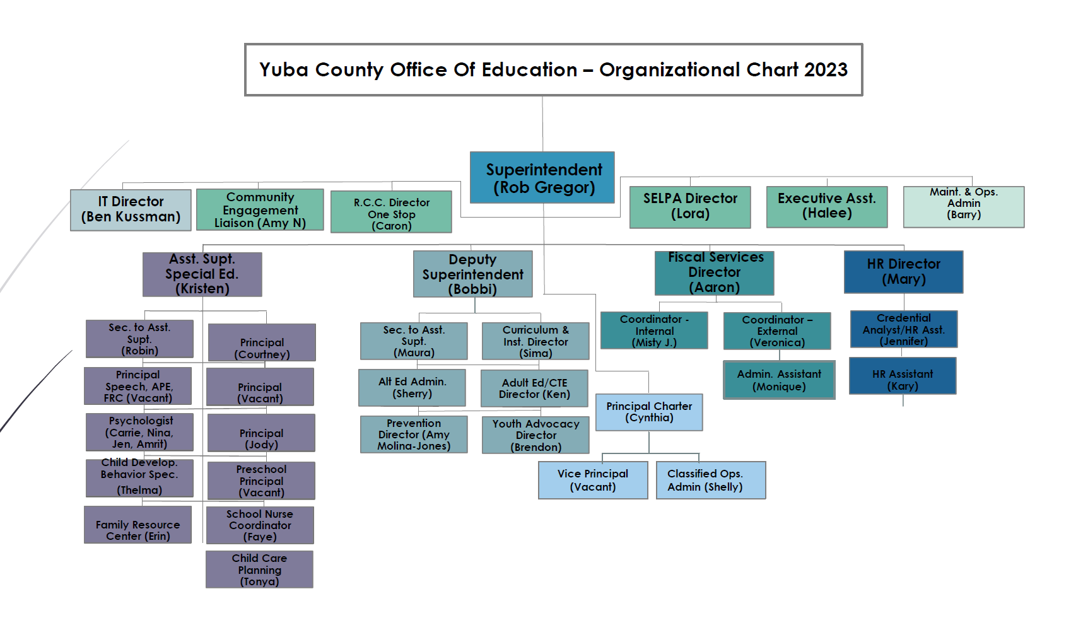

Community Schools Forward Framework
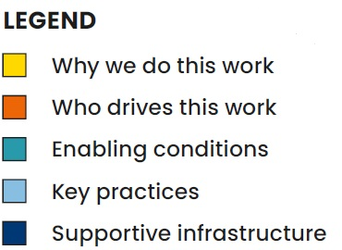
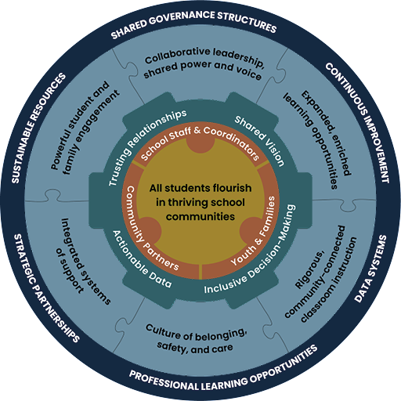

Continuous Improvement Model
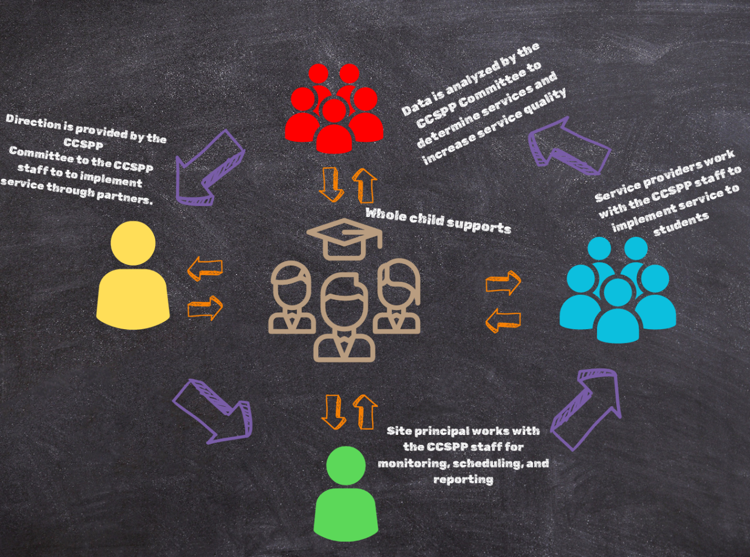

The YCCPCS Advisory Council is established to ensure all interest-holders have a voice in the transformation process of YCCPCS. Inclusivity is paramount, with invitations extended to teachers, classified unions, and site administration to ensure diverse perspectives at these tables. Most significantly, the voices of students and parents play a crucial role in governing the school's work. The YCCPCS Advisory Council prioritizes coordination of services, fosters supportive relationships, and progress monitors the implementation and effectiveness of the site plans.

Strategy 4: Coherence: Policy and Initiative Alignment
Establishing coherence and alignment across policies and initiatives is critical in the success of the community school strategy. Coherence helps clarify purpose, ensures efficient use of resources, avoids conflicting policies, creates synergy and the amplification of impact, and promotes sustainability.
A coherent and comprehensive plan/strategy for community schools “de-silos” all parallel LEA and school-level initiatives. Schools fully integrate the community school strategy with all existing school-wide strategic plan(s)/ improvement plan(s) such as the LCAP and SPSA. The community school implementation plan and school improvement plan become one cohesive plan. Describe your goals and action steps for establishing policy and initiative alignment.

Site Level Goals and Measures of Progress
Goals | Action Steps
Align all site plans, including the Community School Forward Framework, to create coherence of goals, actions, metrics, and outcomes | - Gather qualitative and quantitative data  - Analyze data, conduct root cause analysis, etc.  - Share data with educational partners  - Identify needs and assets  - Use the annual evaluation of needs/assets to align site plan goals, actions, metrics, and outcomes as they are updated.
Develop a comprehensive site-level procedure for the implementation of new initiatives to ensure new implementations are productive and align with established organizational and schoolwide goals and actions | YCCPCS will support the implementation of new initiatives by  - drafting a procedure defining ‘new implementation’ and ‘initiative’ and outlining administrative expectations by header section  - Convene the school site leadership team  - Leadership will review and revise the procedure  - Share the procedure with the Advisory Council and staff to elicit input  - Train staff on the final procedure  - Monitor new implementations to ensure they align with the documented procedure

Strategy 5: Staffing and Sustainability
A focus on staffing and sustainability ensures that the necessary human and financial resources are available to maintain the strategy over time, and to sustain continuous progress and improvement.
Describe your goals and action steps for ensuring that: staffing serves the target student population, LEAs recruit and hire diverse, multilingual staff to support site-level work, including an LEA-level Community School Director/Coordinator. Schools hire site-level coordinators. Both sites and systems develop sustainability plans to ensure core staffing is sustained through long-term funding.

Site Level Goals and Measures of Progress
Goals | Action Steps
YCCPCS will build staff capacity on the principles of ‘Community Schools’ to create common language, engage in planning, and de-silo student integrated support and continuum of care. | - YCCPCS administration will improve school climate and increase access to community resources by  - arranging Community Schools training for staff  - Staff will be provided key terms  - Staff will discuss key terms in the context of the training and develop a glossary of shared language  - Expanding on the strength-based approach to learning and achieving  - continue training in standards-aligned instruction and restorative practices  - Convening the leadership team  - The leadership team will meet with YCOE departments and community partners and conduct additional research, as needed, to identify evidence-based strategies. Evidence-based strategies training will be embedded in staff meetings or professional development days  - YCCPCS will monitor the implementation and effectiveness of the goal and actions
Hire a community schools coordinator by August 2024. | The Community Schools Coordinator will:  - work with family liaisons,  - teachers,  - staff members  - student and family leaders, and  - community partners  To facilitate the community schools process.  - Develop a comprehensive long-term funding plan that considers every aspect of the initiative, including blending and braiding existing funding sources and pursuing new funding sources (e.g., grants and partnerships with externally funded organizations, MOU, and Medi-Cal Billing).

Key Staff/Personnel
Director (Existing) | The Director serves as the YCCPCS Chief Administrator overseeing Community School implementation and transformation.
Community School Coordinator (New) | Will work with family liaisons, teachers, other staff members, student and family leaders, and community partners to facilitate the community schools process.
YCOE Director CCSPP (Existing) | Lead the development and maintenance of staffing and policy and implement cycles of continuous improvement, develop partnerships at the county level for services at the site level, support and develop site level professional development.

Describe the plans or steps you are considering to build sustainability beyond the life of your implementation grant:
In order to build sustainability beyond the life of the implementation grant, the YCCPCS Advisory Committee will
- Actively explore additional grant opportunities, partnerships, and revenue-generating activities (e.g., funds through the sale of goods from the commercial garden/kitchen) that will contribute to the sustainability of the program.
- Medi-Cal billing/funding for example, Local Educational Agency Medi-Cal Billing Option Program.
- Expand/improve existing partnerships to better support students and families.
- Staff /student/family and community partner training completed during the life of the grant to build operational capacity to sustain the project.
- Increase community engagement to build a sense of ownership and foster community support. Our community-supported project is more likely to attract continued funding or local resources if substantial engagement exists.
- Over time, build strategic partnerships with other organizations, businesses, and government agencies. Collaborative efforts bring in additional resources, expertise, and support for sustaining the project beyond the grant period.

Strategy 6: Strategic Community Partnerships
Developing strategic community partnerships allows schools and LEAs to build a stronger network of support and culturally responsive programming and resources for students, educators and families, and to foster a more inclusive, democratic and supportive learning environment that benefits everyone in the community.
In alignment with strategies developed in response to the deep needs and asset assessment, schools identify and establish school-community partnerships who share a holistic focus on students, families and the community. This section should demonstrate your goals and action steps to ensure community partners are actively involved in the planning, development, and continuous improvement of the community school.

Site Level Goals and Measures of Progress
Goals | Action Steps
Maintain and strengthen existing partnerships | YCCPCS will work on various strategies including but not limited to:  - Maintaining regular and open communication  - Developing a shared understanding of the goals of the partnership.  - Ensuring consistent delivery of any information to build trust and reliability, which is crucial for long-term partnerships.  - Conduct regular reviews of assets and areas for improvement.  - Celebrate successes by publicly acknowledging milestones.  - Adapting to changes in the school and community landscape.
Develop new partnerships to meet  the evolving needs and strengths of  the local community | - YCCPCS will develop/maintain a list of 1. existing and 2. potential partners in the surrounding community.  - As new partnerships are formed, develop a shared goal and common ground for the partnership that benefits both the school site and the community to build relationships and strengthen joint efforts to amplify the impact of collective contributions.

Describe the partnerships you have established or plan to establish, and how your school’s partnerships will be responsive to the vision and priorities of students, staff, families and community members:
To engage a wide array of educational partners, the YCCPCS Advisory Committee will implement practices that dive deeply into meeting the various student needs to break down barriers and achieve successful fulfilling lives. Additionally, the YCCPCS Advisory Committee will incorporate the development of annual internal and external asset mapping to incorporate economic and employment trends within the community and increase student workforce pathways for those with extensive support needs.

YCCPCS maintains positive, student-centered partnerships throughout the county. These partnerships include, but may not be limited to:
- Yuba College: Dual enrollment, articulated courses, financial aid presentations, and career readiness
- Yuba Sutter Food Bank: Volunteer opportunities & regular distribution of food to students and families
- Military Services: ASVAB preparation and recruitment
- Yuba County Office of Education
  - One Stop: Employment readiness, job opportunities, and paid internships
  - Youth Advocacy: Assistance in removing barriers for students
  - Prevention Support and Services: Education for Homeless Youth and Families, Student Mental Health and Wellness, Tobacco Use Prevention and Education, Education for Homeless Youth and Families, and Parent Education
- Career Technical Education (CTE) Partners
  - Water Agency: Field Trips
  - Sacramento Autorama: Annual field trips and volunteer opportunities
  - Grand National Roadster Show: Annual field trip and volunteer opportunities
  - Field Haven: Vet tech program partners
  - SPCA: Partner by internships
  - YCCPCS is providing YCOE court and community school programs access to its CTE auto and welding programs
  - health screenings for age-appropriate development in partnership with local health agencies.
  - A Referral system to local healthcare agencies has been established, along with a follow-up system to support students in gaining access to community resources.
  - Personnel identified to work directly with students experiencing homelessness or foster placement

Strategy 7: Professional Learning
Professional learning enhances collaboration and coordination and provides opportunities for interest-holders to develop shared understanding, build relationships, and coordinate their efforts to better support student success.

Below, describe your goals and action steps for professional learning opportunities specific to the community school strategy. Consider role-specific professional learning supports that are offered to administrators, educators, classified staff, families, and other role groups as necessary. Also consider how schools identify the supports and professional learning needed to support the community schools initiative, including learning focused on shared leadership and a reimagining of teaching and learning to be collaborative, relationship-centered, culturally-affirming/relevant, asset-based, democratic and community-based.

Site Level Goals and Measures of Progress
Goals | Action Steps
Provide evidence-based professional learning opportunities | - Administer an annual survey to gather perceptions on current professional learning and determine future needs.  - Align professional learning with evidence-based pedagogy and instructional practices that focus on alternative education/independent study/CTE.  Monitor implementation and effectiveness reflection data as part of the annual LCAP planning process.
Implement cycles of continuous improvement | - Convene a leadership team  - Provide whole group structured staff professional learning PLC time to support the use of research/evidence-based instructional and SEL practices that focus on a tiered system of support.  - Review and analyze data (lead and lag data) at the school site and teacher level.  - Make data-driven program and instructional decisions

Strategy 8: Centering Community-Based Curriculum and Pedagogy
Community-based curriculum and pedagogy builds on the rich, diverse cultural, linguistic backgrounds of students and families. It can increase students’ engagement in their learning by connecting to real-life experiences and issues that are relevant to students’ lives and communities, improving their sense of ownership and agency.

Describe your goals and action steps to assist educators in learning the theoretical roots and practical elements of community-based learning.

Site Level Goals and Measures of Progress
Goals | Action Steps
Develop community partnerships to strengthen project-based learning opportunities within the community setting to support real-world work experience. | The Director and Advisory Committee will identify partnership opportunities for our CTE programs utilizing the “11 Elements of a High-Quality CTE Program”. Including continued programming in the areas of Agriculture and Natural Resources Pathways, and Culinary Arts.
Enhance the CTE curriculum that supports the unique needs specific to students who receive support through the IEP process. | CTE staff will work with the local county office of education special education team to develop strategies to support students who receive services through an IEP in obtaining career opportunities. This includes the unique supports that can be implemented in the community and classroom based on student needs.

Strategy 9: Progress Monitoring and Possibility Thinking
When interest-holders come together to review data on student outcomes and program effectiveness, they can ensure that the strategy is responsive to the assets and needs of students and families and adapt practices to better support success. Progress monitoring and possibility thinking allows for the celebration of successes, development of new strategies, structures and practices, and builds stronger relationships and partnerships among interest-holders.

Describe how your site, with educational partners, will explore the development of an evaluation plan for the community schools initiative, rooted in local data and measures that allows for diverse community-based definitions of success. Describe how you are developing metrics to gauge success and to guide their work. Identify those potential outcomes/indicators. Site Level Goals and Measures of Progress
Goals | Action Steps | Outcome/Indicators
Develop a system of student resource utilization rates. | Define services and tracking systems to collect data around resource utilization. | Develop a tracking system that clearly shows resource utilization and how many times these supports have been accessed.
YCCPCS provides public presentations and annual reporting of community school implementation and impact. | YCCPCS will provide public presentations at the advisory committee meetings, provide information through the use of Parent Square on successes and milestones and share outcomes with all educational partners. | YCCPCS will develop a PowerPoint for an annual update presentation at an Advisory Committee meeting. This will include outcomes, successes, and milestones along with future goals.

Developed by the California Department of Education and State Transformational Assistance Center, November 2023.

